GET IT DONE
Write two sentences about the people in the pictures. Use the words in parentheses.

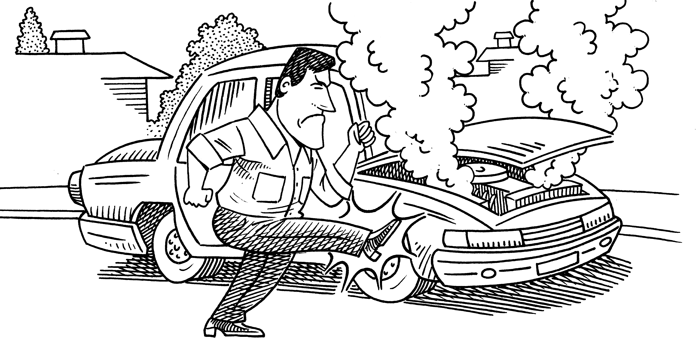 |  | 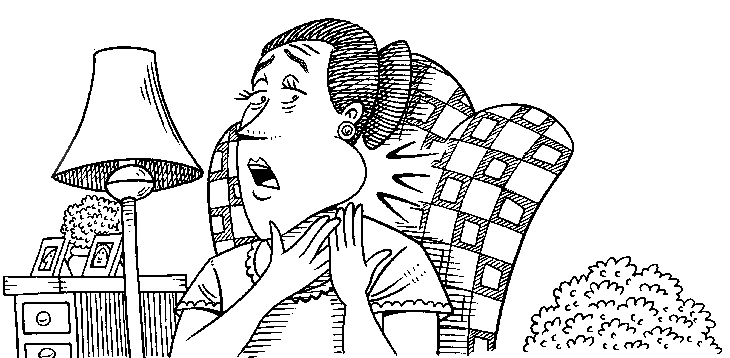

1. He needs to have a mechanic repair his car.  (have / mechanic / repair / car)  2. He needs to get his car repaired.  (get / car / repair) |  | 3.  (have / dentist / take out / tooth)  4.  (have / tooth / take out)

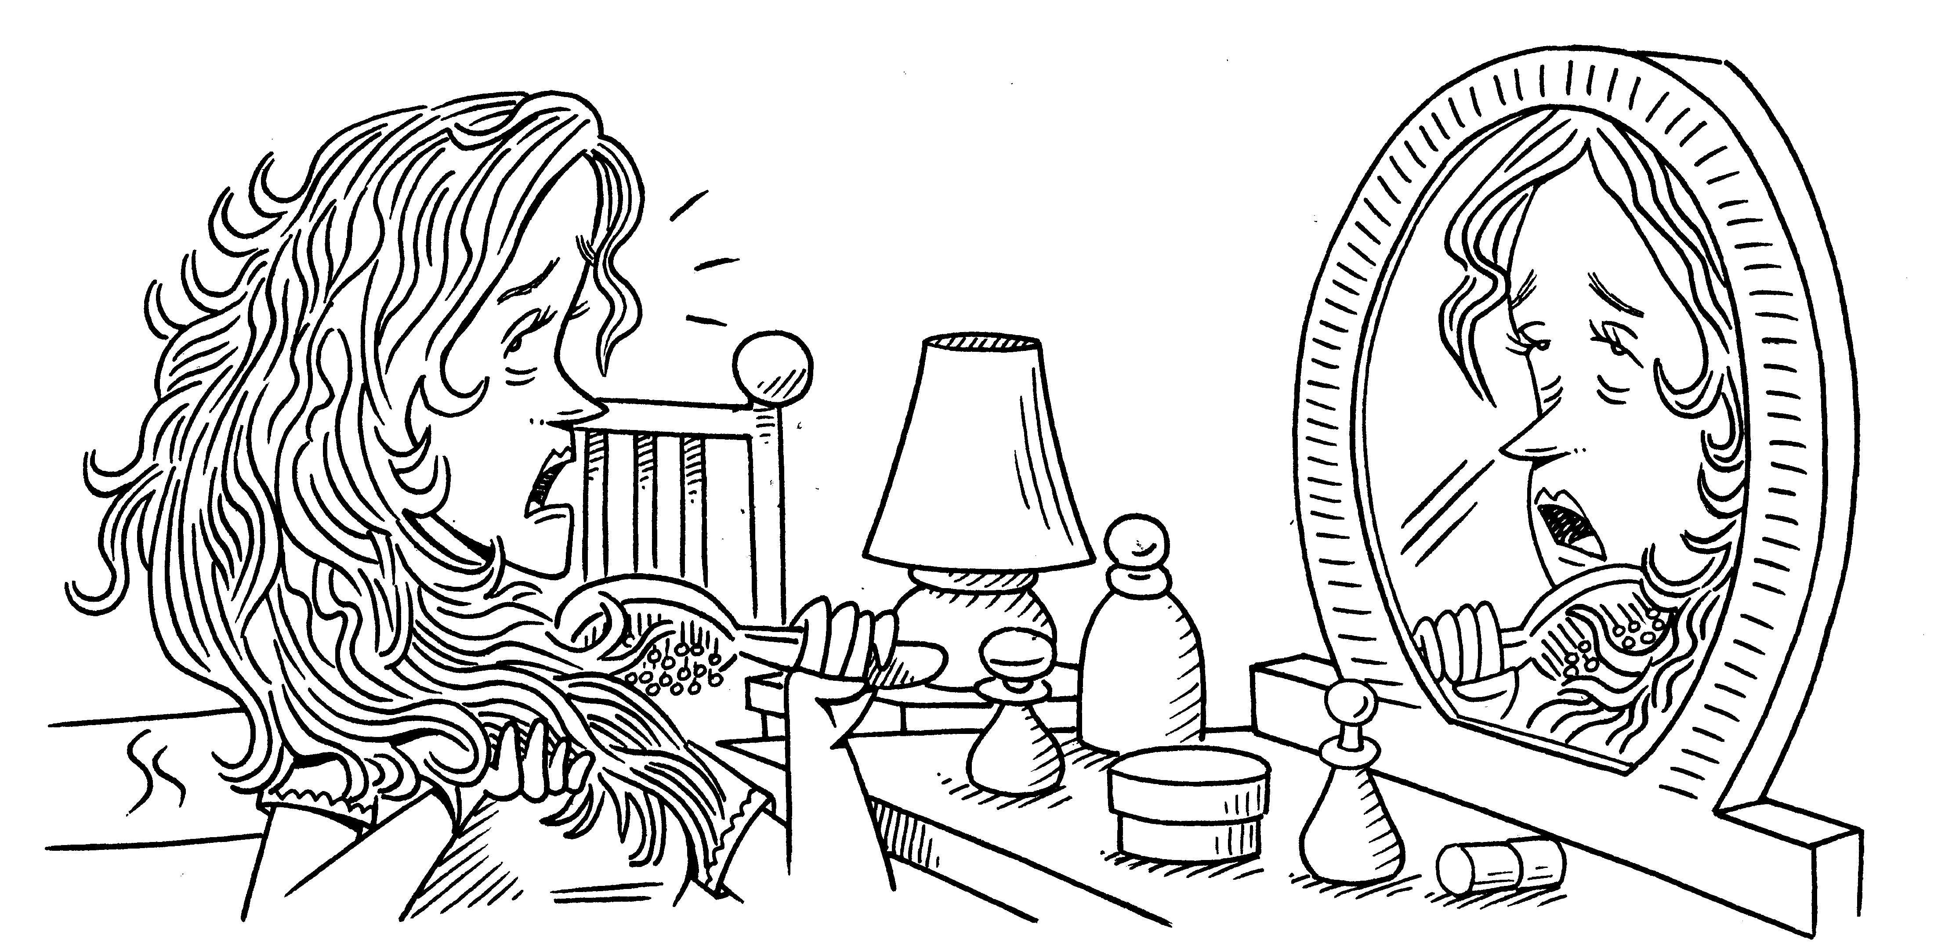 |  | 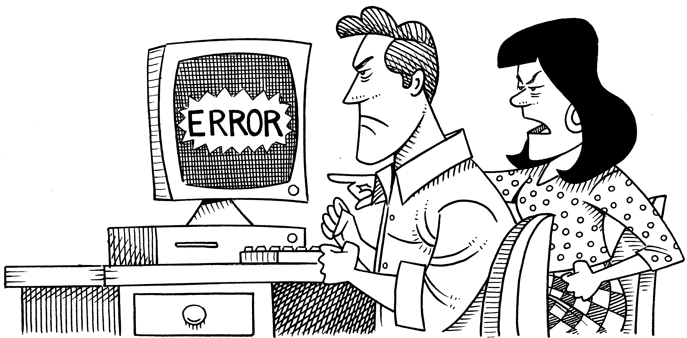

5.  (have / hairstylist / cut / hair)  6.  (get / hair / cut) |  | 7.  (get / computer technician / fix / problem)  8.  (have / problem / fix)
WHY DON’T YOU?
GROUP WORK Imagine you have the problems in the exercise above.
Take turns complaining about the problems and giving suggestions.
A: My car breaks down all the time!
B: Why don’t you have a mechanic look at it?
C: Have you thought about buying a new one?

