WHAT WILL HAPPEN?
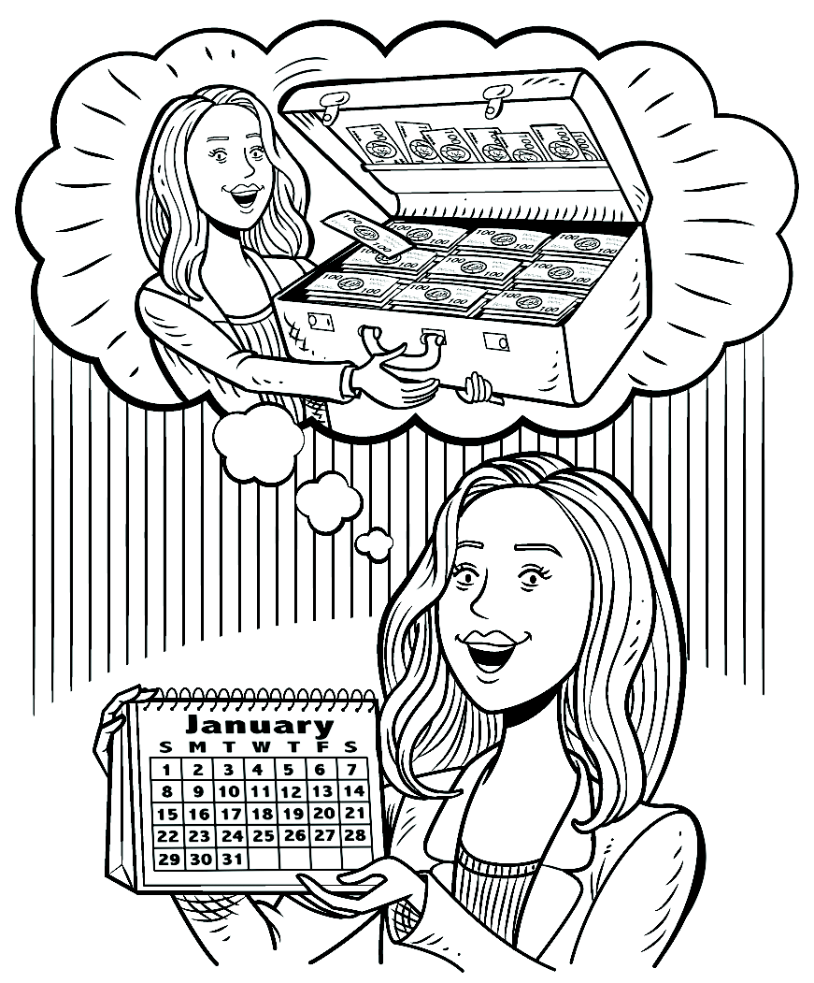
Complete the sentences with your own information.
1. If I win a lot of money,

2. If I lose my job,

3. If I have more free time next year,

4. If I exercise more,

5. If , I’ll have to move.
6. If , I might buy a new car.
7. If , I’ll be very surprised.
8. If , I’ll be very happy.
OUR CHANGING WORLD
A How were these things in the past? How are they now? How will they be in the future?
Complete the chart with your ideas.

Topic | Past | Present | Future
Shopping | small stores | large malls | only online shopping
Communication |  | cell phones
Transportation |  | cars
B GROUP WORK Compare your ideas.
A: In the past, there were no large malls. There were only small stores.
B: That’s right. Now most people shop at malls. What about the future?
C: In the future, I think people will buy everything on the Internet.

