TRUE ABOUT YOU?
A Are these sentences true about you? Check () Yes or No.

In my home, . . . | Yes | No |  | In my neighborhood, . . . | Yes | No
1. there’s a big living room. □ □  2. there are curtains on every window. □ □  3. there’s a TV in my bedroom. □ □ |  |  |  | 4. there’s a subway station. □ □  5. there are nice stores. □ □  6. there are good restaurants. □ □

B For sentences that are not true, write the sentences in the negative form to make them true.
1.
2.
3.
4.
5.
6.
WHAT’S THE APARTMENT LIKE?
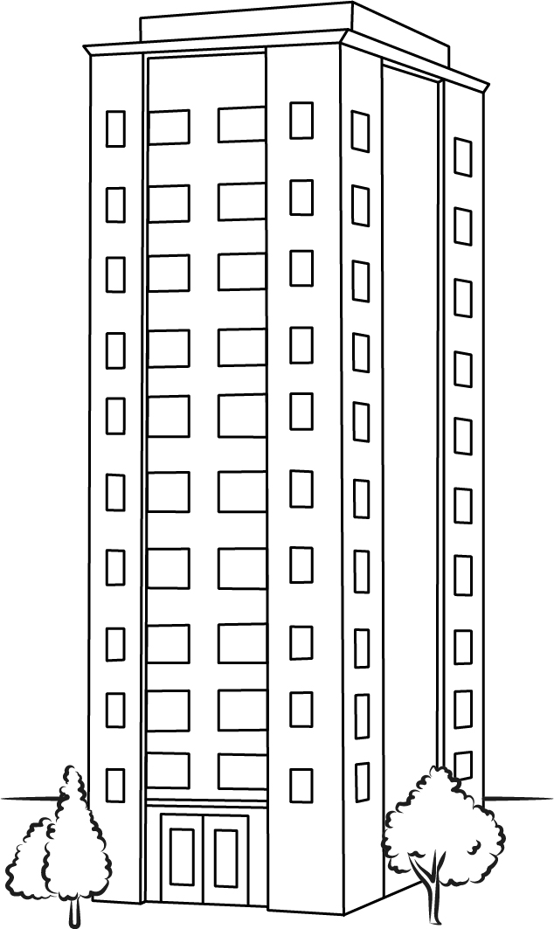
A Complete the conversation with the correct words in parentheses.
Sandra: Hello?
Chris: Hello. I’m calling about the apartment.
Sandra: Oh, yes, sure.
Chris: First, does (do / does) it have many rooms?
Sandra: It __________ (has / have) a living room, a kitchen, three
bedrooms, and two bathrooms.
Chris: Great. And __________ (do / does) the apartment come
with furniture?
Sandra: Yes, it __________ (do / does). But it __________
(do / doesn’t) have a refrigerator.
Chris: __________ (Do / Does) the windows have curtains?
Sandra: No, I’m sorry, they __________ (don’t / doesn’t).
Chris: __________ (Do / Does) the building have a laundry room?
Sandra: Yes, it __________ (do / does).
Chris: That sounds nice. Thanks.

B PAIR WORK Your partner is selling an apartment. You want to buy it.
Have a conversation like the one in part A.

