PLANS
Write about things you are going to do in the next three weeks. Use the phrases
in the box or add your own ideas.
buy something I need | give my best friend a present | look for a new job
celebrate my birthday | go dancing | play sports
cook for my friends | go out with friends | relax
do something unusual | have a party | see a movie
1. I’m going to celebrate my birthday on June 22nd. I’m going to have a big party.
2.
3.
4.
5.
6.
7.
8.
HOLIDAYS AND CELEBRATIONS
PAIR WORK Look at the pictures. Choose a holiday or celebration and imagine how you are going
to celebrate it. Your partner is going to guess your holiday or celebration. Use questions like the
ones below. Take turns.
Are you going to . . . ? What are you going to . . . ?
Where are you going to . . . ? Who is going to . . . ?
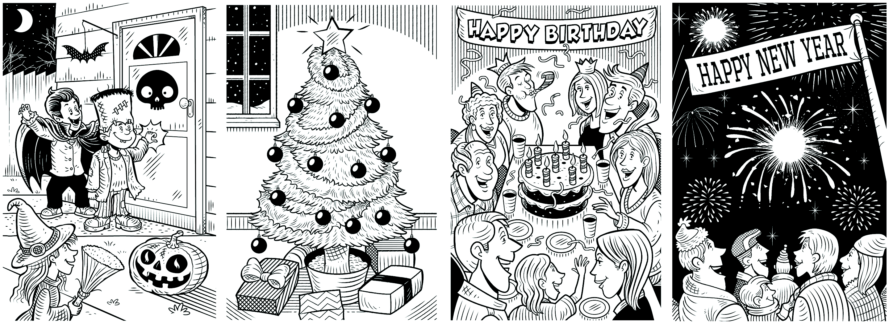
Halloween Christmas Birthday New Year
A: Are you going to stay home?
B: No, I’m not.

