WHAT’S FOR LUNCH?
You want to make a sandwich and a green salad for lunch. You have the ingredients
in the picture. What do you need to buy? What don’t you need? Complete the chart.
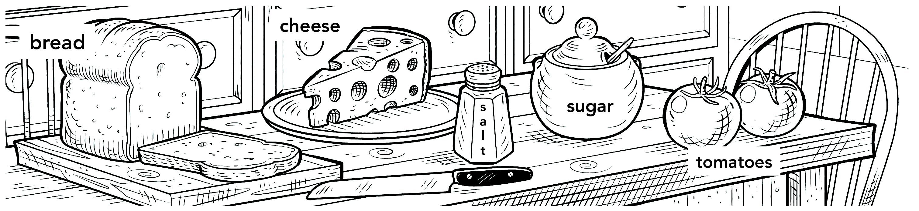

I need . . . | I don’t need . . .
I need to buy some lettuce. | I don’t need any bread.
DO YOU EVER . . . ?
A Read the chart. Add two more activities.

Do you ever . . . | Always | Usually | Often | Sometimes | Hardly ever | Never
1. eat in restaurants? | □ | □ | □ | □ | □ | □
2. have soup for breakfast? | □ | □ | □ | □ | □ | □
3. go on picnics? | □ | □ | □ | □ | □ | □
4. eat snacks at night? | □ | □ | □ | □ | □ | □
5. drink tea? | □ | □ | □ | □ | □ | □
6. eat Chinese food? | □ | □ | □ | □ | □ | □
7. use milk in your coffee? | □ | □ | □ | □ | □ | □
8. have pizza for lunch? | □ | □ | □ | □ | □ | □
9. ____________________ | □ | □ | □ | □ | □ | □
10. ____________________ | □ | □ | □ | □ | □ | □

B PAIR WORK Now interview your partner. Ask questions from the chart.
Check () the boxes that are true about your partner.
A: Do you ever eat in restaurants?
B: Yes, I often do. / Sometimes I do.

