EXPECTATIONS AT WORK
How should you behave at work? Check () the correct words to complete the sentences.

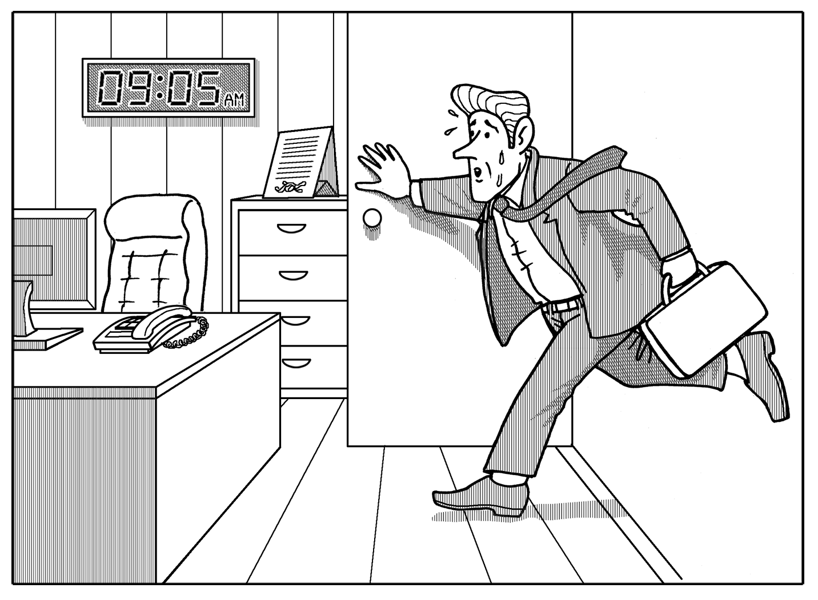 |  | 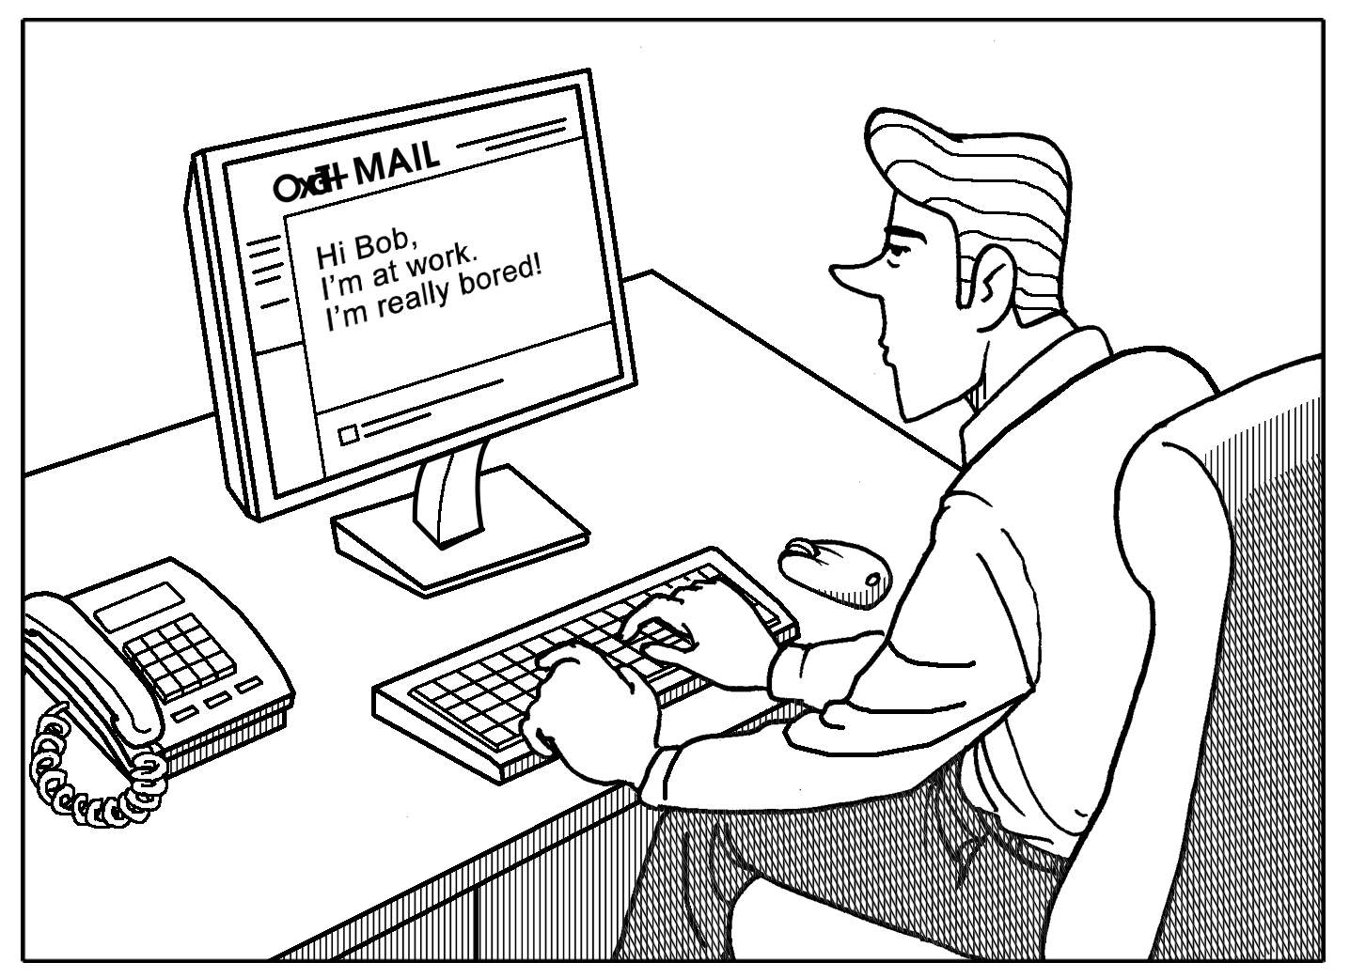 |  | 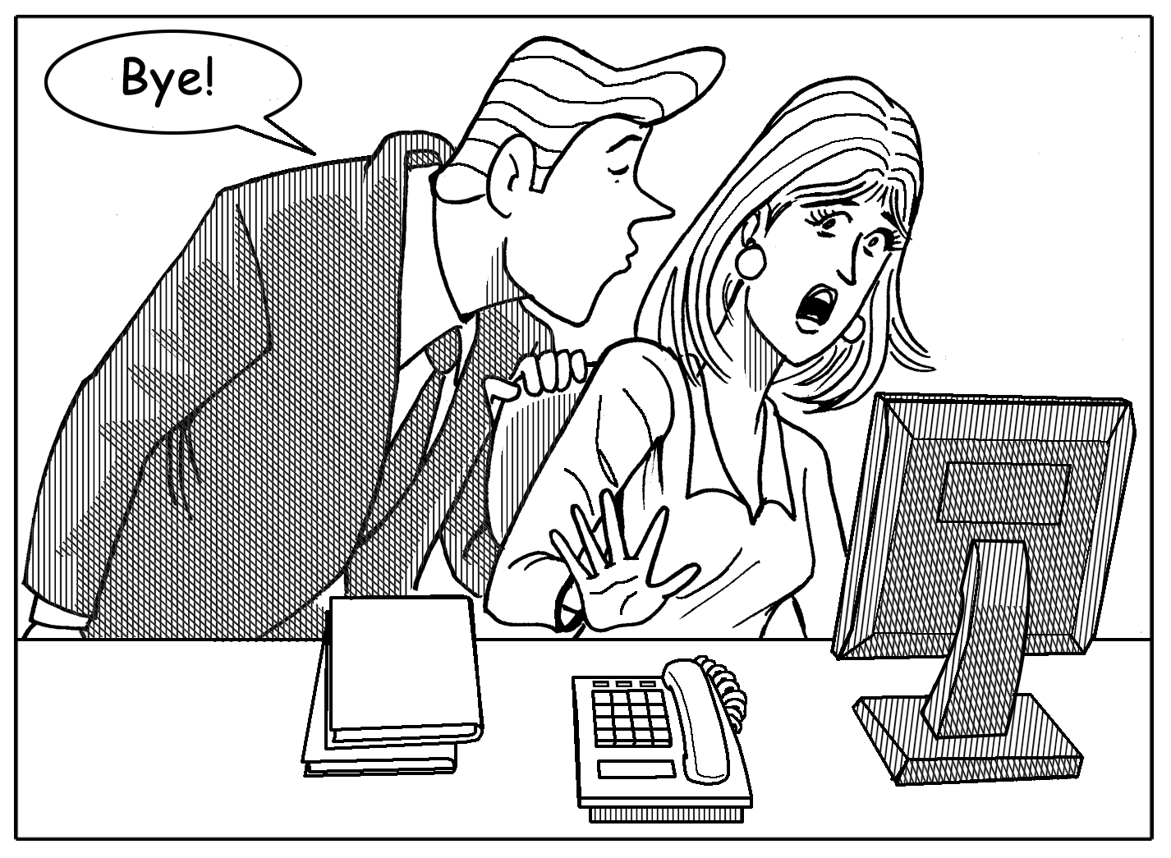

1. □ You’re expected to . . . 2. □ You’re expected to . . . 3. □ It’s the custom to . . .
□ You aren’t supposed to . . . □ You aren’t supposed to . . . □ It’s not the custom to . . .
. . . be punctual. . . . write personal email. . . . kiss your colleagues.

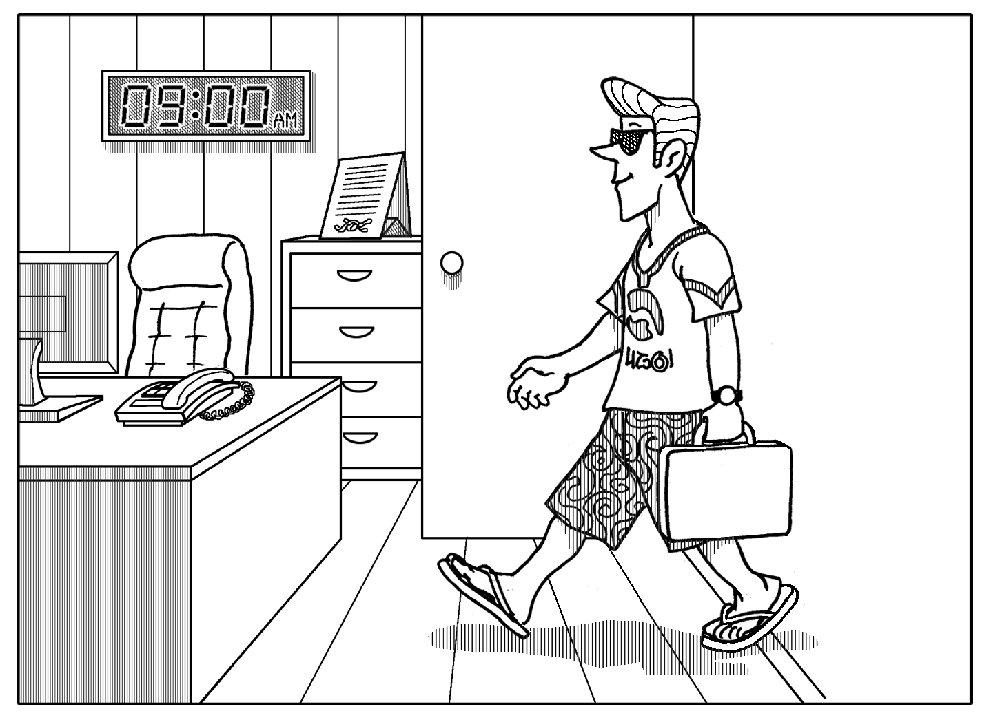 |  | 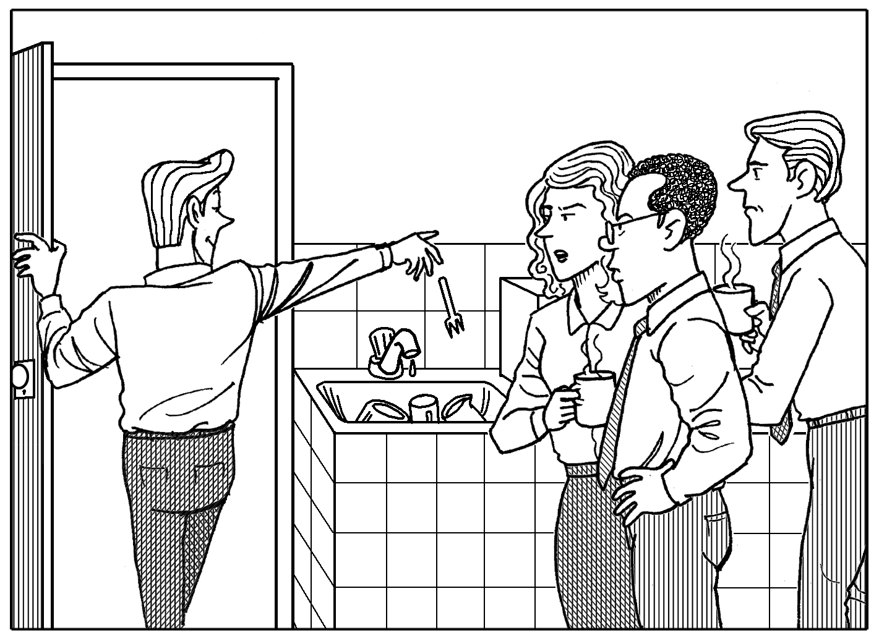 |  | 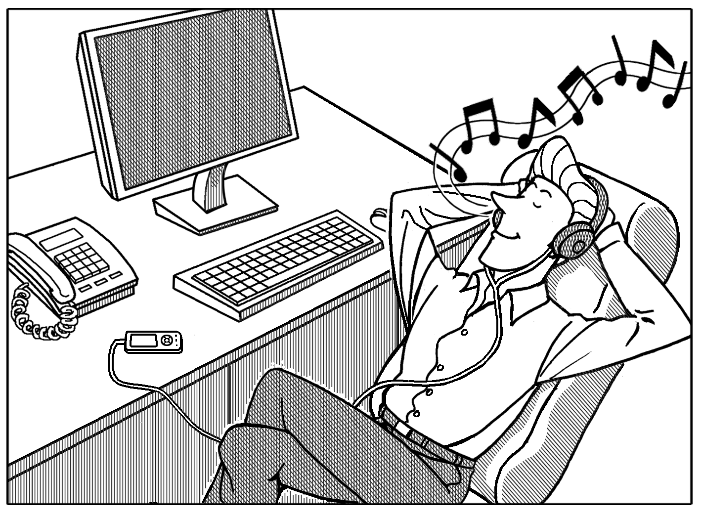

4. □ It’s acceptable to . . . 5. □ You’re expected to . . . 6. □ You’re supposed to . . .
□ It’s not acceptable to . . . □ You’re not expected to . . . □ You’re not supposed to . . .
. . . wear shorts. . . . wash your dishes. . . . listen to music.
LIVING ON A TROPICAL ISLAND
A Imagine you live alone on a tropical island. Complete the chart.

I’d miss . . . | I wouldn’t miss . . . | I’d worry about . . .
my computer

B GROUP WORK Compare your ideas.
A: Something I’d really miss is my computer. I use it every day.
B: I’d miss my cell phone.
C: I’d miss that, too. But one thing that I wouldn’t miss is the winter. I hate
cold weather!

