WHAT ARE THEY WEARING?
A Look at Picture 1. Complete the sentences with is, isn’t, are, or aren’t.
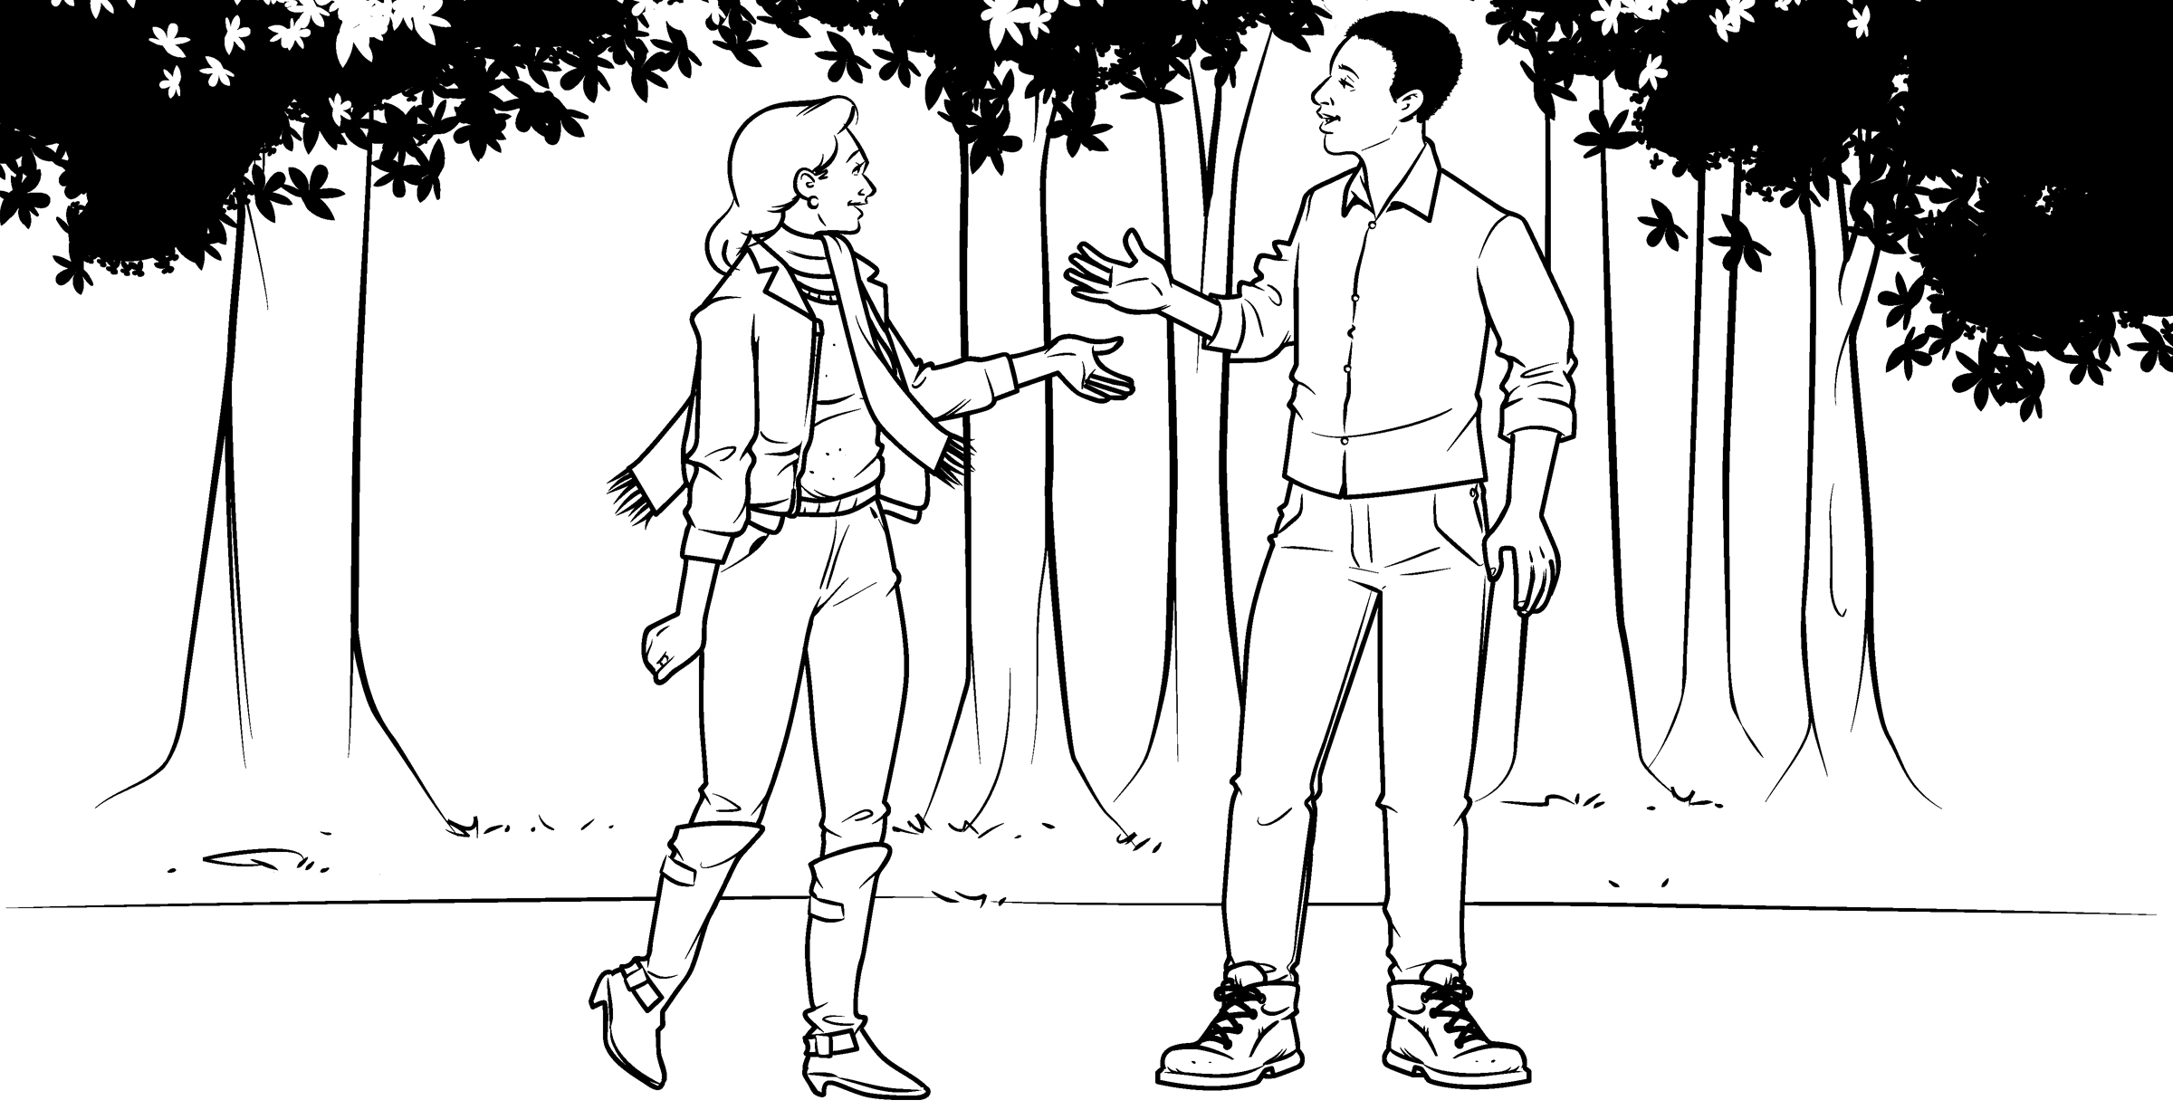Picture 1
1. Pam and Bob are wearing boots.
2. Pam wearing a scarf.
3. Bob wearing a scarf.
4. Pam and Bob wearing jeans.
5. They wearing shorts.
6. Bob wearing sneakers.
7. He wearing a sweater.
8. Pam and Bob wearing caps.

B Now write about something you are wearing and something you aren’t wearing.
1.
2.
FIND THE DIFFERENCES
PAIR WORK Look at Picture 1. Then look at Picture 2. How are they different?
Tell your partner.
A: In Picture 2, Bob is wearing a tie.
B: In Picture 1, he isn’t wearing a tie.
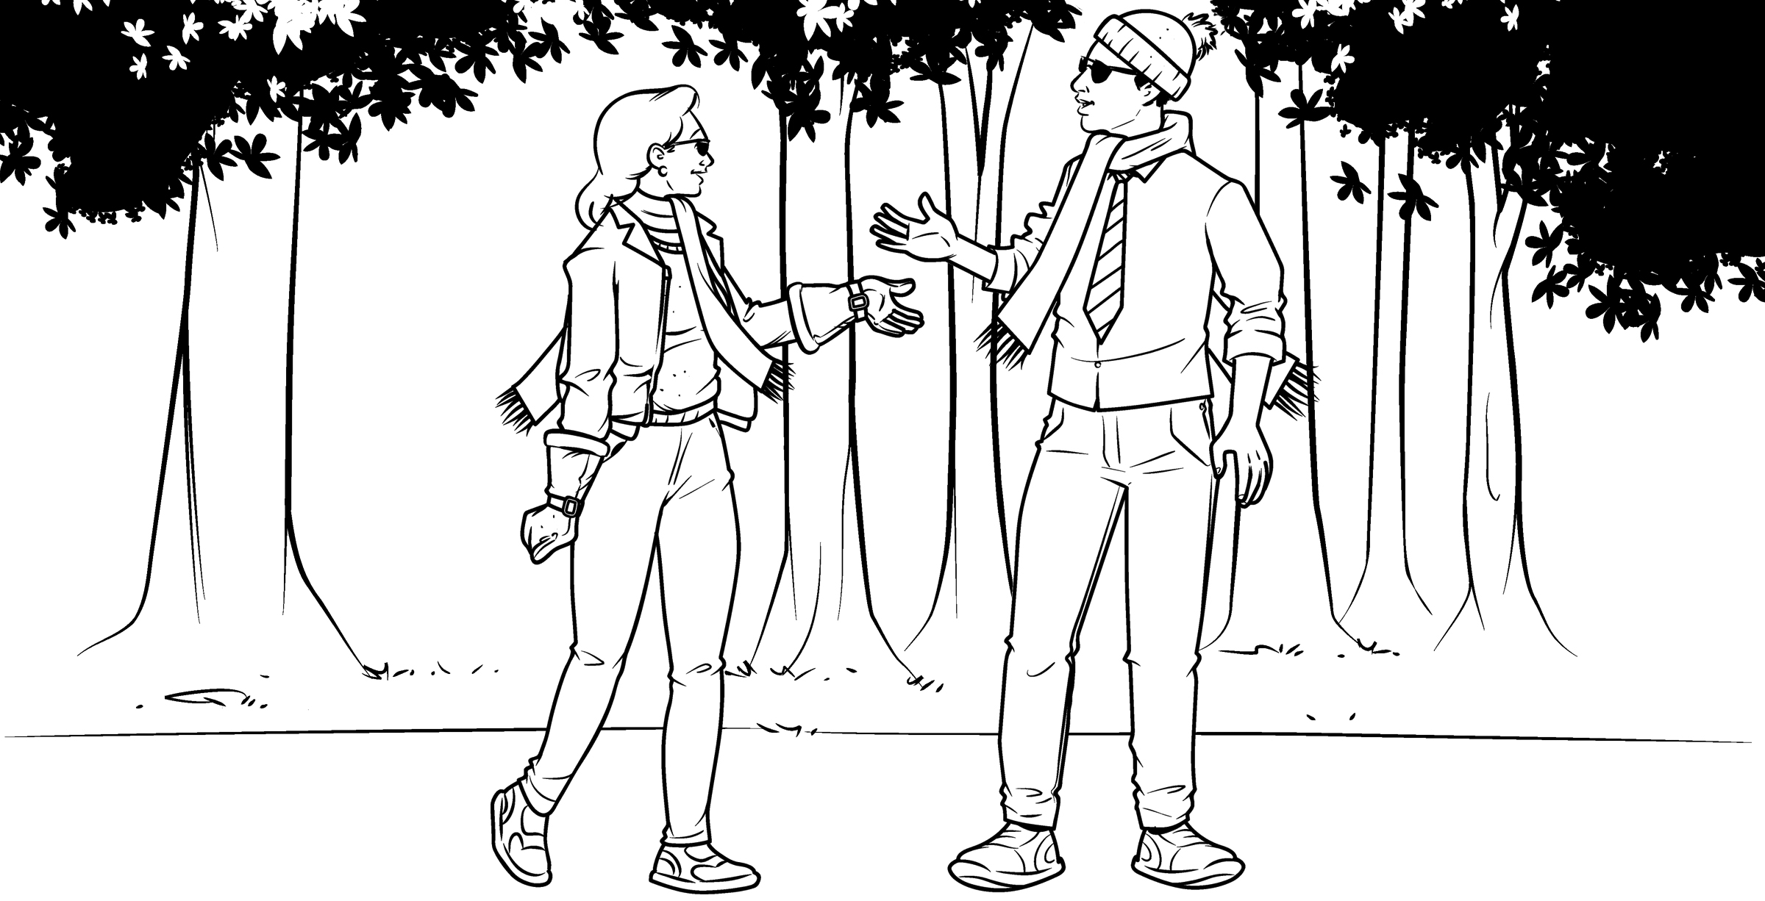Picture 2

