CLASSROOM AND PERSONAL OBJECTS
Your Vocabulary Log
Make a vocabulary log. Write words or draw pictures to help you remember.
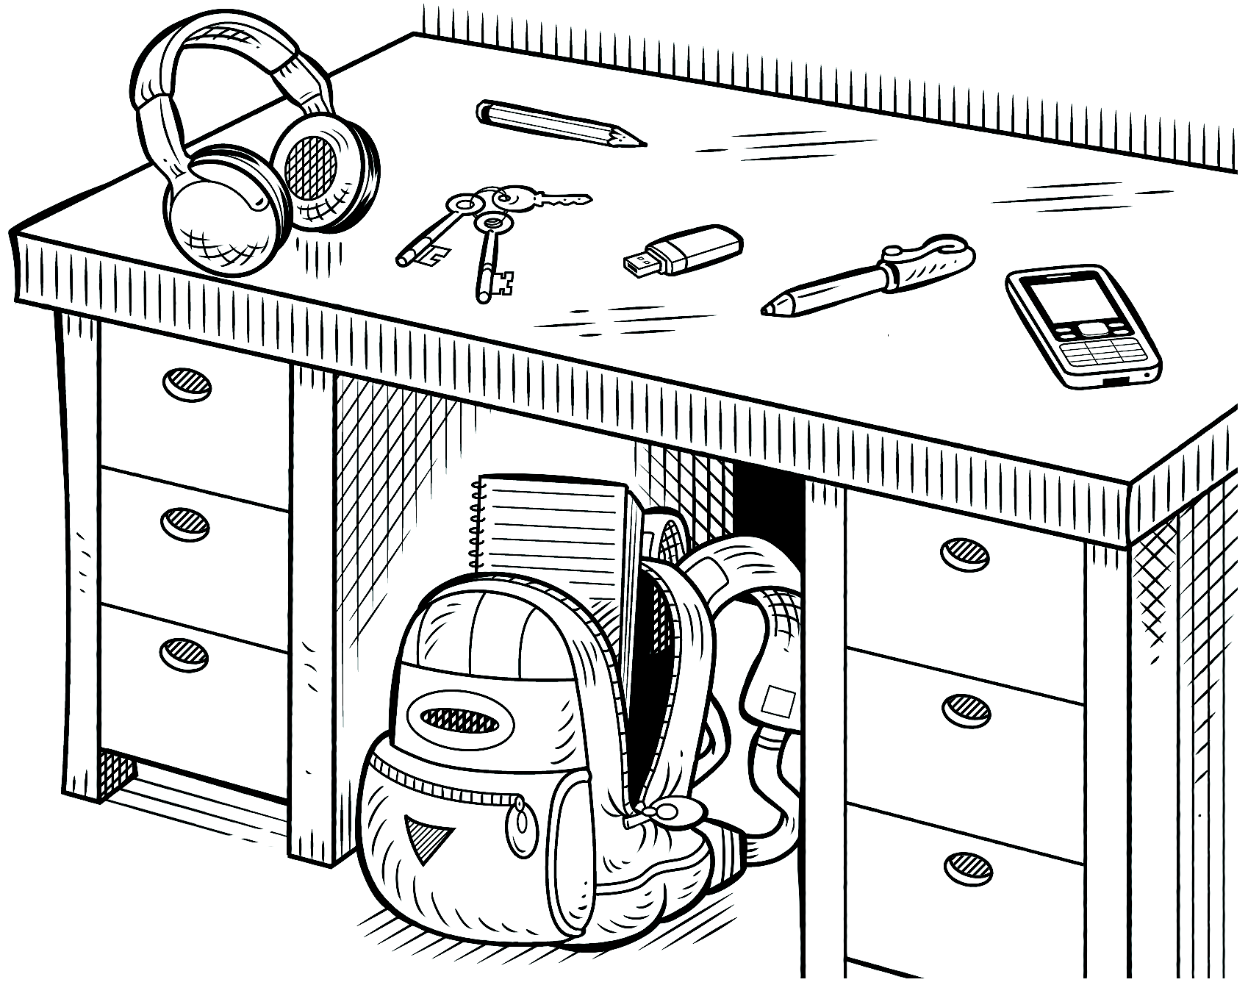
Practice
PAIR WORK Look at the picture for one minute.
Then cover it. Ask and answer questions.
How much can you remember? Use words from
your vocabulary log.
A: Where’s the notebook?
B: It’s in the backpack.

