WHAT’S YOUR JOB?
A Complete the sentences.
□ Lara: My sister at City Hospital, too.
Eric: Really? What she do? Is she a doctor?
1
□ Lara: What do you do?
Eric: I am a doctor.

□ Lara: My job? I a lawyer.
Eric: How you like your job? it interesting?
Lara: Yes, I love it. It’s very exciting.

□ Lara: No, she isn't. She a technician.
Eric: What about you? What do you ?

□ Lara: Oh. Where do you ?
Eric: I at City Hospital.

B Now unscramble the conversation. Number the parts of the conversation
from 1 to 5.
WHO IS IT?
PAIR WORK Take turns. Talk about each person. Who is it? Guess.
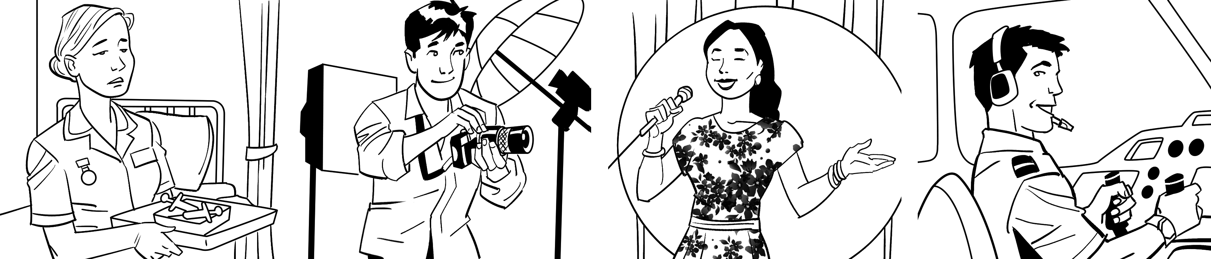
Amy West José Gomez Fernanda Ferreira Adam Chang
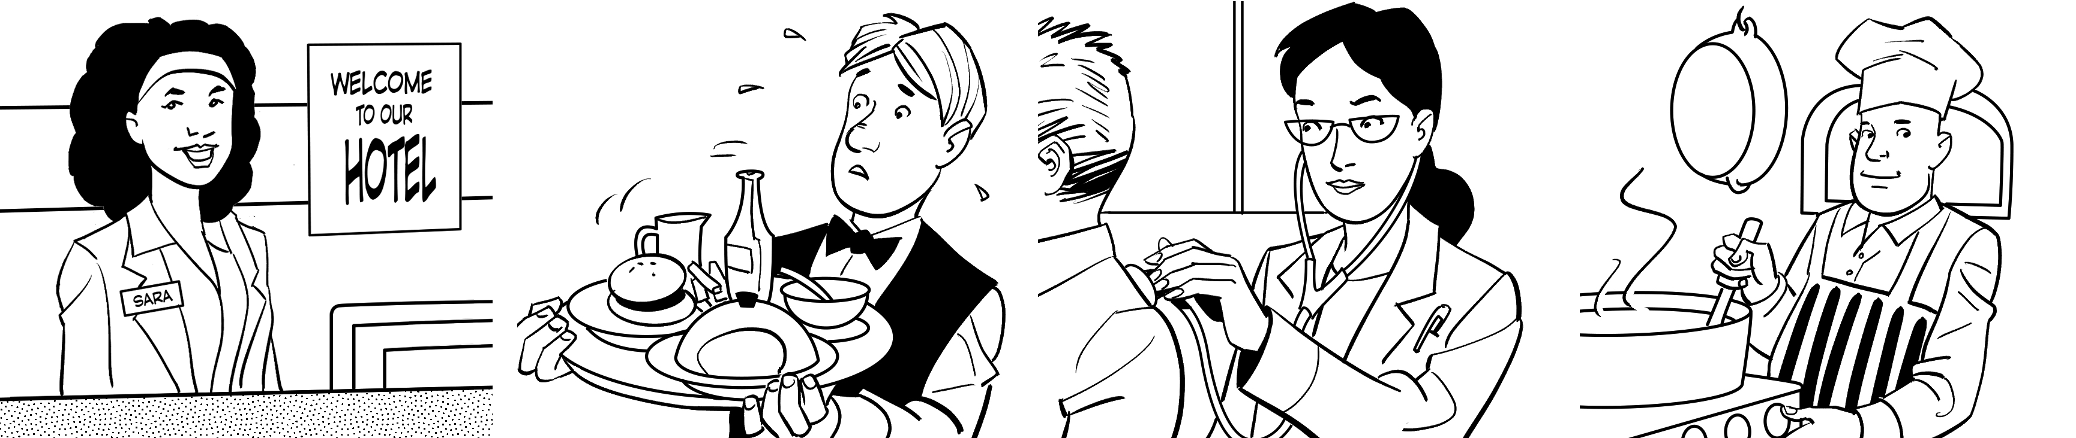
Sara Clinton Matt Hill Maria Costas Zack Young
A: He’s about 25 years old. He works inside. He has an interesting job.
I think he likes his job. Who is it?
B: It’s José Gomez.

