UNUSUAL CELEBRATIONS

Aim: Give Ss practice describing holidays/celebrations.
Preparation: Make one copy of the worksheet for every S.
Materials: Poster paper; colored pencils or pens

Plan
■ Give each S a worksheet.
■ Explain the task. Ss choose an unusual celebration in their country and answer the questions.
■ Go over the questions. Elicit answers from
the class.
Prepare
A
■ Divide the class into small groups.
■ Have Ss choose a country and research an unusual celebration there. Encourage Ss to use books, magazines, or the Internet to find the information. Ss can research in class if these items are available or do the research as homework and share results in the next class.

B
■ Have groups prepare a presentation about this celebration. Remind them to use pictures, costumes, food, or music to explain the tradition.
Present
■ Have groups present the celebration to the class. Encourage other Ss to ask questions.

UNUSUAL CELEBRATIONS

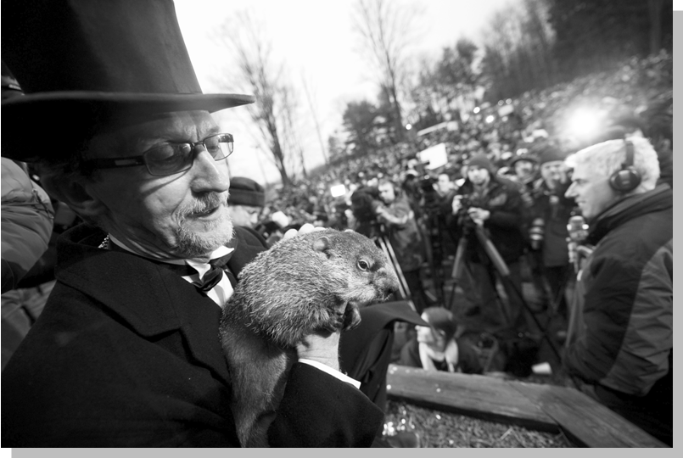
Punxsutawney Phil on Groundhog Day
Plan
Think of an unusual celebration in your country. Answer these questions.
Who celebrates it?
Where is it celebrated?
Why is it celebrated?
Prepare
A GROUP WORK Choose a country you want to learn more about. Then research an
interesting celebration in that country. Use these questions and your own questions.
Why is it celebrated?
How is it celebrated?
What do people wear?
What do people eat?
Is there any music or a special ceremony?

B GROUP WORK Prepare a presentation about the celebration. Use pictures,
costumes, food, or music to present the information you learned. Be creative!
Present
CLASS ACTIVITY Explain the celebration to the class. Share what you learned and
be prepared to answer questions.

