WHat place Do YOU RECOMMEND?

Aim: Give Ss practice making recommendations.
Preparation: Make one copy of the worksheet for every S.
Materials: None

Plan
■ Give each S a worksheet.
■ As a class, brainstorm types of services. If necessary, refer Ss to the Snapshot and the Perspectives on page 58 of the Student’s Book
for ideas.
Prepare
A
■ Divide the class into small groups.
■ Explain the task. Each group chooses a service and finds information about places in their community that offer that service.
■ Ask groups to use magazines, newspapers, or the Internet to find places that offer the service.
■ Have the groups write questions to ask the people who work in the places.
B
■ Outside of class, Ss call or visit the places.
■ In the next class, Ss discuss the results and make
a recommendation.
■ Option: Have Ss create an ad for the place.
Present
■ Have groups share their recommendations with
the class. Remind them to explain why they chose
the place.

WHat place do YOU RECOMMEND?
Plan
What types of services are available where you live?
Prepare
A GROUP WORK Choose a service. Then find places in your community that offer
the service. Use these questions and your own questions to get more information.
How much does the service cost?
How long does it take to get it done?
Is it necessary to have an appointment?
Is the location of the place convenient?
B GROUP WORK Call or visit places to ask your questions. Based on your
findings, choose one place to recommend to the class.
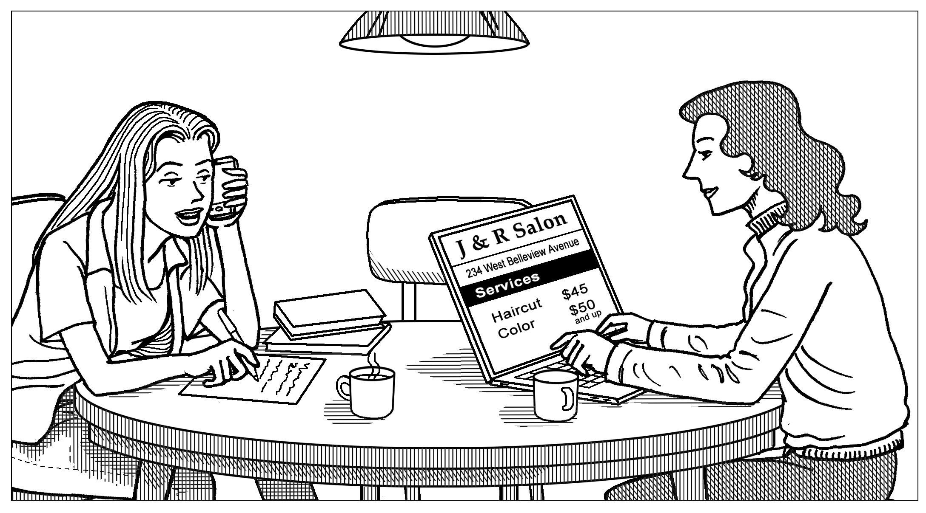
Present
CLASS ACTIVITY Share your recommendation with the class. Explain why it’s the best
place to go for the service.

