MOVING Day
Complete this email. Use not enough, too, or not as . . . as and the adjectives
or nouns in parentheses.

THE WISH GAME
A GROUP WORK Imagine you are the people in these pictures. Write as many
I wish sentences for each person as possible.

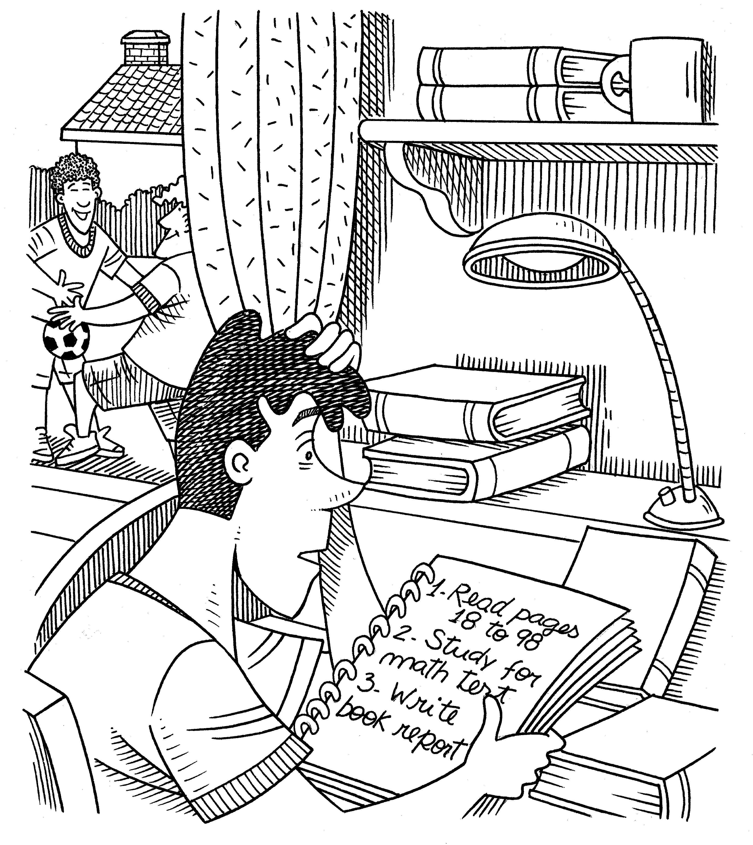 |  | 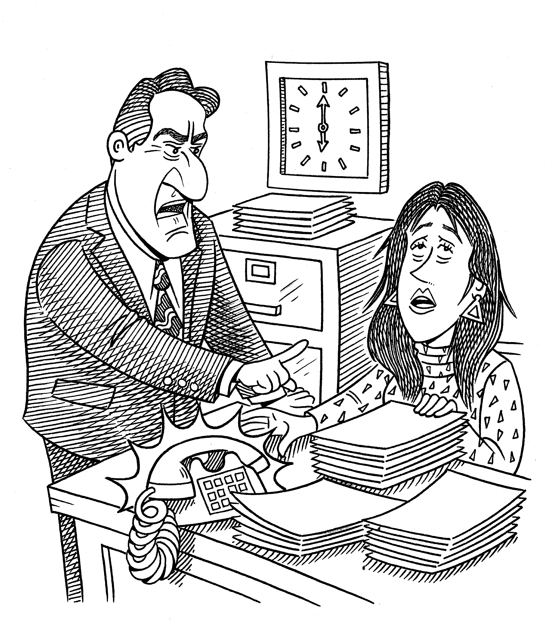 |  | 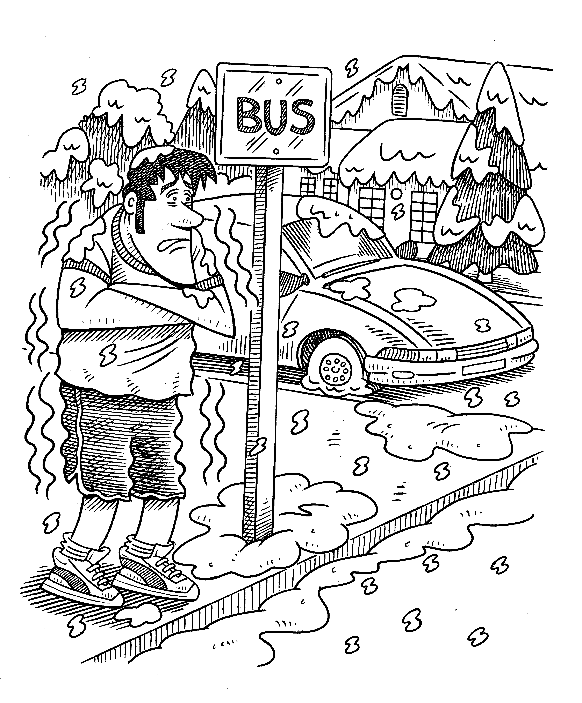

B GROUP WORK Read your sentences to the class. Which group has the most sentences?

