HISTORICAL EVENTS

Aim: Give Ss practice comparing time periods.
Preparation: Make one copy of the worksheet for every two Ss.
Materials: Poster paper; colored pencils or pens

Plan
■ Ss work in pairs. Give each pair a worksheet.
■ Ss answer the questions. Encourage them to think about events that may have had future consequences (e.g., James Watt’s improvements on the steam engine led to the Industrial Revolution.).
■ Elicit events and reasons from the class.
Prepare
A
■ Each pair joins another pair.
■ Explain the task. Groups choose and research five events. Remind them to find photos or draw pictures to represent each event. Students can research in class if computers are available or do the research as homework and discuss results in the next class.
■ Have groups create a time line including the events and when they occurred.
B
■ Have groups predict five future events and add them to their time line.
Present
■ Have groups share their time lines with the class. Remind them to explain why the past events were significant and the reasons that they predicted the future events.

HISTORICAL EVENTS

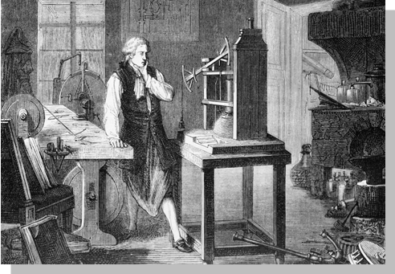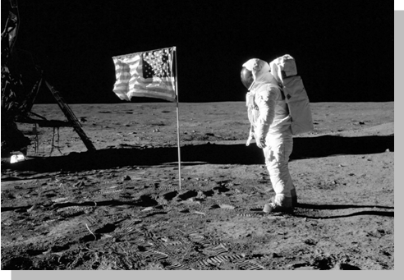
1775: James Watt invents the first
reliable steam engine.
July 20, 1969: Neil Armstrong walks on the moon.

Plan
PAIR WORK Think of three important historical events. Why do you think
they are important?

 | Event | Reason
1.
2.
3.
Prepare
A GROUP WORK Choose five important historical events and research information
about them. Then make a time line showing when the events occurred. Use pictures to
represent each event.
B GROUP ACTIVITY Predict five events that you think will happen in the future.
Add them to your time line.
Present
CLASS ACTIVITY Share your time line with the class. Explain the significance
of each past event and the reasons why you predicted each future event.

