WHAT’S YOUR NAME?
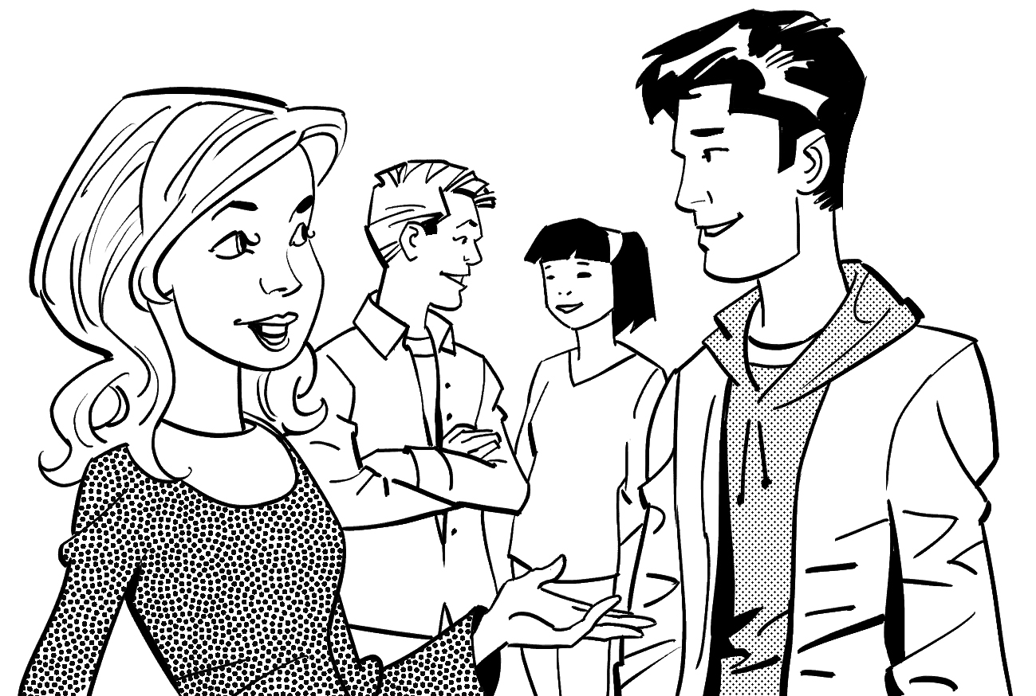
Complete the conversations.
1. | Lisa: | Hi! Are you Will?
 | Nick: | Will? I’m not Will. My name is Nick.
 | Lisa: | Oh, I’m sorry! _________ you Nick Morris?
 | Nick: | Yes, I _________. And what’s _________ name?
 | Lisa: | _________ Lisa Jones.

 |  | 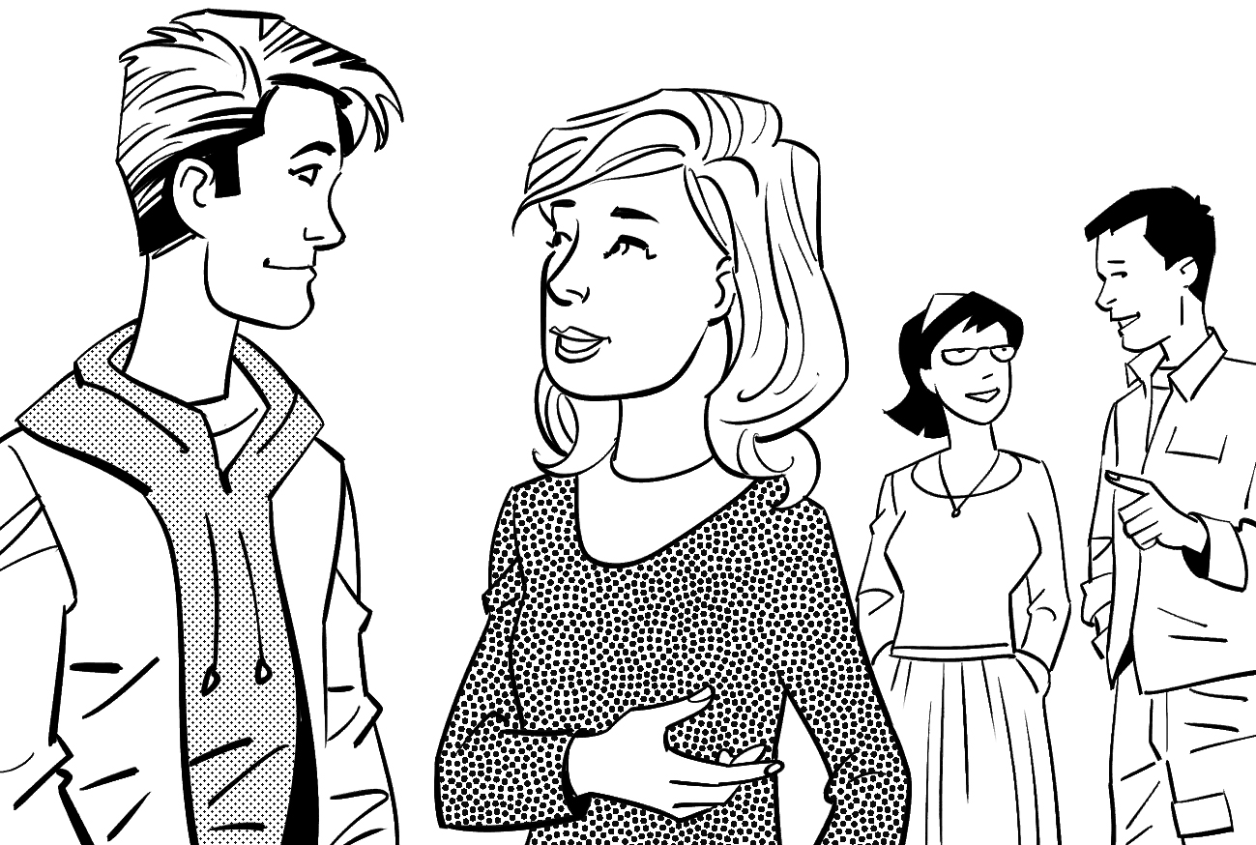
2. | Nick: | What’s his name?
 | Lisa: | Dan Adams. _________ in my class.
 |  | And _________ name is Sofia Clark.
 | Nick: | _________ in your class, too, right?
 | Lisa: | Well, yes. _________ my teacher!

HELLO AND GOOD-BYE
GROUP WORK Complete the conversation. Then act it out.
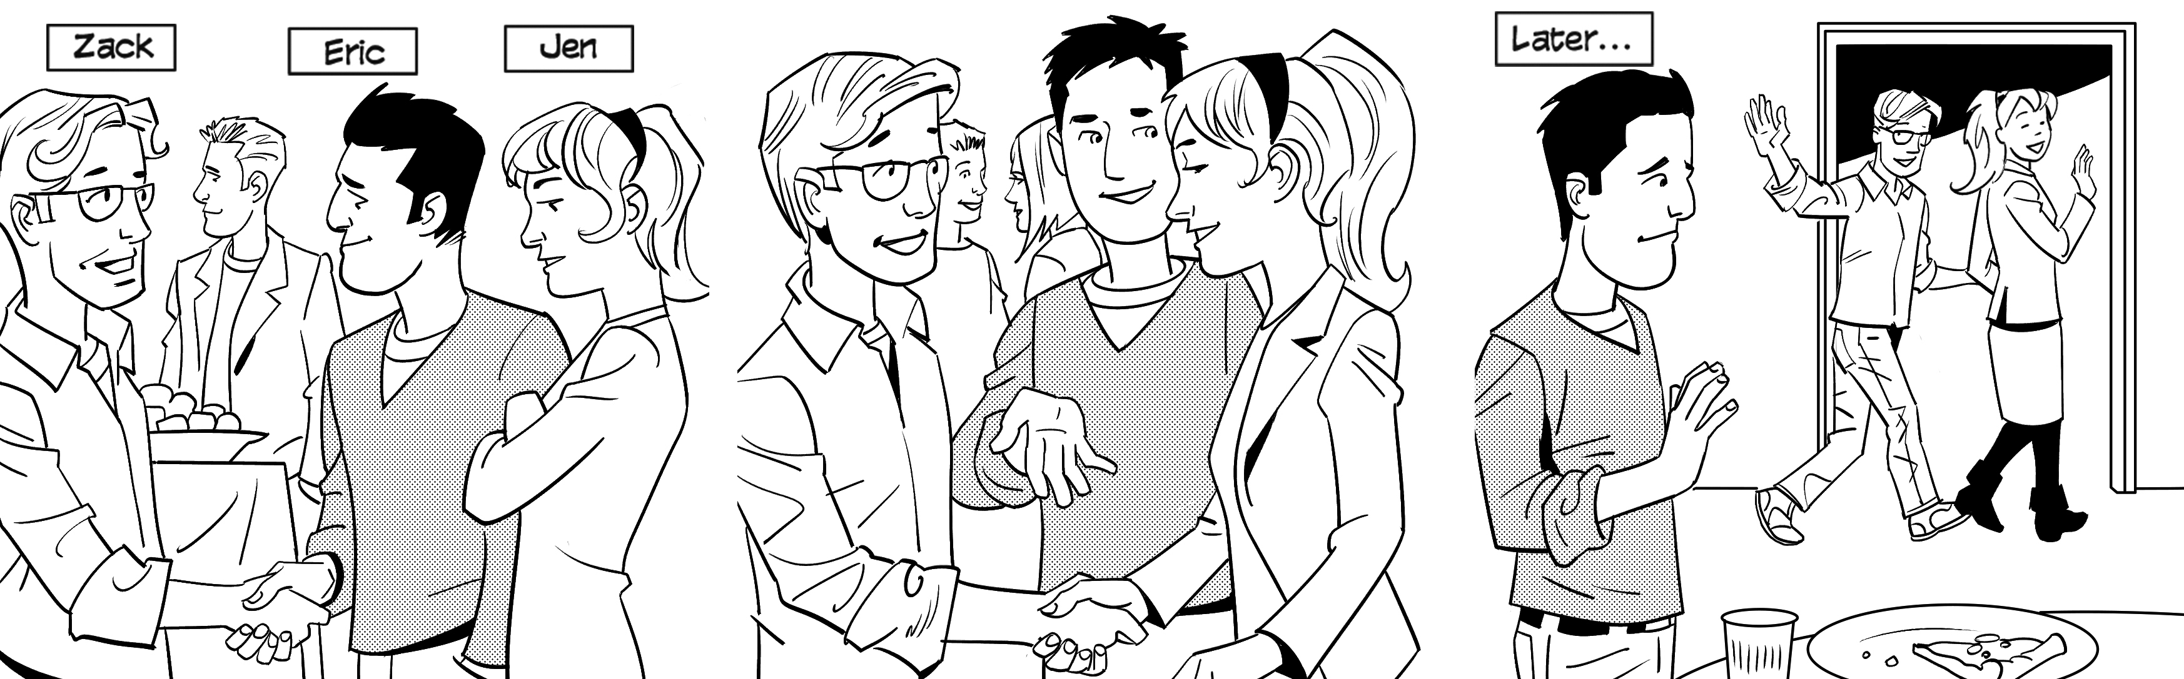
Eric: |  | Eric: |  | Zack: | , Eric!
 |  |  |  | Jen: | Good-bye, Eric!
Zack: | Hello, Eric. | Zack: | Nice to meet you, Jen.
 |  | Jen:

