IN A HURRY
Complete the paragraph with the correct words in parentheses.
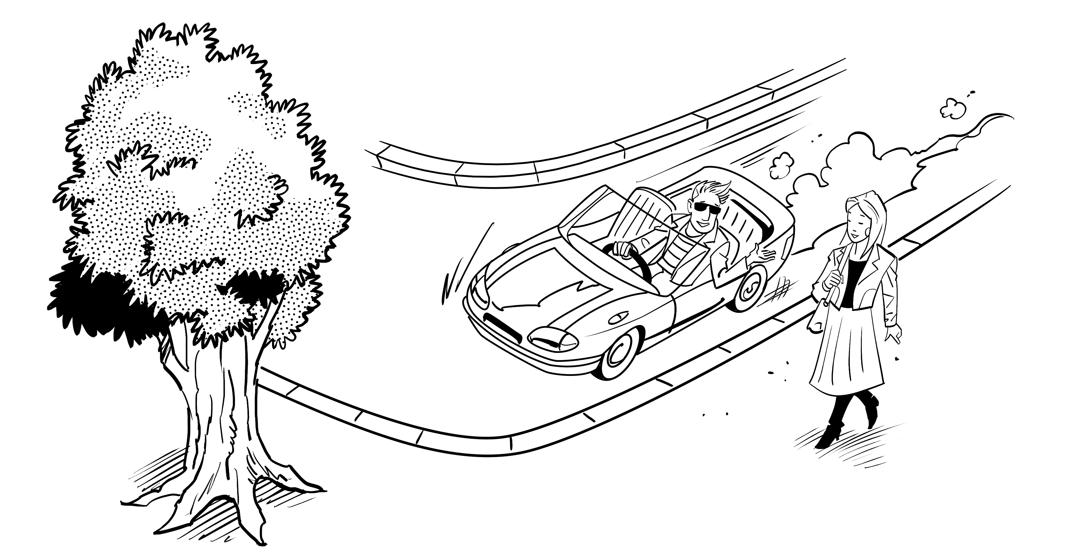
My name is Andrei. My brother Ivan has always done everything in a hurry.
__________________ (By the time / Until) he was 16, he was already working.
__________________ (Then / Once) he had his first job, he rented an apartment.
__________________ (As soon as / Later) he moved into his apartment, he wanted to get
married. __________________ (The moment / Before) he met Lisa, he asked her to
marry him. Then, two days __________________ (before / during) the wedding, he changed
his mind. He was a bit depressed __________________ (when / after) canceling the
wedding, so he bought an expensive sports car. __________________ (While / Once) he was
driving home one day, he saw Lisa. He raised his hands to get her attention and
crashed into a tree! The car was completely destroyed, and Ivan broke his leg.
__________________ (The moment / Until) he had the accident, Ivan was always in a hurry.
__________________ (After / Before) the accident, he became the most patient person I know.
IF YOU’D BEEN MORE CAREFUL . . .
PAIR WORK Imagine you are Andrei and Ivan. Role-play a conversation.
Andrei: Ivan, you shouldn’t have taken your hands off the wheel.
If you’d been more careful, you wouldn’t have had an accident.
Ivan: But if I hadn’t had the accident, I wouldn’t have become more patient!

