WHAT’S CHICAGO LIKE?
Check () the correct sentences to make conversations.

1. A: I feel safe in Chicago.  B: □ You’re right. It’s pretty safe.  □ You’re right. It’s not too safe.  2. A: It’s pretty exciting, too.  B: □ But it’s very beautiful.  □ And it’s very beautiful.  3. A: It’s really hot in the summer and cold in  the winter.  B: □ It’s very nice in the spring, though.  □ It’s not very nice in the spring, though. | 4. A: There are some nice museums.  B: □ And they’re not interesting.  □ But they’re always crowded.  5. A: There are great shows.  B: □ Some of them are expensive, however.  □ They are too exciting, however.  6. A: Lake Michigan is pretty clean.  B: □ And it’s really beautiful.  □ Yes, it’s not too clean.
YOUR FAVORITE CITY
A Write information about your favorite city in the You column.

 | You | Your partner
Favorite city
Things you can do there
Things you should see there
Things you shouldn’t do there

B PAIR WORK Interview a partner who chose a different city.
Write the answers in the Your partner column.
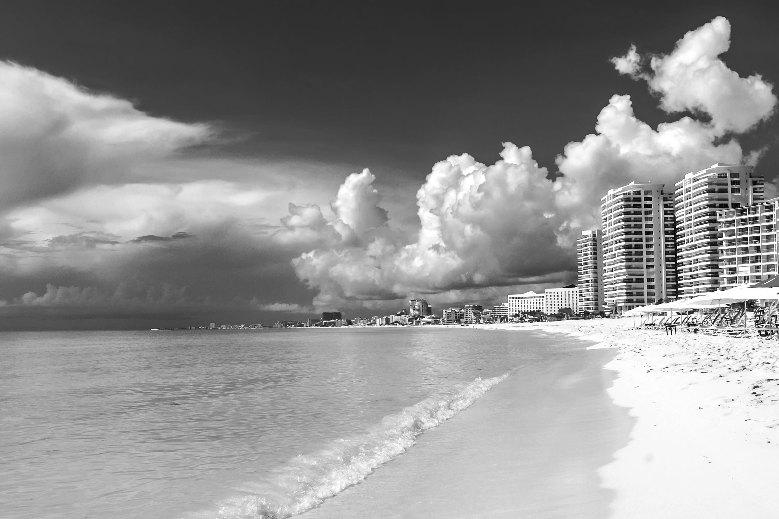
A: What’s your favorite city, Carla?
B: It’s Cancún
A: What can you do there?
B: You can go to the beaches.
They’re really beautiful.
A: What should people see there?
B: Well, they shouldn’t miss the
Mayan ruins at Tulum.

