LIVING ROOMS

Aim: Give Ss practice asking and answering questions about furniture.
Preparation: Make one copy of the worksheet for every two Ss.
Cut the copies in half.
Comment: Use instead of or after part C of the Word Power on page 46.

■ Ss work in pairs. Give Picture A to S1 and Picture B to S2 of each pair.
■ Set the scene and explain the task. Ss have pictures of living rooms. They take turns asking questions about their partner’s living room and complete the list of furniture in the room, writing how many – if any – there are of each item.
■ Point out that Ss cannot look at each other’s pictures.
■ Write this conversation on the board:
A: Does the room have armchairs?
B: Yes, it does. It has two armchairs. OR
No, it doesn’t.
Then model the task with a S.
■ Ss complete the task.
■ Then they look at each other’s pictures to check their answers.


Answers
Student B’s Living Room:
armchairs 3
bookcases 2
chairs 0
clocks 0
coffee tables 1
curtains 0
desks 1
lamps 1
pictures 1
rugs 0
sofas 0
TVs 1
Student A’s Living Room:
armchairs 2
bookcases 0
chairs 0
clocks 1
coffee tables 0
curtains 1
desks 0
lamps 2
pictures 3
rugs 1
sofas 1
TVs 0

Living Rooms
Student A
Student B’s Living Room
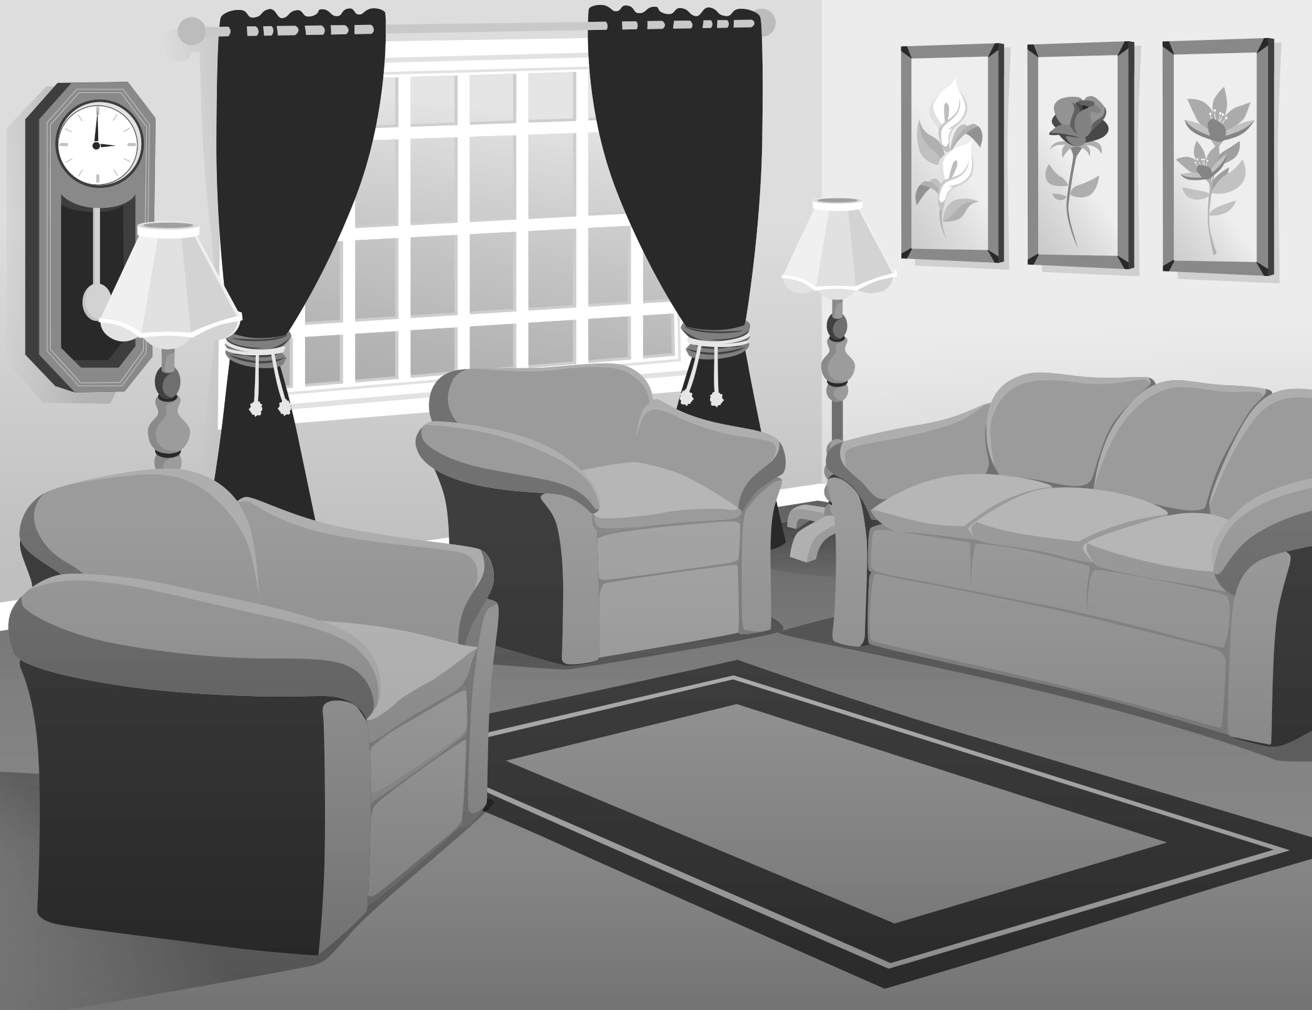 | armchairs ________________  bookcases ______________ _  chairs ____________ _ ____ _  clocks _________________ __ _  coffee tables __________ ___  curtains _____________ ____  desks ________________ __ _  lamps __________________ _ _  pictures _________________  rugs ____________________  sofas _______________ ____  TVs ________________ ____

Student B
Student A’s Living Room
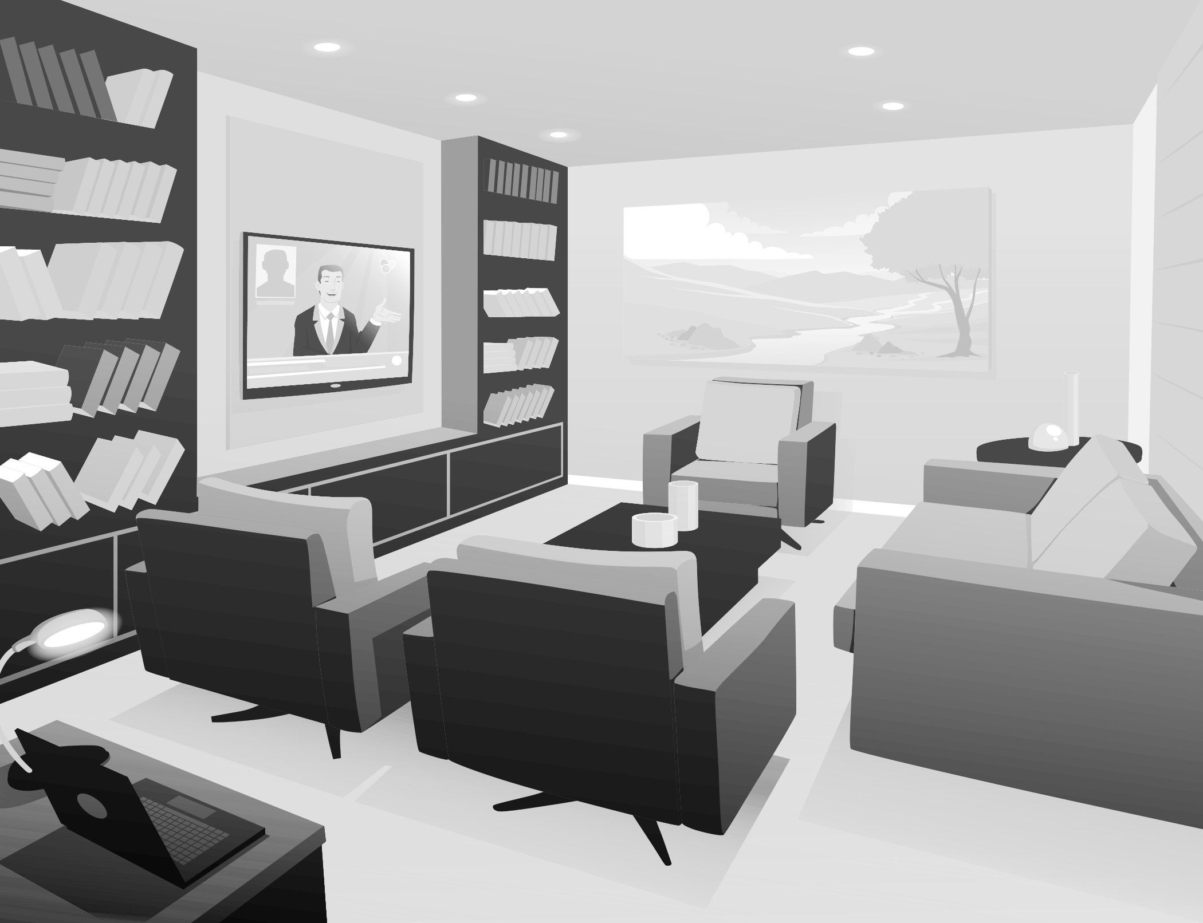 | armchairs ________________  bookcases ____________ ___  chairs ___________________  clocks ________________ __  coffee tables _____________  curtains _________________  desks ________________ __  lamps ______________ _ ___  pictures _________________  rugs ____________________  sofas ________________ ___  TVs ________________ ____

