WHAT’S THE LATEST?

Aim: Give Ss practice using the simple past, past continuous, and
past perfect.
Preparation: Make one copy of the worksheet for every S.
Materials: Examples of tabloid newspapers or tabloid-style stories
from a website (optional)

Plan
■ Give each S a worksheet.
■ If necessary, show examples of a tabloid newspaper or tabloid-style articles from a website.
■ Go over the questions as a class.
■ Have Ss write three headlines. Then elicit examples from the class.
Prepare
■ Divide the class into small groups.
■ Explain the task. Ss share their headlines and decide on ideas for articles.
■ Each S writes one article. Encourage them to be creative and to draw pictures or find photos to go with each article.
■ Have Ss put the articles together into a newspaper format.
Present
■ Have Ss share their newspapers with the class.
■ Ss vote on the most creative and funniest articles.

WHAT’S THE LATEST?
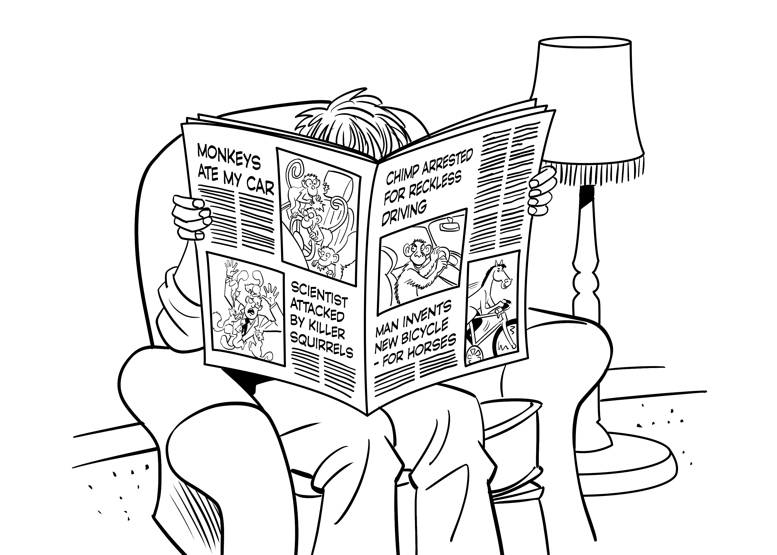
Plan
What tabloid newspapers do you know? What kinds of articles do they have?
Write three headlines that you might read in a tabloid.
1. _________________________________________________________________________
2. _________________________________________________________________________
3. _________________________________________________________________________
Prepare
GROUP WORK Create a tabloid newspaper. Decide on headlines for articles.
Each student writes at least one article. Then put all the articles together to create
a newspaper. Use pictures or find photos to go with each article. Be creative!
Present
CLASS ACTIVITY Share your newspaper with the class. Then vote on the
funniest and most creative articles.

