I HATE CLEANING!

Aim: Give Ss practice using infinitives and gerunds.
Preparation: Make one copy of the worksheet for every S.
Materials: Poster paper; colored pencils or pens

Plan
■ Give each S a worksheet.
■ As a class, brainstorm chores Ss hate to do. Elicit reasons.
■ Have Ss write their least favorite chores and reasons.
Prepare
■ Divide the class into small groups.
■ Explain the task. Ss choose one chore they dislike.
■ Ask Ss to design an invention to perform their chore.
■ Have Ss make an ad for the invention. Encourage them to draw pictures and to describe what the device can do.
Present
■ Have groups share their inventions with the class. Encourage them to describe how the invention works and what it could be used for.

I HATE CLEANING!
Plan
What are some chores that you hate to do? Why do you dislike them?

 | Chore | Reason
1.
2.
3.
Prepare
GROUP WORK Choose a chore that you dislike and design an invention to do
it for you. Then make an advertisement. Be sure to draw a picture of your invention
and list its features.
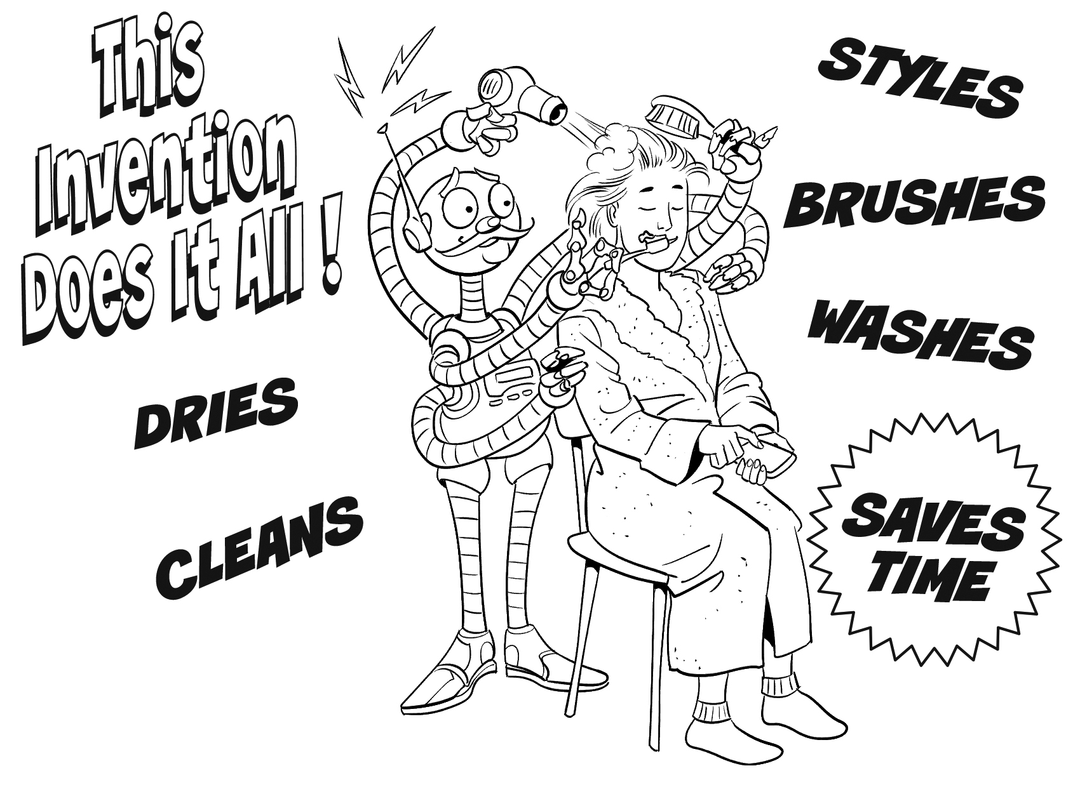
Present
CLASS ACTIVITY Share your invention with the class. Explain how it works and what it can
be used for.

