AT A DEPARTMENT STORE
Write each complaint a different way.
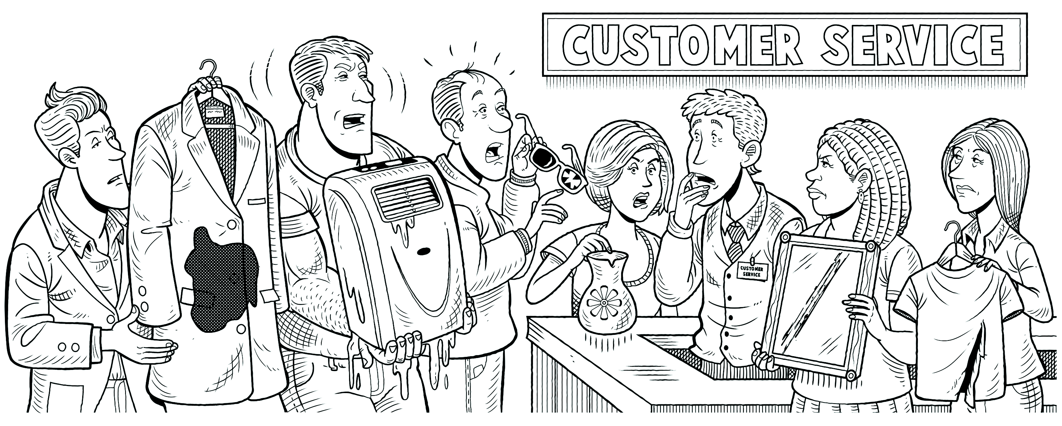
1. This coat is stained.
This coat has a stain on it .
2. This air conditioner has a leak.
This air conditioner .
3. These sunglasses are cracked.
These sunglasses .
4. This vase has a chip in it.
This vase .
5. This mirror has scratches on it.
This mirror .
6. This T-shirt is torn.
This T-shirt .
NEXT, PLEASE!
PAIR WORK Role-play the situations from the exercise above. One student
is a salesperson. The other student is a customer. Use the verbs in the box.

clean | fix | repair | replace

A: Excuse me. I’d like to return this air conditioner. It has a leak.
B: Oh, that’s not a problem. It just needs to be fixed.
A: I know it needs fixing! But I want a new one! I just bought it yesterday!

