WHEN IN ROME . . .

Aim: Give Ss practice giving travel advice using modals for
necessity and suggestion.
Preparation: Make one copy of the worksheet for every group.
Materials: Colored pencils or markers (optional)

Plan
■ Divide the class into small groups. Give each group a worksheet.
■ Ss discuss the questions.
■ Elicit examples of how things you should and shouldn’t do vary from country to country.
Prepare
■ Explain the task. Ss choose a country and research what people should and shouldn’t do there. Ss can research in class if computers are available or do the research as homework and discuss the results
in class.
■ Option: Assign each group a country.
■ Ss write a list of guidelines for travelers. Encourage Ss to include photos or drawings to explain the rules.
Present
■ Have groups share their guidelines with the class. Encourage Ss to use modals for necessity and suggestion (e.g., You shouldn’t eat on the street. You’d better . . .).
■ Option: Collect the lists to make a class
travel guide.

WHEN IN ROME . . .

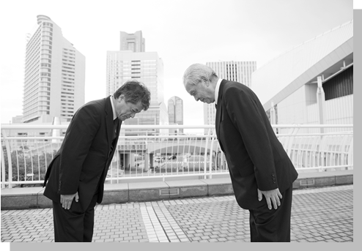
Plan
GROUP WORK Discuss these questions.
How do people greet each other in your country?
What is something people do in your country, but shouldn’t do in other countries?
What is something people do in other countries, but shouldn’t do in your country?
Prepare
GROUP WORK Choose a country you are interested in learning more about. Research
things you should and shouldn’t do there. For example, how should you dress, greet
people, and behave in public? Make a list of guidelines for travelers to that country.
Present
CLASS ACTIVITY Imagine your class is going to travel to this country. Share your
guidelines with the class. Be sure to warn them about what they should and shouldn’t do!

