CLASSROOM OBJECTS
Complete the questions.
1. A: | What’s this called in English?
B: | It’s an eraser.
2. A: | _________ _________ these?
B: | They’re flash drives.
3. A: | Are _________ pens?
B: | No. They’re pencils.
4. A: | _________ _________ your books?
B: | They’re in my backpack.
5. A: | _________ _________ your backpack?
B: | It’s under my desk.
6. A: | _________ _________ your eraser?
B: | Yes, it is. Thanks!
WHERE ARE THEY?
PAIR WORK Look at the picture. Ask and answer the questions.
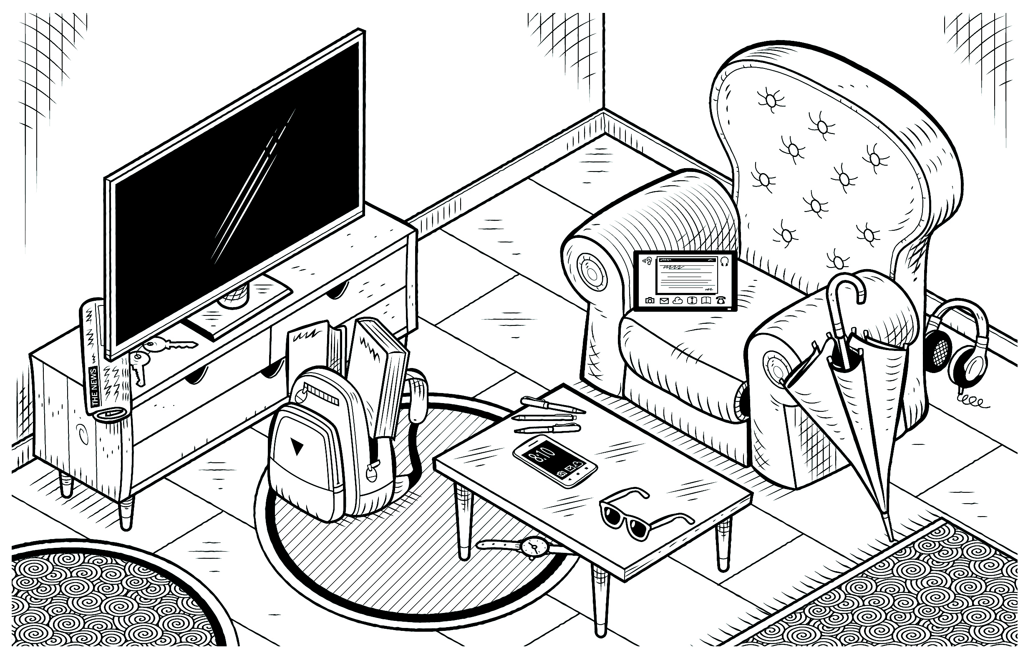
1. Where are the books? 6. Are the pens on the chair?
2. Where is the watch? 7. It’s on the table, next to the pens. What is it?
3. Where is the umbrella? 8. It’s in front of the television. What is it?
4. Are the sunglasses on the table? 9. They’re behind the chair. What are they?
5. Is the tablet on the chair? 10. They’re under the newspaper. What are they?

