IT’S A MYSTERY.

Aim: Give Ss practice offering explanations using past modals for
degrees of certainty.
Preparation: Make one copy of the worksheet for every S.
Materials: None

Plan
■ Give each S a worksheet.
■ Focus Ss’ attention on the pictures. Elicit information.
■ As a class, brainstorm other mysteries (e.g., The Mary Celeste, Atlantis, mental telepathy, the Loch Ness Monster).
Prepare
■ Divide the class into small groups.
■ Explain the task. Groups choose a mystery and research explanations. Ss can research in class
if computers are available or do the research
as homework.
■ Ask Ss to compare their information and decide whether each explanation is almost certain, possible, or not possible.
Present
■ Have groups share their findings with the class. Groups describe the mystery and the explanations. Encourage them to use degrees of certainty to express their opinions.

IT’S A MYSTERY.
Plan
Look at the pictures. What do you know about these things? Think of other
mysteries that scientists and experts have not been able to explain.
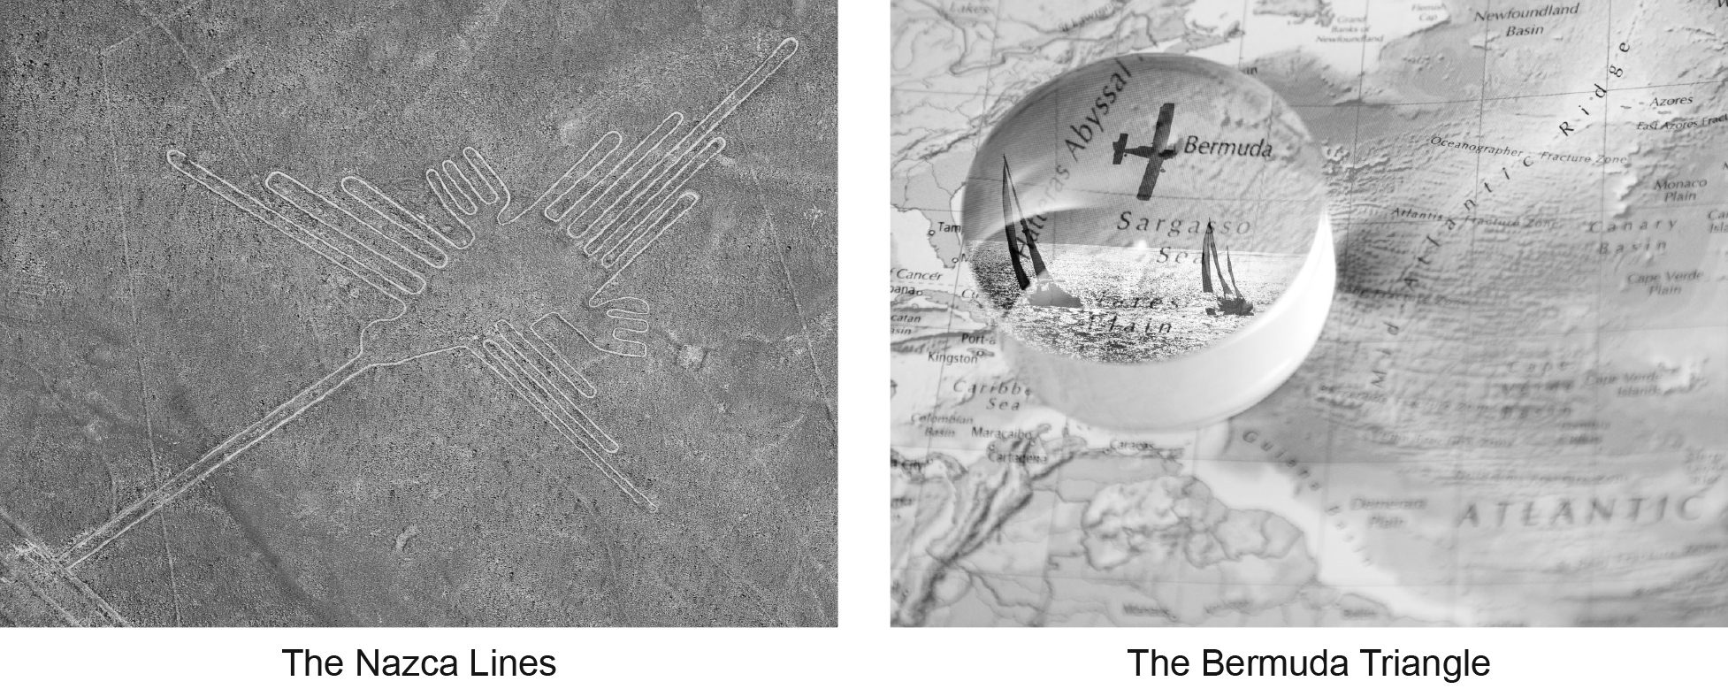
Prepare
GROUP WORK Research the existing explanations for one well-known mystery.
Then share the information with your group. Decide whether each explanation
is almost certain, possible, or not possible.
Present
CLASS ACTIVITY Describe the mystery and some explanations. Then share your
opinions with the class.
