REQUESTS
Complete the requests with the correct word in parentheses.

1. | Turn down (down / up / on) the music. I’m trying to study.
2. | Turn _______________ (down / off / on) the TV. I’d like to watch the news.
3. | Hang _______________ (over / down / up) your clothes. They’re on the floor.
4. | Please let the cat _______________ (away / out / off). He needs some exercise.
5. | Clean _______________ (up / away / off) your room. It’s a mess!
6. | Pick _______________ (up / down / over) the newspaper. It’s on the floor.
7. | Take _______________ (in / out / off) the garbage. The wastebasket is full.
8. | Take _______________ (away / out / off) your coat. It’s warm in here.
9. | Put _______________ (away / off / on) the groceries. They’re in the kitchen.
10. | Turn _______________ (on / off / out) the lights. I can’t see a thing!
RESPONDING TO REQUESTS
PAIR WORK Make conversations using the requests from above and
the expressions in the box. Your partner responds.
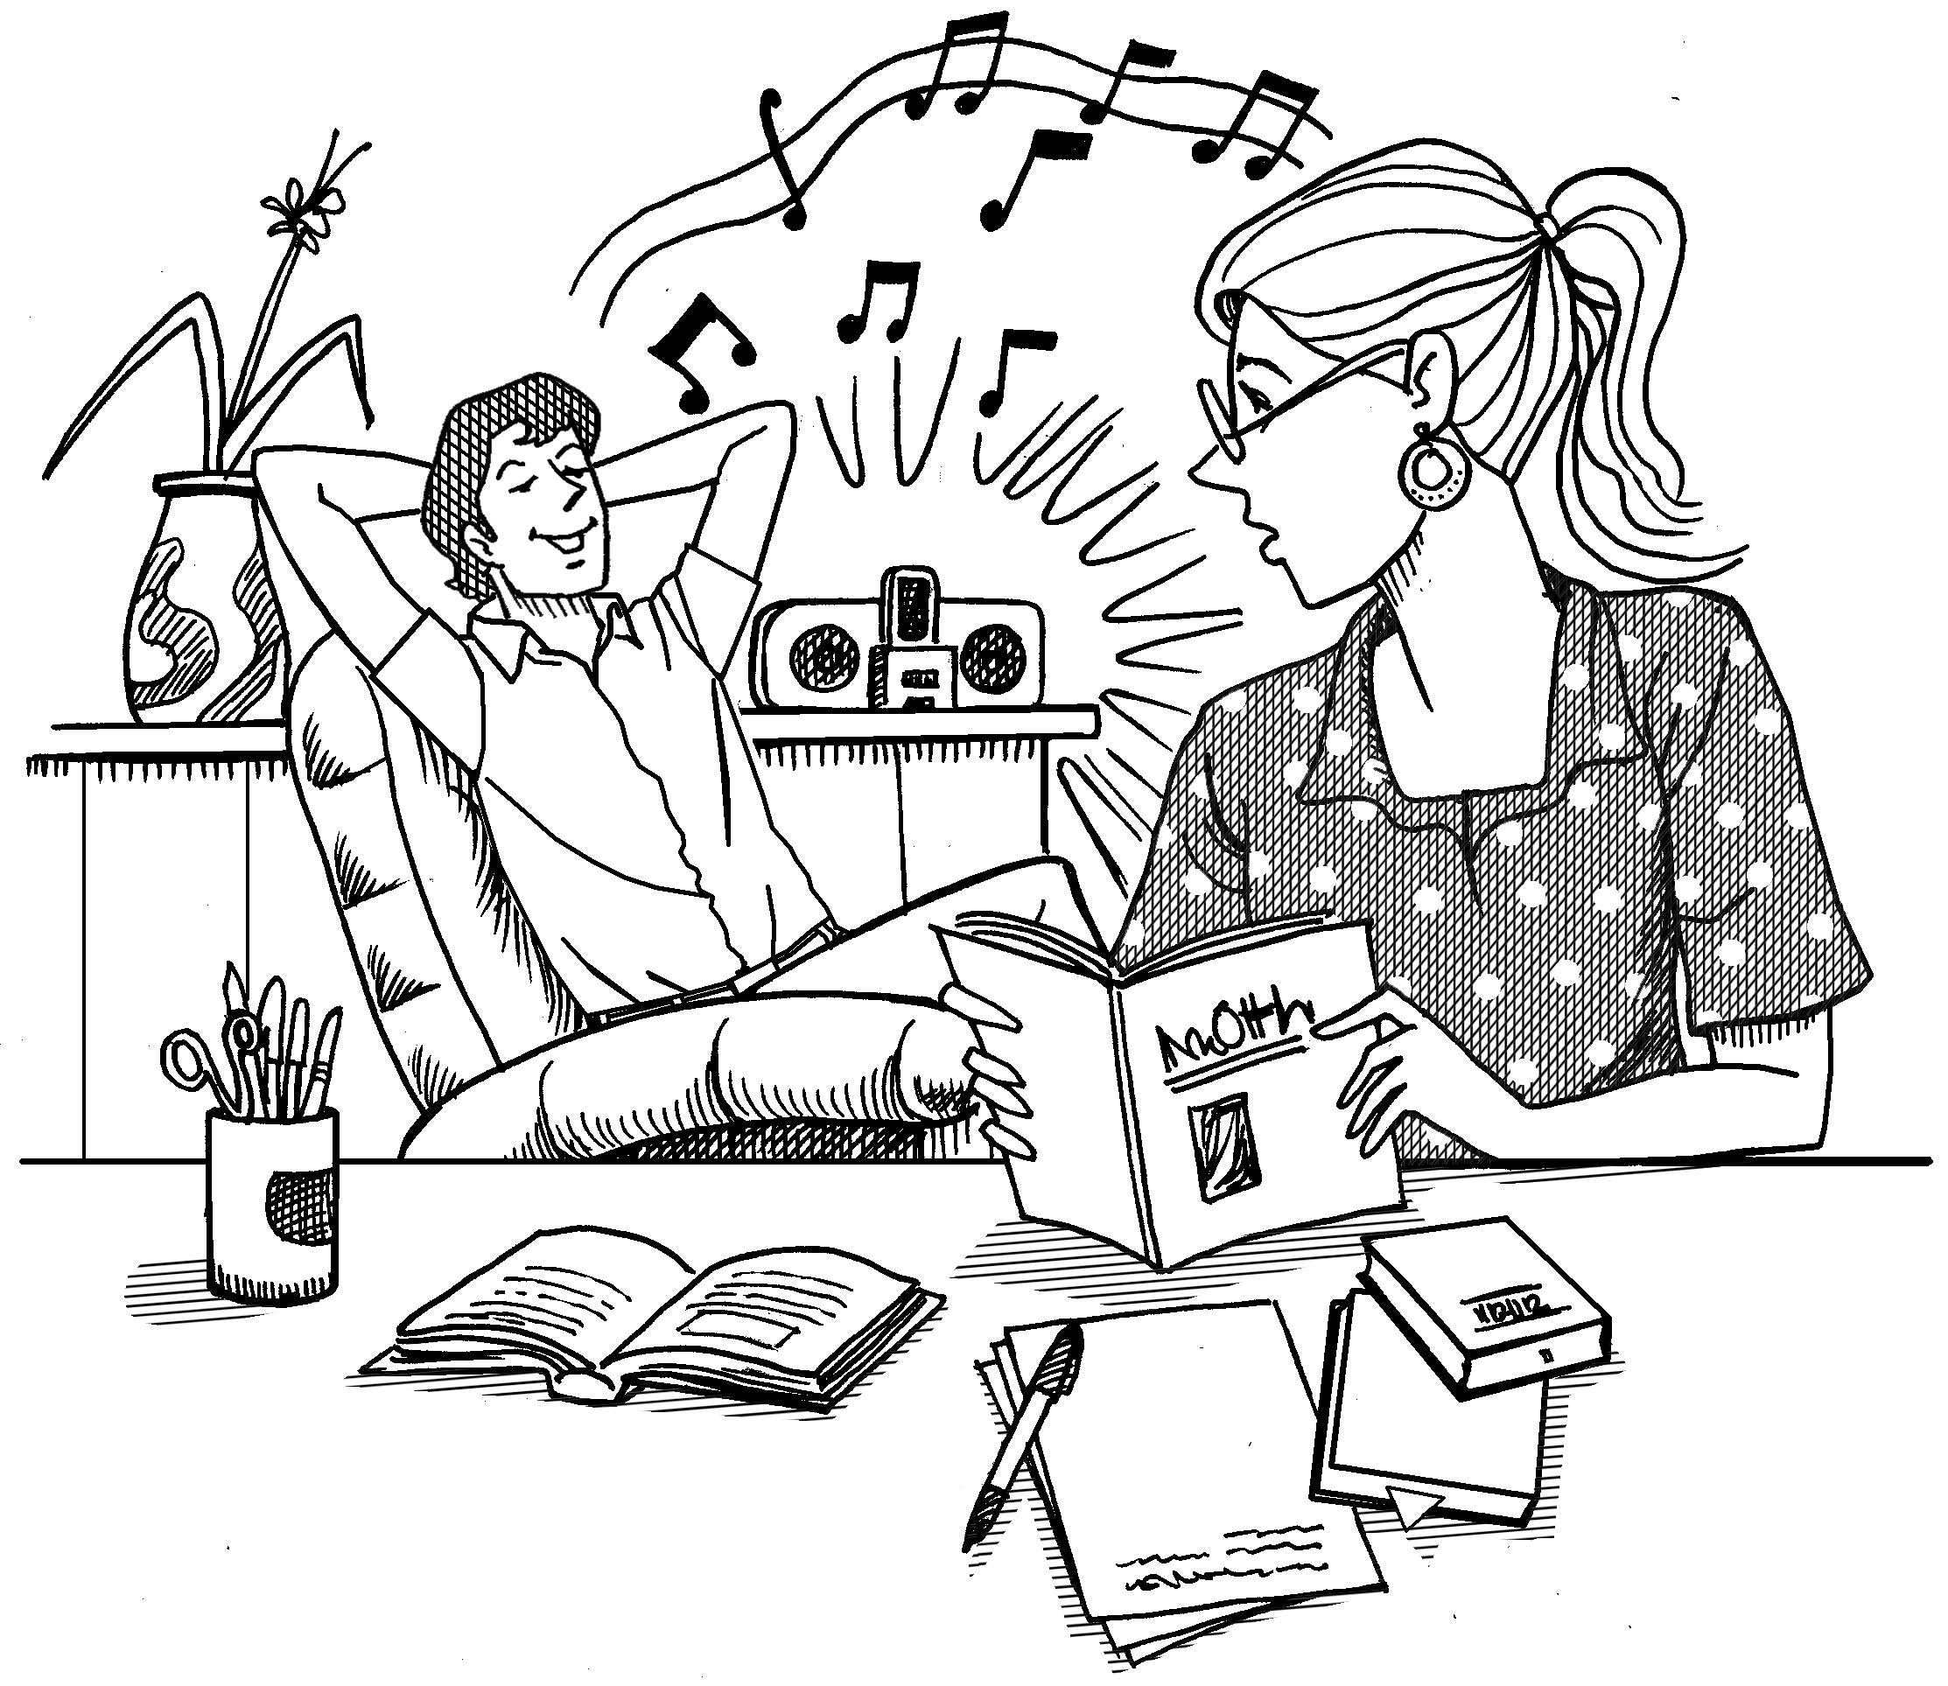

Can you . . . ?
Could you . . . ?
Would you please . . . ?
Would you mind . . . ?

A: Could you turn down the music? I’m trying to study.
B: Of course. I didn’t realize it was so loud.

