SIMPLE PAST VERBS
Your Vocabulary Log
Write the present form of the irregular verbs. Then review the past form of the regular verbs.
Practice
A Look at the pictures. What did these people do last weekend? Tell the class.
Use words from your vocabulary log.
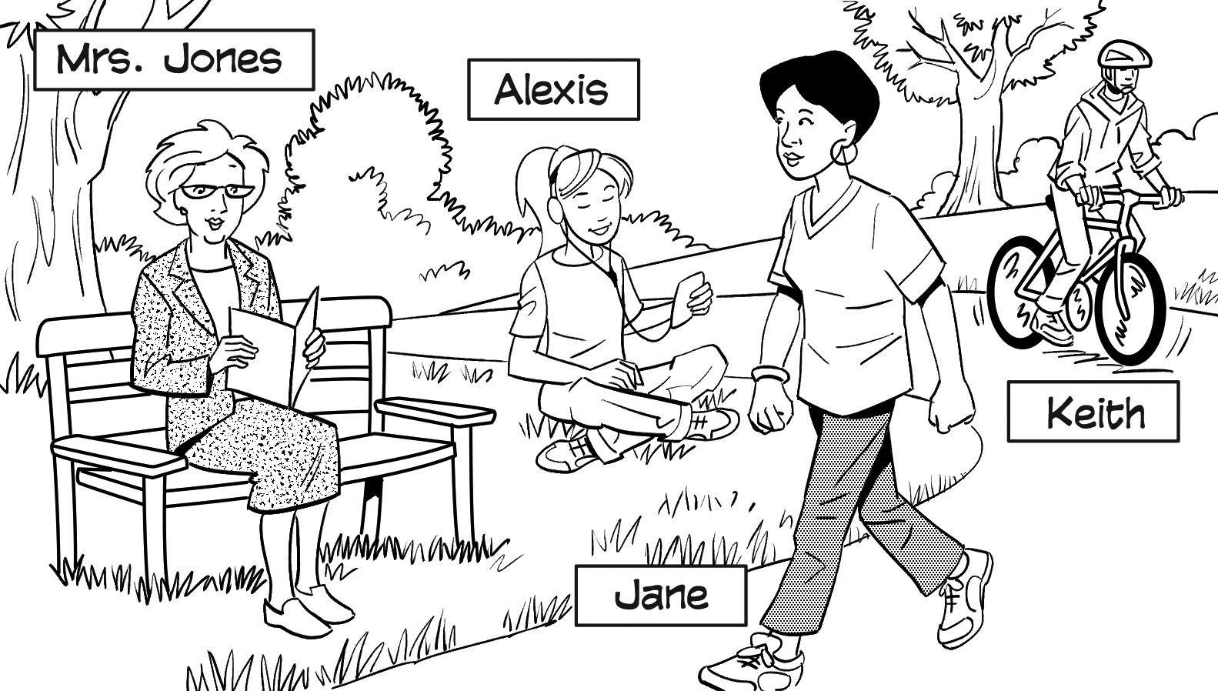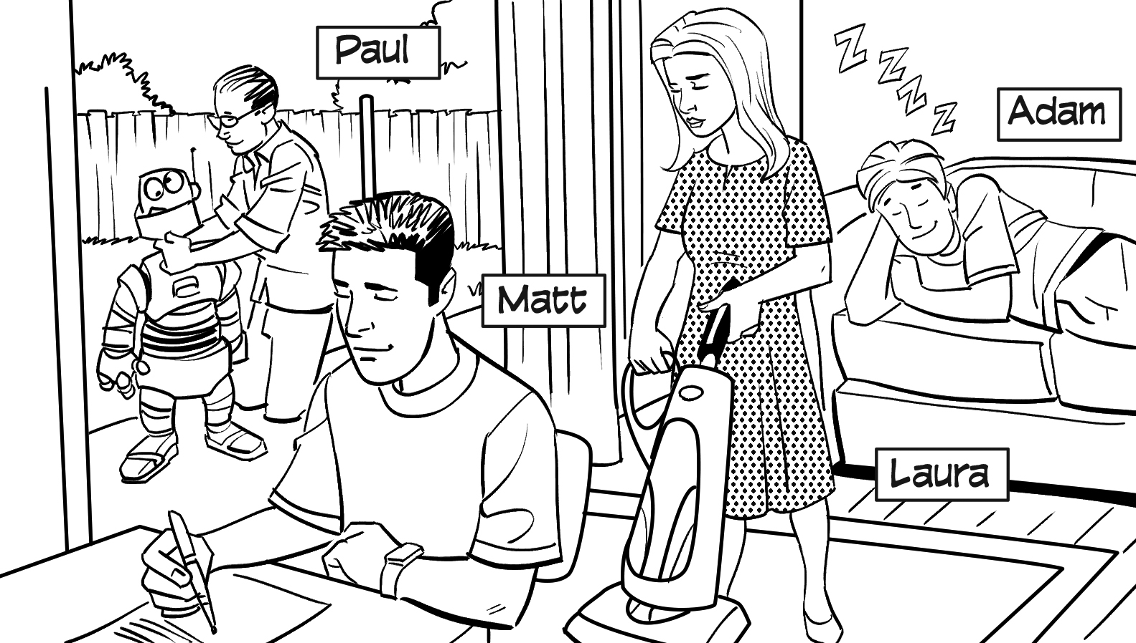
B PAIR WORK Cover the pictures in part A. Talk about what the people did.
How much do you remember?
A: Matt wrote letters. A: Laura built a robot.
B: That’s right. B: No, she didn’t. She vacuumed.

