HOW DO I GET THERE?

Aim: Give Ss practice giving directions and describing places.
Preparation: Make one copy of the worksheet for every two Ss.
Materials: City map; brochures of tourist attractions

Plan
■ Ss work in pairs. Give each pair a worksheet.
■ Ss list attractions in their city or town.
■ Option: Ss choose any city that they know about and list its tourist attractions.
■ Elicit suggestions. Then ask: “Why should someone visit these places?” Elicit reasons.
Prepare
A
■ Each pair joins another pair. Explain the task. Ss decide on a city and choose places to see.
■ Have Ss write a walking tour of the city. Refer Ss to the Reading on page 91 of the Student’s Book. Encourage them to describe each place.
B
■ Have Ss draw a map of the walking tour. Refer Ss to the maps on pages 90 and 91 of the Student’s Book. Encourage Ss to use an actual map of the city to verify street names and intersections.
■ Option: Assign each group one attraction and have them research it and write a description.
Present
■ Have Ss share their maps with the class.

HOW DO I GET THERE?
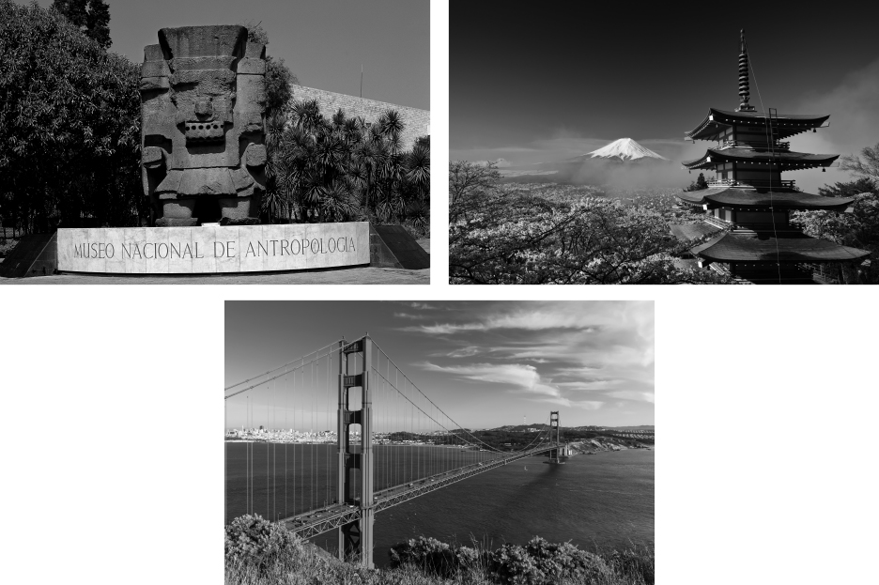
Plan
PAIR WORK Make a list of some popular attractions in your city or town.
_________________________________________________________________________
_________________________________________________________________________
_________________________________________________________________________
_________________________________________________________________________
_________________________________________________________________________
Prepare
A GROUP WORK Choose a city and at least five places for a visitor to see.
Then plan a walking tour of the city. Write directions from one place to the next.
B GROUP WORK Draw a map of the city that includes all the places.
Present
CLASS ACTIVITY Share your map with the class. Include interesting
information about each place.

