**Chapter 12 Supplement**

**Business Meeting Etiquette**

During your meetings with potential investors (or interviewing for a new job), you will undoubtedly be invited to meet over lunch or dinner. There is more going on at a business lunch then you may realize. The investor will also be evaluating you on how you present yourself in terms of dress and manners. So, a quick review of some business meeting etiquette is in order (just in case you've forgotten some of the manners that your mother taught you).

**The Power Business Lunch**

While a business plan and angel letter may help you get your foot in the door, how you present yourself and act in person is what will either seal the deal or send you packing. Investors (or companies recruiting new employees) will be interested in the presence and interpersonal skills that you bring to the table. While your interview may occur in the typical office set up, more and more such interviews are being held at what is described by the now ever so famous phrase, The Power Business Lunch. The Business Lunch is a great opportunity for you to win the approval the investor or your future employer and the two keys to a successful lunch are your attire and manners.

More than half of all business deals are finalized over a meal, and a higher percentage of business discussion occurs while out to lunch (officially) or dinner. Business meals are often used to conduct interviews, get to know a customer or consultant, network with a colleague, or sign an agreement. Still not convinced? Have you ever been on a date and witnessed your companion’s manners to be objectionable? Your impression of that person was tainted. This is the same thing that can occur in a business setting whether you choose to acknowledge it or not.

Here are some basic suggestions to follow for restaurant etiquette.

***Napkin Etiquette***

The meal begins when the host unfolds his or her napkin. This is your signal to follow. Place your napkin on your lap, completely unfolded if it is a small luncheon napkin or half, lengthwise if it is a dinner napkin. Usually, you should place your napkin soon after sitting down but always follow your host’s lead. If you need to leave the table during the meal, place your napkin on your chair as a signal to your server that you will return.

The napkin stays on the lap until the entire event is over; this includes a dinner followed by a speaker. Bear in mind that the napkin is considered to have been soiled during your dinner. It should remain in your lap until everyone else has completed the meal and is ready to get up from the table. Even if the plates have been cleared, a soiled napkin shouldn’t be tossed on the table. Leave it in your lap until the event is over. Dirty napkins on the table are neither sanitary nor attractive.

The host will signal the end of the meal by placing his or her napkin on the table. Once the meal is over, you too should place your napkin neatly on the table to the left of your dinner plate. Do not refold your napkin nor wad it up, simply place it. This is a signal to the server that you are finished dining and will not be returning.

The purpose of the napkin is to blot your mouth as needed, to remove particles of food, especially before drinking from a glass. The napkin isn’t used to “wipe your mouth,” although this seems to be an oft-used phrase. That is all you are to do with your napkin. The napkin is not to be used to mop your brow, no matter how much your brow is perspiring. Excuse yourself from the table if you are sweating. If you are in need of a tissue and you do not have one, excuse yourself from the table. Do not bring the napkin anywhere near your nose.

The napkin is placed on your lap after the host or senior person has done so. A dinner napkin, which is the larger, is placed folded in your lap with the crease toward you. The smaller luncheon napkin is opened all the way and laid in your lap. Do not tuck it into your belt and do not tuck it into your collar, even if you are having lobster or ribs.

***Ordering***

Look over the menu and if there are items you are uncertain about, ask your server questions. They are trained to know the restaurant’s menu for this specific purpose and better to know ahead of time if you are allergic to a sauce than mid-meal.

Usually the employer will suggest you order first but sometimes the server may decide the sequence and timing of orders. Follow your host's lead. Often, women’s orders are taken before men’s. Use common sense when ordering and avoid the most expensive thing on the menu or more than two courses. However, should your host indicate it is all right directly or by saying, “The dessert here is fabulous or you must try their prime rib,” this is a sign for you to go ahead.

***Table Setting***

Sometimes it can appear to be a puzzle figuring out what silverware should be used when and for what. It is actually quite simple. To try and figure out what will be served, draw an imaginary line down the middle of the serving plate. To the right will be glassware, cup and saucer, knives and spoons, as well as a seafood fork if the meal includes seafood. It is important to place glassware or cup back in the same position after its use in order to maintain the visual presence of the table. To the left will be bread and butter plate, (including a small knife placed horizontally across the top of the plate), salad plate, napkin, and forks. Simple rules will help to remember. See Figure 12.2 (Formal Place Setting) and 12.3 (Simple Place Setting) for reference.

A simple rule to remember: Liquids on your right and solids on your left.

Water glass

Red wine glass

White wine glass

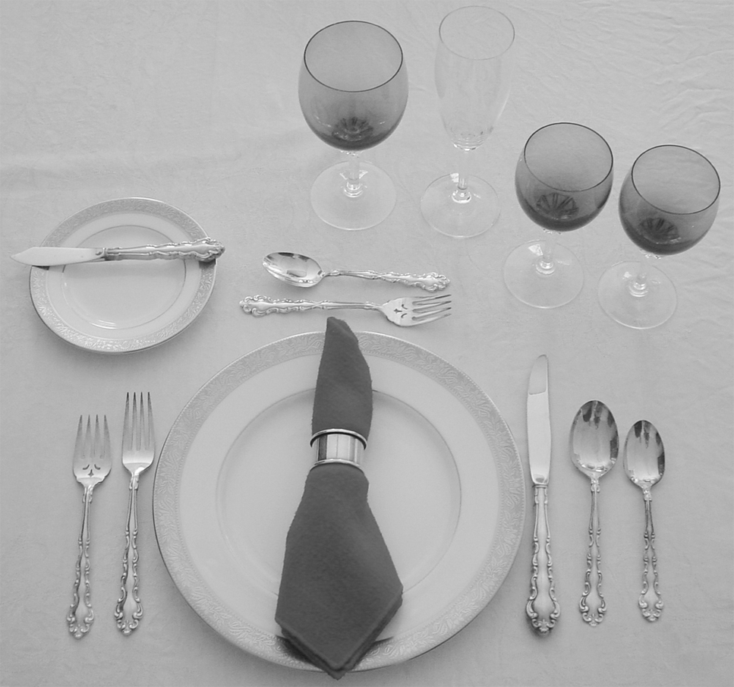

Dessert fork

Dessert spoon

Butter knife

Soup spoon

Dinner knife

Dinner fork

Dinner spoon

Salad fork

**Figure 12.2** A Formal Place Setting.

Water glass

Wine glass

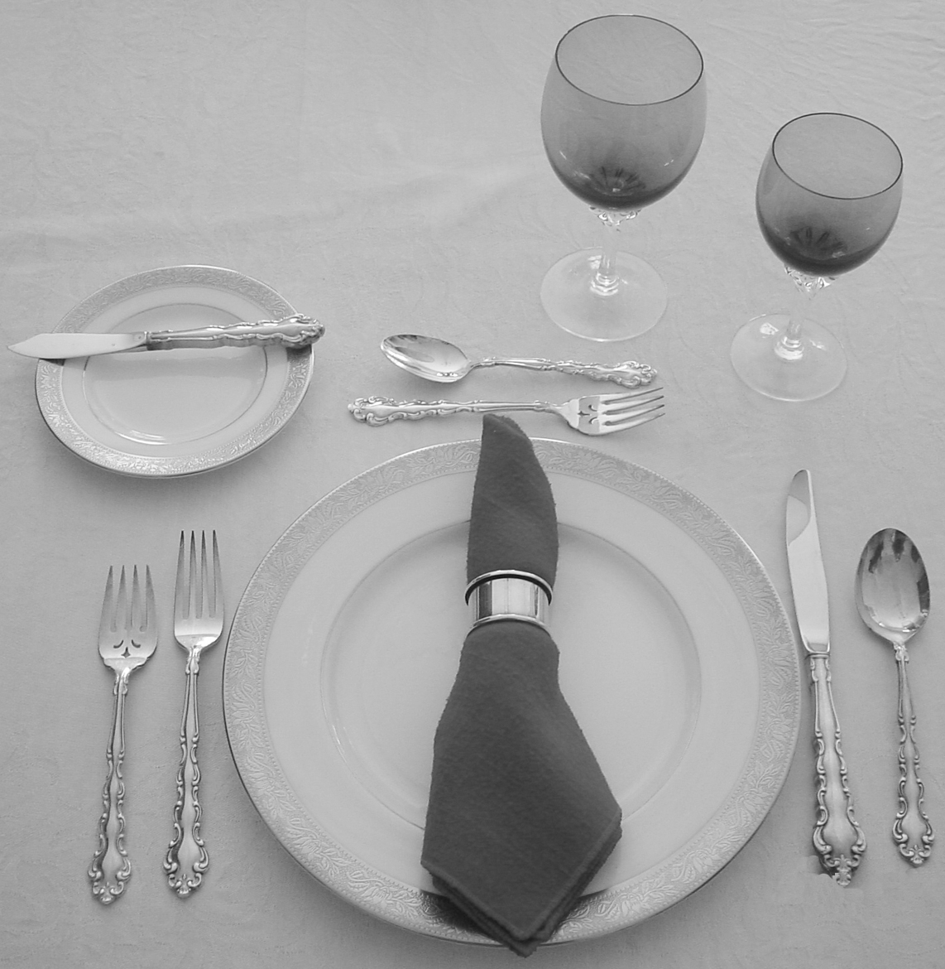

Dessert spoon

Dessert fork

Butter knife

Soup spoon

Salad fork

Dinner knife

Dinner fork

**Figure 12.3** A Simple Place Setting.

**Silverware.** To choose the correct silverware, begin with the outermost knife, fork or spoon from your plate. Work your way in, using one utensil for each course. The salad fork is on your outermost left, followed by your dinner fork. You will find your soup spoon on your outermost right, followed by your beverage spoon, salad knife and dinner knife. Your dessert spoon and fork are above your plate or brought out with dessert. If you only remember to work your way from the outside in, you will be fine.

There are two ways to use a knife and fork to cut and eat your food and how to place your knife and fork while resting during the meal, prior to the finish:

* American style (Figures 12.4 and 12.5) or
* European/Continental style (Figures 12.6 and 12.7).

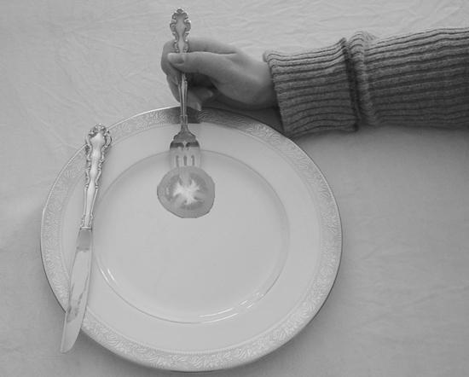

**Figure 12.4** Bringing Food to Your Mouth, American Style.

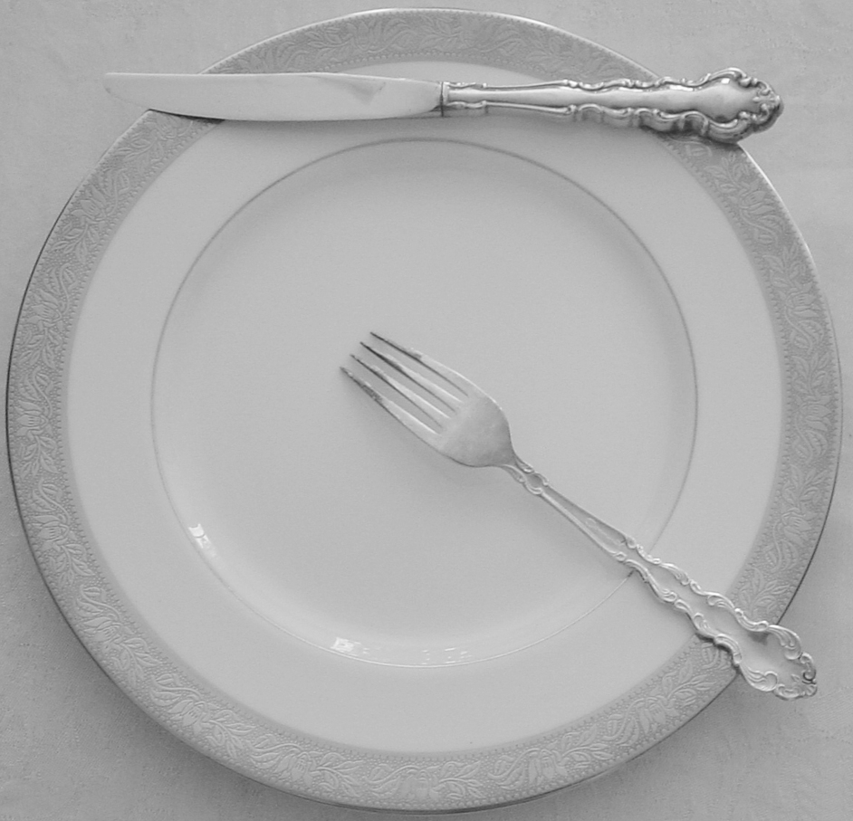

**Figure 12.5** Resting Position, American Style.

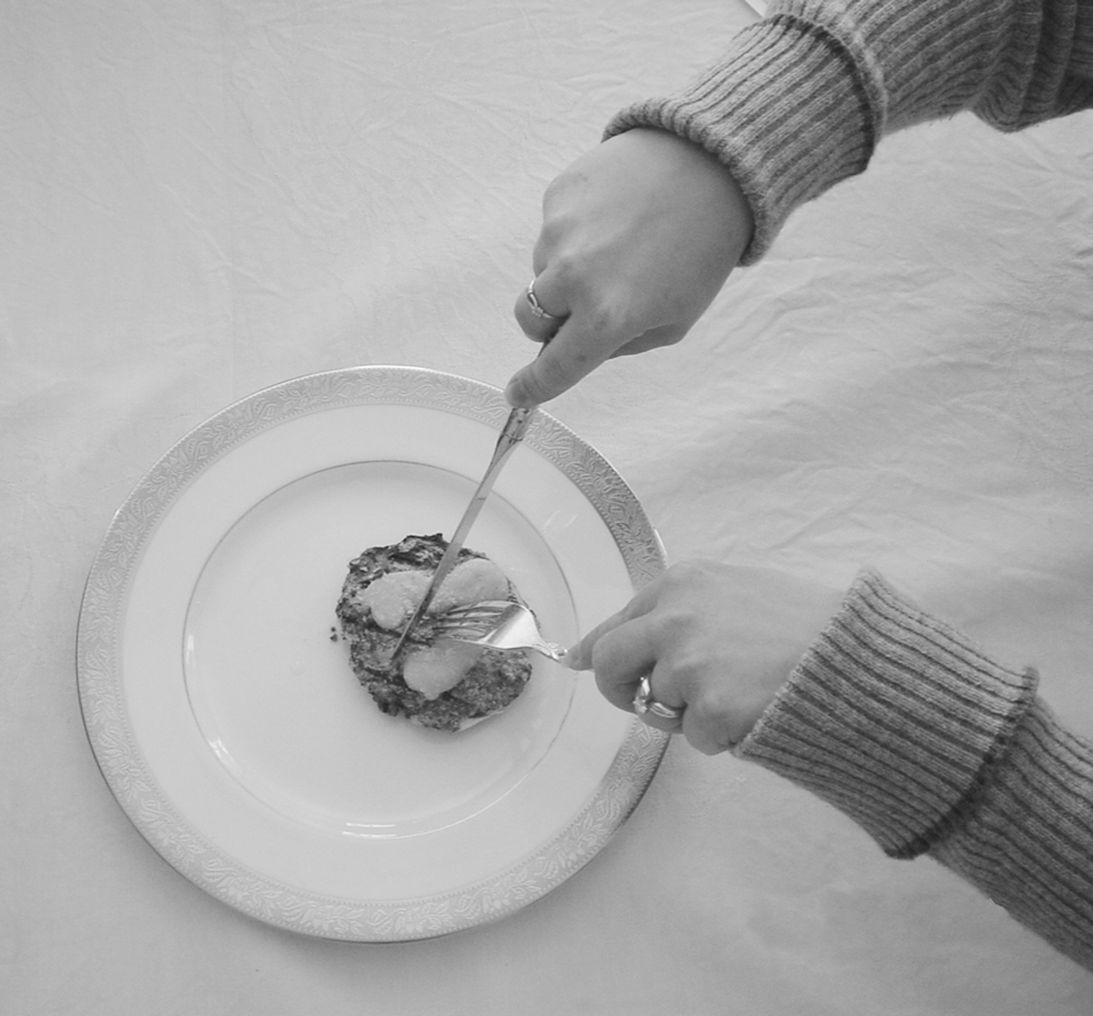

**Figure 12.6** Bringing Food to Your Mouth, Continental Style (note cutting technique; cut bite size piece and then fork used to bring to mouth).

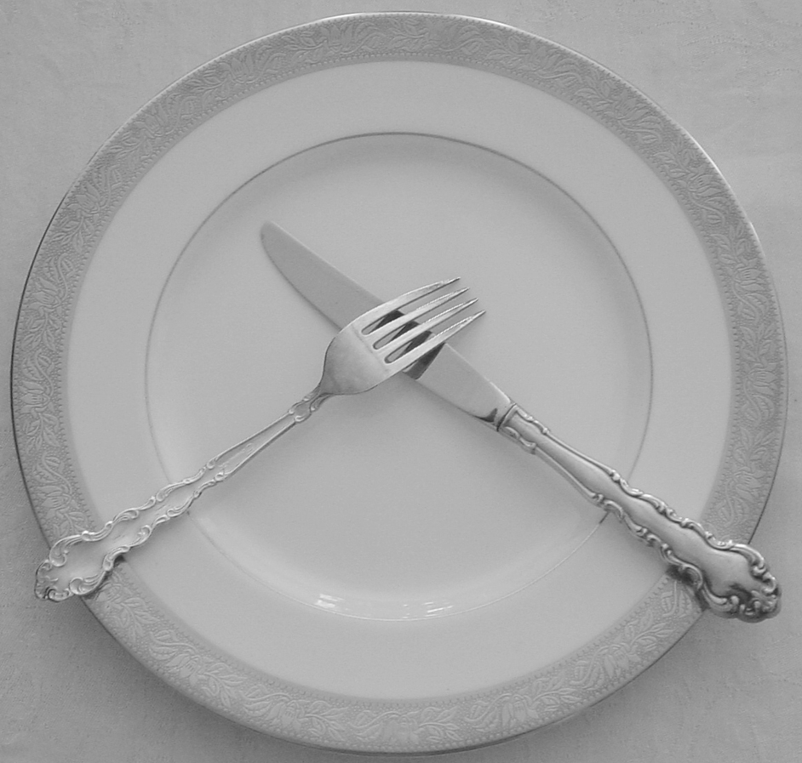

**Figure 12.7** Resting Position, Continental Style (Tines Down).

Either style is considered appropriate. In the American style, one cuts their food by holding the knife in the right hand and the fork in the left hand with the fork tines piercing the food to secure it on the plate. Cut a few bite size pieces of food, then lay your knife across the top edge of your plate with the sharp edge of the blade facing in toward you. Change your fork from your left to your right hand to eat, fork tines facing up. The European or Continental style is the same in the way with which to cut your meat but the difference is that the fork remains in your left hand, tines facing down, and the knife in your right hand. Simply eat the cut pieces of food by picking them up with your fork still in your left hand.

***Other Eating Rules***

**Soup.** When eating soup, the spoon is taken away from you to the outside of the bowl or plate. Clear soups are eaten from the side of the spoon and soups with “objects” are eaten from the front of the spoon. Although in some cultures, you can drink from your bowl using proper protocol (Japanese do not even use spoons), do not risk this in a Western setting. Place the soup spoon on the plate or bowl between spoonfuls. When finished, place the spoon on the saucer beside the bowl (soup bowls are often served on saucers) or if the soup was served in a bowl that was placed directly on the dinner plate, then leave the spoon in the bowl with the handle pointing to the right hand side of the bowl.

**Bread.** Bread should be eaten in bite-sized pieces. Never butter a large roll or piece of bread and then start to munch, and never cut your bread; tear it in pieces eating a piece at a time, buttering individually.

**Passing Foods.** Pass food to the right. Always keep salt and pepper together and never place them into a person's hand.

**Sharing Foods.** At a business meal, do not share food or sample from someone else's plate.

**Elbows.** Elbows should be off the table at all times. If not using a hand, place it on your lap.

***Finishing the Meal***

Do not push your plate away from you when you have finished eating, leave it. The common way to show that you have finished your meal is to lay your fork and knife diagonally across your plate. Place your knife and fork side by side, with the sharp side of the knife blade facing inward and the fork, tines down to the left of the knife. The knife and fork should be placed as if they are pointing to 10 o’clock. Make sure they are placed in a way that they do not slide off the plate as it is being removed. Once you have used a piece of silverware, never place it back on the table. Do not leave a used spoon in a cup, either; place it on a saucer. You can leave a soupspoon in a soup place. Any unused silverware is simply left on the table. See Figures 12.8 (Finished American Style) and 12.9 (Finished Continental Style) to summarize.

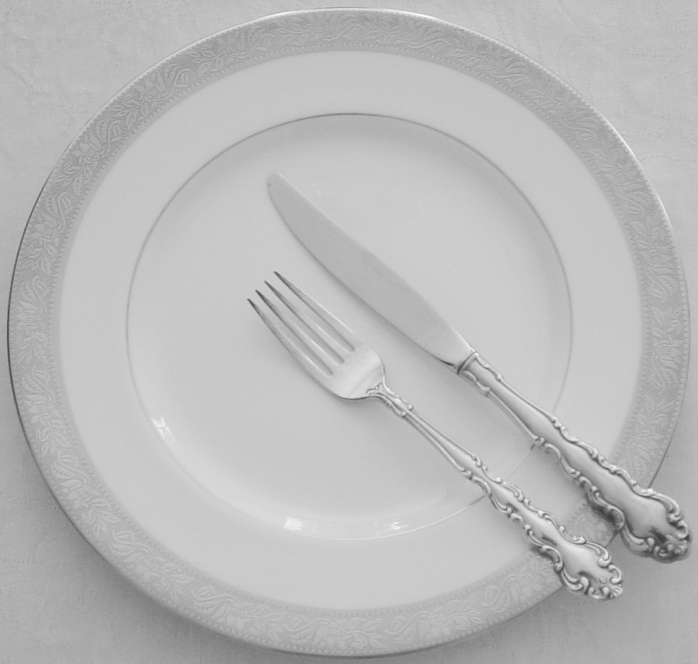

**Figure 12.8** Finished Position, American Style (Tines Up).

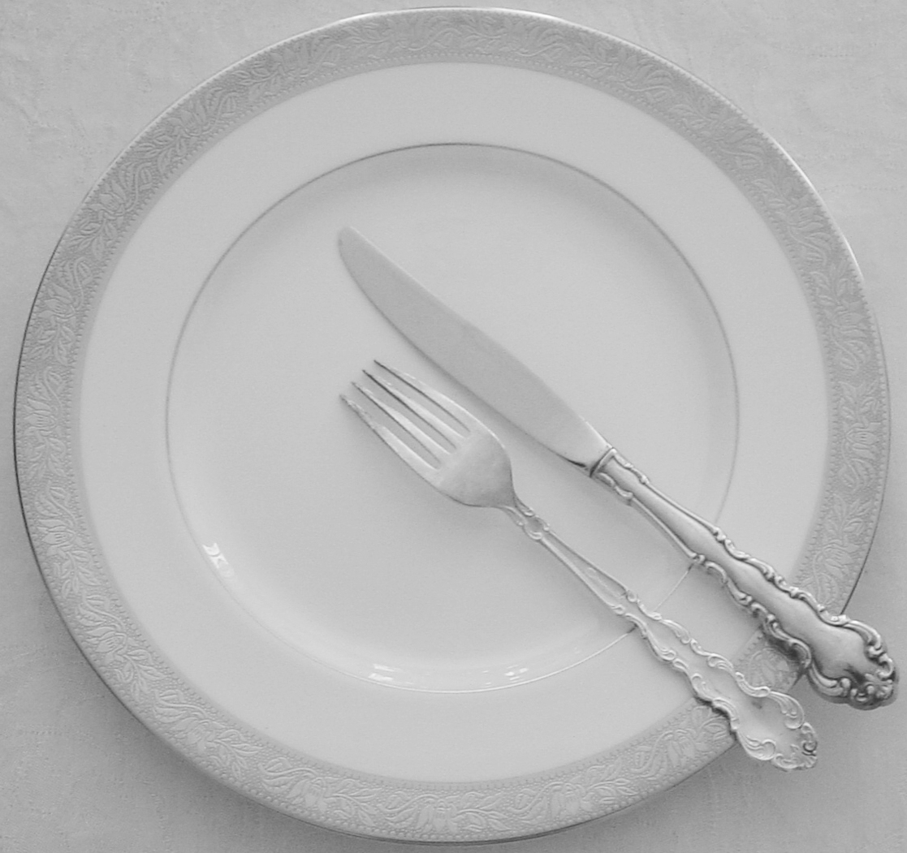

**Figure 12.9** Finished Position, Continental Style (Tines Down).

***Other Dinner Rules to follow***

1. **Avoid Talking With Food in Your Mouth**. It seems obvious but sometimes there is such limited time for your meeting and many things to discuss. Avoid the temptation and remember to swallow before speaking. And while you are at it, avoid any comparison to cows. Chew with your mouth closed.
2. **Give Your Dining Companion Full Attention.** Avoid leaving the table to greet other people. Instead, smile and wave and return to the conversation. It is not only rude to leave your guest or host to chat with others, but it also interrupts the flow of conversation.
3. **Turn Off Your Cell Phone.** By leaving your phone on, you are sending a message to your companions or interviewer that the meeting is not your top priority. This is immediately translated into how you would perform at their company or on the job for a client. If you must make a call, excuse yourself from the table. If there is some personal reason that you must keep your cell phone on for an emergency communication, then tell your party of the situation before hand (sick child, doctor’s call, etc).
4. **Keep Absences Brief.** Do not leave the table for more than a few minutes, and before you get up from the table say, “Please excuse me for a moment.”
5. **Steer Clear of Inappropriate Discussion Topics**. Avoid complaining or gossiping about others. While your companion may share these opinions, neither is appropriate to discuss in a business setting. Also, avoid profanity, inappropriate jokes or revealing any information that’s too personal.
6. **Don’t Interrupt.** Remain polite, no matter how heated the discussion becomes. Don’t finish your dining companion’s sentences.
7. **Avoid Alcoholic Beverages.** Unless your business associate works in the food and wine industry, drinking liquor during a business meal isn’t appropriate. Most companies frown on midday drinking.
8. **Avoid Messy Foods.** The goal here is to create a positive impression. Food all over your fingers, face is likely to disgust the other people at your table. Dishes such as stringy pasta dishes, corn on the cob, slippery seafood dishes, or greasy meats such as fried chicken or spare ribs are all calls for disaster. Wait until after a successful interview when you have been hired and are celebrating with friends.

**Business Attire**

Now that you know how to eat a business lunch, it is just as important to show up appropriately dressed for your successful meal. It is impossible to ever make another first impression and since clothes are among the first thing people see when they look at you, they count a lot whether you like it or not. Although a first impression may be made in less than a minute, its impact can carry greater weight than the years you spend putting together the items listed on your resume.

Is dress important? The Queen of England is reported to have said to Prince Charles:

“…dress gives one the outward sign from which people can judge the inward state of mind. One they can see, the other they cannot…”

First impressions and day-to-day impressions are critical in how the world views you. Ask yourself how you size up people; generally it is often before you speak to them. Remember the following dress code rules.

***Women’s Attire***

**Suits and Dresses.**A suit or tailored dress is the most professional attire. It is always safe to go with a conservative, classic style due to its versatility. You can use this outfit in many business settings so it is worth the investment. Fabrics such as lightweight wool crepe or wool gabardine can be worn in several seasons. Your chosen career path will influence what you wear but for a first impression, classic is always best.

**Color and Pattern.**Pick a neutral color that suits you and begin to build a wardrobe around it. Colors such as navy, charcoal gray, black, off white, camel or olive are versatile. The best patterns for professional suits are solid, hounds tooth, tweed and plaid.

**Shoes.**Shoes should be closed toe pumps with heels ranging from one to two inches. Styles should be on the conservative side. Neatness is important so make sure that your shoes are clean and polished. How you treat your shoes and clothes carries over into how you will treat your desk and assignments at the office. Comfort is key so do not buy shoes that need to be ‘broken in.’

**Accessories.**Make sure that any accessories you choose to wear are coordinated with your outfit. Handbags, belts, scarves should be versatile but use them in moderation. Simple is best.

**Jewelry.**Avoid dangly earrings, multiple rings and noisy bracelets. Jewelry that moves too much or makes noise is distracting. Gold, silver and pearls are best and make sure to choose earrings in proportion to your size.

**Hair.**Select a hairstyle appropriate for your hair type, face, life-style, profession, and personality. Your hair should be clean, neat, and controlled. A short style is always professional. Long hair should be pulled away from the face for the most professional look. The condition of your hair is also important. Take good care of it as dry, brittle, bleached hair communicates poor personal hygiene.

**Nails.**A neat appearance is important. Nails should be short and well groomed. Choose a neutral shade or clear nail polish.

**Makeup.** Aim for a natural look that accentuates your positive features and enhances them but does not overwhelm. Focus on eyes or mouth, not both.

***Men’s Attire***

**Suits.**A pure wool or wool-blend suit in navy or charcoal gray is the best choice for a fabric. Solid or pinstripes are fine. Single-breasted styles are considered a conservative look while double-breasted styles are trendier. Other styles such as muted plaids and tweeds in neutral colors are acceptable. Black is not usually considered appropriate for business; for socials and funerals yes.

**Trousers.**Pants should be long enough to cover your socks, and socks should cover your shins even when you cross your legs. Pants are long enough if they have a slight break over the shoe in front.

**Shirts.**Wear traditional cotton or cotton blend well pressed shirts with long sleeves and straight or button collars. White and light blue are recommended for interviews. Reserve pinstriped or chalk-striped shirts for less conservative situations.

**Ties.**When choosing a tie, silk is always best followed by polyester that looks like silk and silk-polyester blends. Tie clips and tacks are way out of date. The tie should just reach your belt buckle. No flashy ties, be conservative. Solids, stripes or small patterns are best.

**Shoes.**Shoes are one of the most important ingredients in a professional outfit. The best shoes for an interview are leather or simulated leather lace-up shoes, like wingtips. Choose dark colors like black, cordovan, or dark brown. Your shoes should match the color of your belt for a coordinated look. Dress socks should match the color of your slacks or shoes.

**Jewelry.**Watches, wedding rings, and conservative men’s rings are appropriate in any situation. Steer clear of items like bracelets and earrings, which convey a casual look (and attitude about the job).

**Grooming.**Personal hygiene is essential in all professional settings, including clean and well-groomed hair; clean healthy nails; and well-groomed facial hair. Any mustache or beard not fully grown should be shaved before an interview. If you have a beard or mustache, groom it daily. In particular, your mustache should be well above your upper lip. A short, conservative hairstyle is the most professional.

**A Few More Rules**

1. **Thank you**. After being invited for an interview, send a written thank you note. This also applies to being invited to the home of the “boss” or to a colleague, especially the first time this happens is very important. After the first such occasion, taking time to at least call the host and express your thanks is a minimum courtesy.
2. **Introductions**. Always introduce yourself. In making business introductions, introductions are based on rank and hierarchy, not gender.
3. **Salutations**. Always use a person's last name until that person asks you to use a less formal approach. It is very embarrassing for you to call her Sally and then she calls you Mr. Smith. Older people always deserve to be called by their family names, i.e. Ms. Smith.
4. **Cell Phones**. Never have your ringer on when you are in a public place or in someone else’s office.
5. **Email**. Make sure you have a descriptive word(s) in the message identifier. When replying to a message, keep either the original message or an excerpt so the other person knows the reference of the email.
6. **Name tags**. Wear your tag on the right shoulder (the unnatural place to pin it for a right-handed person) so that it is easier to read during an introduction.
7. **Eye Focus**. When talking to or being talked to, make frequent eye contact to indicate strong interest and attention. Advert constantly looking down.
8. **Seat posture**. During a one on one meeting, pay particular attention to general posture and avoid crossing of legs (crossing of legs indicates informality).
9. **Language**. Swearing or vulgar language is NEVER appropriate in any business setting. If you don’t know what bad grammar is, rest assured that those with whom you speak do know, and they won’t be impressed.