Figure 7.1 Regular re-use pattern of 1/4 of frequencies

Figure 7.2 First order AR process

Figure 7.3 Multiple input multiple output system

Figure 7.4 FDMA, TDMA, and FH-CDMA

Figure 7.5 Erlang model

Figure 7.6 Near and Far Terminals

Figure 7.7 Three sector system

Figure 7.8 4-cell system

.

Figure 7.9 Two-user power control problem

Figure 7.10 Feasibility regions with and without noise and peak power constraints

Figure 7.11 Adaptive antenna problem with multipath and interference

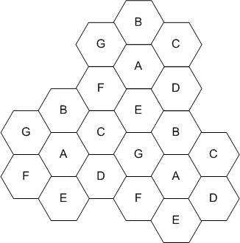

Figure 7.12 A cellular system with reuse factor 7.

Figure 7.13 Two linear prediction filters with two and three delay taps.

Figure 7.14 A two by two MIMO system.

Figure 7.15 Maximal ratio combining

Figure 7.16 Array processing

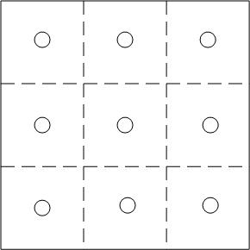

Figure 7.17 Sensor deployment in a square.

Figure 7.18 A linear feedback shift register of length 4.

Figure 7.19 Two-ray ground reflection model.

Figure 7.20 Packet transmission in a shared channel.

