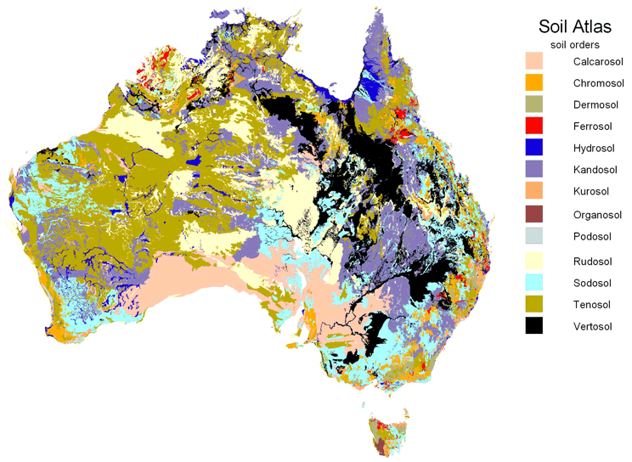
Figure 3.6 Generalised soil map of Australia

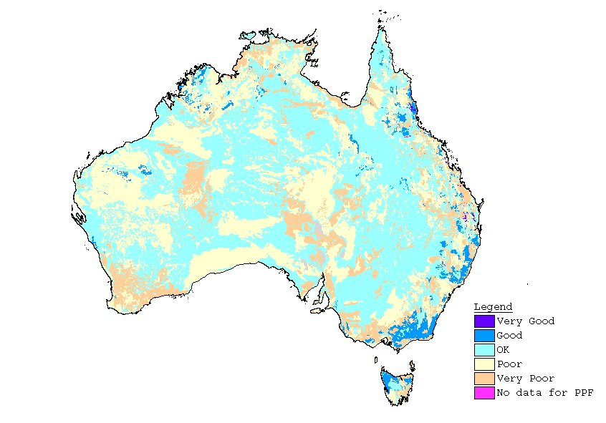
Figure 3.7 Quality of dominant soils of Australia

