Supplementary Material for

**Varieties of Structural Transformation: Patterns, Determinants and Consequences**

by

Kunal Sen

*UNU-WIDER and University of Manchester*

Part of

**Elements in Development Economics**

Series Editor-in-Chief

Kunal Sen

*UNU-WIDER and University of Manchester*

ISBNs: 9781009449915 (HB), 9781009449953 (PB), 9781009449939 (OC)

Information on this title: www.cambridge.org/ 9781009449915

DOI: 10.1017/9781009449939

|  |  |  |  |  |  |  |  |  |  |  |  |  |  |  |  |  |  |  |  |  |  |  |  |  |  |  |  |  |  |  |  |  |  |  |  |  |  |  |  |  |  |  |  |  |  |  |  |  |  |  |  |  |  |  |  |  |  |  |  |  |  |  |  |  |  |  |  |  |  |  |  |  |  |  |  |  |
| --- | --- | --- | --- | --- | --- | --- | --- | --- | --- | --- | --- | --- | --- | --- | --- | --- | --- | --- | --- | --- | --- | --- | --- | --- | --- | --- | --- | --- | --- | --- | --- | --- | --- | --- | --- | --- | --- | --- | --- | --- | --- | --- | --- | --- | --- | --- | --- | --- | --- | --- | --- | --- | --- | --- | --- | --- | --- | --- | --- | --- | --- | --- | --- | --- | --- | --- | --- | --- | --- | --- | --- | --- | --- | --- | --- | --- |
| **APPENDIX TO “VARIETIES OF STRUCTURAL TRANSFORMATION; PATTERNS, DETERMINANTS AND CONSEQUENCES”**  **Table A1. Patterns of Structural Transformation by Income Status, using ETD data**   |  |  |  |  |  |  |  | | --- | --- | --- | --- | --- | --- | --- | | **Country Groups** | **Period** | **Agriculture** | **Manf.** | **Nonmanf.** | **Bus.Serv.** | **Non-bus. Serv.** | | Low income | 1990-1994 | 85.49% | 2.92% | 1.10% | 0.4% | 10.1% | | Low income | 2015-2018 | 64.35% | 5.75% | 4.68% | 1.5% | 23.7% | | Lower middle income | 1990-1994 | 60.79% | 8.29% | 4.25% | 1.4% | 25.2% | | Lower middle income | 2015-2018 | 42.11% | 11.09% | 7.33% | 3.9% | 35.7% | | Upper middle income | 1990-1994 | 33.33% | 14.45% | 8.13% | 4.2% | 39.8% | | Upper middle income | 2015-2018 | 19.96% | 12.33% | 9.38% | 8.9% | 49.4% | | High income | 1990-1994 | 8.49% | 23.99% | 10.16% | 9.6% | 47.8% | | High income | 2015-2018 | 3.67% | 13.72% | 9.85% | 16.7% | 56.1% | |  |  |  |  |  |  |  |  |  |  |  |  |  |
|  |  |  |  |  |  |  | 8.8% | 57.4% | 20.3% | 5.6% | 6.5% | 3.1% | 21.9% |
| *Source:* our calculations, using ETD data  **Table A2. Stages of Structural Transformation, Country Classification, using GGDC data**   |  |  |  | | --- | --- | --- | | Structurally Underdeveloped  (8) | Structurally Developing  (12) | Structurally Developed  (19) | | Ethiopia  India  Kenya  Malawi  Nigeria  Senegal  Tanzania  Zambia | Bolivia  Botswana  Brazil  People’s Republic of China  Colombia  Costa Rica  Ghana  Indonesia  Peru  Philippines  Thailand  South Africa | Argentina  Chile  Denmark  France  Hong Kong, China  Italy  Japan  Malaysia  Mauritius  Mexico  Netherlands  Singapore  Republic of Korea  Spain  Sweden  Taiwan  United Kingdom  United States  Venezuela |   **Note:** The GGDC data ends in 2010.  **Source:** Author’s compilation. |  |  |  |  |  |  | 9.7% | 62.1% | 22.0% | 5.7% | 7.6% | 3.7% | 23.1% |
|  |  |  |  |  |  |  | 9.1% | 66.3% | 22.5% | 5.7% | 9.1% | 3.9% | 25.2% |
|  |  |  |  |  |  |  | 8.6% | 69.4% | 22.7% | 5.5% | 10.7% | 4.2% | 26.3% |
|  |  |  |  |  |  |  | 8.8% | 71.4% | 22.9% | 5.4% | 11.5% | 4.4% | 27.2% |
|  |  |  |  |  |  |  | 8.8% | 72.8% | 22.6% | 5.3% | 12.2% | 4.5% | 28.1% |
|  |  |  |  |  |  |  | 0.8% | 10.5% | 5.0% | 0.6% | 0.3% | 0.1% | 4.5% |
|  |  |  |  |  |  |  | 1.0% | 11.3% | 5.9% | 0.6% | 0.4% | 0.1% | 4.3% |
|  |  |  |  |  |  |  | 1.4% | 13.6% | 7.0% | 0.6% | 0.5% | 0.1% | 5.3% |
|  |  |  |  |  |  |  | 2.0% | 16.9% | 8.7% | 0.8% | 0.7% | 0.2% | 6.6% |
|  |  |  |  |  |  |  | 2.5% | 20.8% | 10.3% | 1.2% | 0.9% | 0.2% | 8.2% |
|  |  |  |  |  |  |  | 3.0% | 25.2% | 12.4% | 1.5% | 1.2% | 0.3% | 9.8% |
|  |  |  |  |  |  |  | 3.2% | 26.6% | 9.8% | 2.4% | 1.1% | 0.3% | 13.0% |
|  |  |  |  |  |  |  | 3.7% | 28.3% | 11.0% | 2.7% | 1.3% | 0.4% | 13.0% |
|  |  |  |  |  |  |  | 4.1% | 30.7% | 12.5% | 3.1% | 1.5% | 0.4% | 13.2% |
| **Table A3. Patterns of Structural Transformation using GGDC data**   |  |  |  |  |  |  |  | | --- | --- | --- | --- | --- | --- | --- | | Country Group | Period | Agriculture | Manufacturing Industry | Nonmanufacturing Industry | Business Services | Non-business Services | | Underdeveloped | 1960–1979 | 78.2 | 4.4 | 2.3 | 0.4 | 14.6 | |  | 1980–1999 | 73.3 | 4.5 | 2.2 | 0.6 | 19.3 | |  | 2000–2012 | 66.4 | 6.2 | 3.2 | 1.0 | 23.1 | | Developing | 1960–1979 | 56.3 | 10.3 | 6.0 | 2.3 | 25.1 | |  | 1980–1999 | 42.0 | 11.9 | 7.3 | 3.4 | 35.5 | |  | 2000–2012 | 31.1 | 12.0 | 7.5 | 5.3 | 44.1 | | Developed | 1960–1979 | 20.1 | 22.8 | 9.4 | 4.2 | 43.4 | |  | 1980–1999 | 10.4 | 20.9 | 8.9 | 7.8 | 52.1 | |  | 2000–2012 | 5.9 | 15.8 | 9.0 | 12.1 | 57.2 |   **Note:** In percentages of total employment, unweighted averages.  **Source:** Author’s calculations based on GGDC data. |  |  |  |  |  |  | 4.6% | 33.3% | 13.9% | 3.6% | 2.0% | 0.5% | 13.4% |
|  |  |  |  |  |  |  | 5.4% | 36.4% | 15.4% | 3.8% | 2.7% | 0.7% | 13.8% |
|  |  |  |  |  |  |  | 6.2% | 39.6% | 17.1% | 4.2% | 3.1% | 0.8% | 14.4% |
|  |  |  |  |  |  |  | 5.9% | 44.1% | 15.9% | 3.8% | 3.3% | 0.9% | 20.1% |
|  |  |  |  |  |  |  | 6.1% | 48.0% | 17.4% | 4.3% | 4.2% | 1.1% | 20.9% |
|  |  |  |  |  |  |  | 5.8% | 52.1% | 19.8% | 4.6% | 4.8% | 1.2% | 21.7% |
|  |  |  |  |  |  |  | 6.4% | 54.4% | 20.8% | 4.9% | 5.6% | 1.5% | 21.6% |
|  |  |  |  |  |  |  | 7.2% | 56.8% | 21.3% | 5.1% | 6.5% | 1.7% | 22.1% |
|  |  |  |  |  |  |  | 7.6% | 58.3% | 21.9% | 5.1% | 7.2% | 1.7% | 22.3% |

**Table A4. Country Codes for ETD data, used in Figures A5-A16.**

|  |  |  |  |
| --- | --- | --- | --- |
| Country Code | Country | Country Code | Country |
| ARG | Argentina | MYS | Malaysia |
| BGD | Bangladesh | MUS | Mauritius |
| BOL | Bolivia | MEX | Mexico |
| BWA | Botswana | MAR | Morocco |
| BRA | Brazil | MOZ | Mozambique |
| BFA | Burkina Faso | MMR | Myanmar |
| KHM | Cambodia | NAM | Namibia |
| CMR | Cameroon | NPL | Nepal |
| CHL | Chile | NGA | Nigeria |
| CHN | China | PAK | Pakistan |
| TWN | Chinese Taipei | PER | Peru |
| COL | Colombia | PHL | Philippines |
| CRI | Costa Rica | KOR | Republic of Korea |
| ECU | Ecuador | RWA | Rwanda |
| EGY | Egypt | SEN | Senegal |
| ETH | Ethiopia | SGP | Singapore |
| GHA | Ghana | ZAF | South Africa |
| HKG | Hong Kong | LKA | Sri Lanka |
| IND | India | TZA | Tanzania |
| IDN | Indonesia | THA | Thailand |
| ISR | Israel | TUN | Tunisia |
| JPN | Japan | TUR | Turkey |
| KEN | Kenya | UGA | Uganda |
| LAO | Laos | VNM | Viet Nam |
| LSO | Lesotho | ZMB | Zambia |
| MWI | Malawi |  |  |

**Source:** Our illustration.

**Figure A1. Share of Employment by Major Sector, All Economies, using GGDC data**

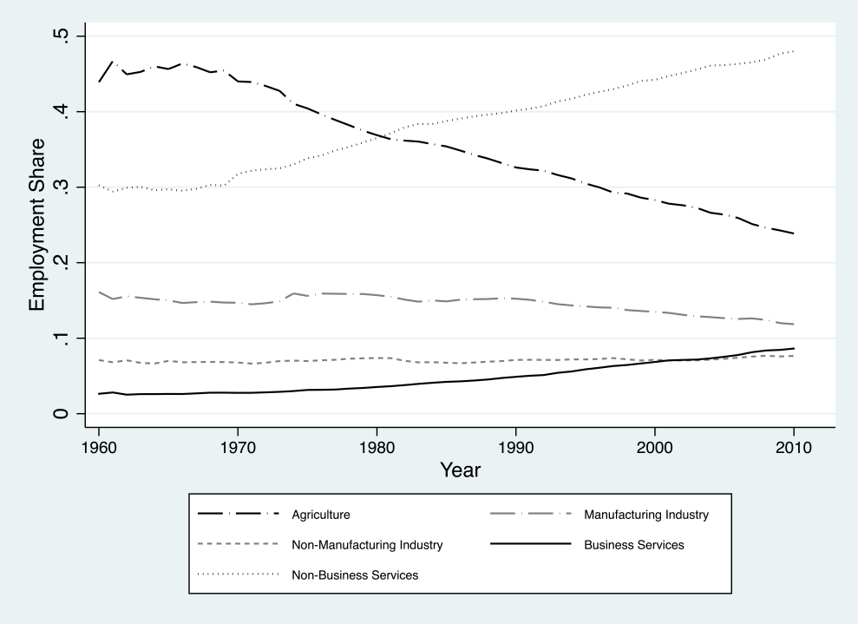

Note: Share of employment by sector in total employment.

Source: Author’s calculations based on GGDC data.

**Figure A2. Share of Employment by Major Sector, Structurally Developed Economies, using GGDC data**

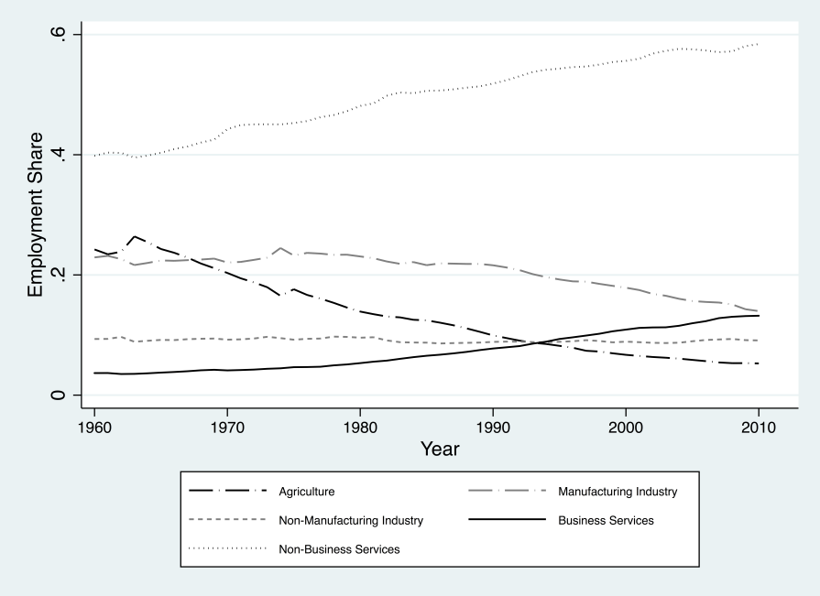

Note: Share of employment by sector in total employment.

Source: Author’s calculations based on GGDC data.

**Figure A3.** **Share of Employment by Major Sector, Structurally Developing Economies, using GGDC data**

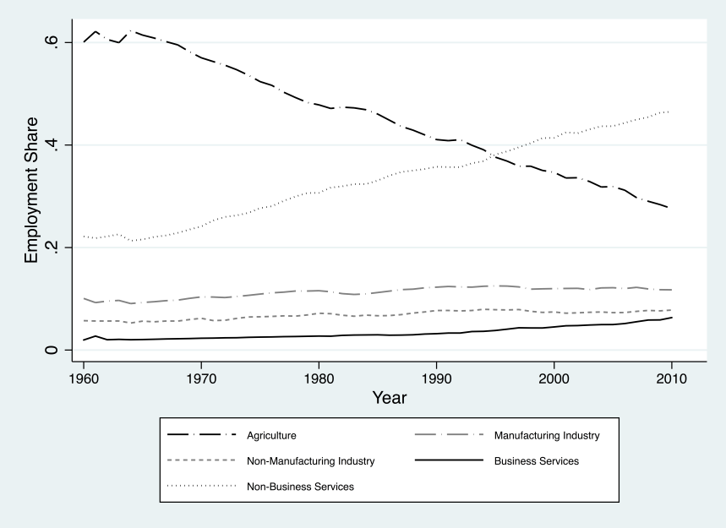

Note: Share of employment by sector in total employment.

Source: Author’s calculations based on GGDC data.

**Figure A4. Share of Employment by Major Sector, Structurally Underdeveloped Economies, using GGDC data**

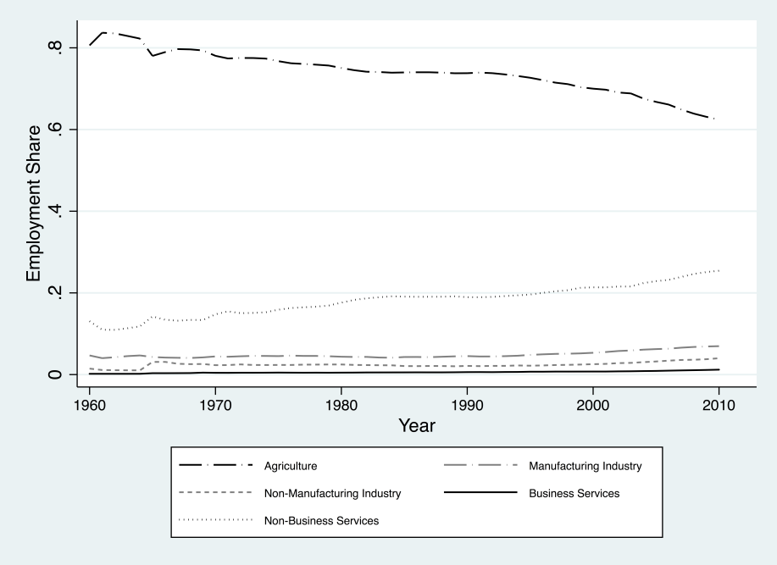

Note: Share of employment by sector in total employment.

Source: Author’s calculations based on GGDC data.

**Figure A5. Agricultural Employment Share by country over time, Structurally Underdeveloped Group**



**Source:** our calculations, based on ETD data.

**Figure A6. Agricultural Employment Share by country over time, Structurally Developing Group**



**Source:** our calculations, based on ETD data.

**Figure A7. Agricultural Employment Share by country over time, Structurally Developed Group**



**Source:** our calculations, based on ETD data.

**Figure A8. Manufacturing Employment Share by country over time, Structurally Underdeveloped Group**



**Source:** our calculations, based on ETD data.

**Figure A9. Manufacturing Employment Share by country over time, Structurally Developing Group**



**Source:** our calculations, based on ETD data.

**Figure A10.** **Manufacturing Employment Share by country over time, Structurally Developed Group**



**Source:** our calculations, based on ETD data.

**Figure A11. Business Services Employment Share by country over time, Structurally Underdeveloped Group**



**Source:** our calculations, based on ETD data.

**Figure A12.** **Business Services Employment Share by country over time, Structurally Developing Group**



**Source:** our calculations, based on ETD data.

**Figure A13.** **Business Services Employment Share by country over time, Structurally Developed Group**



**Source:** our calculations, based on ETD data.

**Figure A14.** **Non-Business Services Employment Share by country over time, Structurally Underdeveloped Group**



**Source:** our calculations, based on ETD data.

**Figure A15. Non- Business Services Employment Share by country over time, Structurally Developing Group**



**Source:** our calculations, based on ETD data.

**Figure A16. Non-Business Services Employment Share by country over time, Structurally Developed Group**



**Source:** our calculations, based on ETD data.

**Figure A17. The Inverted U shaped Relationship between Manufacturing Employment Share and GDP per capita using GGDC data for 1960-2010**



**Note:** GDP per capita is GDP per capita, in PPP constant US dollars.

**Source**: our calculations, using GGDC.

*Annexe A1: A Neoclassical Model of Structural Transformation*

Here, we describe a model of structural transformation that combines both the demand-side and supply-side explanations. The model is drawn from Duarte and Restuccia (DR, 2010). Our interest in proposing this benchmark neoclassical model of structural transformation here is that we will evaluate how well the model does in explaining the stylized facts of structural transformation that we observe in low- and middle-income countries (which we have set out in Section 4). This model has one key limitation – it is a model of the closed economy. However, an advantage of the model for our purpose is its analytical tractability and that it allows us to derive a straightforward reduced form specification for structural transformation, which makes it amenable to relatively simple numerical simulations (which we do in Section 5).

In the DR model, there are three sectors – agriculture (a), manufacturing (m), and services (s) – which are produced using constant returns-to-scale production functions. Sector-specific technology is given by Ai, where i is agriculture, manufacturing, and services.

The model assumes a continuum of homogenous firms in each sector that are competitive in goods and factor markets. The representative household is endowed with L units of labor, which is supplied inelastically to the market. The representative household consumes agricultural goods (ca) and a composite non-agricultural good comprising manufacturing (cm) and services goods (cs). The model assumes a closed economy and abstracts from intertemporal optimization (hence, the model is static and the problem of the household is effectively a sequence of static problems).

The per period utility is given by

(A1.1)

The subsistence level of agricultural goods below which the household cannot survive is given by ā > 0. The composite non-agricultural good (ct) is given by (A1.2)

Where $\overline{s}>0$, b is between 0 and 1, and ρ < 1. For $\overline{s}>0$, these preferences imply that the income elasticity of services is greater than one. Therefore, $\overline{s}$ works as a negative subsistence consumption level – when the income of the household is low, fewer resources are allocated to the production of services, and when the income of the household rises, resources are reallocated to services.

Both product and labor markets clear, so that La + Lm + Ls = L and ca = Ya, cm = Ym and cs = Ys.

The first order conditions for consumption imply that the optimal labor input in agriculture (La) is given by

(A1.3)

When a = 0, the household consumes $\overline{a}$ of agricultural goods each period, and labor allocation in agriculture depends on the level of labor productivity in that sector. As labor productivity in agriculture increases, labor moves away from the agricultural sector.

The first order conditions for consumption of manufacturing and service goods imply that

where(A1.4)



This equation reflects the two forces that drive labor reallocation between manufacturing and services in the model. The technological explanation will stress the role of differential productivity growth in explaining structural transformation. This is evident if we assume homothetic preferences (that is, $\overline{s}$ = 0). In this case Lm/Ls = 1/x and differential productivity growth in manufacturing relative to services is the only source of labor reallocation between these sectors as long as ρ is not equal to zero. In particular, when $\overline{s}$ = 0, the model can be consistent with the observed reallocation of labor from manufacturing to services as labor productivity grows in manufacturing relative to services and as long as the elasticity of substitution between manufacturing and services is low. The second explanation is the utility-based explanation, which is evident if $\overline{s}$ > 0 (that is, preferences are nonhomothetic) and labor productivity grows at the same rate in manufacturing and services, or ρ=0, so that x is constant. Here, for a given La there is a reallocation of labor from manufacturing to services as the latter is more income elastic than the former, per Engel effects.

DR evaluate the fit of their model in reproducing the salient features of structural transformation using sectoral data on hours worked in agriculture, industry and services mostly drawn from high-income and middle-income countries. The model replicates well the patterns of allocation of hours across sectors for these countries.[1] However, an important question that remains is whether the DR model can replicate the pattern of structural transformation for low-income countries, as well as a larger set of middle-income countries from that in the original DR sample. We address this question next. **[2]**

The DR model has the following parameters: a, $\overline{a}$, $\overline{s}$, b, and ρ. In addition, to generate the values for labor allocation in agriculture, manufacturing, and services requires the actual productivity levels from 1990 to 2018 in agriculture, manufacturing, and services.

Duarte and Restuccia (2010) first calibrate their model to US data for the period 1956–2004. Their calibration strategy involves selecting parameter values so that the equilibrium of the model matches the salient features of structural transformation for the US economy from 1956 to 2004. The parameter a is the share of employment in agriculture in the initial year, the parameter $\overline{a}$ is the share of employment in agriculture in the terminal year, the parameter $\overline{s}$ is the share of employment in manufacturing in the terminal year, and b is the average share of employment in manufacturing for the period under consideration; all of these parameters are for the US. Duarte and Restuccia (2010) then use this parameter model to simulate shares of employment in agriculture, manufacturing, and services for individual economies using actual sectoral productivity data for these economies. They find that their model “reproduces the salient features of structural transformation and aggregate productivity across economies” (Duarte and Restuccia, 2010: 150). The model replicates basic trends in the agricultural employment share for all economies, though it underpredicts the share of employment in services and overpredicts the share of employment in manufacturing in less-developed economies.

A limitation of Duarte and Restuccia (2010)’s analysis is that their sample does not include any low-income economies, with the economies in their sample being either high- or middle- income economies. Moreover, they do not differentiate between business and non-business services, when these two service sub-sectors have very different profiles of productivity (as we have observed in Section 6.1).

To see whether the DR model can predict the patterns of structural transformation that we observed in Section 4, we simulate with the sample of fifty-one economies for the period 1990–2018. We do it by structural transformation country group to take into account the fact that countries at different stages of structural transformation show very different patterns. Table 12 in the Element shows four simulations for each economy group. In the first scenario, we use the same parameter values as in the DR calibration exercise and include business and non-business services in one all-inclusive services sector. In the second scenario, we group business services with manufacturing as one sector; as we have already noted in Section 4, the business services sector has a similar productivity profile as the manufacturing sector, and parts of business services also have similar properties as manufacturing in terms of externalities and tradability, among others (see, for example, Amirapu and Subramanian, 2015). The third and fourth scenarios relax the stringent assumption in DR of the US being the benchmark economy for the calibrations. This is important as several economies are quite far from the US in terms of their structural features. The third and fourth scenarios uses parameter values that correspond to the average in a particular structural transformation country group for the initial and terminal years. The difference between the two scenarios is that Scenario 3 groups business and non-business services as one services sector, while Scenario 4 groups manufacturing and business services as one sector and non-business services as another sector.[3]

Figures A18, A19, and A20 provide the simulations and actual shares of agriculture, manufacturing, and services for structurally developed, developing, and underdeveloped economies for Scenario 1, respectively. Figures A21, A22, and A23 provide the simulations and actual shares of agriculture, manufacturing, and services for structurally developed, developing, and underdeveloped economies for Scenario 2, respectively. Figures A24, A25, and A26 provide the simulations and actual shares of agriculture, manufacturing, and services for structurally developed, developing, and underdeveloped economies for Scenario 3, respectively. Figures A27, A28, and A29 provide the simulations and actual shares of agriculture, manufacturing, and services for structurally developed, developing, and underdeveloped economies for Scenario 4, respectively.

Across all four scenarios, the Duarte and Restuccia model predicts actual employment shares in agriculture, manufacturing, and services in structurally developed economies well, as may be expected. However, there are systematic errors in prediction across all four scenarios for structurally developing and underdeveloped economies (Table 13 in the Element). The Duarte and Restuccia model overpredicts the share of employment in manufacturing, particularly for structurally underdeveloped and developing economies, in Scenarios 1 and 2. For example, the percentage difference between the actual employment share in manufacturing and its predicted share is 65 per cent for structurally developing economies and 75 per cent for structurally underdeveloped economies. In contrast, the difference is 29 per cent for structurally developed economies.

Across all four scenarios, there are clear differences in how the model does in explaining actual employment shares, especially for structurally developing and underdeveloped economies. For example, for structurally underdeveloped economies, the model overpredicts the services employment share by 91 per cent and 134 per cent for Scenarios 1 and 2, respectively. For Scenarios 3 and 4, the model underpredicts the services employment share by 93 per cent and 96 per cent, respectively. This suggests that the Duarte and Restuccia model can provide a realistic explanation of structural transformation for rich economies but not for poor economies. While more realistic versions of the model may be able to generate simulations that are closer to the actual employment shares for low income countries, one reason for the low predictive power of the DR model could be the assumption of a closed economy, which, as we have already noted in Section 2, is a limitation of the model.[4] More realistic models of structural transformation that bring in open economy features along the lines of Rodrik (2016) and Matsuyama (2009) is clearly needed in the literature.

**Figure A18. Scenario 1, Structurally Underdeveloped Economies**

**Source**: Author’s calculations based on ETD data.

**Figure A19. Scenario 1, Structurally Developing Economies**

**Source**: Author’s calculations based on ETD data.

**Figure A20. Scenario 1, Structurally Developed Economies**

**Source**: Author’s calculations based on ETD data.

**Figure A21. Scenario 2, Structurally Underdeveloped Economies**

**Source**: Author’s calculations based on ETD data.

**Figure A22. Scenario 2, Structurally Developing Economies**

**Source**: Author’s calculations based on ETD data.

**Figure A23. Scenario 2, Structurally Developed Economies**

**Source**: Author’s calculations based on GGDC data.

**Figure A24. Scenario 3, Structurally Underdeveloped Economies**

**Source**: Author’s calculations based on ETD data.

**Figure A25. Scenario 3, Structurally Developing Economies**

**Source**: Author’s calculations based on ETD data.

**Figure A26. Scenario 3, Structurally Developed Economies**

**Source**: Author’s calculations based on ETD data.

**Figure A27. Scenario 4, Structurally Underdeveloped Economies**

**Source**: Author’s calculations based on ETD data.

**Figure A28. Scenario 4, Structurally Developing Economies**

**Source**: Author’s calculations based on ETD data.

**Figure A29. Scenario 4, Structurally Developed Economies**

**Source**: Author’s calculations based on ETD data.

1. The countries in the DR sample outside North America, Australia, New Zealand, and Western Europe which are from middle income countries are mostly from Latin America along with Korea, Japan, and Turkey (DR obtain this data from the GGDC 10 sector data-base, which we describe in greater detail in Section 3).
2. This section draws from Sen (2019b). The analysis presented in this paper has been updated using ETD data.
3. While Duarte and Restuccia (2010) include non-manufacturing industry with manufacturing as one sector, we take the level of employment in non-manufacturing industry as exogenously given in my simulations. This is done for two reasons: (i) the share of employment in mining, which is one important sub-sector in non-manufacturing industry, is not a function of productivity or income elasticities, and depends on whether the economy has mining resources; and (ii) both utilities and construction, the other sub-sectors in non-manufacturing industry, are very different in their properties from the manufacturing sector.
4. The failure of traditional neoclassical models to explain structural change has also been noted by Buera and Kaboski (2009).