Questions/Exercises for ‘Atmospheric Dynamics’ by Mankin Mak.

Introductory remarks
This set of problems/exercises is related to the book ‘Atmospheric Dynamics’ by Mankin Mak accessible through the website of the Cambridge University Press (www.cambridge.org/mak). It is intended to help readers get a better feel for the materials. Neatly posed challenging problems in atmospheric dynamics are not easy to come by. I plan to update this set periodically and even hope to include some contributions from readers so that it would become a broad depository of interesting problems. To this end, I welcome anyone to send me problem(s) of atmospheric dynamics with answer(s) by email (mak@atmos.uiuc.edu). The appropriate ones would be added to the collection with acknowledgment of the source(s).

Chapter 1

1.1 Let the x and y axes stand for two interstate highways in orthogonal directions. The intersection is the origin of the coordinates with the x-axis pointing east. A car travels eastward at a speed $U=\text{20}{\text{ms}}^{−1}$ and is located at $x=x_{o}=−2\text{.}2\text{km}$ at $t=0$. Suppose there is another observer sitting on a rotating platform at the intersection. The rotation rate of the platform is one revolution per minute in counterclockwise direction. The rotating coordinates $\left(x^{'},y^{'}\right)$ coincide with the stationary coordinates $\left(x,y\right)$ at $t=0$ .
(a) Deduce analytically and plot the trajectory of the car as seen by the observer on the rotating platform. How would he describe what he sees?
(Clues: The rotation rate of the platform is much faster than the earth’s rotation which may be reasonably neglected.)
(b) What is the Coriolis force acting on the car from the observer’s perspective when it passes under the highway intersection?
(c) Determine the formula for the kinetic energy of the car from this observer’s perspective.
(d) How would this observer interpret his result of the energy of the car?

1.2 Calculate the gravitational force on an air parcel with mass $m=1\text{kg}$ at an elevation $h=\text{10}\text{km}$ and latitude $ϕ={\text{45}}^{∘}N$ towards the center of mass of the solid earth. Also calculate the centrifugal force associated with the rotation of the earth. Compare their magnitudes and directions. Determine the net force on this air parcel.
Data: Mass of earth $M=5\text{.}\text{97}×{\text{10}}^{\text{24}}\text{kg}$, radius of the equivalent spherical earth$R=\text{6370}\text{km}$, gravitational constant $G=6\text{.}\text{67}×{\text{10}}^{−\text{11}}m^{3}{\text{kg}}^{−1}s^{−2}$.

1.3 Suppose a circumpolar ring of air parcels at latitude $ϕ=\text{45}°$ are moving eastward at a speed of $U$=100 m/s relative to the surface. Further, suppose the atmospheric pressure at that moment varies only in the local vertical direction and the corresponding pressure gradient force acting on the air parcels balances the “gravity”. $Ω=7\text{.}\text{29}x{\text{10}}^{−5}s^{−1}$. Do the following:
(a) Determine the net force acting on such air parcel. Draw a sketch of this force on a local y-z plane where y is the meridional axis and z is the vertical axis.
(b) Where would be the approximate location of the circumpolar ring of air parcels after 100 s?

1.4 Determine the change of entropy when $m=1\text{kg}$ of ice is melted. The latent heat of melting is $L_{m}=3\text{.}\text{35}×{\text{10}}^{5}{\text{Jkg}}^{−1}$. The melting temperature is $T=\text{273}K$.

1.5 Use $T_{o}=\text{273}K$ as the vertical mean temperature in the troposphere and approximate the troposphere as an isothermal atmosphere. What is the corresponding value of Brunt-Vaisala frequency $N$ ? $g=9\text{.}8{\text{ms}}^{−2}$, $c_{p}=\text{1004}{\text{JK}}^{−1}{\text{kg}}^{−1}$. Compare your value with the observed typically value of $N$.

Chapter 2

2.1 Suppose an airplane flies eastward at a constant speed $V$ along the following trajectory
$z\left(x\right)=H+h\text{sin}\left(\frac{2πx}{L}\right)$
where $H,h$ and $L$ are constants. A passenger in this airplane pays a lot of money in order to experience the sensation of “zero gravity”. At which points of the flight path would zero gravity be most easily achieved? For $h=\text{500}m$ and $V=\text{400}{\text{ms}}^{−1}$, what value of $L$ would produce zero gravity sensation for a passenger?

2.2 Suppose a streamline pattern is identical to a pressure pattern as indicated below. This flow occurs in the northern hemisphere. The locations of minimum and maximum pressure are indicated by$L$ and $H$. Deduce whether the velocity is faster than, equal to or slower than the geostrophic velocity at the points A, B and C. Given a reason for each of your answers.

2.3 Consider the background density decreases exponentially with elevation $ρ_{o}=ρ_{\text{oo}}e^{{−z}/H}$and is in hydrostatic equilibrium with the background pressure. What is the corresponding Brunt-Vaisala frequency defined as $N=\sqrt{\frac{g}{θ_{o}}\frac{{dθ}_{o}}{\text{dz}}}$ ?

2.4 Suppose a layer ($z_{1}≤z≤z_{2}$) of an isothermal atmosphere ($T=T_{o}$) in hydrostatic balance with a horizontally uniform surface pressure $p_{o}$ absorbs an amount of heat $Q$ say via radiative processes. For simplicity, let us assume no mixing of air across the upper and lower surfaces of this layer during this process and the layer remains in hydrostatic balance. Answer the following:
(a) What would most likely happen to this layer?
(b) Does the pressure at $z_{1}$ increase or decrease afterward?
(c) Does the pressure at $z_{2}$ increase or decrease afterward?
(d) Make estimates of the new elevations of the upper and lower boundaries of this layer.
Data: $T_{o}=\text{273}K$, $p_{o}={\text{10}}^{5}\text{Pa}$, $z_{1}={\text{10}}^{3}m$, $z_{2}=2×{\text{10}}^{3}m$, $Q={\text{10}}^{6}J$,$R=\text{287}{\text{JK}}^{−1}{\text{kg}}^{−1}$,
$c_{v}=\text{717}{\text{JK}}^{−1}{\text{kg}}^{−1}$, $c_{p}=\text{1004}{\text{JK}}^{−1}{\text{kg}}^{−1}$

2.5 Suppose the surface pressure is 1005 mb and the surface temperature is$\text{30}°C$. A weather balloon reports that its elevation is 1980 m when it crosses the 800 mb pressure level. Determine the temperature at 800 mb on the basis of hydrostatic balance. (R=287$m^{2}s^{−2}K^{−1}$; assume linear variation of temperature between 800 mb and surface)

2.6 Suppose the surface pressure is 1000 mb. The wind between surface and 600 mb has a convergence of $1x{\text{10}}^{−6}$ $s^{−1}$ and the wind between 600 mb and the tropopause at 300 mb has a divergence of $2x{\text{10}}^{−6}$ $s^{−1}$. What would the surface pressure be 24 hours later ?

2.7 Suppose that the lapse rate $\left(−\frac{∂T}{∂z}\right)$ at the 850-mb level is 4 K/km, the wind is westerly at 10 m/s, and the temperature at this level decreases toward the west at a rate of 5 K/100 km. The temperature at a location on this level decreases at a rate of 2 K/hour. Compute the vertical velocity at the 850 mb level using the adiabatic method.

2.8 Suppose the center of a large-scale circular shallow surface low pressure disturbance has moved to a point half way between Urbana, Illinois and New York, NY. Further, suppose the layer average temperature from surface to 700 mb increases linearly in the zonal direction from the Midwest to the east coast. Qualitatively deduce the wind over Urbana and over New York at 700 mb. State your reasoning. Sketch the 700 mb wind field over the eastern half of the U.S.

2.9 Suppose the streamfunction of a wind field (i.e. horizontal flow) at an instant is
$ψ=\text{sin}\left(x\right)\text{cos}\left(y\right)$
A plot of $ψ$ in a nondimensional domain $0<x<2π$ , $0<y<2π$ is given below.
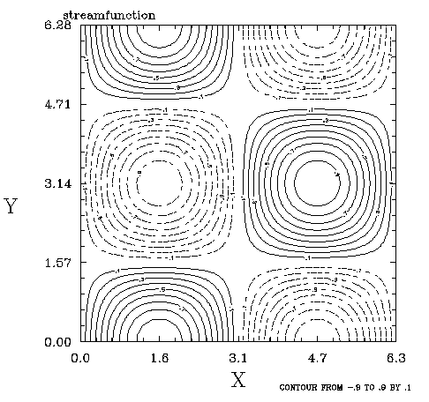
Also suppose the wind is related to the streamfunction as $\vec{V}=\vec{k}×∇ψ$;
where the unit vectors are $\vec{i},\vec{j},\vec{k}$ with $\vec{i}×\vec{j}=\vec{k}$, $\vec{j}×\vec{k}=\vec{i}$, $\vec{k}×\vec{i}=\vec{j}$. (unit of Distance = 1000 km, unit of velocity =10 ${\text{ms}}^{−1}$, unit of time = ${\text{10}}^{5}s$)
- Determine the wind at the point $\left(x,y\right)=\left(0\text{.}8,2\text{.}8\right)$. Draw this wind on the $ψ$ diagram. Comment on your result.
- Determine the distributions of divergence, vorticity, shearing deformation and stretching deformation of this wind field.
- Make a sketch of each of them. Comment on your results with respect to the structure of the $ψ$ field.
- Where do we find maximum stretching deformation? How would a fluid parcel at that point be deformed?

2.10 Suppose the surface pressure at Urbana is 1000 mb. Four weather stations located at 500 km to the east, south, west and north of Urbana are referred to as E, S, W and N. The average wind in the 500-1000 mb layer over E,S,W and N is (direction, speed)= $\left(\text{60}°,\text{10}{\text{ms}}^{−1}\right)$ , $\left(\text{90}°,\text{12}{\text{ms}}^{−1}\right)$ , $\left(\text{110}°,8{\text{ms}}^{−1}\right)$ and $\left(\text{150}°,6{\text{ms}}^{−1}\right)$ respectively. The wind direction is measured in clockwise direction from the south. Suppose the average winds of the 0-500 mb layer over E, S, W and N have the same corresponding speeds as in the 500-1000 mb layer, but each veers by $\text{30}°$ (i.e. $\text{30}°$ further in the clockwise direction). How much would the surface pressure at Urbana change in 24 hours under such wind condition in unit of mb?

2.11 The actual wind is directed $\text{30}°$ to the right of the geostrophic wind. If the geostrophic wind is $\text{25}{\text{ms}}^{−1}$, what is the rate of change of wind speed? $f={\text{10}}^{−4}s^{−1}$.

2.12 The visible part of a rotating supercell extends below the base of a much larger cumulonimbus (Cb) and is often called “wall-cloud”. Suppose the base of the Cb is 2 km high. The wall-cloud has a radius of 1 km, extends 400 m below the base of the Cb and has an angular velocity of $2\text{.}x{\text{10}}^{−2}s^{−1}$. Suppose a tornado develops in mid-latitude as a result of the air in the wall-cloud transforming to a cylindrical funnel that touches the ground. For simplicity, assume that there is no mass flux through the base of the Cb or through the side and bottom of the wall-cloud. For further simplicity, also assume that the density of air below the cloud base is uniform and friction is negligible.
What is the maximum wind of this tornado in ${\text{ms}}^{−1}$?

2.13 Suppose a vertical atmospheric column is initially isothermal from 900 to 500 mb. Suppose the wind is geostrophic being $\text{10}{\text{ms}}^{−1}$ from the south at 900 mb, $\text{10}{\text{ms}}^{−1}$ from the west at 700 mb, and $\text{20}{\text{ms}}^{−1}$ from the west at 500 mb.
(a) Compute the rate of advective temperature change in each layer.
(b) How long would this advection pattern have to persist in order to establish a dry adiabatic lapse rate between 600 and 800 mb?

2.14 The 1000-500 mb thickness is predicted to increase from 5280 m to 5460 m at a given location. Assuming that the lapse rate remains constant, what change in surface temperature would you predict?

2.15 Transform the primitive equations in isobaric coordinate as given in (2.15) to a log-pressure vertical coordinate, $ξ=H\text{ln}\left(\frac{p_{s}}{p}\right)$. The inverse relation is $p=p_{s}\text{exp}\left(−\frac{ξ}{H}\right)$ implying that $ξ$ is simply the physical height if pressure decreases exponentially with elevation. For this reason, this vertical coordinate is commonly used in analyses of stratospheric circulation.

2.16 The earth’s surface is neither a constant pressure surface nor a constant height surface. Suppose you know the elevation $h\left(x\right)$, pressure $p_{s}\left(x\right)$ and temperature $T_{s}\left(x\right)$ of the surface stations on a line in the zonal direction. The task is to determine approximate values of the north-south component of the geostrophic wind at surface locations on that line in terms of $h\left(x\right)$, $p_{s}\left(x\right)$ and $T_{s}\left(x\right)$. Introduce any reasonable assumption that you might need to complete this task.
Chapter 3

3.1 Consider a large cylindrical tank of water at Melbourne, Australia. There is a hole at the bottom in the center, through which water leeks out. The radius of the tank is $R$
What are the characteristics of the flow in the tank ?
(b) Derive the configuration of the free surface of the water at a time when the depth of water at the outer rim of the cylinder is $H$. Assume that the tank is large and water is inviscid.
(c) What is the depth of water at the half-radius of the tank at this time?

3.2 Suppose the velocity of a flow is $\vec{V}=\left(u,v,w\right)$ . The distributions of the velocity components in Cartesian coordinates are:
$u=A\text{sin}\frac{x}{L}\text{cos}\frac{y}{L}\text{cos}\frac{z}{H}$, $v=B\text{cos}\frac{x}{L}\text{sin}\frac{y}{L}\text{cos}\frac{z}{H}$, $w=C\text{cos}\frac{x}{L}\text{cos}\frac{y}{L}\text{sin}\frac{z}{H}$.
where $A,B,C,L,H$ are constants. Verify that this general velocity vector and the vorticity vector are orthogonal to one another.

3.3 The tangential velocity of a cyclonic vortex in cyclostrophic balance has a profile, $V=V_{o}{\left(r/{r_{o}}\right)}^{n}$ where $V_{o},r,n$ are constants and $r$is radius.
What is the average vorticity of the fluid within a radius $r=r_{1}$ ?

3.4 Suppose the velocity field, $\vec{V}=\left(u,v,w\right)$, in Cartesian coordinates is $u=A\text{sin}\left(\frac{x}{a}\right)\text{sin}\left(\frac{y}{a}\right)\text{cos}\left(\frac{z−b}{b}\right)$, $v=A\text{cos}\left(\frac{x}{a}\right)\text{cos}\left(\frac{y}{a}\right)\text{cos}\left(\frac{z−b}{b}\right)$ , $w=B\text{cos}\left(\frac{x}{a}\right)\text{sin}\left(\frac{y}{a}\right)\text{sin}\left(\frac{z−b}{b}\right)$.
(a) Determine the vorticity field of this flow.
(b) Determine the circulation of this flow for the closed curve defined by the square in the following sketch at an elevation $z=b$

y
$aπ$

$0$ $aπ$ x

3.5 Suppose there is a low level jet centered over station U at 900 mb. It is a Gaussian jet oriented in a direction perpendicular to axis $x^{'}$ as shown in the sketch, $v^{'}=G\text{exp}\left(−{\left(x^{'}\right)}^{2}\right)$, with $G=\text{10}{\text{ms}}^{−1}$ . Distance is measured in unit of $a=2×{\text{10}}^{5}m$. The coordinates of the points ABCD of a rectangular area are: A(x,y)=(0,-1),
B=(1,-1), C=(1,1), D=(0,1). The wind is geostrophic. The angle between the $x$ and $x^{'}$ axes is $φ=\text{60}°$.
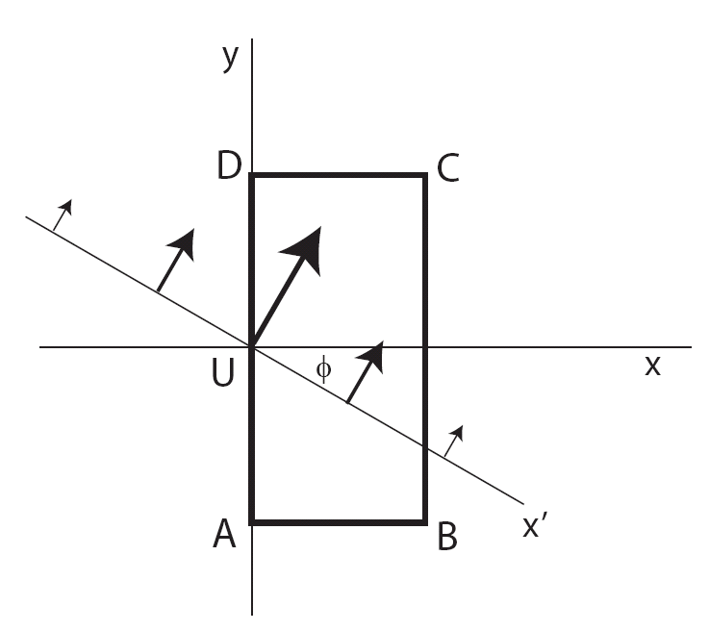

(a) Label the locations of minimum pressure and maximum pressure on this figure. Explain the reasoning behind whatever you do.
(b) Determine the circulation of this flow for the closed curve ABCD.
(c) Determine the average vorticity of the flow in the area ABCD.

3.6 Suppose a uniform westerly at latitude $\text{45}°$ flows toward a north-south oriented mountain barrier. In the upstream region, the pressure at the bottom and top of an air column between two isentropic surfaces is 900 mb and 600 mb respectively. When the air column reaches the top of the mountain, it has been deflected by $5°$ latitude to the south and the pressures at those two isentropic surfaces are 850 mb and 560 mb respectively. What would its relative vorticity be at the top of the mountain?

3.7 The horizontal momentum equations in isobaric coordinates are
$$u_{t}+{\text{uu}}_{x}+{\text{vu}}_{y}+{ωu}_{p}=−Φ_{x}+\text{fv}+\tilde{K}u_{\text{pp}}$$
$$v_{t}+{\text{uv}}_{x}+{\text{vv}}_{y}+{ωv}_{p}=−Φ_{y}−\text{fu}+\tilde{K}v_{\text{pp}}$$
Standard notations are used above.
(a) Derive the equation that governs the rate of change of the horizontal divergence in time. That is called “divergence equation”. Separate the terms into appropriate groups on the basis of their physical meaning as we did in class with the “vorticity equation”.
(b) Simplify the divergence equation for synoptic scale disturbances by applying a scale analysis. Use $\tilde{K}≤{\text{10}}^{−3}{\left(\text{Pa}\right)}^{2}s^{−1}$
What would be the maximally simplified form of the divergence equation ?
(c) What would be a more general form of the divergence equation if you include not only the largest terms, but also the terms that are one order of magnitude smaller ?

3.8 Suppose the distributions of temperature and pressure on a vertical plane $\left(x,z\right)$ near the surface are
$T=T_{\text{oo}}+a_{1}x−a_{2}z$
$p=p_{\text{oo}}−b_{1}x−b_{2}z$
where $a_{1},a_{2},b_{1},b_{2},T_{\text{oo}}$ and $p_{\text{oo}}$ are constants.
(a) Obtain the expression for the rate of change of the circulation for a closed rectangular contour ABCD due to the baroclinic effect. The positions of the corners ABCD are $\left(−x_{o},0\right)$, $\left(x_{o},0\right)$, $\left(x_{o},z_{o}\right)$, and $\left(−x_{o},−z_{o}\right)$.
(b) If this rate of change of circulation persists for 1 hour, what would be the change of average speed of the flow on this contour?
(c) What must be the value of $b_{1}$ be if there is to be no change in the circulation of any closed contour on the $\left(x,z\right)$ plane due to the distributions of $T$ and $p$ described above?
Given data: $a_{1}=2×{\text{10}}^{−4}{\text{Km}}^{=1}$, $a_{2}=3×{\text{10}}^{−3}{\text{Km}}^{=1}$, $b_{1}=1×{\text{10}}^{−4}{\text{mbm}}^{−1}$, $b_{2}=0\text{.}1$ ${\text{mb}}/m$, $T_{\text{oo}}=\text{300}K$, $p_{\text{oo}}=\text{1000}\text{mb}$, $x_{o}=\text{20}×{\text{10}}^{2}m$, $z_{o}={\text{10}}^{3}m$, $R=\text{287}{\text{JK}}^{−1}{\text{kg}}^{−1}$

3.9 Suppose the atmosphere in a coastal region is calm (no wind) at sunrise, t=0. Consider the sea-breeze on a vertical plane perpendicular to the coast along a closed curve such as ABCD. For simplicity, we neglect the effect of earth’s rotation and the frictional damping of the circulation per se.
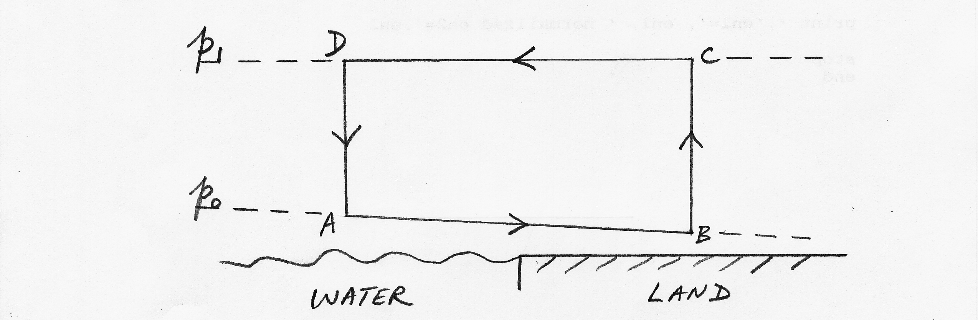
Let $T_{\text{BC}}$ be the average temperature over land in the layer between B and C and $T_{\text{AD}}$ be the counterpart over water between A and D. The water is warmer than the land at sunrise. Therefore, suppose $T_{\text{BC}}$ and $T_{\text{AD}}$ both vary sinusoidally in time as follows
$T_{\text{BC}}=T_{}+a\text{sin}\left(\frac{2πt}{τ}\right)$ ; $T_{\text{AD}}=T_{}+b\text{sin}\left(\frac{2π\left(t+t_{o}\right)}{τ}\right)$
Consider $τ=\text{24}\text{hours}$, $t_{o}=2\text{hours}$, $T_{}=\text{290}K$, $a=6K$, $b=2K$, $p_{o}=\text{980}\text{mb}$, $p_{1}=\text{920}\text{mb}$, $R=\text{287}{\text{Jkg}}^{−1}K^{−1}$.
What is the average velocity of the sea-breeze along ABCD in ${\text{ms}}^{−1}$ at noon if AB is 30 km and BC is 0.8 km?

3.10 (a) How far a zonal band of air initially at rest with respect to the earth’s surface at $\text{60}°$ latitude and 100-km height must be displaced latitudinally in order to acquire an easterly flow (east to west) of 12 m/s with respect to the earth’s surface ? Neglect friction. (earth’s radius=6370 km)
(b) To what height must it be displaced vertically in order to acquire an easterly flow of 12 m/s with respect to the earth’s surface?

3.11 A hurricane moves from $8°N$ to $\text{12}°N$ . A horizontal ring of air inside the hurricane with a radius 150 km shrinks to a radius of 100 km during this movement without any external influence. If the tangential velocity of this ring of air is initially $\text{30}{\text{ms}}^{−1}$, what is its tangential velocity at the new location? ($Ω=7\text{.}3x{\text{10}}^{−5}s^{−1}$)

3.12 A flow in a QG shallow-water model on a beta-plane is governed by the PV eq.
$\left(\frac{∂}{∂t}+u\frac{∂}{∂x}+v\frac{∂}{∂y}\right)q=0$
where $u=−ψ_{y}$, $v=ψ_{x}$, $q=ψ_{\text{xx}}+ψ_{\text{yy}}+f_{o}+βy−λ^{2}ψ$, $f_{o},β$ and $λ$ are constants.
Consider a perturbation embedded in a basic flow $\left(\bar{u},\bar{v}\right)=\left(U,V\right)$= constant.
(a) Derive the appropriate governing equation for a perturbation in this case
(b) Obtain the solution for the perturbation and its dispersion relation
(c) Make a sketch of such Rossby wave that propagates in the direction of north-by-northwest ($\text{22}\text{.}5°$ counter-clockwise from the north) in the absence of a basic flow $\bar{u}=\bar{v}=0$. Show in your sketch the structure of this wave where its phase function has values between $−π$ and $π$. Indicate with appropriate symbols the pressure distribution, velocity distribution, phase velocity and group velocity of this wave.

3.13 The zonal-average westerly jet stream in winter at z=10 km over $\text{35}°N$ is 40 ${\text{ms}}^{−1}$. What is the corresponding relative vorticity at this level averaged over the polar region north of $\text{35}°N$ ? Radius of earth=6370 km

3.14 Drivers on the highways of Arizona commonly encounter small rotating columnar vortices (known as dust devils) in summer afternoons. Consider such a dust devil with a radius of 2 $m$ and a tangential velocity 20 ${\text{ms}}^{−1}$ at the outer edge. The central surface pressure is 995 mb and the temperature is equal to 35 $°C$. Gas constant is $\text{287}m^{2}s^{−2}K^{−1}$. Neglect the frictional effect and the variation of surface density within the dust devil.
- Obtain the formula for the surface pressure in this dust devil.
- What is the environmental pressure at the edge of the devil?
- Dust devils are primarily produced by strong solar heating at the surface. Suppose such heating gives rise to a localized average horizontal divergence of $6×{\text{10}}^{−5}s^{−1}$ in a layer of 20 $m$ thick leading to a drop of surface pressure hydrostatically. If the density of air is decreased to $1{\text{kg}}/{m^{3}}$ by the heating, how long would it take for this dust devil of 20 $m$ tall to form?

3.15 Derive the PV equation for a shallow-water model with a bottom surface $η_{B}\left(x,y\right)$ The three unknowns are $u,v,η$ where is the height of the free surface. The momentum equations and the mass continuity equation are then
$$u_{t}+{\text{uu}}_{x}+{\text{vu}}_{y}=−{gη}_{x}+\text{fv}$$
$$v_{t}+{\text{uv}}_{x}+{\text{vv}}_{y}=−{gη}_{y}−\text{fu}$$
$$η_{t}+{\left(u\left(η−η_{B}\right)\right)}_{x}+{\left(v\left(η−η_{B}\right)\right)}_{y}=0$$

3.16 (a) Derive the equations that govern the rate of change of the horizontal components of the relative vorticity vector on a local Cartesian coordinate.
(b) Give a physical interpretation to each of the terms appearing in the equations.
(c) How much simplification can you justifiably introduce into these equations for synoptic scale flow in the atmosphere?

Chapter 4

4.1 The following sketch shows the contours of a 900-mb height field $Z$ in the Northern Hemisphere with $a>A>0$.

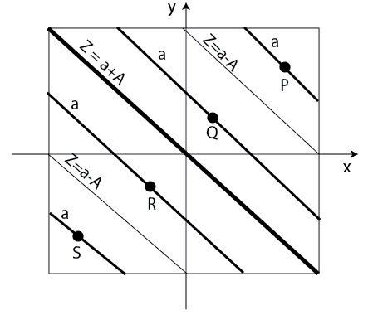

(a) Draw the geostrophic wind vectors at P, Q , R and S in the sketch.
(b) There is an Ekman layer below the geostrophic wind field everywhere. Sketch the hodographs of the wind in the Ekman layer at P, Q, R S. Indicate the reasoning behind your sketches (no need to refer to any equation).
(c) Deduce the regions where you would expect ascending motion at the top of the Ekman layer in the domain under consideration (no need to use any equation). Briefly state the reasoning that underlies your conclusion.

4.2 Consider an infinitely deep ocean whose surface is subjected to a horizontal stress due to the wind $\left(τ_{\left(x\right)},τ_{\left(y\right)}\right)$ . For simplicity, assume that there is no geostrophic current in this ocean model. Use appropriate assumptions pertaining to an Ekman layer to determine
(a) the angle between the wind stress and the surface ocean current,
(b) the angle between the wind stress and the vertically integrated ocean current.

4.3 A homogeneous barotropic atmosphere of depth 10 km has a zonally symmetric geostrophic jet, which has a profile given by the expression
$u_{g}=U\text{exp}\left(−{\left(\frac{y}{L}\right)}^{2}\right)$
where $U=\text{50}{\text{ms}}^{−1}$ and $L=\text{500}\text{km}$ and the Coriolis parameter is $f={\text{10}}^{−4}s^{−1}$. The eddy viscosity in the Ekman layer over a surface is $K=\text{10}m^{2}s^{−1}$. Assume that the vertical velocity at the top and surface of this atmosphere vanish.
(a) Derive the vertical velocity at the top of the Ekman layer $\left(z=D_{e}=π/γ\right)$ produced by convergence in the Ekman layer.
(b) Derive the expression for the secondary cross-stream motion forced in the interior of the atmosphere.
(c) If the change in zonally averaged momentum is due entirely to the cross-stream flow, compute the spin-down time for the zonal jet.
(d) Sketch $w$ and $v$ on a $y−z$ plane. Indicate the maximum $w$ and $v$ location relative to the jet. Explain the physical mechanism which spins down the zonal jet.

4.4 Suppose an approximate horizontal momentum equation in the lower layer of an atmosphere can written as
$\frac{∂\bar{u}}{∂t}=−\frac{∂}{∂z}\overline{u^{'}w^{'}}$
where the overbar denotes area average, the prime denotes the deviation from the mean, $u$and $w$ are horizontal and vertical wind respectively. Other symbols have standard meanings.
(a) When $\bar{u}$ increases with height, is the correlation $\overline{u^{'}w^{'}}$ more likely to have a negative or positive value?
(b) Derive the energy equation for the area mean flow and discuss the physical meaning of the equation.
(c) Observations in a stationary boundary layer indicate that:
(i) $−\overline{u^{'}w^{'}}$ is proportional to $∂{\bar{u}}/∂z$ , with $−\overline{u^{'}w^{'}}=K∂{\bar{u}}/∂z$ ,
(ii) $K$ is a linear function of $z$ .
Determine the distribution of $\bar{u}$ as a function of $z$ satisfying the observations (i) and (ii).

Chapter 5
5.1 Consider a prototype 2-D internal gravity wave that has a horizontal wavelength longer than its vertical wavelength. Determine whether the propagation of its energy is faster or slower than the propagation of its wavefront.

5.2 To get a feel for the dependence of the phase velocity and group velocity of the prototype internal gravity waves in general on its horizontal and vertical wavelengths, construct a diagram that shows the variations of the magnitude of these two quantities as a function of the wavenumbers in the x-direction and in the z-direction. Use $N={\text{10}}^{−2}s^{−1}$.

5.3 Consider perturbations in a deep layer of atmosphere with the generic model of internal gravity waves. The background density in this model is $ρ_{o}=ρ_{\text{oo}}\text{exp}\left(−\frac{z}{H}\right)$ where $ρ_{\text{oo}}$ and $H$ are constants and the latter is the scale height. Show that the governing equation for a perturbation in this model is
$\frac{∂^{2}}{∂t^{2}}\left(\frac{∂}{∂z}\left(\frac{1}{ρ_{o}}\frac{∂}{∂z}\left(ρ_{o}w^{'}\right)\right)+\frac{∂^{2}w^{'}}{∂x^{2}}\right)+N^{2}\frac{∂^{2}w^{'}}{∂x^{2}}=0$
Seek solution in the form of $w^{'}=W\left(x,z,t\right)e^{z/{\left(2H\right)}}$ and obtain the dispersion relation of the IGW in this case.
(a) How different is this dispersion relation from that in the case of a thin layer of atmosphere?
(b) Determine the expressions for the phase and group velocity.
(c) Determine the structure of this IGW and comment on the characteristics.

5.4 A long vertical column is filled with an incompressible fluid with density decreasing approximately linearly with hight z. The Brunt-Vaisala frequency is N, and the x-dimensional of the column is L. A paddle is located at z=0, and starts to oscillate at t=0 with a frequency $ω<N\text{.}$ What is the characteristic frequency $\tilde{ω}$and vertical wavenumber $\tilde{m}$ of the internal gravity wave which will first be observed at a distance z=H above the paddle (H being very large)? Assume that the motion is independent of the y-coordinate and is unaffected by friction.
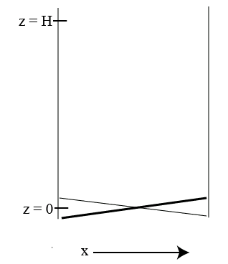

5.5 Derive from first principle (by generalizing the formulation in section 5.3.1) the following single partial differential equation that governs non-hydrostatic 3-D perturbations in a stably stratified rotating atmosphere
$\left\{\frac{∂^{2}}{∂t^{2}}\left(\frac{∂^{2}}{∂x^{2}}+\frac{∂^{2}}{∂y^{2}}+\frac{∂^{2}}{∂z^{2}}\right)+N^{2}\left(\frac{∂^{2}}{∂x^{2}}+\frac{∂^{2}}{∂y^{2}}\right)+f^{2}\frac{∂^{2}}{∂z^{2}}\right\}w^{'}=0$

5.6 When the horizontal wavelength of a IGW is much longer than its vertical wavelength, hydrostatic approximation would be applicable. This problem serves to ascertain the dynamics of a hydrostatic prototype (2D) internal gravity wave.
(a) Derive the governing equation for perturbations in a 2-D non-rotating, hydrostatic fluid model.
(b) Comment on the difference between this equation and that for a nonhydrostatic perturbation.
(c) Get the dispersion relation for hydrostatic internal gravity waves.
(d) What is the main difference in the frequency dependence on the ratio of the vertical wavenumber to the horizontal wavenumber between hydrostatic IGW and non-hydrostatic IGW?

5.7 This problem serves to ascertain how different are the properties of a hydrostatic IGW from those of a general (nonhydrostatic) prototype IGW. Let us do so in the context of a IGW that has the following characteristics :
$k>0$ , $m>0$ , $σ<0$ and $ξ=π/3$ .
(a) Write each of the solutions of $\left(u\text{',}w\text{',}p\text{',}θ'\right)$ entirely in terms of real variables and parameters (i.e. without using $i=\sqrt{−1}$)
(b) Determine the expressions for the phase velocity and group velocity of this wave.
(c) Summarize all properties of this IGW at $t=0$ in a sketch on x-z plane, showing wave fronts equal to $φ=0,\frac{π}{2},π,\frac{3π}{2},2π$ .
Draw arrows to indicate the structure of velocity field of this IGW. Label the locations of minimum and maximum values of $p'$ and $θ'$.
(d) Make an analysis of the energetics of this wave. What does the total energy consist of?
(e) Show that the vector $\vec{B}≡\left(\left[p'u'\right],\left[p'w'\right]\right)$ on the x-z plane represents the propagation of energy by this IGW, where refers to the average over one wavelength.

5.8 Consider the generic 2-D model for small amplitude IGW with the presence of a uniform zonal basic flow $\bar{u}$.
(a) Show that the governing equations for the vertical velocity of such a perturbation can be reduced to
${\left(\frac{∂}{∂t}+\bar{u}\frac{∂}{∂x}\right)}^{2}\left(\frac{∂^{2}w^{'}}{∂x^{2}}+\frac{∂^{2}w^{'}}{∂z^{2}}\right)+N^{2}\frac{∂^{2}w^{'}}{∂x^{2}}=0$
where $N^{2}=\frac{g}{θ_{\text{oo}}}\frac{{dθ}_{o}}{\text{dz}}$.
(b) Determine the dispersion relation for such IGW of which the vertical velocity is in the form of $w^{'}={\text{Ae}}^{iφ}$ with $φ=\text{kx}+\text{mz}−σt+ξ$.
(c) Suppose the basic flow is a westerly, $\bar{u}>0$ . Focus on an IGW that has a westward Doppler-shifted phase speed, i.e. $\left(\bar{u}−\frac{σ}{k}\right)<0$. What is its phase velocity, $\vec{c}$ ?
(d) What is the corresponding expression for its group velocity, ${\vec{c}}_{g}$ ?
(e) Determine the dot product of $\vec{c}$ and ${\vec{c}}_{g}$. Is the angle between them greater or smaller than $\text{90}°$ ?
(f) Determine the polarization relations among the dependent variables of the IGW, $\left(u^{'},w^{'},p^{'},θ^{'}\right)$.
(g) Make a sketch that shows all properties of such IGW, $m=k>0$, $σ>0$ and $ξ=π/3$ .
(h) Concisely discuss the impact of a basic zonal flow on all properties of an IGW.

5.9 This problem is concerned with orographically forced IGW by a steady basic zonal flow $\bar{u}$ going over a low topography of sinusoidal shape, $h=h_{o}e^{\text{ikx}}$. The governing equation for the vertical velocity of a two-dimensional weak disturbance in this atmosphere is
$${\left(\frac{∂}{∂t}+\bar{u}\frac{∂}{∂x}\right)}^{2}\left(\frac{∂^{2}w^{'}}{∂x^{2}}+\frac{∂^{2}w^{'}}{∂z^{2}}\right)+N^{2}\frac{∂^{2}w^{'}}{∂x^{2}}=0$$
Suppose $N={\text{10}}^{−2}s^{−1}$ , $\bar{u}=\text{20}{\text{ms}}^{−1}$ and $h_{o}=\text{500}m$. The appropriate boundary conditions are : @z=0, $\bar{u}\frac{∂h}{∂x}−w^{'}=0$ and finite response everywhere.
Do the following:
(a) Obtain a general solution for the forced response.
(b) Obtain the specific solution and deduce whether the wave is a vertically propagating or vertically trapped if the topography has a wavelength, $L=\frac{2π}{k}=\text{10}\text{km}$
(c) Describe the structural characteristics of the response as revealed by your solution.
(d) Where is the zonal position of maximum ascending motion relative to one of the mountain tops?
(e) What is the maximum vertical velocity in this forced wave?
(f) Give a conceptual explanation for the vertical structure of the forced response.

5.10 Explain why prototype Rossby waves must have an intrinsic westward component in its phase velocity from a dynamical point of view.

5.11 Show that the angle $θ$ subtended by the phase velocity vector $\vec{c}$ and the group velocity vector ${\vec{c}}_{g}$ of a two-dimensional prototype Rossby wave depends on the $k$ the x-wavenumber and $ℓ$ the y-wavenumber is greater than $\text{90}°$ .

5.12 Determine analytically the value of the zonal wavenumber of a Rossby wave in unit of $\left|ℓ\right|$ that has maximum $c_{\text{gy}}$ for a positive value of $ℓ$. Verify your result with Fig. 5.13.

5.13 Suppose the streamfunction field of a prototype Rossby wave in a two-dimensional $β$–plane model is $ψ=A\text{sin}\left(\text{kx}+ℓy−σt\right)$ where for the sake of convenience $k$ and $ℓ$ are measured in a unit such that $k=1$ and $ℓ=2$. This wave comes from the east towards a north-south barrier and is reflected. Consider the case of perfect reflection (i.e., no loss of energy).
(a) What are the wavelengths and amplitude of the reflected wave?
(b) Determine the phase velocity and group velocity of the incident wave and the reflected wave.
(c) Summarize all properties of the incident wave and the reflected wave near the barrier in a sketch. Comment on the characteristics of these waves.

5.14 Consider a shallow-water model with a mean thickness$H$, an uneven large-scale surface topography, $h_{B}\left(x,y\right)$ and on a beta-plane plane, $f=f_{o}+βy$ . The quasi-geostrophic potential vorticity equation governs the height of the free surface of the layer $h$ of a large-scale flow. This equation is (5.60) which after multiplying by $H$ is
$$\left(\frac{∂}{∂t}+u\frac{∂}{∂x}+v\frac{∂}{∂y}\right)q=0$$
$$q=βy+\frac{g}{f_{o}}\left(h_{\text{xx}}+h_{\text{yy}}\right)−\frac{f_{o}}{H}\left(h−h_{B}\right)$$
where $g$ is gravity, $u$ the geostrophic velocity in x-direction, $v$ the geostrophic velocity in y-direction and $q$ the quasi-geostrophic potential vorticity. A simple forcing is a steady uniform basic zonal flow $\bar{u}$ going over a sufficiently low sinusoidal topography $h_{B}=B\text{sin}\text{kx}$.
Do the following:
(a) Write down the equations that relate $u$, $v$ to $h$.
(b) Decompose each of $u$, $v$, $h$ and $q$ as a sum of a basic state component and a perturbation component. Identify the dependence of $\bar{q}$ on $\bar{h}$, $β$ and $h_{B}$.
(c) Deduce the linearized potential vorticity equation about the given basic state.
(d) Get the solution of the linearized governing equation for $h^{'}$ for $h_{B}=A\text{sin}\text{kx}$.
(e) Identify the dependence of the forced wave on the model parameters.
(f) What is the basic flow that would excite a particularly strong orographic planetary wave for $k=2π×{\text{10}}^{−7}m^{−1}$ , $f={\text{10}}^{−4}s^{−1}$, $H=\text{10}\text{km}$, $g=\text{10}{\text{ms}}^{−2}$and $β=1\text{.}6×{\text{10}}^{−\text{11}}s^{−1}$ ?
(g) How would we interpret such a response?

5.15 A “constant level” balloon has a fixed mass $M$ and is rigid so that its volume $V$is constant. It floats at an altitude $z$ where $ρ_{\text{air}}=M/V$ . What is the free period of oscillation of such a balloon in an atmosphere with a lapse rate $Γ=6K/{\text{km}}$ at a level where $T=\text{287}K$?

5.16 Consider the ocean as an unbounded shallow-water model with a constant Coriolis parameter. It has a flat bottom and a constant depth $H$ in the unperturbed state.
(a) Derive the governing equation for the perturbation height.
(b) Obtain the dispersion relation of the normal modes (external gravity waves).
(c) Obtain the expressions for the components of the phase velocity.
(d) Obtain the expressions for the components of the group velocity.
(e) Show that the angle subtended by the phase velocity and the group velocity of any of these external gravity waves is $\text{45}°$
(f) Make a sketch of an eastward propagating external gravity wave with $k=ℓ$ that summarizes all of its properties. Contrast the properties of such long waves $\left(k^{2}\text{<<}\frac{f^{2}}{\text{gH}}\right)$ with those of such short waves $\left(k^{2}\text{>>}\frac{f^{2}}{\text{gH}}\right)$

5.17 Consider a layer of incompressible rotating fluid in a channel bounded by two straight coastlines at $y=±Y$. Determine a general solution in this model made up of Kelvin waves. Comment on the characteristics of the solution.

5.18 Examine the effect of surface friction on Rossby waves in the context of Ekman layer dynamics. The simplest model for such problem is a quasi-geostrophic shallow-water viscous model with a mean thickness$H$ over a flat surface. The governing equation can be written in terms of a geostrophic streamfunction $ψ=\frac{gη}{f_{o}}$ where $η$ is the departure of the surface elevation from the mean depth as
$\left(\frac{∂}{∂t}−ψ_{y}\frac{∂}{∂x}+ψ_{x}\frac{∂}{∂y}\right)q=−ε\left(ψ_{\text{xx}}+ψ_{\text{yy}}\right)$
$q=f_{o}+βy+ψ_{\text{xx}}+ψ_{\text{yy}}−λ^{2}ψ$,
$λ^{2}=\frac{f_{o}^{2}}{\text{gH}}$, $ε=\frac{f_{o}}{H}{\left(\frac{κ}{2f_{o}}\right)}^{1/2}$
$κ$ is the eddy coefficient.
(a) Obtain the governing equation for small amplitude perturbation about a basic state at rest.
(b) Determine the normal mode solution
(c) Discuss the effect of the Ekman layer friction on the frequency and amplitude of a Rossby wave. Specifically comment on the dependence of such effect on the wavelength of the wave.

5.19* This problem is concerned with the dynamics of a special wave mode in the atmosphere. It is a generalized version of the one known as Lamb wave (named after Horace Lamb, 1875). It suffice to consider perturbations in a 2-D non-rotating inviscid adiabatic atmosphere with a resting isothermal basic state, $T_{\text{oo}}$. Specifically we focus on a set of perturbations that have no vertical motion anywhere. This wave mode turns out to be a special member of a type of waves (sound waves) that is not discussed in this book for brevity. However, applying the methodology discussed in chapter 5, the following steps would systematically lead one to the results:
(a) Start with the complete set of governing equations for this model atmosphere in Cartesian coordinates.
(b) Linearize these equations about a basic state defined above.
(c) Derive the governing equations for a subset of perturbations with $w=0$ at all levels.
(d) Solve for the complete solution of such a perturbation.
(e) Examine the energetics of Lamb wave
(f) Discuss the characteristics of the dynamics and structural properties of Lamb waves.
(g) Discuss the implications for numerical modeling an atmospheric model that contains Lamb waves.

5.20* General perturbations in this model of a compressible stratified fluid have nonzero vertical motion. It follows that the general perturbations can be sound waves or internal gravity waves. The problem is to delineate the dynamics and structure of those two classes of wave modes in an effectively infinite domain.

5.21* The problem is concerned with how one might filter out a priori sound wave solutions from a compressible stratified fluid model on the basis of the differences of the properties of the sound waves and internal gravity waves.
(a) Do so by applying an unrestricted Boussinesq approximation
(b) Do so by applying a local Boussinesq approximation
Discuss the similarities and differences of the results.

Chapter 6

6.1 Suppose the horizontal flow field at an upper level of a mid-latitude synoptic scale system consists of a strong uniform zonal wind $U$ and a much weaker wave disturbance $\left(u^{'},v^{'}\right)$ where $u^{'}=−ε\text{cos}ℓy\text{sin}k\left(x−\text{ct}\right)$, $v^{'}=ε\frac{k}{ℓ}\text{sin}ℓy\text{cos}k\left(x−\text{ct}\right)$
(a) Deduce a consistent expression for the horizontal divergence field in the context of quasi-geostrophic theory as a function of x,y and t
(b) Given $U=\text{20}{\text{ms}}^{−1}$, $c=\text{10}{\text{ms}}^{−1}$, $ε=4{\text{ms}}^{−1}$, $k=1\text{.}5×{\text{10}}^{−6}m$, $ℓ=0\text{.}\text{75}×{\text{10}}^{−6}m$,
$Ω=7\text{.}\text{29}×{\text{10}}^{−5}s^{−1}$, earth’s radius $6\text{.}\text{37}×{\text{10}}^{6}m$. This system is located in a latitudinal region centered at $\text{43}N\text{.}$ What is the amplitude of the horizontal divergence?

6.2 Consider a basic state at rest and a perturbation in a quasi-geostrophic, two-layer, inviscid, and adiabatic model with isobaric coordinates on a beta-plane.
(a) Derive the governing equations for such perturbations in Cartesian coordinates $\left(x,y\right)$.
(b) Solve for the normal mode solution. Determine the dispersion relation.
(c) What are the propagation characteristics of the normal modes?
(d) What are the relative phases among $ψ_{1},ψ_{3}$ and $ω_{2}$ of each normal mode?
(e) What does each of the normal modes represent physically?

6.3 Use the Q-vector formulation of the omega equation to qualitatively deduce the vertical velocity at the locations A and B in the following disturbance consisting of a sequence of high and low pressure centers. They are embedded in a broad temperature field with north-south thermal contrast.

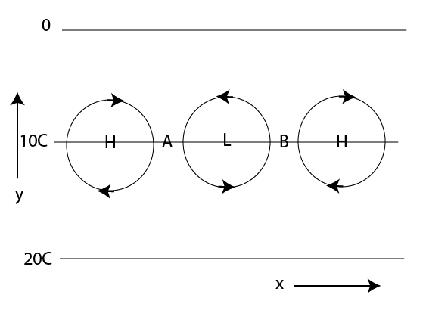

6.4 Consider a two-layer quasi-geostrophic model in which there is a basic state $Ψ_{j}$and a perturbation $ψ_{j}^{'}$, with
$Ψ_{j}=−U_{j}y$ , for $U_{j}=$constant
(a) Derive the governing equations for one-dimensional disturbances, $ψ_{j}^{'}\left(x,t\right)$.
(b) Show that the following omega equation for the case of $β=0$ is
$\frac{f_{o}}{δp}\left(\frac{d^{2}}{{\text{dx}}^{2}}−2λ^{2}\right)ω=λ^{2}\left(U_{2}−U_{1}\right)\frac{d^{3}}{{\text{dx}}^{3}}\left(ψ_{2}^{'}+ψ_{1}^{'}\right)$
A linear instability analysis reveals that, for $U_{1}>U_{2}$ , the solution of an unstable baroclinic wave with a zonal wavenumber $k=λ$ is
$ψ_{2}^{'}=A\text{exp}\left(\text{ik}\left(x−\text{ct}\right)\right)$
$$ψ_{1}^{'}=A\text{exp}\left(i\left(k\left(x−\text{ct}\right)+ξ\right)\right)$$
where $ξ=π/3$ , $A=$ constant and $c$ depends on the basic flow.
Determine the phase angle of $\left(−ω\right)$ relative to the lower level streamfunction perturbation $ψ_{2}^{'}$ . What is the physical meaning of this mathematical result?
(c) Qualitatively sketch the structure of $ψ_{j}^{'}\left(x,t\right)$ and $−ω\left(x,t\right)$ in $0≤\text{kx}≤2π$ at time $t=t_{o}$ such as ${\text{kc}}_{r}t_{o}=2π$. Comment on the implication of this structure from the energetics point of view of the instability.
6.5 This problem is concerned with the initial evolution of a MERIDIONAL jet streak embedded in a baroclinic zonal flow, $U_{j}$, in a two-layer quasi-geostrophic model with beta-plane approximation. An idealized baroclinic jet streak is defined in terms of its distribution of relative vorticity field, $ζ_{j}=∇^{2}ψ_{j}$, as follows
$ζ_{1}=−\text{Ax}\text{exp}\left(−x^{2}\right)F\left(y\right)$
$F\left(y\right)=\left(1+\text{tanh}\left(a\left(y−y_{S}\right)\right)\right)$ for $−Y≤y≤0$
$F\left(y\right)=\left(1−\text{tanh}\left(a\left(y−y_{N}\right)\right)\right)$ for $Y≥y≥0$
$z_{3}={\text{ez}}_{1}$, $e<1$
By PV inversion, we can then obtain $ψ_{j}$. The sample analysis is made with $U_{1}=1\text{.},U_{3}=0\text{.}3$ , $a=2,A=6,y_{S}=−1\text{.}5,y_{N}=1\text{.}5,ε=0\text{.}2$ (refer to section 6.7.1 for the non-dimensionalization). Using $V=\text{10}{\text{ms}}^{−1}$ , $β=1\text{.}6×{\text{10}}^{−\text{11}}m^{−1}s^{−1}$, $p_{2}=\text{600}×{\text{10}}^{2}{\text{Nm}}^{−2}$, $δp=\text{400}×{\text{10}}^{2}{\text{Nm}}^{−2}$, $S=6\text{.}\text{25}×{\text{10}}^{−6}N^{−2}m^{6}s^{−2}$, $f_{o}={\text{10}}^{−4}s^{−1}$, we would have $λ^{−1}={\text{10}}^{6}m$ and $\tilde{β}=1\text{.}6$. The non-dimensional domain is $−X≤x≤X$, $−Y≤y≤Y$ with $X=\text{15}\text{.}$,$Y=5\text{.}$ The results of non-dimensional $ψ_{1}$ and $q_{1}$(without including the constant value of the mean Coriolis parameter) are shown in Fig. (A) and (B).

(A) (B)
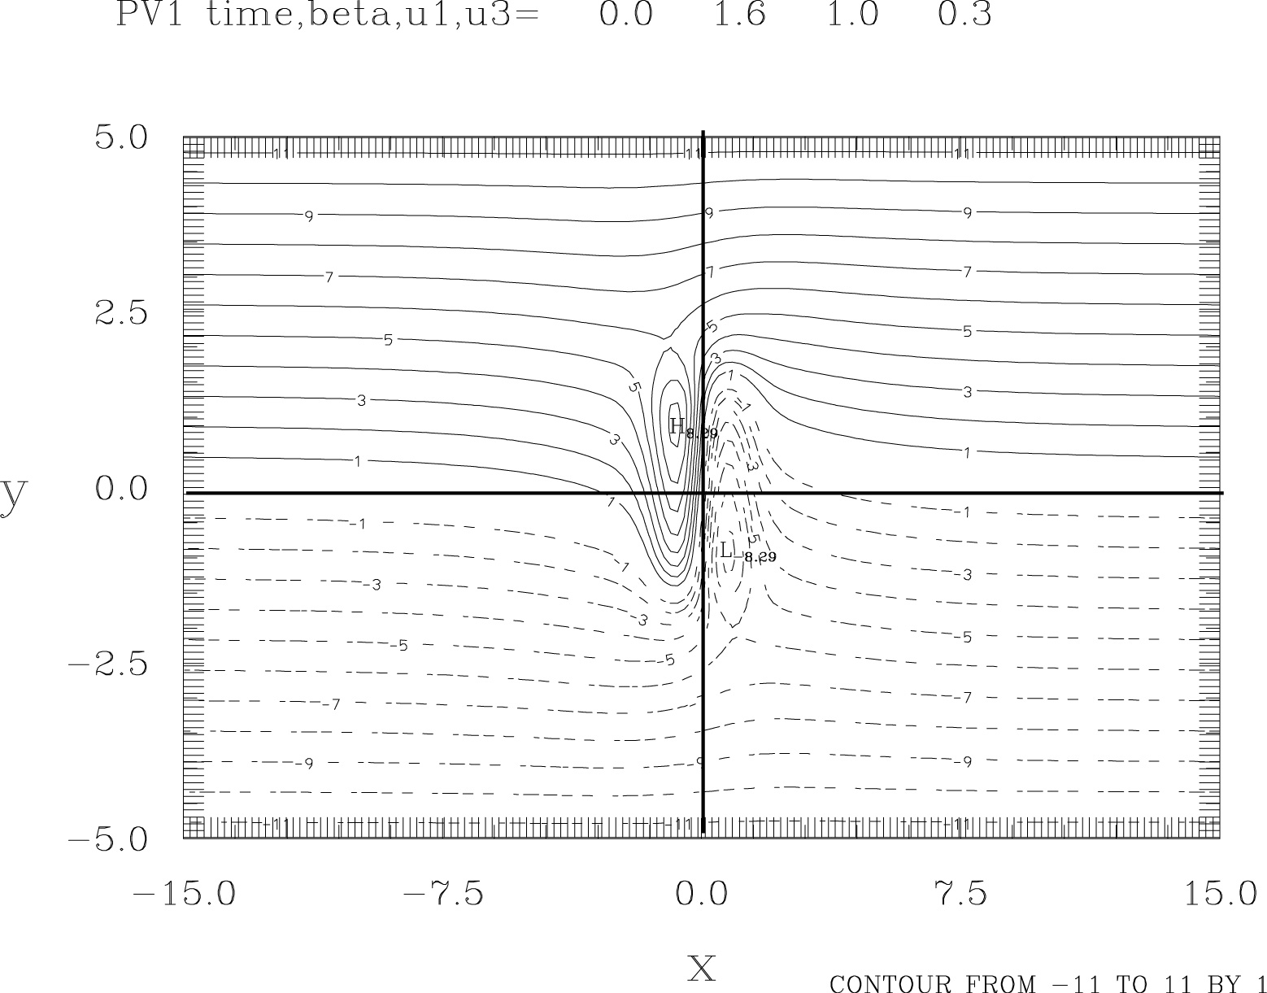
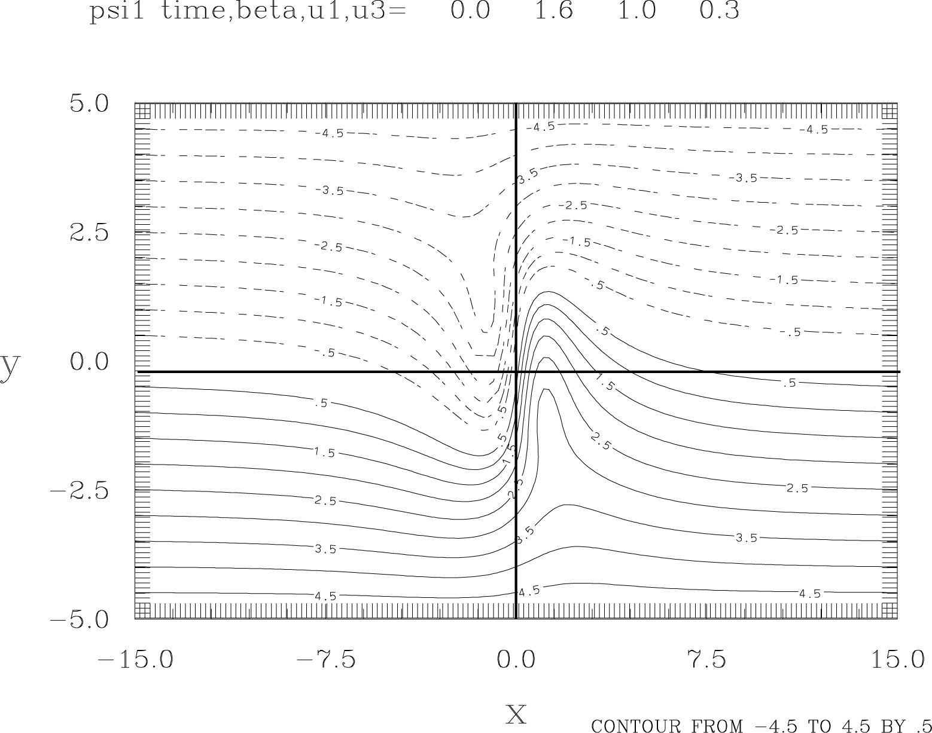

(a) What are the governing equations of the flow in the model?
(b) Qualitatively identify the areas of major positive advection of potential vorticity (PV-adv) and those of major negative PV-adv in the flow at this level & Explain. Indicate the former by a couple of “+” marks and the latter by a couple of “-” marks in Figure (A).
(c) Using Figure (B) as a guide, sketch the distribution of potential vorticity that you could deduce one day later on the basis of the initial tendency of PV. Comment on the main features.

6.6 The following figure shows the non-dimensional Q-vector field (arrows) with the streamfunction field at mid-level (contours) of the flow considered in problem (2). Label the areas of major rising motion with “U” and of sinking motion with “D” on this figure. Explain.

6.7 Here is an extensive project. Considering the meridionallly oriented baroclinic jet streak defined in problem 6.5 ,
(a) Compute the streamfunction fields in the two layers. Verify that figure (A) of problem 6.5. is indeed the streamfunction of the upper layer.
(b) Verify that the total PV in the upper layer is figure (B) of problem 6.5.
(c) Write a computer code for this two-layer QG model for the purpose of examining the evolution of this flow.
(d) Then use the code to verify that the upper layer PV at t=1,3,5 is

(i) t=1 (iii) t=5
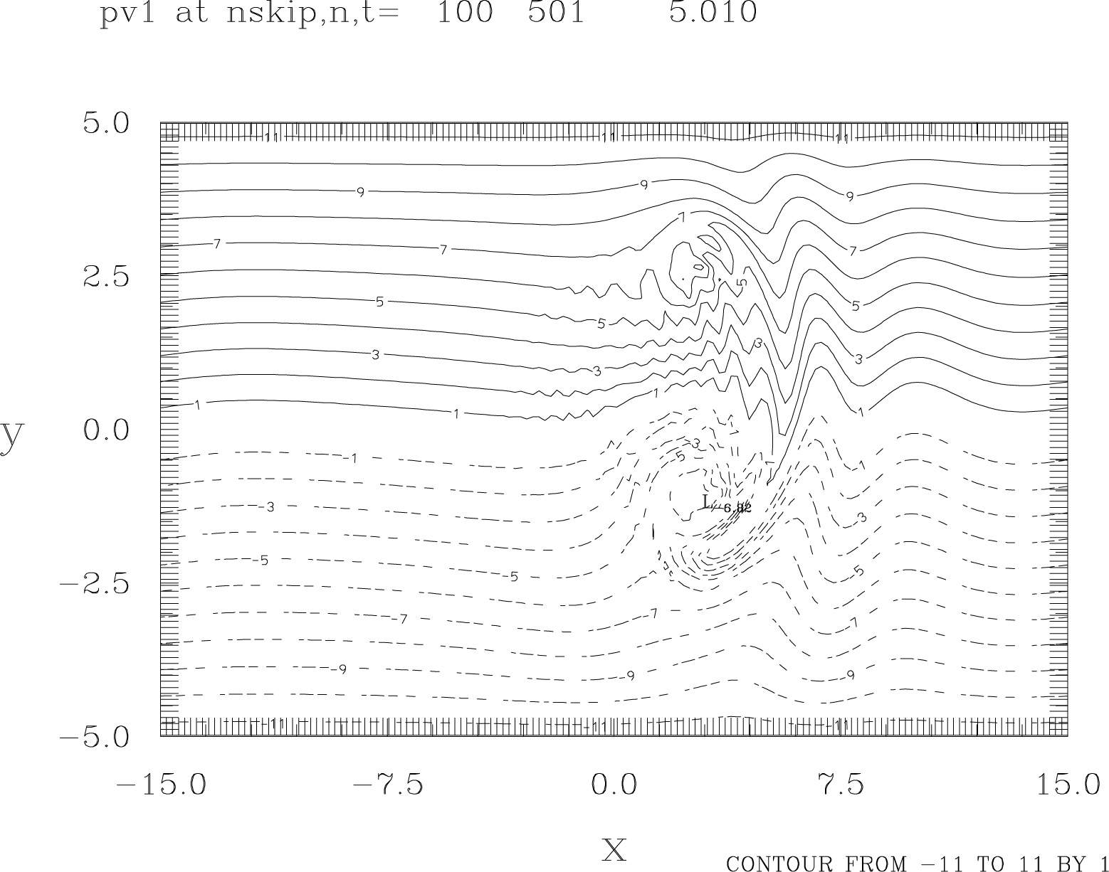
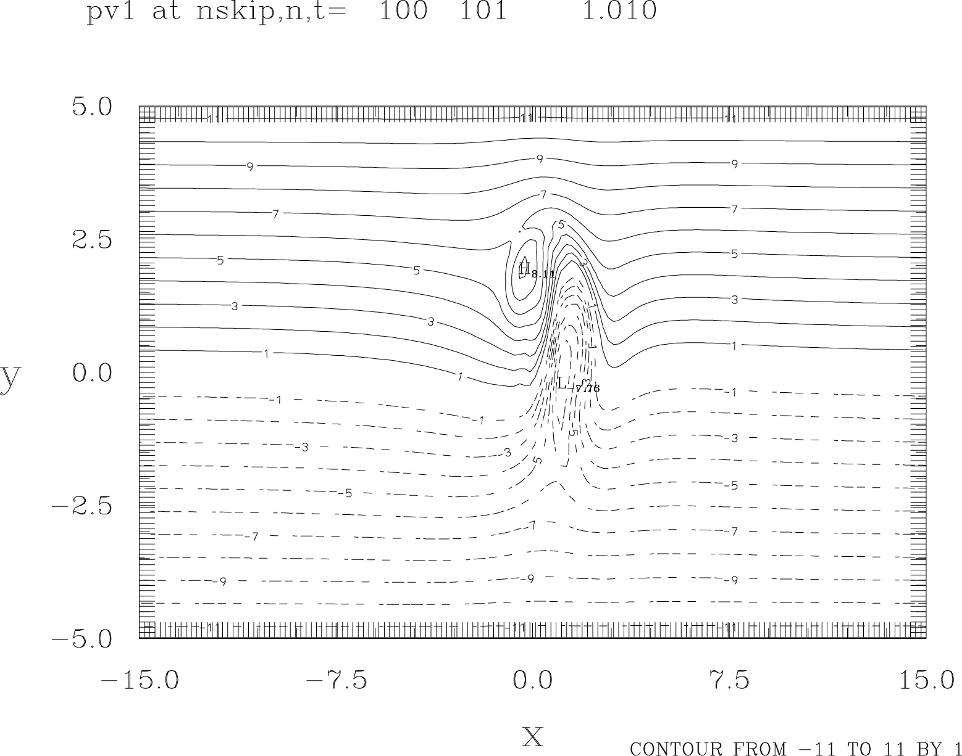
(ii) t=3
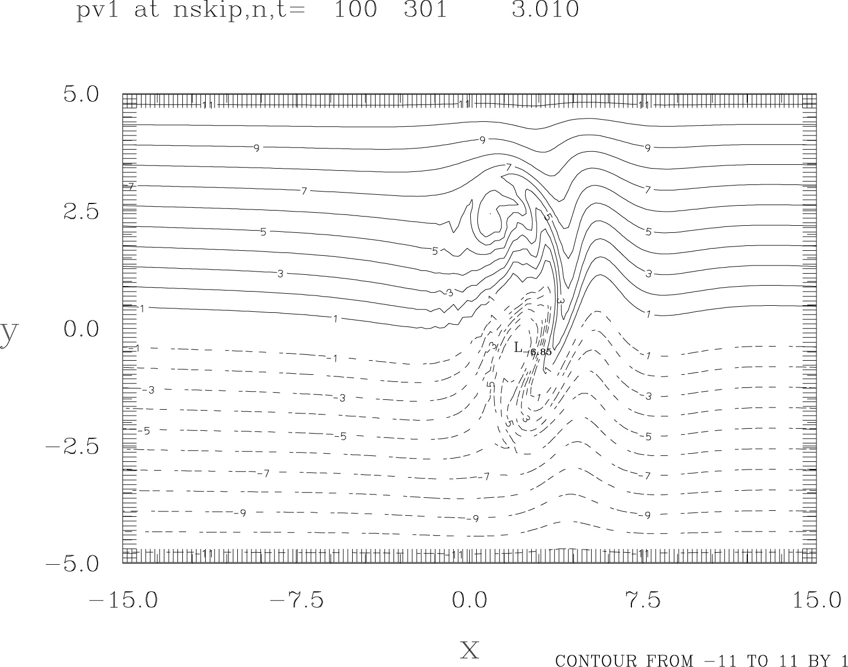

Comment on the characteristics of this evolution.
(e) The corresponding evolution of the omega field at t=1,3,5 is

(i) t=1 (iii) t=5
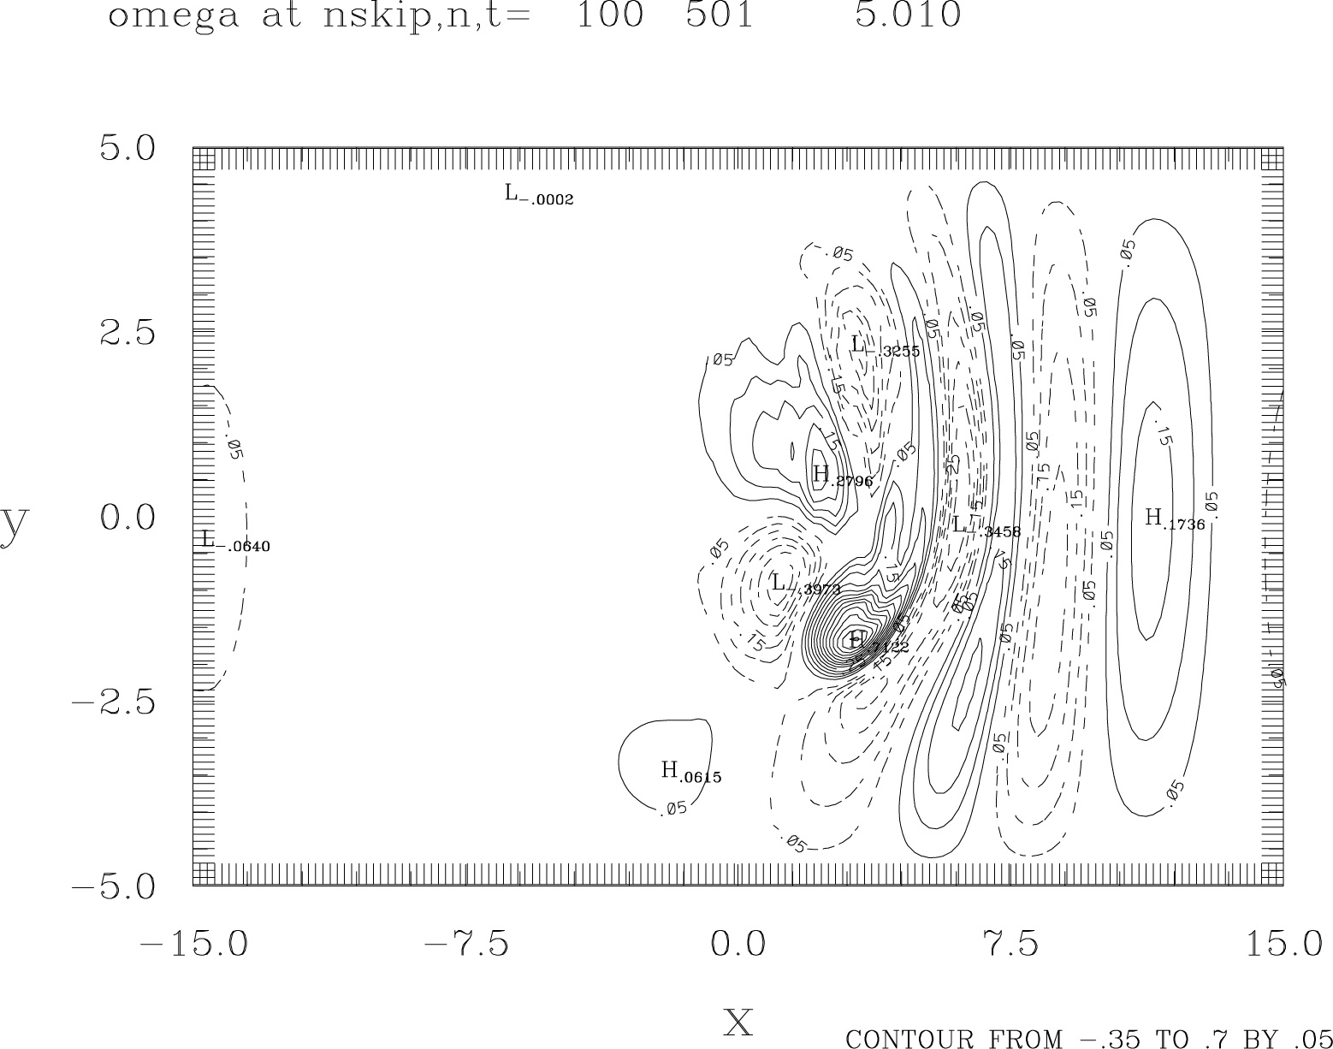
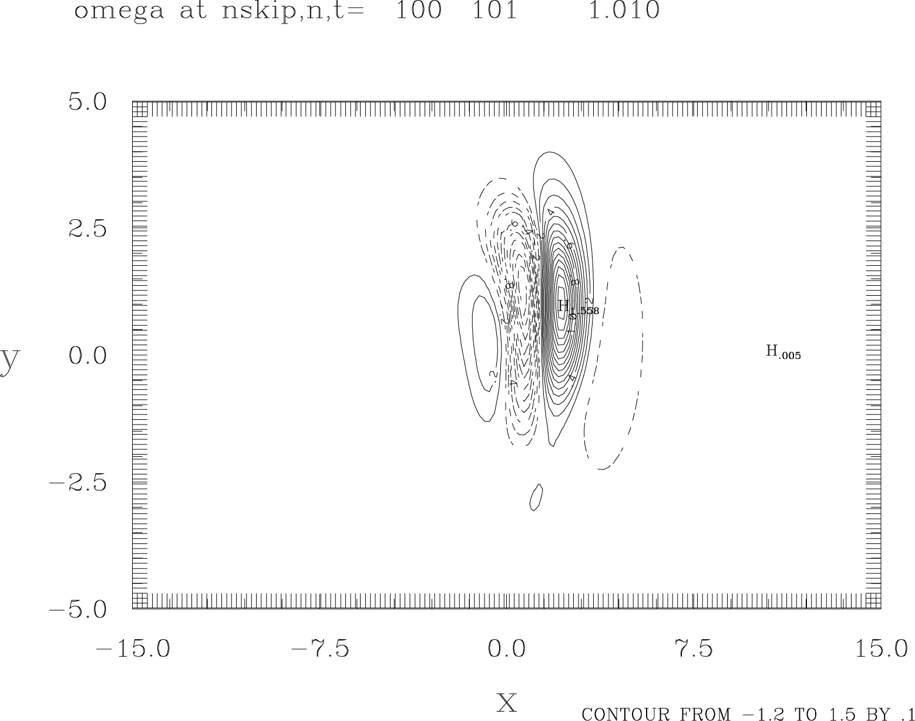

(ii) t=3
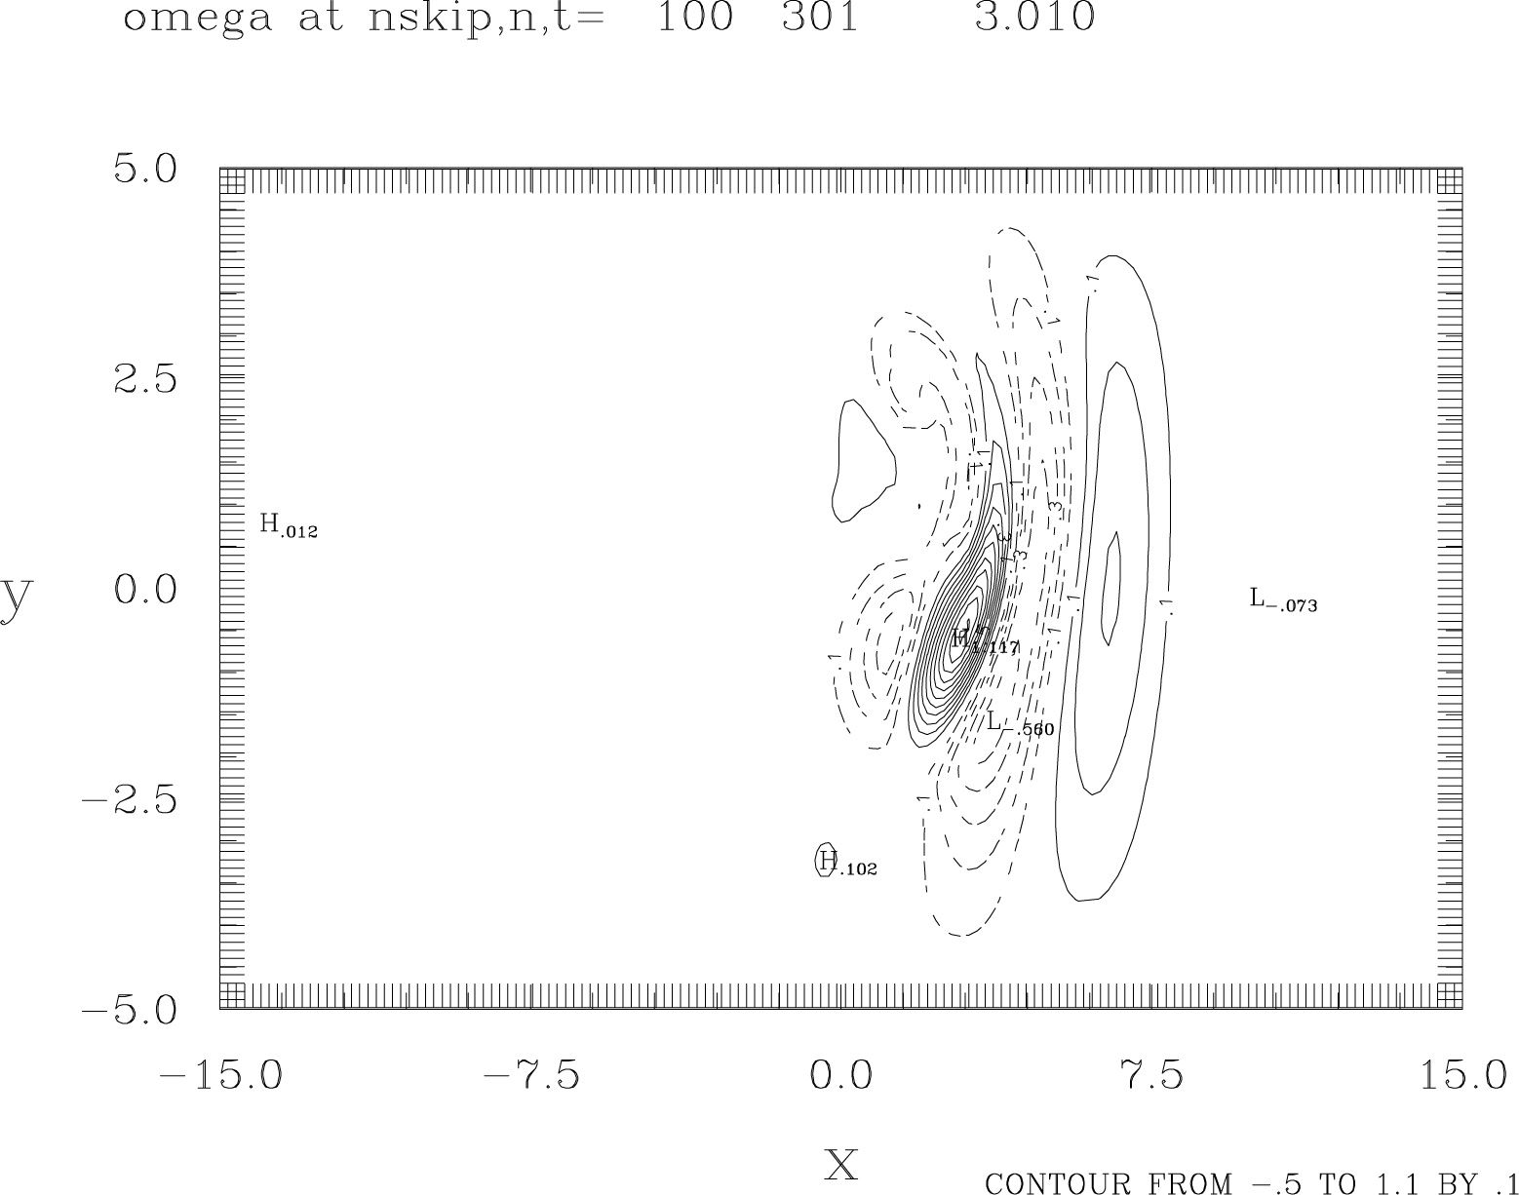

Comment on this evolution. Highlight the difference between the evolution of a zonally oriented jet streak and that of a meridionally oriented jet streak.

6.8 Consider the following configuration of geopotential height on an isobaric surface in the Northern Hemisphere. Suppose the geostrophic winds decrease with increasing elevation everywhere

4000 km

N

LOW

HIGH

(a) Where do we find maximuze ascent and descent, according to the quasi-geostrophic theory? Explain your reasoning.
(b) Why must there be vertical velocity in the pattern above?
(c) Explain how static stability affects the magnitude of vertical motions.
(d) Show, on the above pattern, where surface cyclones and anticyclones would be expected to develop and what direction they would be expected to move.
(e) Show the axis along which we find maximum cyclonic relative vorticity. Show the axis along which the cyclonic relative thermal vorticity is maximum.

Chapter 7

7.1 Suppose the initial state of a layer of unbounded, shallow, rapidly rotating, inviscid fluid (shallow-water model) at t=0 is:
$u\left(x,y\right)=0$, $v\left(x,y\right)=0$, $h\left(x,y\right)=H+h^{'}\left(x\right)$
$u$and $v$ are the velocity components. $h$ is the elevation of the free surface of the layer graphically shown below where $H=$ mean thickness of the layer with $H\text{>>}A$ . 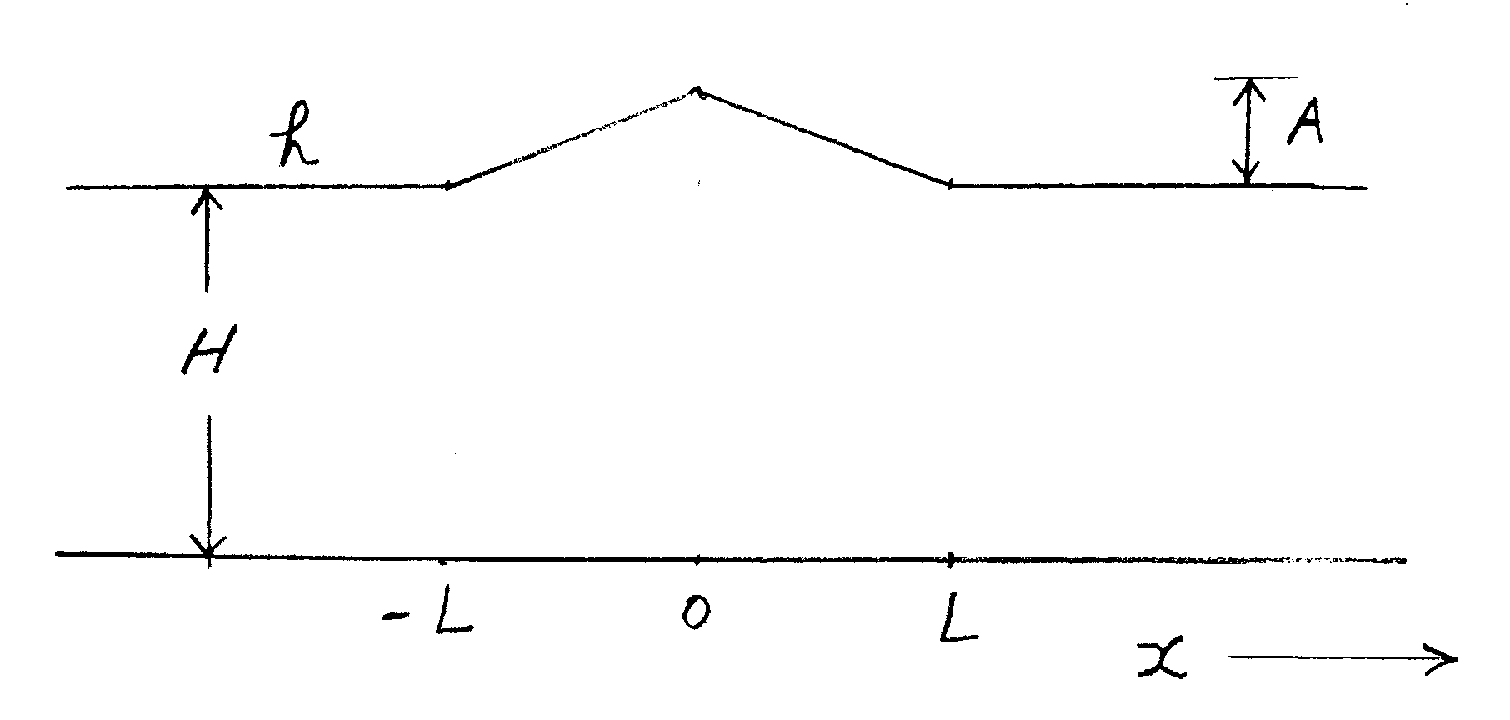
This system would evolve to a geostrophically balanced state at large time in the central part of the domain.
(a) hat would happen qualitatively speaking after t=0?
(b) Show that the analytic solution for $h$ of the balanced state is
$h=H+\frac{A}{Lλ}\left(1−\text{cosh}\left(Lλ\right)\right)e^{λx}$ in the region $x≤−L$
$h=H+A\left(\frac{e^{λx}}{Lλ}+1+\frac{x}{L}\right)−\frac{A}{Lλ}e^{−λL}\text{cosh}\left(λx\right)$ in the region $−L<x≤0$
$h=H+A\left(\frac{e^{−λx}}{Lλ}+1−\frac{x}{L}\right)−\frac{A}{Lλ}e^{−λL}\text{cosh}\left(λx\right)$ in the region $0<x≤L$
$h=H+\frac{A}{Lλ}\left(1−\text{cosh}\left(Lλ\right)\right)e^{−λx}$ in the region $x≥L$
where $λ^{2}=\frac{f^{2}}{\text{gH}}$ ($f$ is Coriolis parameter and $g$ is gravity);
$e^{−ξ}=1+\sum_{n=1}^{∞}{\frac{{\left(−ξ\right)}^{n}}{n!}}$ is a convergent series for small $\left|ξ\right|$.
(c) What is the analytic solution of the velocity at large time?
(d) Make a sketch of $h\left(x\right)$ of the balanced state for the case of $L\text{>>}λ^{−1}$ . Important to be quantitatively correct at the key points.
(e) Make a sketch of $h\left(x\right)$ of the balanced state for the case of $L\text{<<}λ^{−1}$. Important to be quantitatively correct at the key points.
(f) In which of the two cases does the geostrophic adjustment occur by means of significantly altering the velocity field, rather than the mass field? Why?
Chapter 8A

8A.1 (a) Use the parcel method to show that when an air parcel is adiabatically displaced in the vertical direction by a small distance from its equilibrium position, it will undergo buoyancy oscillations with the Brunt-Vaisala frequency , $N=\sqrt{\frac{g}{θ_{o}}\frac{{dθ}_{o}}{\text{dz}}}$ where $θ_{o}\left(z\right)$ is the background potential temperature and $g$ the gravity.
(b) What will be the frequency of oscillation of a parcel that is constrained to move along a line that is inclined at an angle $φ$ from the vertical (see the figure below)?
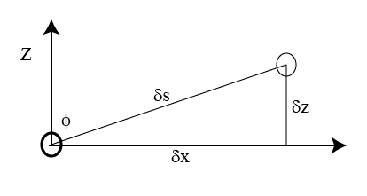
(c) An example of such constrained movement of air parcels would be those associated with a plane internal gravity wave with horizontal wavenumber $k$ and vertical wavenumber $m$. Use the considerations of part (b) to derive the dispersion relation for such wave motion.

8A.2 (a) Consider a westerly Gaussian jet in northern hemisphere that centers at $y=y_{o}$ $\bar{u}=U\text{exp}\left(−{\left(\frac{y−y_{o}}{a}\right)}^{2}\right)$
with $U>0$ and $a$ is a constant. The Coriolis parameter is $f_{o}$.
Suppose this jet is sufficiently strong and narrow to be inertially unstable. Determine the latitudinal region where an inertially unstable disturbance may be expected in this jet. You may either get an approximate solution analytically or describe a graphical method.
(b) Determine the possible region of inertially unstable disturbance for $f_{o}={\text{10}}^{−5}s^{−1}$, $a=\text{40}\text{km}$, $U=\text{20}{\text{ms}}^{−1}$

8A.3 Potential density, D, is defined as the density which an air parcel would change to when it is adiabatically displaced to a reference pressure level (an analogy to potential temperature).
(a) Determine the relationship between potential density and potential temperature.
(b) Show that $\frac{−}{D}\frac{∂D}{∂z}=−\left(\frac{1}{ρ}\frac{∂ρ}{∂z}+\frac{c_{v}g}{c_{p}\text{RT}}\right)$
(c) Explain then that the static stability of an atmosphere depends on the vertical distribution of potential density

Chapter 8B

8B.1 If a zonal wind in the northern hemisphere with an easterly vertical shear $\left(\frac{∂\bar{u}}{∂z}<0\right)$ is baroclinicially unstable, what must be the structure of an unstable wave in the zonal vertical plane? Make a sketch for the structure in terms of the phase relations among the maximum values of:
(i) the perturbation velocity component normal to the plane
(ii) the perturbation temperature
(iii) the perturbation vertical velocity
State the reasoning underlying your sketch

8B.2 Consider the most unstable baroclinic wave for the simple case $β=0$ in a two-layer quasi-geostrophic model.
(a) Compute the relative phase relationships among the streamfunction field, the temperature field and the vertical velocity field of this unstable wave at the mid-level. Given: $U_{1}−U_{3}=\text{40}{\text{ms}}^{−1}$ , $U_{1}+U_{3}=\text{40}{\text{ms}}^{−1}$, $σ=2×{\text{10}}^{−2}m^{2}s^{−2}{\text{mb}}^{−2}$, $f_{o}={\text{10}}^{−4}s^{−1}$.
(b) Comment on the physical implications of your numerical results in terms of the energy conversion processes associated with the development of the wave.
(c) What is the relative phase between the streamfunction field at level 1 and that at level 3 for this unstable wave?

8B.3 Consider a non-rotating barotropic zonal shear flow $\bar{u}\left(y\right)$ that is piece-wise continuous consisting of line segments such as a jet with a triangular profile:
for $y≥y∗$, $\bar{u}=0$
for $y∗y≥0$, $\bar{u}=γ\left(y∗−y\right)$
for $0≥y≥−y∗$, $\bar{u}=γ\left(y∗+y\right)$
for $y≤$, $\bar{u}=0$
(a) Obtain an analytic solution of a perturbation whereby one can examine the modal instability properties of this basic flow. (Clue: $ψ^{'}$ and $p^{'}$ are continuous at $y=0,±y∗$ where $ψ^{'}$ and $p^{'}$ refer to the perturbation streamfunction and pressure. Also impose $ψ^{'}→0$ as $y→±∞$).
(b) Evaluate the instability properties for
$γ={\text{10}}^{−4}s^{−1}$, $k=2×{\text{10}}^{−6}m^{−1}$ , $y∗0\text{.}5×{\text{10}}^{6}m$.

8B.4 Consider a barotropic jet that has a structure $U=u\text{*cos}\left(\frac{y}{a}\right)$ on a beta-plane
in a domain $−π≤\frac{y}{a}≤π$. Is this jet unstable for the following conditions ?
(a) $u∗\text{30}{\text{ms}}^{−1}$, $a={\text{10}}^{6}m$, $β=1\text{.}6×{\text{10}}^{−\text{11}}m^{−1}s^{−1}$ ?
(a) $a={\text{10}}^{7}m$, $u∗\text{30}{\text{ms}}^{−1}$, $β=1\text{.}6×{\text{10}}^{−\text{11}}m^{−1}s^{−1}$?
(c) $u∗3{\text{ms}}^{−1}$, $a={\text{10}}^{6}m$, $β=1\text{.}6×{\text{10}}^{−\text{11}}m^{−1}s^{−1}$?
(d) $β=0$, $u∗\text{30}{\text{ms}}^{−1}$, $a={\text{10}}^{6}m$?
What do you learn from this problem?

8B.5 (provided by Dr. Ming Cai)
Consider a two layer QG fluid on an f-channel domain (beta=0) with the mean flow in the upper and lower layers are U and –U, respectively, where U is a positive constant (U > 0). The linearized perturbation PV equations in the two-layer system are
where $F$ corresponds to $λ^{2}$ in the book’s notations. The lateral boundary condition for the perturbation streamfunction is
, n = 1 and 2
Normal mode solution
, n = 1 and 2
where $k>0$ and $l=1,2,3\text{.}\text{.}\text{.}$
Answer the following questions at the longwave limit,$F\text{>>}\left(k^{2}+{\left(\frac{lπ}{L}\right)}^{2}\right)$:
(a) Prove that the eigenvalues are: C → iγU where γ = ± 1 (γ= +1 for one mode, γ = −1 for the other mode).
(b) Prove that the eigenfunction structure satisfies: A₁/A₂ → iγ .
(c) Prove that the perturbation streamfunctions can be written in the form of
$ψ_{1}=B_{o}\text{cos}\left(\text{kx}+\frac{\text{γπ}}{2}\right)$and $ψ_{2}=B_{o}\text{cos}\left(\text{kx}\right)$ , and $B_{o}=A_{o}\text{sin}\left(\frac{lπ}{L}y\right)\text{exp}\left(γ\text{kUt}\right)$.
(d) Derive the zonal mean and vertical mean heat flux of the perturbation flow:
<(v’₁+v’₂) (ψ’₁ - ψ’₂ ) >=<(ψ’₁ - ψ’₂ )*∂(ψ’₁ + ψ’₂)/∂x>, where < > is the zonal mean over one wave length.
(e) Which is the unstable mode? Sketch and of the unstable mode as a function of x. What is its vertical structure (tilting westward or eastward, and by how much)? What is the direction of perturbation heat flux?
(f) repeat 1.5, but for the decaying mode.

8B.6 Consider a basic state in a two-layer quasi-geostrophic model that is characterized by the following parameters :
$U_{1}=\text{36}{\text{ms}}^{−1}$, $U_{3}=\text{10}{\text{ms}}^{−1}$, $β=1\text{.}6×{\text{10}}^{−\text{11}}m^{−1}s^{−1}$, $S=3\text{.}\text{125}×{\text{10}}^{−6}m^{2}{\text{Pa}}^{−2}s^{−2}$,
$f_{o}={\text{10}}^{−4}s^{−1}$, $δp=4×{\text{10}}^{4}\text{Pa}$
The notations are the same as those used in the analysis discussed in the text. Use and as the units of distance and velocity to non-dimsnionalize the parameters. Then we can use the quantitative instability results to answer the following questions.
- What is the dimensional wavelength of the longest wave that is marginally unstable for this basic state?
- What is the dimensional wavelength of the shortest wave that is marginally unstable?
- What is the dimensional wavelength of the most unstable wave?
- What is the dimensional growth rate of the most unstable wave? What is the corresponding e-folding time in hours?
- What is the dimensional phase speed of the most unstable wave?
- Determine the structure of the temperature perturbation at mid-level $T_{2}^{'}$ relative to the structure of the streamfunction perturbation at mid-level $ψ_{2}^{'}$, where $T_{2}^{'}$ is proportional to $\left(ψ_{1}^{'}−ψ_{3}^{'}\right)$. Specifically determine the phase angle between $T_{2}^{'}$ and $ψ_{2}^{'}$. Make a sketch of the variation of $T_{2}^{'}$ and $ψ_{2}^{'}$ in x-direction over one wavelength at a particular time.
- Use the result of Part (f) to interpret how the total energy of an unstable baroclinic wave increases in time .

8B.7 (provided by Dr. Ming Cai)
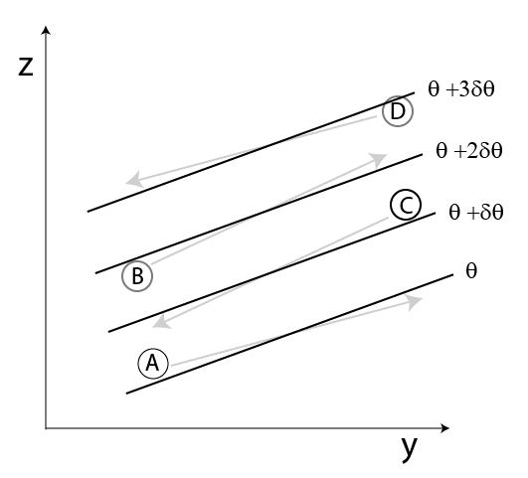
Baroclinic instability essentially is a slant-wise convection in a stably stratified fluid. The schematic above sketches four parcel trajectories (alphabetically labeled arrows) relative to the zonal mean isentropic surfaces (heavy solid lines, δθ > 0). Note that all trajectories have a positive slope as the zonal mean isentropic surfaces.
(a) Discuss which parcel trajectories are unstable and which are stable.
(b) Write the inequality between the slopes of the zonal mean isentropic surface and an unstable trajectory. Do the same for a stable trajectory.
(c) Apply the inequality to one unstable and one stable trajectory among the four trajectories and re-write it in terms of the relation between meridional and vertical temperature advection terms.
(d) Discuss stability/instability of the stable and unstable parcel trajectories according to the net temperature tendency due to advection of the mean potential temperature Θ.
(e) Deduce a logically plausible relation between the slope of the most unstable parcel trajectory and the slope of the basic isentropic surface and explain why.
(f) Discuss why an air parcel trajectory with a negative slope would be stable.

Chapter 8C

8C.1 Consider a baroclinic jet in a quasi-geostrophic two-layer beta-plane model.
$U_{1}=ε_{1}\text{exp}\left(−{\left(y/a\right)}^{2}\right)$, $U_{3}=ε_{3}\text{exp}\left(−{\left(y/a\right)}^{2}\right)$
Subscripts “1” and “3” denote the properties at the upper and lower levels respectively. The meridional domain is $−Y≤y≤Y$. For convenience, a modal instability analysis is done in non-dimensional form using $L=\text{1000}\text{km}$, $V=\text{30}{\text{ms}}^{−1}$ and $V^{−1}L=3\text{.}\text{33}×{\text{10}}^{4}s$ as units of distance, velocity and time respectively. The perturbation streamfunction is $ψ_{j}\left(x,y,t\right)=ξ_{j}\left(y\right)\text{exp}\left(i\left(\text{kx}−tσ\right)\right)$, $j=1,3$. The calculation for a particular setting ($ε_{1}=1\text{.}5$ , $ε_{3}=0\text{.}3$ , $a=1\text{.}5$, $β=0\text{.}5$ and $Y=4$) reveals that the most unstable mode has a wavelength of 5.5 and the eigenvalue is equal to $σ=0\text{.}\text{438}+i0\text{.}\text{111}$. The structure of this unstable mode deduced from the eigenvector in terms of (a) $ψ_{1}$ , (b) $ψ_{3}$, (c) $ω_{2}$ and (d) $T_{2}$ fields over a wavelength (standard notations) is shown in the following four panels. Subscript “2” denotes the properties at the mid-level.

(a) (c)

(b) (d)

(a) Use the thermal wind equation in the context of a two-layer model to mathematically deduce the corresponding distribution of the basic temperature, $Θ_{2}\left(y\right)$, at level-2 .
(b) What is the wavenumber of the most unstable mode in $m^{−1}$?
(c) What is the e-folding time of intensification in days?
(d) What is the phase speed of the most unstable mode in ${\text{ms}}^{−1}$?
(e) Identify the significant structural characteristics of the most unstable mode.
(f) Deduce the sign of the following non-dimensional conversion rates among different components of energy :- $\left\langle \left(U_{1}−U_{3}\right)v_{2}T_{2}\right\rangle$ , $\left\langle −ω_{2}T_{2}\right\rangle$ and $\left\langle −\frac{{\text{dU}}_{1}}{\text{dy}}u_{1}v_{1}−\frac{{\text{dU}}_{3}}{\text{dy}}u_{3}v_{3}\right\rangle$ where $u_{j}=−\frac{∂ψ_{j}}{∂y}$, $v_{j}=\frac{∂ψ_{j}}{∂x}$ and the angular bracket stands for domain integral.
(g) What is the physical nature of this instability from the perspective of energetics on the basis of your deductions in part (a)?
Summarize the energetics of this unstable mode with a schematic diagram.

Chapter 9

9.1 The dispersion relation for a non-divergent barotropic Rossby wave on a $β$-plane in the presence of a constant zonal mean flow $U$ is
$σ=\text{kU}−\frac{βk}{k^{2}+ℓ^{2}}$
where $k$ and $ℓ$ are the wavenumbers in the $x$ and $y$ directions respectively.
(a) Show that the group velocity of a stationary Rossby wave is parallel to its wavenumber vector.
(b) Suppose such a wave propagates from the southwest to northeast direction. Use the result in part (a) to qualitatively deduce the path of propagation of such a wave in the presence of a basic flow $U\left(y\right)$ that increases gradually in the$y$- direction. Sketch the path of propagation of the wave on a $x−y$plane showing the key features. State your line of reasoning.

9.2 Consider an idealized topography at latitude $ϕ_{o}$, $h_{1}=B\text{sin}λ$, and the surface pressure, $p_{1}=D+C\text{sin}\left(λ+ξ\right)$ , where $λ$ is longitude. B,C,D and$ξ$ are constants. Determine the mountain torque acted on the atmospheric air in a meridional strip of 1 meter wide with respect to the axis of the earth. The data are $B=\text{100}m$, $C=\text{1000}{\text{Nm}}^{−2}$, $ξ=π/4$, $ϕ_{o}=\text{45}°$, earth radius $a=6\text{.}\text{37}×{\text{10}}^{6}m$. Is angular momentum transferred from the atmosphere to the solid earth or the other way round?

Chapter 10

10.1 Use the Transformed Eulerian Mean equations, (11a,b,c,d), to derive the following governing equation for in response to given fields of eddy forcing, dissipation and diabatic heating.
with.
Similarly, obtain the following governing equation for

Comment on the difference and similarity between these two equations.

10.2 Verify that the counterpart of equations (10.20) and (10.21) written in pressure coordinates are

$$\frac{∂\left[q\right]}{∂t}+\frac{1}{a\text{cos}ϕ}\frac{∂}{∂ϕ}$$
$$∂\frac{q∗}{∂t}+\frac{∂\left[ψ\right]}{∂ϕ}\frac{1}{a^{2}\text{cos}ϕ}∂\frac{q∗}{∂λ}+\frac{v∗}{a}\frac{∂\left[q\right]}{∂ϕ}=0$$
where $\left[q\right]=\frac{1}{a^{2}\text{cos}ϕ}\frac{∂}{ϕ}\left(\text{cos}ϕ\frac{∂\left[ψ\right]}{∂ϕ}\right)+\frac{∂}{∂p}\left(\frac{f_{o}^{2}}{−Θ_{p}R_{(p)}}\frac{∂\left[ψ\right]}{∂p}\right)$
$$v∗\frac{1}{a\text{cos}ϕ}∂\frac{ψ∗}{∂λ}$$
$$q∗∇^{2}ψ∗+\frac{∂}{∂p}$$
$$∇^{2}=\frac{1}{a^{2}\text{cos}ϕ}\frac{∂}{∂ϕ}\left(\text{cos}ϕ\frac{∂}{∂ϕ}\right)+\frac{1}{a^{2}{\text{cos}}^{2}ϕ}\frac{∂^{2}}{∂λ^{2}}$$

Chapter 11

11.1 Consider the instability of a purely baroclinic basic flow as a baroclinic triad interaction. The basic flow would correspond to a baroclinic spectral component with zero horizontal wavenumber p = 0. An unstable disturbance must consist of a barotropic component and a baroclinic component of the same wavenumber, q = -k.
(a) Show that for a wave disturbance to be able to extract energy from a zonal baroclinic flow ( $\overset{}{T_{o}}<0$, $\overset{}{T_{k}}>0,$ $\overset{}{U_{k}}>0$), its wavelength must not be shorter than a certain threshold value. What is that value?
(b) Compare this result with the shortwave cutoff previously obtained in a linear instability analysis of such a basic flow (see Fig. 11.17 in section 8B.5).

11.2 Consider the barotropic triad involving the following three spectral components $\vec{k}=\left(1,0\right)$, $\vec{p}=\left(−2,1\right)$, $\vec{q}=\left(1,−1\right)$ in appropriate unit.
(a) Make a sketch of this triad.
(b) Work out the characteristics of the energy transfer and enstrophy transfer in this triad interaction.

Chapter 12

12.1 Consider an essentially 2-D phenomenon to be depicted in an isobaric coordinate. The y-momentum equation and the mass continuity equation are then
$\left(\frac{∂}{∂t}+u\frac{∂}{∂x}\right)v+ω\frac{∂v}{∂p}=−{\text{fu}}_{a}$
$\frac{∂u_{a}}{∂x}+\frac{∂ω}{∂p}=0$
where $u_{a}$ is the ageostrophic component of the flow in the $x$ -direction. Other notations ( $t,p,v,ω,f$) have conventional meanings. Show that the two equations above are transformed to

$\left(\frac{∂}{∂τ}+u_{g}\frac{∂}{∂X}\right)v=−\text{fU}$

$\frac{∂U}{∂X}+\frac{∂W}{∂P}=0$

in a new coordinate defined by

$X=x+\frac{v}{f}$, $P=p$, $τ=t$

where $u=u_{a}+u_{g}$ with $u_{g}=$ geostrophic velocity
$U=u_{a}+\frac{ω}{f+\frac{∂v}{∂x}}\frac{∂v}{∂p}$
$W=\frac{ω}{1+\frac{1}{f}\frac{∂v}{∂x}}$

12.2 (a) Formulate the governing equations for a two-layer primitive-equation zonally symmetric model with Boussinesq approximation in spherical coordinates for the purpose of investigating the dynamics of Hadley circulation as a forced dissipative flow. A sketch of the model showing the model unknowns is
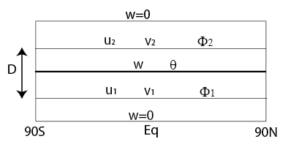
Lateral boundary conditions:
@$φ=±\frac{π}{2}$, $v_{1}=v_{2}=0$, $\frac{∂u_{1}}{∂φ}=\frac{∂u_{2}}{∂φ}=0$
The thermal forcing is parameterized in this model in the form of thermal relaxation, $\frac{1}{τ}\left(θ'_{E}−θ'\right)$ with $θ_{E}^{'}=Δ\left[\frac{1}{2}−{\text{sin}}^{2}\left(φ−φ_{o}\right)\right]$
Assume that surface friction is the only net damping effect, $−k{\vec{v}}_{1}$.
There is frictional exchange of momentum between the upper and lower layers; $−κ\left({\vec{v}}_{2}−{\vec{v}}_{1}\right)$ at the upper level and $κ\left({\vec{v}}_{2}−{\vec{v}}_{1}\right)$ at the lower level .
(b) Cast the equations in part (a) to finite-difference form using center-difference scheme.
(c) Numerically integrate the equations obtained in part (b) for the following forcing and damping parameters of the annual mean Hadley circulation: $k=0\text{.}5×{\text{10}}^{−5}s^{−1}$, $κ=0\text{.}5×{\text{10}}^{−6}s^{−1}$, $τ=\text{20}\text{days}$, $φ_{o}=0$, $Δ=\text{80}K$

