**Guide to online resources**

1. THE NASA GATEWAY: NASA provides a unified gateway to US data centers, called DAACs (Distributed Active Archive Centers) at the NASA Earth Observation System Data and Information System (EOSDIS): <https://earthdata.nasa.gov/data>

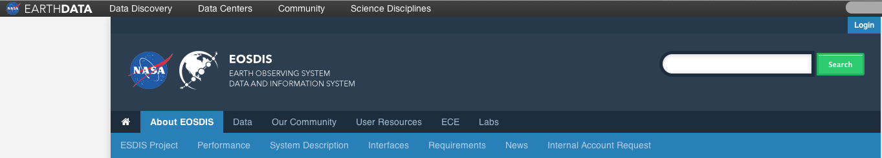

Further description of the NASA Earth Science Data system is provided at http://eospso.gsfc.nasa.gov/content/nasa-earth-science-data

“EOSDIS is designed as a distributed system, with major facilities at data centers located throughout the United States. These institutions are custodians of EOS mission data and ensure that data will be easily accessible to users. The EOSDIS data centers process, archive, document, and distribute data from NASA's past and current Earth-observing satellites and field measurement programs. Acting in concert, the data centers provide reliable, robust services to users whose needs may cross the traditional boundaries of a science discipline, while continuing to support the particular needs of users within the discipline communities. User services include:

* Assistance in selecting and obtaining data
* Access to data-handling and visualization tools
* Notification of data-related news
* Technical support and referrals”

There is a link to search and order tools: <https://earthdata.nasa.gov/data/data-tools/search-and-order-tools>, where the Reverb tool provides a powerful search engine that works across all the DAACS.

You may enter the system either as a guest or as a registered user. If you are planning intensive use of the system, I recommend getting an account. There is no charge for NASA data or registration, the registration URL is

<https://earthdata.nasa.gov/about-eosdis/system-description/user-registration-system-urs>

This EOSDIS User Account is valid across all of NASA's Earth Data Systems.

The EOSDIS portal provides an entry point to a large number of NASA and NASA-supported archives, including Giovanni, PO.DAAC, the National Snow and Ice Data Center, and the Alaska Satellite Facility. Giovanni and PO.DAAC provide online software for manipulation of data.

2. Giovanni (Geospatial Interactive Online Visualization ANd aNalysis Infrastructure)

<http://disc.sci.gsfc.nasa.gov/giovanni>

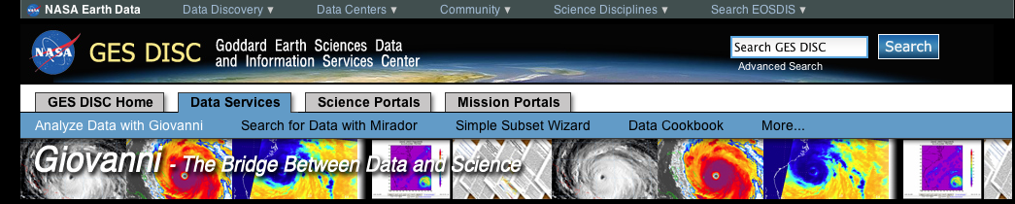

Giovanni is the NASA website and archive for a variety of ocean data, and is the primary site for biological data. The Ocean Portal is one of several portals available on this page. Within this portal, there are a large number of products from MODIS and SeaWiFS, as well as merged products from MODIS and SeaWiFS. These data include the band-ratio, MSP, and NOBM-assimilated products described in Chapter 6, as well as SST and a variety of other products. The interface is designed for visualization and analysis of global products. Users can generate plots, download images in gif, png and KMZ for some plot types, and download data in ASCII, HDF, and NetCDF format. The Giovanni user’s manual is available at <http://disc.sci.gsfc.nasa.gov/giovanni/additional/users-manual>.

The site does not include VIIRS data, which is provided in an EDR swath format at the NOAA CLASS website, described below. As the book describes, the NASA Ocean Biological Processing Group is assessing the quality of VIIRS ocean color products for use as Climate Data Records (CDRs) and to support the VIIRS Ocean Science Team (VOST). I hope this means that the VIIRS ocean color data will eventually be available in Giovanni.

Giovanni data tools. The menu on the home page provides access to four tools: a search function (Mirador), the Simple Subset Wizard that allows search across multiple data sets and centers, a Data Cookbook, which describes the use of these tools and the data formats, and the downloadable for desktop machines [Grid Analysis and Display System (GrADS)](http://www.iges.org/grads/) (<http://www.iges.org/grads/>).

3. PO.DAAC (Physical Oceanography Distributed Active Archive Center) is located at JPL. <http://podaac.jpl.nasa.gov>

(see also Facebook: <https://www.facebook.com/podaac?v=wall>)



Mission statement of PO.DAAC: “In addition to providing access to its data holdings, PO.DAAC acts as a gateway to data stored at other ocean and climate archives. This and other tools and services enable PO.DAAC to support a wide user community working in areas such as ocean and climate research, applied science and industry, natural resource management, policy making, and general public consumption.”

The core data sets available through PO.DAAC include gravity, SST, sea surface salinity, ocean winds, and sea surface topography. These are described at <http://podaac.jpl.nasa.gov/CoreMeasurements>

PO.DAAC is a major NASA/JPL website for ocean data. It contains at least a thousand data sets. The retrievable variables include SST, sea surface salinity, ocean wave height, CCMP (Cross-Calibrated Multi-Platform) winds, and the sea ice extent derived from the scatterometers. The user can search these data sets by level (L-2 (swath), L-3 (gridded), L-4 (blended)), by time and spatial resolution, by dates available, and by platform. For help choosing a dataset, there is an email link to a PO.DAAC data engineer. PO.DAAC also periodically announces the addition of new datasets. To be added to the announcement list, use this email link: [podaac@podaac.jpl.nasa.gov](mailto:podaac@podaac.jpl.nasa.gov?subject=Please%20add%20me%20to%20the%20mailing%20list!).

Visualization tool: State of the Ocean (SOTO) (<http://podaac-tools.jpl.nasa.gov/soto/>). For the 10 days before the present, SOTO displays a variety of variables (SST, salinity, chlorophyll, sea surface height) for illustrative purposes on Google Earth.

DATA Access and Display Tools, including Reverb, are described at <http://podaac.jpl.nasa.gov/dataaccess>

Data is available through ftp, LAS (Live Access Server), HITIDE (HIgh-level Tool for Interactive Data Extraction), OPeNDAP (Open-source Project for a Network Data Access Protocol), and THREDDS (Thematic Realtime Environmental Distributed Data Services).

FTP (<ftp://podaac-ftp.jpl.nasa.gov/>): JPL recommends the use of Browse and Search interfaces such as Reverb to access the datasets.

The LAS (Live Access Server) (<http://thredds.jpl.nasa.gov/las/getUI.do>): “LAS enables the web user to visualize data with on-the-fly graphics; request custom subsets of variables in a choice of file formats; access background reference material about the data (metadata); compare (difference) variables from distributed locations. LAS is a highly configurable web server designed to provide flexible access to geo-referenced scientific data.” Example below shows 10-m wind vectors for August 2005.

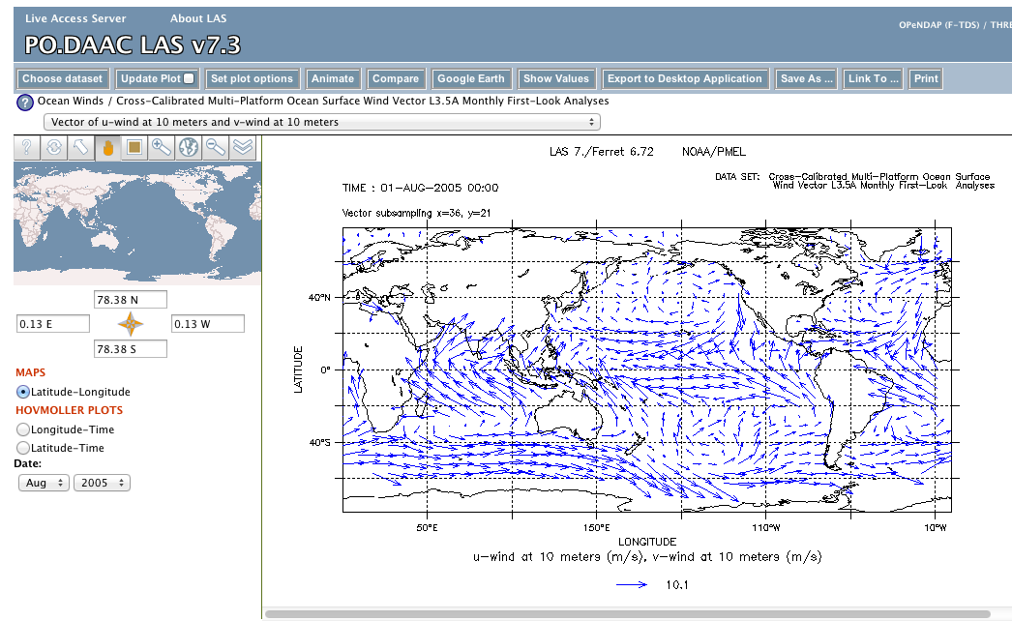

PO.DAAC HIgh-level Tool for Interactive Data Extraction (HITIDE) data subsetter (<http://podaac-tools.jpl.nasa.gov/hitide/>). This is a data subsetter that allows downloads by dataset, datarange, and region.

OPeNDAP (Open-source Project for a Network Data Access Protocol): The different data products such as sea surface salinity are catalogued in OPeNDAP. The GrADS Data Server uses the OPeNDAP protocol to provide subsetting and analysis services across the internet, and was developed by Peter Cornillon at the University of Rhode Island. “OPeNDAP enables remote data sets to be accessed through familiar data analysis and visualization packages, just as if they resided locally on the user's machine. OPeNDAP handles transport, translation and subsetting of data residing in most Earth science data formats. For a list of PO.DAAC data accessible through OPeNDAP, see [PO.DAAC OPeNDAP](http://opendap.jpl.nasa.gov/opendap/) data (http://opendap.jpl.nasa.gov/opendap/). For the complete list of OPeNDAP Datasets and updates on the system, please see the [Unidata OPeNDAP Datasets list](http://www.opendap.org/) (http://www.opendap.org). OPeNDAP data are accessible to users through [MATLAB](http://www.mathworks.com/products/matlab/), [IDL](http://www.exelisvis.com/ProductsServices/IDL.aspx), [Ferret](http://ferret.pmel.noaa.gov/Ferret), [Live Access Server](http://ferret.pmel.noaa.gov/LAS).”

[THREDDS (Thematic Realtime Environmental Distributed Data Services](http://www.unidata.ucar.edu/software/thredds/current/tds/TDS.html)) (<http://podaac.jpl.nasa.gov/podaac_thredds>)

“The THREDDS (Thematic Realtime Environmental Distributed Data Services) project is developing middleware to bridge the gap between data providers and data users. The goal is to simplify the discovery and use of scientific data and to allow scientific publications and educational materials to reference scientific data.”

“The [PO.DAAC THREDDS Data Server (TDS)](http://thredds.jpl.nasa.gov/thredds/catalog.html) serves the contents of selected PO.DAAC datasets through a web catalog service that allows users to select data (granule) from a hierarchal tree (<http://www.unidata.ucar.edu/software/thredds/current/tds/TDS.html>). This tree mirrors the PO.DAAC FTP site or predefined yearly virtual datasets (data aggregated by time) for subsetting or viewing through the provided data access services. The [software for manipulating or displaying NetCDF Data](http://www.unidata.ucar.edu/software/netcdf/software.html) is maintained by Unidata.” The panel below shows the Aquarius THREDDS catalogue.

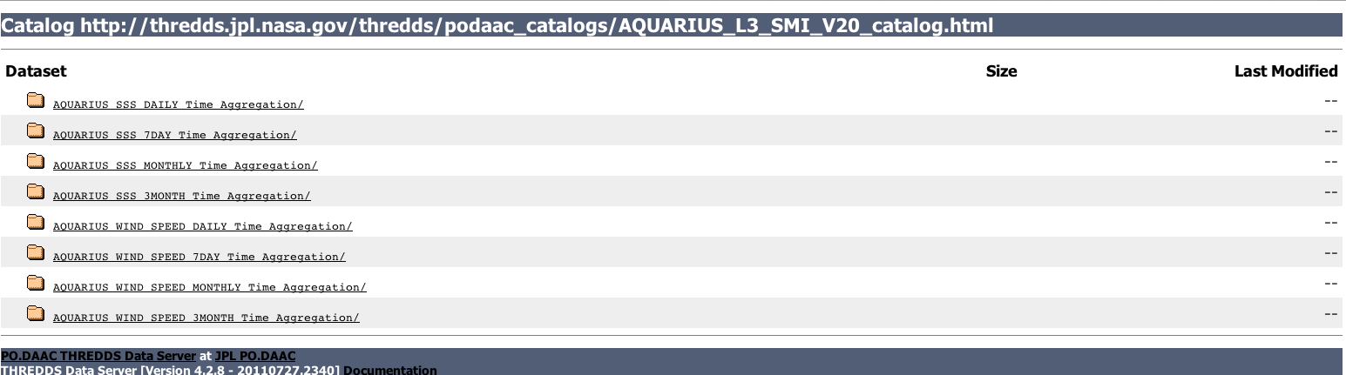

PO.DAAC datasets by satellite

GRACE data is described at <http://grace.jpl.nasa.gov>, with the monthly solution available at <http://grace.jpl.nasa.gov/data/GRACEMONTHLYMASSGRIDSOCEAN/>

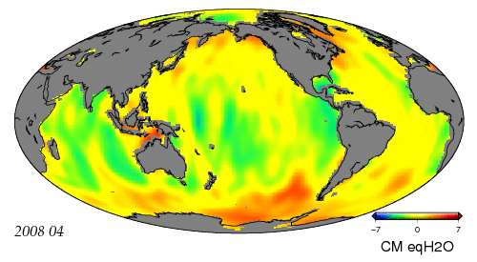

Ocean equipotential surface derived from GRACE (Figure courtesy NASA PO.DAAC)

AQUARIUS sea surface salinity (<http://podaac.jpl.nasa.gov/aquarius>)

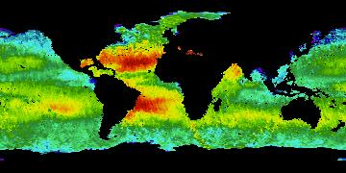

(7-day average sea surface salinity average, January 1, 2013 (courtesy NASA PO.DAAC)

SST (<http://podaac.jpl.nasa.gov/datasetlist?search=Sea%20Surface%20Temperature>)

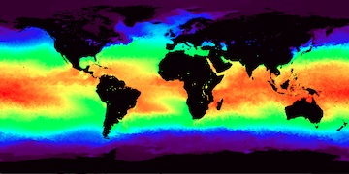

Example of GHRSST Level 4 MUR (Multiscale Ultrahigh Resolution) Global Foundation Sea Surface Temperature (courtesy NASA PO.DAAC)

Winds (<http://podaac.jpl.nasa.gov/OceanWind>)

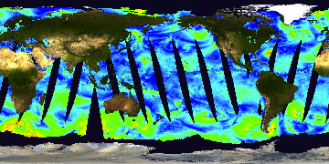

Example of QuikSCAT Level 2B Ocean Wind Vectors in 12.5km Slice Composites Version 3 (courtesy NASA PO.DAAC)

Sea Surface Topography (http://podaac.jpl.nasa.gov/OceanSurfaceTopography)

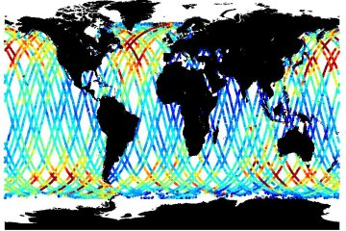

Example of Jason-1 Altimeter Geophysical Data Record (GDR) NetCDF (courtesy NASA PO.DAAC)

4. NSIDC (National Snow and Ice Data Center): <http://nsidc.org>

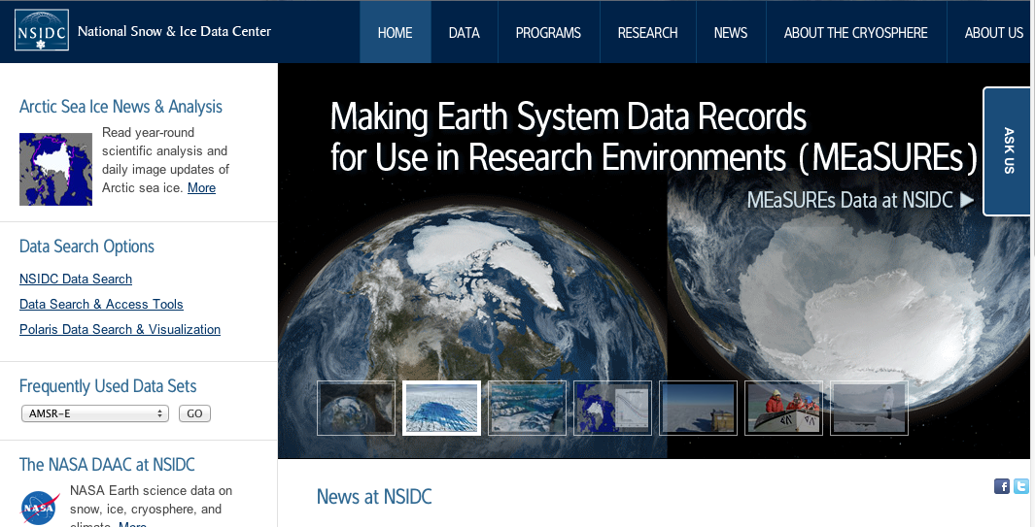

“The NSIDC Distributed Active Archive Center (DAAC) processes, archives, documents, and distributes data from NASA's past and current Earth Observing System (EOS) satellites and field measurement programs. The NSIDC DAAC focuses on the study of the cryosphere.”

Data can be downloaded via ftp, where registration is recommended, or through the Reverb search engine. The Arctic sea ice news is at <http://nsidc.org/arcticseaicenews/>

5. Alaska Satellite Facility (<https://www.asf.alaska.edu>)

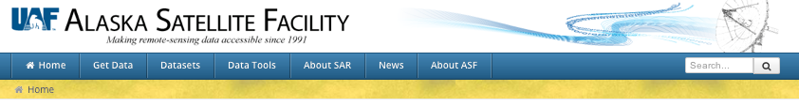

This is the NASA site for obtaining SAR data. The difference between this site and the other DAAC’s described above is that because this data is provided by countries other than the United States, some of this data is either not accessible, or accessible only by submission of a proposal or with preconditions. From the website, “Some synthetic aperture radar (SAR) data are immediately downloadable from ASF's data-access interface Vertex, or from other points on the ASF website. Additional downloadable data have been acquired in partnership with other nations' space programs. Those datasets require proposals or preconditions. In addition some datasets have residency requirements for scientists or principal investigators.”

The ASF provides image galleries, a guide for newcomers, a search engine called Vertex, and a command line search engine through an Application Programming Interface (API), and makes available a variety of mapping tools. Chapter 12 of the book shows several examples of SAR imagery.

6. RAPID RESPONSE: LANCE and LANCE rapidfire:

LANCE (Land and Atmosphere Near real-time Capability for EOS) (<https://earthdata.nasa.gov/tags/lance>) provides a variety of rapid response downloadable imagery for severe storms, wildfires, and other extreme events.

LANCE rapidfire (<http://rapidfire.sci.gsfc.nasa.gov/cgi-bin/imagery/realtime.cgi>) provides the MODIS visible swath data for the past 24 hours that is available within 3 hours of acquisition. These data are available for download at a variety of resolutions, where registration is required for downloading. The rapidfire data are used in cruise and aircraft flight planning. The image below shows a NASA MODIS true color image from the rapidfire website for 12 January 2014 (courtesy NASA).

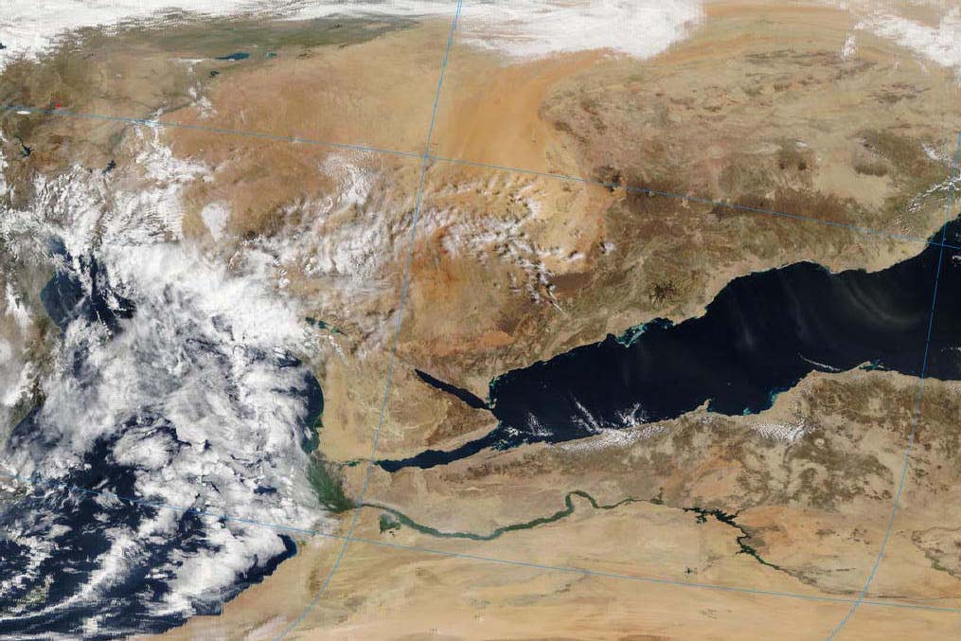

7. The NASA Visible Earth website (<http://visibleearth.nasa.gov>) is a catalogue of historical and extreme weather and ocean imagery, where the images can be easily downloaded in tif or jpg formats. The example below is a VIIRS image of North Africa and Europe (courtesy NASA Visible Earth).

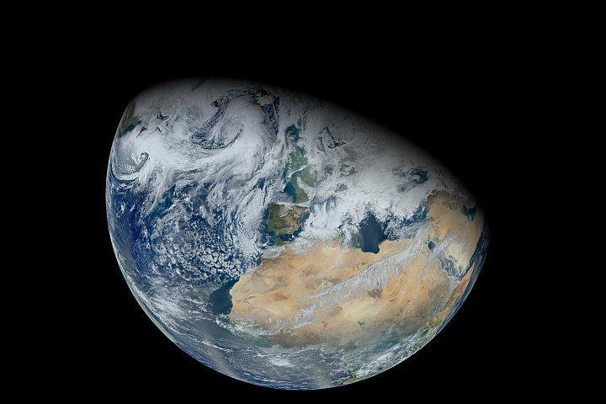

8. Reverb (not an acronym) NASA data search tool (<http://reverb.echo.nasa.gov/reverb/#utf8=✓&spatial_map=satellite&spatial_type=rectangle>): Access to NASA Earth Sciences data is provided by the NASA EOS Clearing House (ECHO) (<https://earthdata.nasa.gov/echo>) through Reverb. This allows the user to search for data across all of the NASA DAACs (Distributed Active Archive Centers). A Reverb tutorial is at <http://www.echo.nasa.gov/reverb/tutorial/Tutorial.html>.

9. Remote Sensing Systems (REMSS) is a private company that is a source of microwave data: <http://www.remss.com>

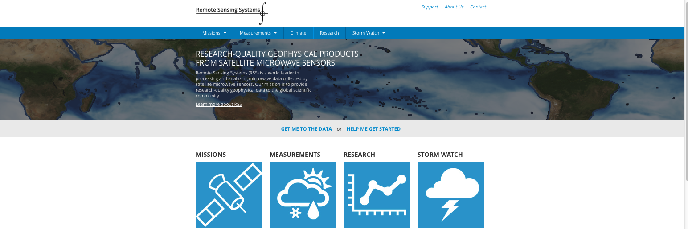

“Remote Sensing Systems (RSS) is a scientific research company located in Northern California, specializing in satellite microwave remote sensing of the Earth. Established in 1974 by Frank J. Wentz, Remote Sensing Systems, presently consists of a team of atmospheric, oceanic, and earth scientists and support personnel.  RSS is a world leader in processing and analyzing microwave data from satellite microwave sensors.  We specialize in algorithm development, instrument calibration, ocean product development, and product validation.  We have worked with more than 30 satellite microwave radiometer, sounder, and scatterometer instruments over the past 40 years. Currently, we operationally produce satellite retrievals for [SSMIS](http://www.remss.com/missions/ssmi), [TMI](http://www.remss.com/missions/tmi), AMSR2, [WindSat](http://www.remss.com/missions/windsat), and ASCAT. The geophysical retrievals obtained from these sensors are made available in near-real-time (NRT) to the global scientific community and general public via [FTP](ftp://ftp.remss.com) and this [web site](http://www.remss.com/support/data-shortcut).”

RSS is the primary source for the processing and posting of passive microwave data. Data on their website comes from the satellites described in Chapters 8, 9 and 11 and is available via ftp and as browse pre-rendered images. The data includes all available passive microwave data, which is reprocessed so that the data is a climate data record (CDR). To obtain data, either login as a guest or as a registered user, with registration recommended. RSS maintains an instrument alert email list that can be signed up for at [support@remss.com](mailto:support@remss.com). To register, use "add me to the mail list" as the subject line and specify the instruments you wish to be informed about in the body of the message. RSS also provides an excellent summary of Radio Frequency Interference (RFI) at <http://www.remss.com/about/projects/radio-frequency-interference>

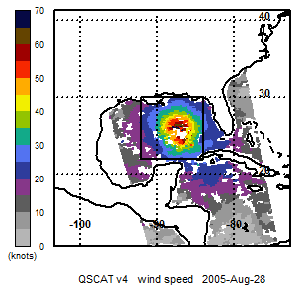

"This image of Hurricane Katrina was obtained from Remote Sensing Systems, [www.remss.com/storm-watch](http://www.remss.com/storm-watch).  Data production is sponsored by NASA Earth Science."

10. NOAA CLASS (Comprehensive Large-Array Stewardship System)

(<http://www.class.ncdc.noaa.gov/saa/products/welcome>)



This site contains the NOAA-specific products, such as VIIRS, Pathfinder SST, and data from the geostationary satellites.

On this site, the VIIRS data can be downloaded band-by-band, or as a variety of products, such as swath data for the Environmental Data Records (EDR) of VIIRS Ocean Chlorophyll. No VIIRS CDRs are available, and the gridded ocean color products are restricted and not available to this user. Registration is required for search and preview images. After registration, the data is available for download, with for SST, preview images of downloaded data. As described in the help file website given below, the Suomi-NPP data are also available via ftp: <http://www.class.ncdc.noaa.gov/release/data_available/npp/npp_ftpserver.htm>

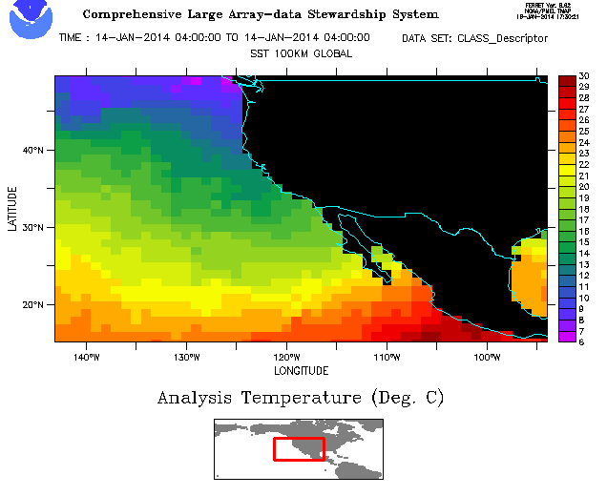

Example of preview SST image (courtesy NOAA CLASS)

11. MyOcean: the European Union Ocean Monitoring and Forecasting website: <http://www.myocean.eu>

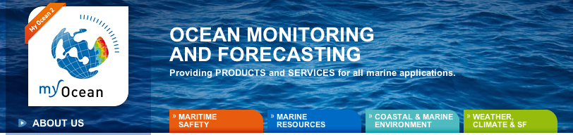

“The MyOcean objective is to provide to users the best generic information available on the state of the ocean. MyOcean (2009-2012) and now MyOcean2 (2012-2014) are committed to develop and run a European service based on a worldwide capacity for ocean monitoring and forecasting, using observation data, modeling and assimilation systems.”

Registration is required for this open and free service, which provides access to a variety of biological and physical products across the EU. Note that the user logs in just before downloading data, not on the home page, and that the browser Safari works poorly on the site. The site provides on-line tutorials on the use of the site, includes biogeochemical products accessible on a gridded weekly scale, and a series of graphics tools for data manipulation.

Example of a near real time ocean chlorophyll data set derived using the FireFox browser (courtesy MyOcean website, generated using MyOcean Products). The data site also provides latitude-longitude profiling tools.

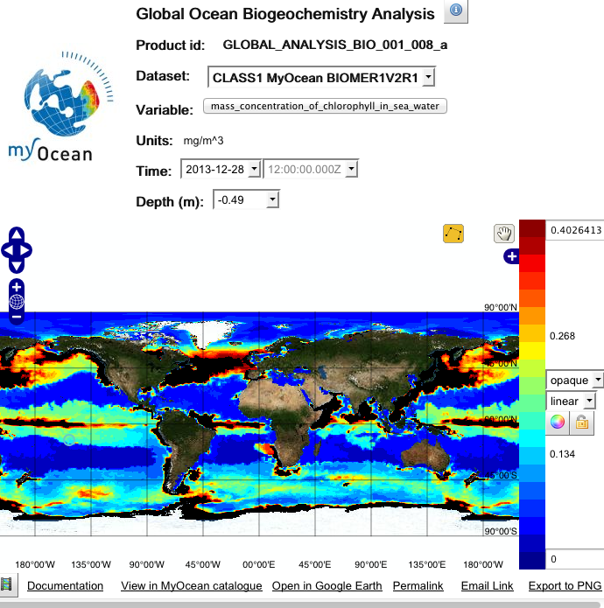

12. Other portals from the CEOS (Committee on Earth Observation Satellites) website

<http://gcmd.nasa.gov/KeywordSearch/Keywords.do?Portal=idn_ceos_svcs&KeywordPath=ServiceParameters%7CMETADATA+HANDLING%7CDATA+DISCOVERY&MetadataType=1&lbnode=mdlb5>



This site provides links to thirty data portals, some of which are already described. These include two links to the India Space Research Organization (ISRO). Thus far, the posted ISRO data appears to be land imagery.

13. GrADS (The Grid Analysis and Display System), downloadable desktop software tools. GrADS is a free software package for manipulation of remote sensing data (<http://www.iges.org/grads/>).

GraDS is “an interactive desktop tool that is used for easy access, manipulation, and visualization of earth science data” where the software is downloadable for Mac, PC and UNIX. “GrADS is free software. You can redistribute it and/or modify it under the terms of the GNU General Public License. GrADS is distributed in the hope that it will be useful, but without any warranty; without even the implied warranty of merchantability or fitness for a particular purpose.”