GUIDE
for using supplementary materials to the book
Electrical Dynamics of the Dendritic Space by Korogod S.M. and Tyc-Dumont S. with the interactive visualization tool NeuronViewer
(developed by Kukushka V.I. and Korogod S.M.)

Part II. PLAYING WITH IMAGES IN THE DISPLAY WINDOWS

- General notes
There are four coupled display windows for simultaneous visualization of data plots of four types (Fig. 1). Each display window has the Title bar on its top with the window heading on the left and three control buttons (minimizing, maximizing and closing) on the right that is standard for MS Windows. The same standard is kept for manipulations with the display windows (activation, dragging, resizing, minimizing, maximizing, and closing). The window heading, 1D, 2D, 3D, or F(t) corresponds to the type of the displayed plot and to the label on its opening button in “Data Control” window. You can open any combination of the display windows by left-clicking on the correspondingly labeled buttons in the “Data Control” window (see p. 4.9 and Fig. 10 in part I of the Guide).

- 1D display window
This window displays the superposition of profiles of the membrane voltage as a function of a unique spatial dimension, the path distance from the origin (that is the zero site of the somatic cylinder) along the neuron parts (e.g. dendrites, axon). This display window is controlled from “Data Control” window only. The plots are shown for the elements selected from the list in the bottom of the “Data Control” window. Checking or un-checking the check-box near the name of a part adds or removes the voltage profiles corresponding to this part. Screenshots in Fig. 1 show an example: the data for the element Dendrite11 (the apical dendrite of the pyramidal neuron) are displayed in the upper screen when this element is checked-in but are not in the lower screen when the corresponding check-box in “Data Control” window is empty. The plots have common abscissa (the path distance, in micrometers) and ordinate (the membrane potential, in mV). The units are not displayed. For the abscissa, the lower limit is fixed at zero (the somatic origin) and the upper limit is defined automatically according to the path length of the longest part in the display check-list. For the ordinate, the lower and upper limits of the displayed range correspond to the values indicated in the left and right “Variable scale” boxes in the “Data Control” window. The selected voltage range is color-coded by a multi-color palette so that the segments of the curves are correspondingly painted. See also p. 4.3 of part I (how to change the palette) and pp. 3 and 4 of part II (how to show the palette in the coupled 2D and 3D display windows).

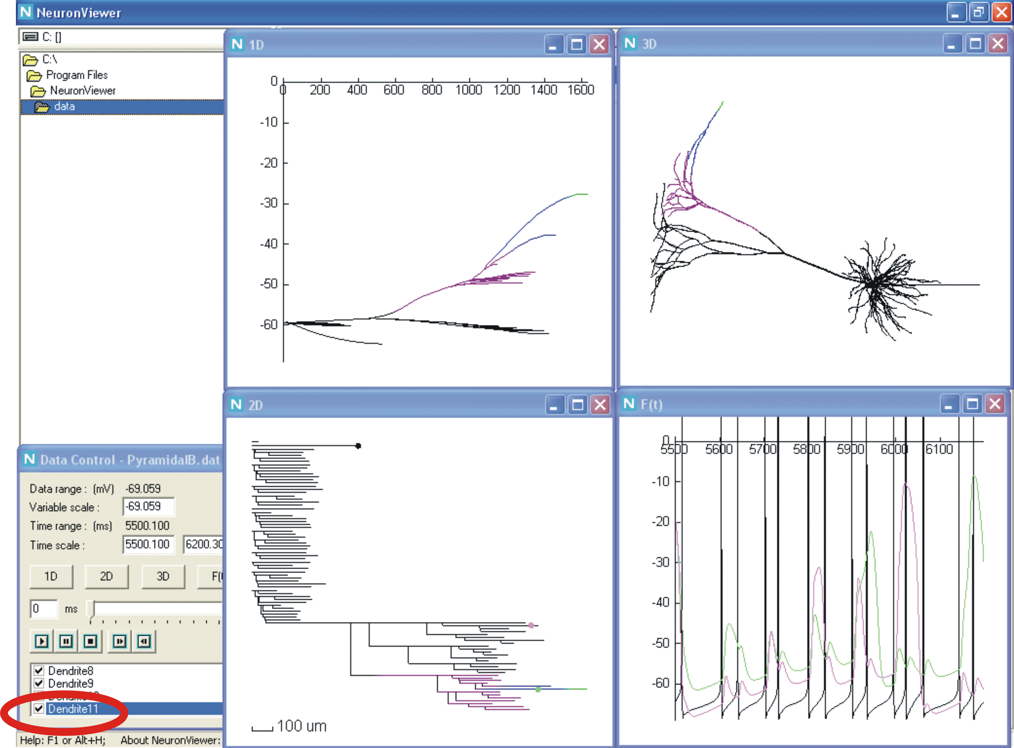

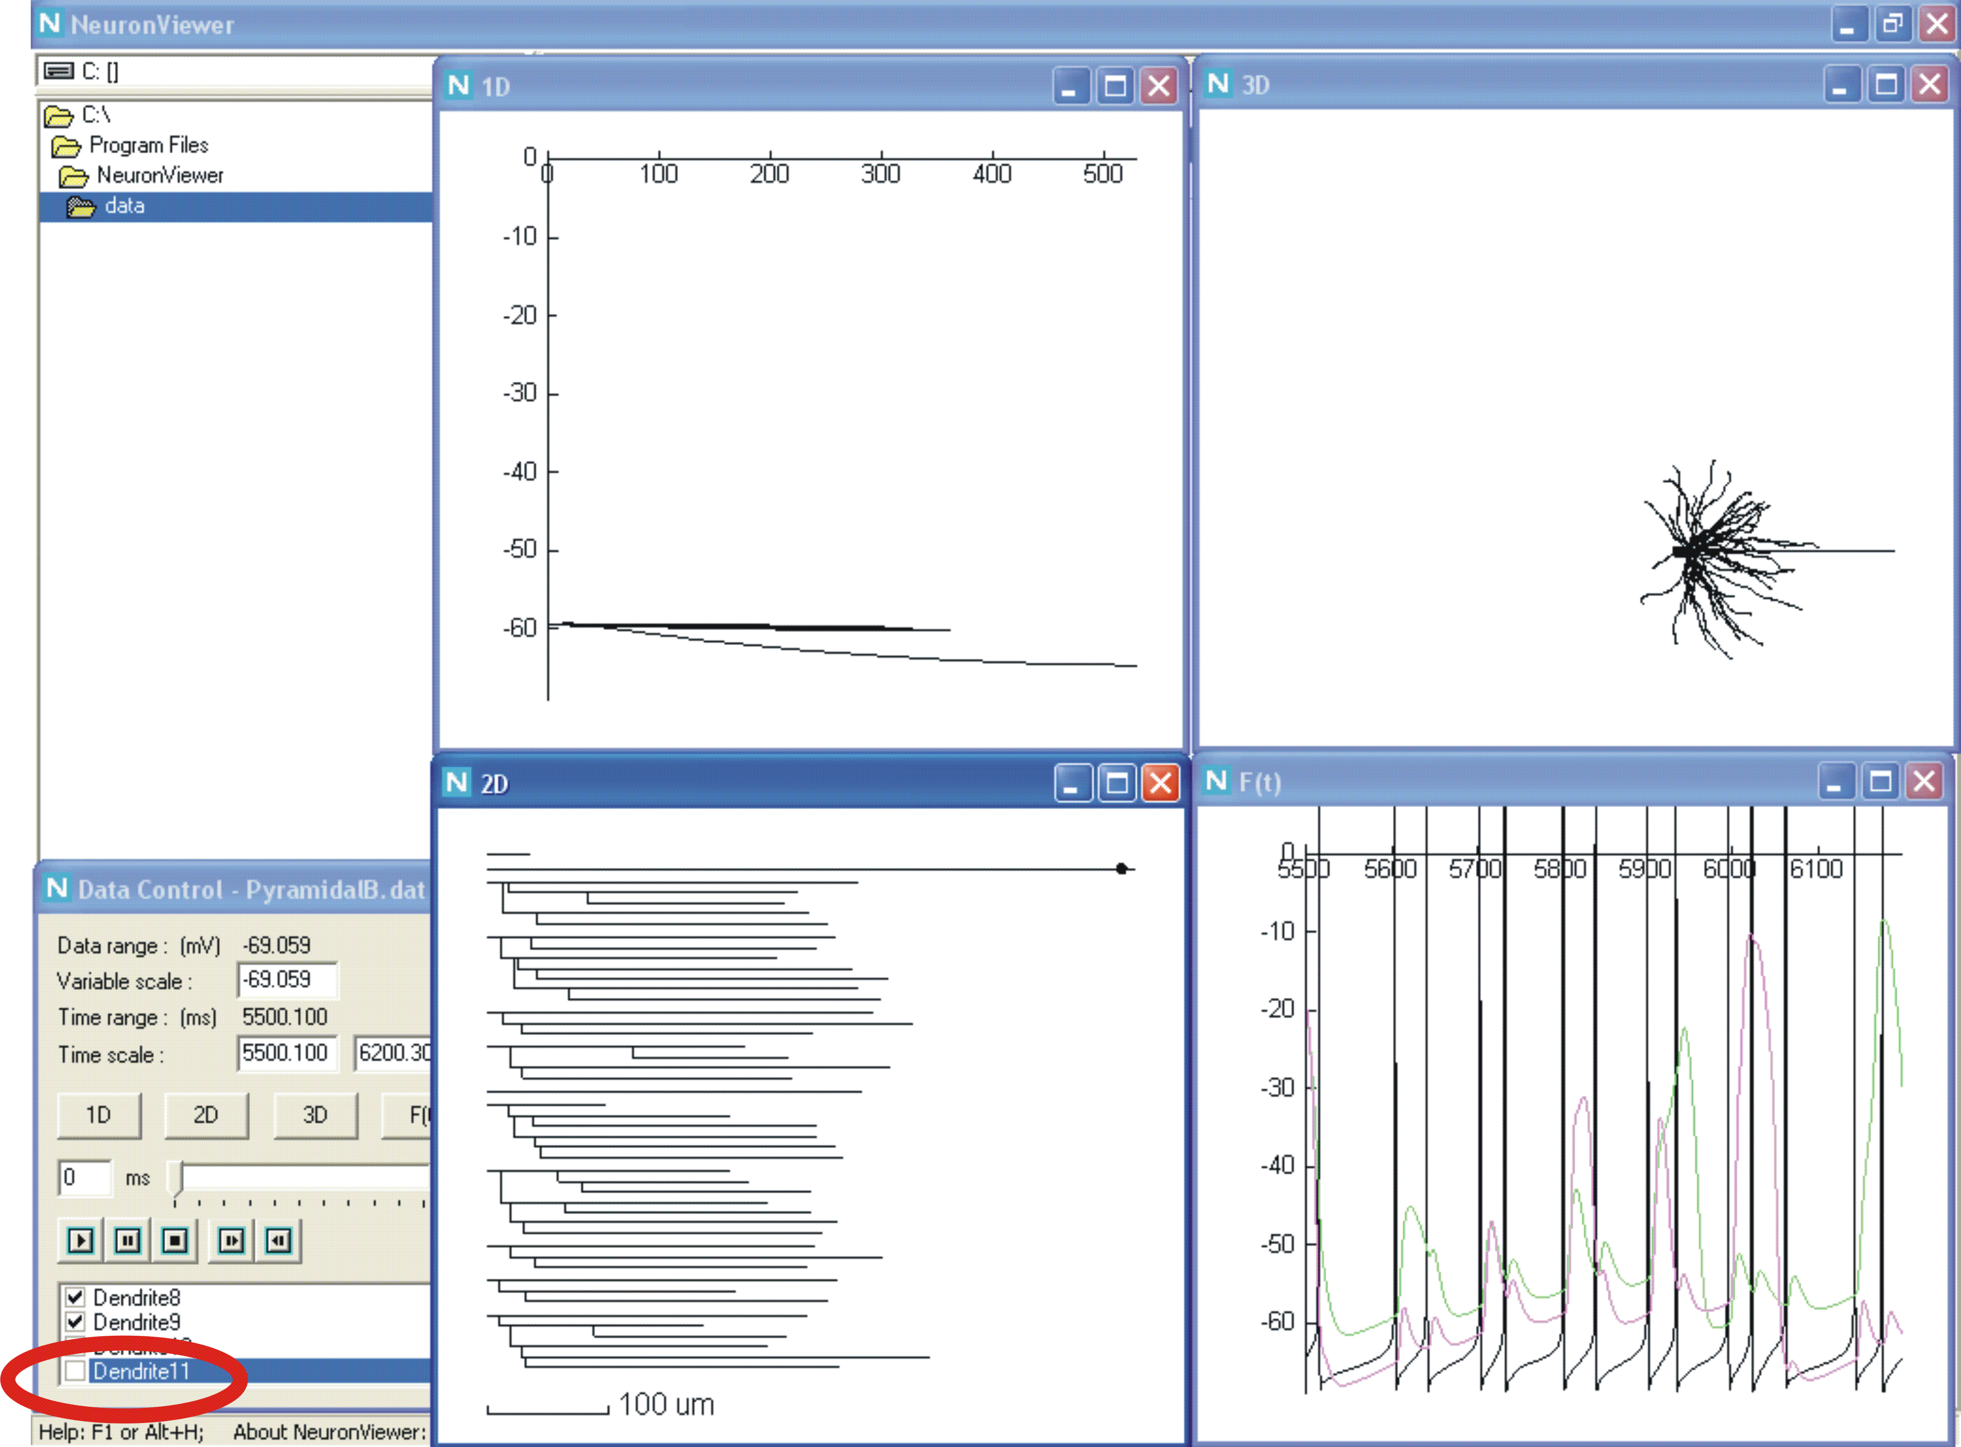
Fig. 1. Adding or removing images by checking or un-checking the neuron parts listed in “Data Control” window.

- 2D display window
This window displays the voltage profiles (the same as those in 1D window) mapped on the dendrogram. The dendrogram represents any element of the structure including the soma, axon and dendrites. The elements are represented by horizontal lines, of which the lengths are scaled relative to the 100-micrometer calibration bar in the bottom. The diameter is not scaled. Vertical lines show the connections (their lengths do not have any meaning).
The window is controlled externally, from the “Data Control” window and internally, with the use of the own two-level menu (Fig. 2).
Selecting and unselecting the elements of the structure in the “Data Control” window are common for all the display windows including 2D: the dendrogram of the corresponding element appears and disappears. The images of the selected elements are automatically distributed over the display window space with updating the calibration bar (e.g. compare the upper and lower screenshots in Fig. 1).
The 2D window has additional control elements available via the two-level context menu (Fig. 2). The first-level menu called by right-clicking inside the window contains four items (lines):
- Select a site and..
- Show recording sites
- Show palette
- Hide palette

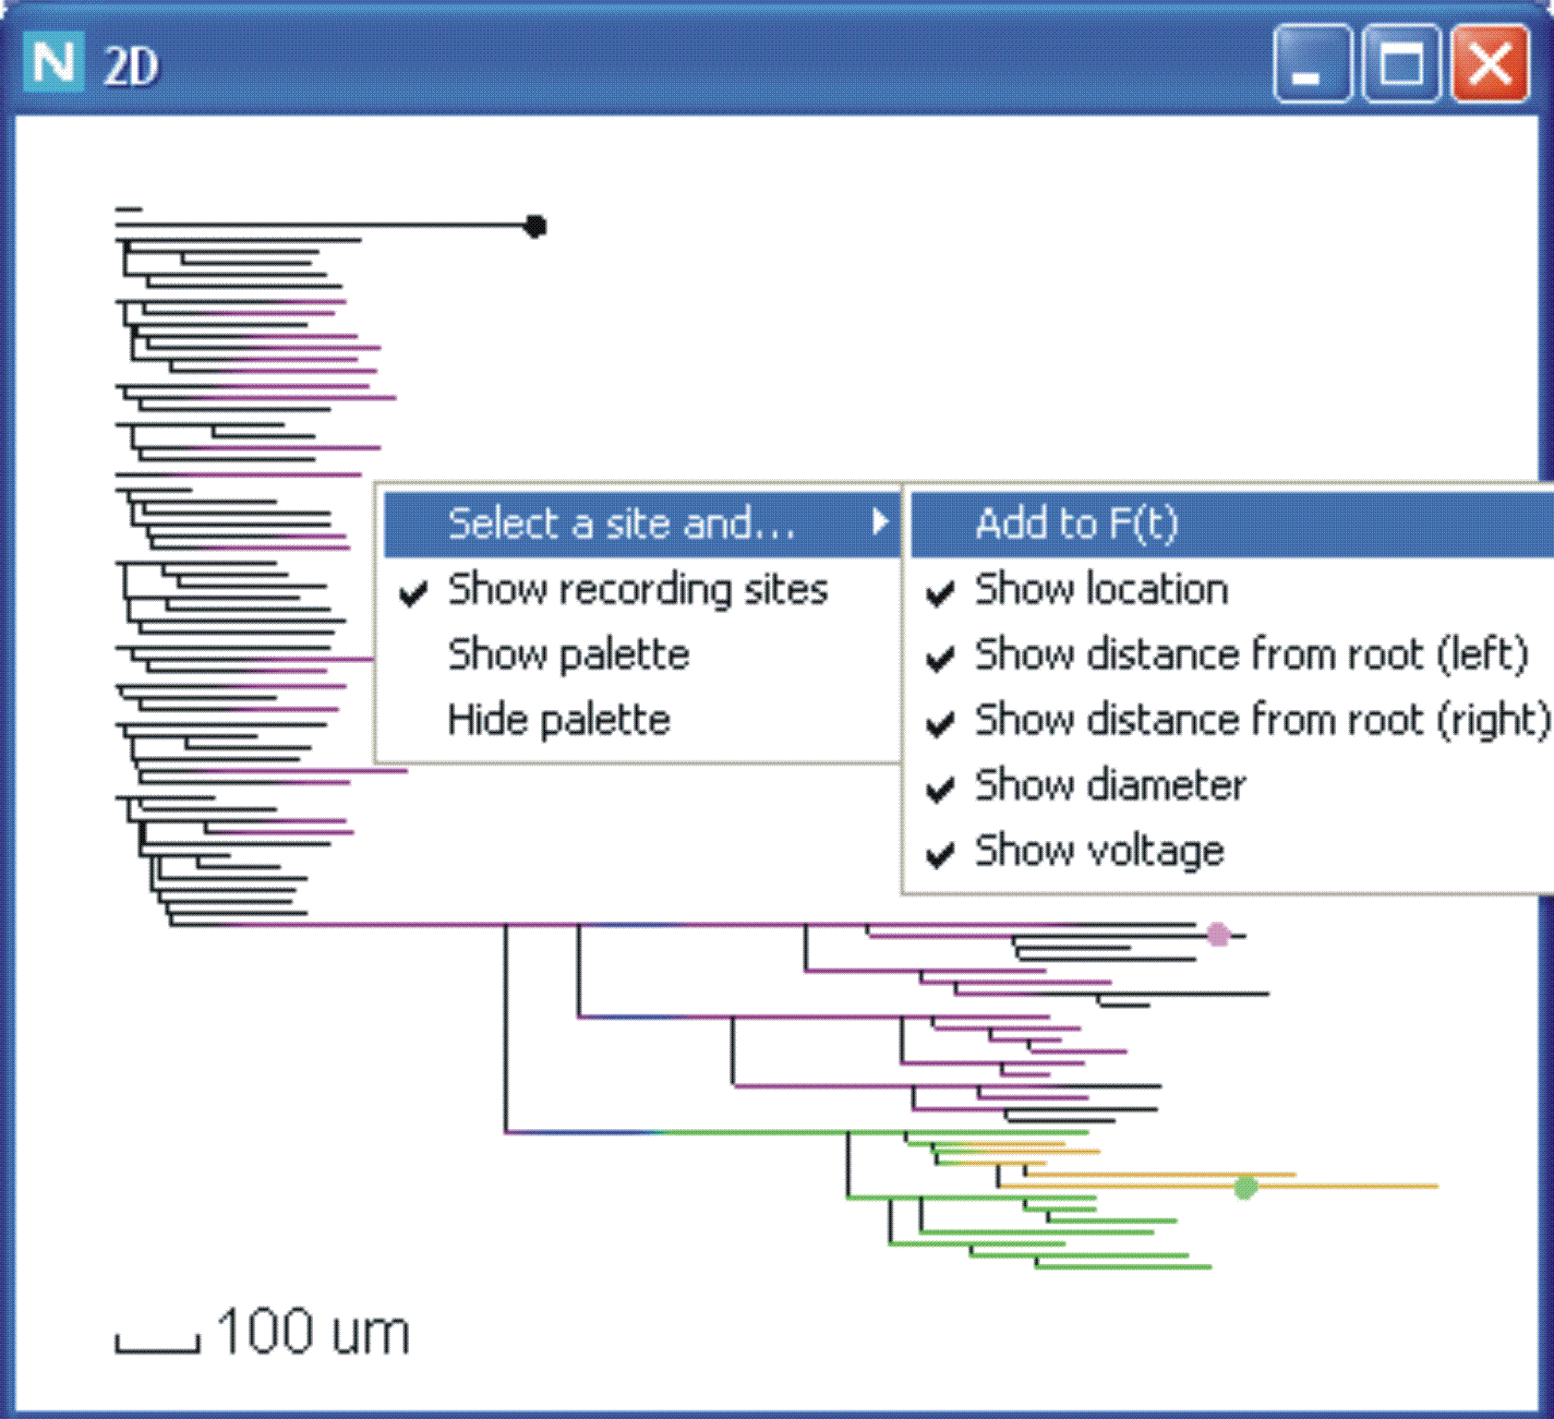

Fig. 2. Two-level menu to control the visualization in 2D display window.
The first item “Select a site and..” of the first-level menu determines operations performed when the pointer is left-clicked at a certain site on the dendrogram (this site is thus “selected”). Positioning the pointer on “Select site and..” item opens the second-level menu, which contains six items (Fig. 2):
- Add to F(t)
- Show location
- Show distance from root (left)
- Show distance from root (left)
- Show diameter
- Show voltage.
The activated (marked by the check-mark on the left) items of the second-level menu determine, which operations will be performed when the user left-clicks at a site on the dendrogram (see Table 1).

Table 1. Second-level menu items and corresponding operations performed when you point and left-click at a dendrogram site
Activated item | Operation
Add to F(t) | Adding to the list of the sites, for which voltage vs. time plots are displayed in the F(t) window
Show location | Displaying the name of structural element and the relative coordinate (like in NEURON simulator)
Show distance from root (left) | Displaying the path distance (in micrometers) from the structure origin to the left end of the segment containing the selected site
Show distance from root (right) | Displaying the path distance (in micrometers) from the structure origin to the right end of the segment containing the selected site
Show diameter | Displaying the diameters (in micrometers) at the left and right ends of the segment containing the selected site. The values are separated by comma.
Show voltage | Displaying the membrane potential (in millivolts) at the selected site
To activate (deactivate) an item at this level:
- open the first-level menu by right-clicking inside the display window;
- locate the pointer on the first item “Select a site” to open the second-level menu;
- check the state of the item: the item has the check-mark on the left if activated and no mark otherwise;
- left-click on the item to change the state and close the menus;
- if you don’t need to change the item state, then left-click outside the menu.
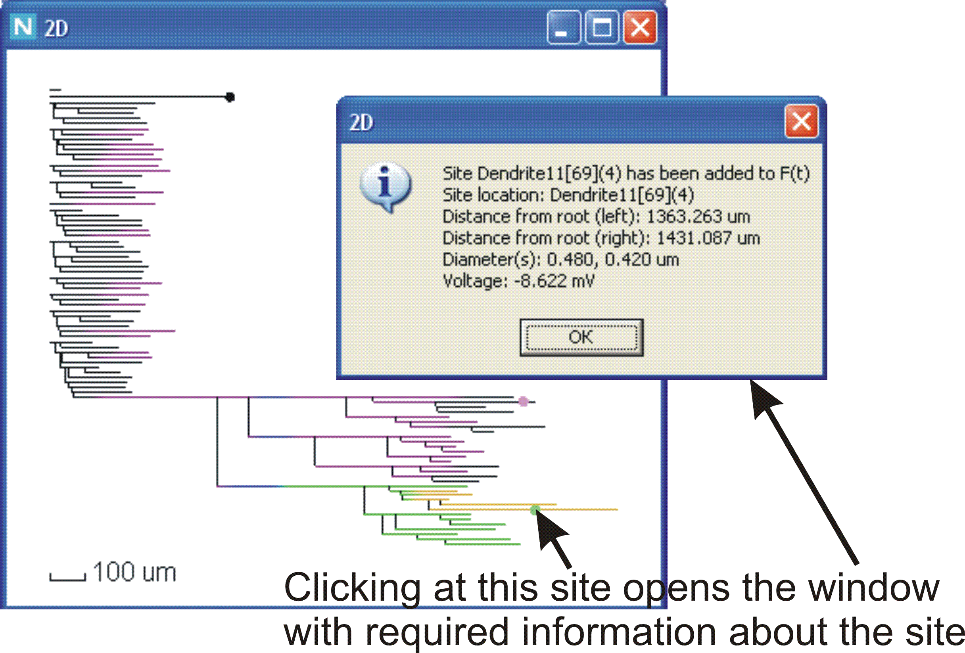
Fig. 3. Adding a site to the recording list and/or getting information about the site. Each selected site is shown by the dot on the dendrogram.

Left-clicking at a selected dendrogram opens the information window, which reports about adding the site to the list of plots in the F(t)-window and/or displays the requested data corresponding to the activated items of the second-level menu (Fig. 3).

Positioning the pointer and left-clicking on the second item “Show recording sites” of the first-level menu activates or deactivates this item that is signaled by, respectively, presence or absence of the check-mark on the left. If the item is activated, then the location of each selected voltage-time recording site is indicated by the corresponding dot on the dendrogram (Figs. 2 and 3). Initially, the indicator dots are black. However, they could be painted in a certain color, which is selected in the F(t) window for the corresponding voltage-time plot (see below).
Positioning the pointer and left-clicking on the third item “Show palette” of the first-level menu leads to displaying the color-coding palette (Fig. 4). The coded voltages in millivolts are indicated on the right of the corresponding color box. The value of the voltage corresponds to the bottom of the color box. In the 2D display window, the bottom-left corner of the vertical palette bar is located at the point of the pointer when the first-level menu is open by right-click. It is also the top-left corner of the menu box. Hence, to put the palette at a desired place:
- put the pointer at this place;
- right-click to open the first-level menu;
- put the pointer on the “Show palette” item and left-click.
The menu is closed and the palette appears.

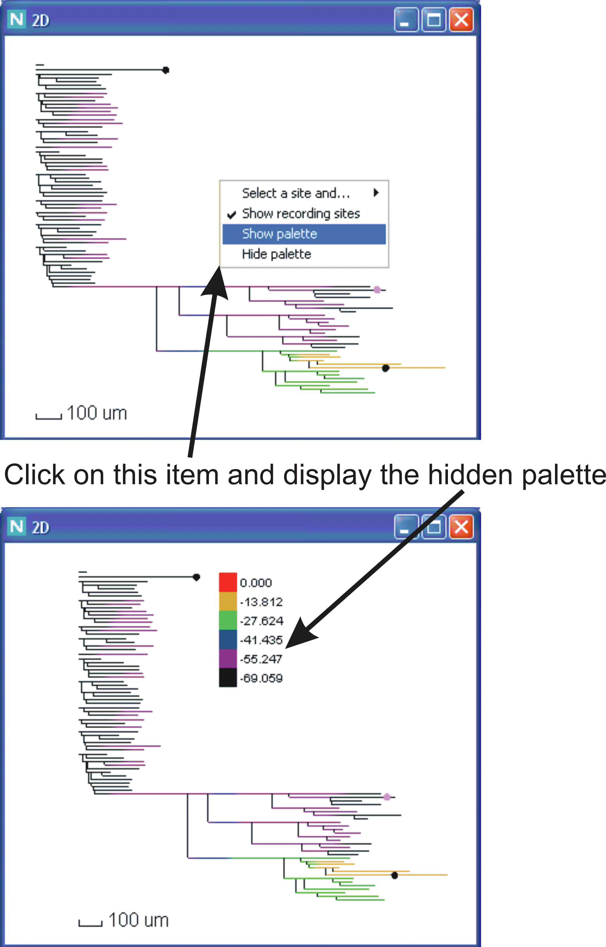

Fig. 4. Showing and hiding the color-coding palette in 2D display window
Positioning the pointer and left-clicking on the fourth item “Hide palette” of the first-level menu hides the displayed palette

- 3D display window
This window displays the voltage profiles (the same as those in 1D and 2D window) mapped on the three-dimensional image of the simulated neuron. Like the 2D window, the 3D window is controlled externally, from the “Data Control” window and internally, with the use of the own two-level menu. Selecting and unselecting the elements of the structure in the “Data Control” window is common for all the display windows including 3D: as a result the 3D image of the corresponding neuronal part appears and disappears (see Fig. 1).

The 3D window has additional control elements available via the two-level context menu (Fig. 5).

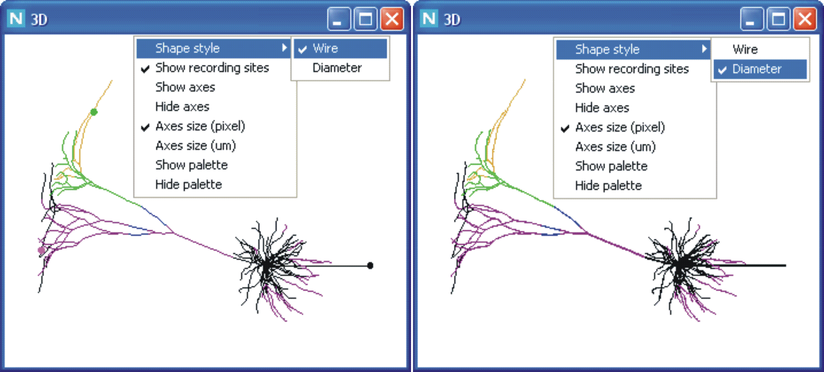
Fig. 5. Two-level menu to control the visualization in 3D display window.

The first-level menu called by right-clicking inside the window contains eight items:
- Shape style
- Show recording sites
- Show axes
- Hide axes
- Axes size (pixels)
- Axes size (um)
- Show palette
- Hide palette
Positioning the pointer on the first item “Shape style” of the first-level menu opens the second-level menu, which contains two items (lines):
- Wire
- Diameter

Activation of either item deactivates another one. The activated item of the second-level menu determines the representation of the 3D image by lines of either uniform (item “Wire,” Fig. 5, left) or non-uniform (item “Diameter,” Fig. 5, right) thickness. In the latter case for each displayed segment the line thickness is proportional to the diameter read from the data file. To activate an item (and simultaneously deactivate another one) at this level:
- open the first-level menu by right-clicking inside the display window;
- locate the pointer on the first line “Shape style” to open the second-level menu;
- check the state of the items: the item has the check-mark on the left if activated and no mark otherwise;
- left-click on the un-checked item to change the state and close the menus;
- if you don’t need to change the items state then left-click outside the menu.

The use of the second item “Show recording sites” of the first-level menu in 3D window is the same as that of the identical item in 2D window (Fig. 3): showing or not showing the markers of the recording sites in the image of simulated neuron in the given display window (Fig. 5, left or right window, respectively).
Positioning the pointer and left-clicking on the third item “Show axes” of the first-level menu leads to displaying the calibration bars oriented along X, Y and Z axes (Fig. 6). The initial orientation is determined by 3D coordinates of the displayed image read from the data files: it is horizontal for the X-bar (red), vertical for the Y-bar (green), and “normal to the window” for the Z-bar (blue) (Fig. 6, right window). The user can change or restore the initial orientation by mouse-driven or keyboard-driven operations. The size of the calibration bars is determined in pixels or micrometers (see below Fig. 7 (A) or (B), respectively).

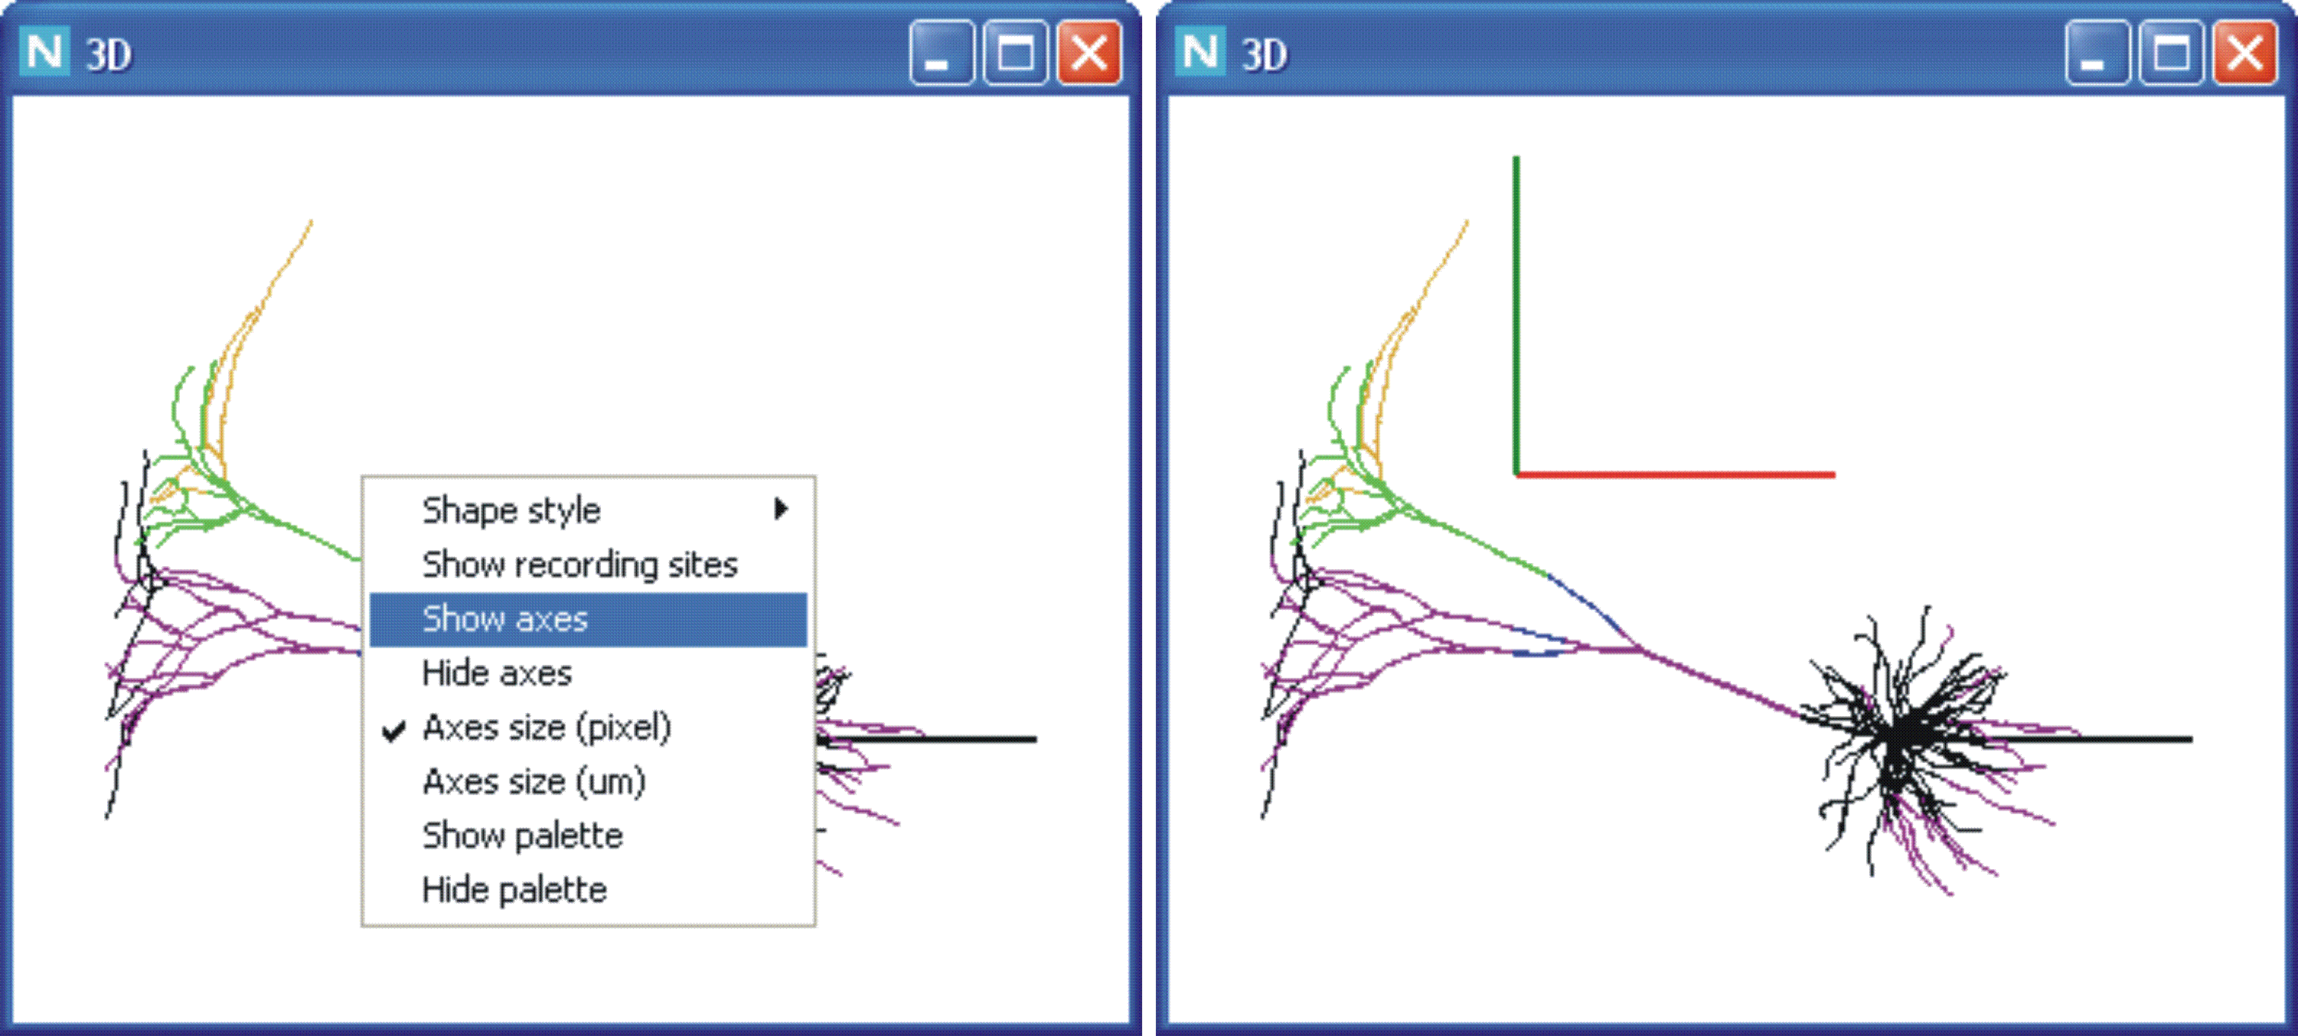
Fig. 6. Selecting the first-level menu item “Show axes” (left) displays the XYZ calibration bars (right) measured in pixels (this example) or micrometers depending the activated item “Axes size (pixel)” or “Axes size (um)”, respectively.

Positioning the pointer and left-clicking on the fourth item “Hide axes” of the first-level menu hides the displayed calibration bars and closes the menu.

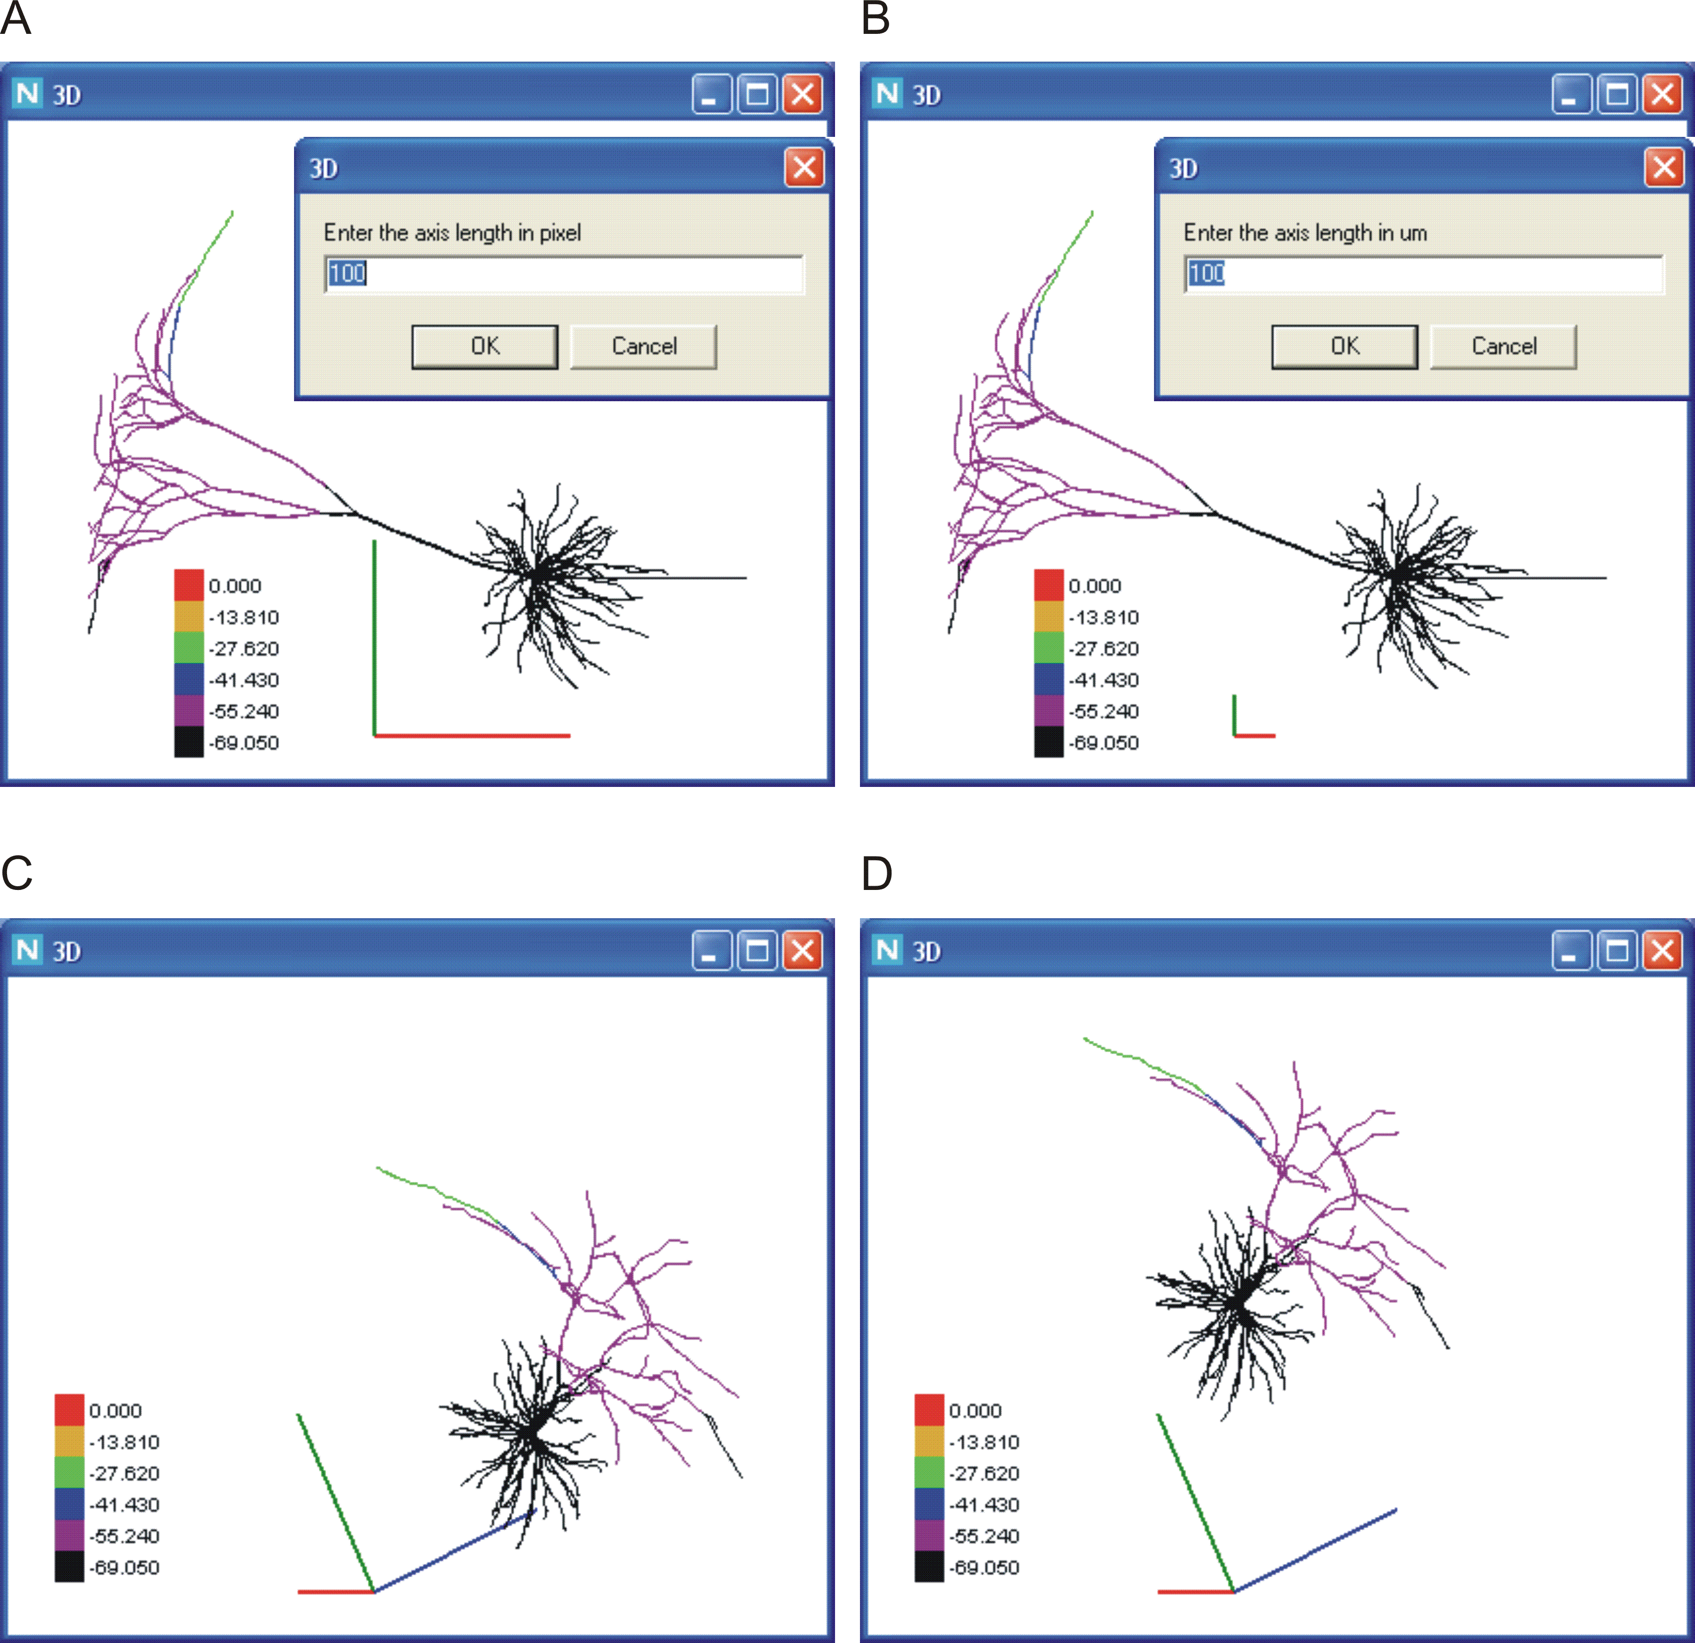
Fig. 7. Operations with the 3D image: calibration in pixels (A) or micrometers (B), rotation (C) and shift (D).

The fifth and sixth items (“Axes size (pixels)” and “Axes size (um)”, respectively) are alternative. They control the size and measure of the X, Y, Z calibration bars (Fig. 6, right window). The activated item has the check-mark on the left (e.g. Fig. 6, left window). The length of the calibration bars is measured either in pixels if the “Axes size (pixels)” item is activated (Fig. 6; Fig. 7 (A), (C), (D)) or in micrometers otherwise (Fig. 7 (B)). To toggle the current state of the items put the pointer and left-click on the deactivated (unchecked) item. This causes: (i) toggling the states of the two items; (ii) opening the input window (see Fig. 7 (A) and (B)) with two control buttons “OK” and “Cancel” and the input box containing the current value of the X-, Y-, and Z-bar length. If another calibration is required, type it in the input box and left-click on “OK” button or press “Enter” key, otherwise left-click on the “Cancel” button or press “Esc” key. Note that in the 3D display window the calibration bar is adjustable by the fourth and fifth menu items, but the size of the neuron 3D image rigidly linked to the window size. Hence, to increase or decrease the screen size of the image one has to increase or decrease the whole 3D window.
The seventh and eights items “Show palette” and “Hide palette” in the 3D display window operate identically to the items of the same names in the first-level menu in 2D display window (see above p. 3 and Fig. 4).
The 3D display window allows three spatial transformations of the original 3D image: zoom, shift and rotation. Zooms and shifts are keyboard-operated. Rotations are either keyboard- or mouse-operated. Fig. 7 shows an example: the original image (A) is first rotated (C) and then shifted (D). Fig. 8 illustrates zoom.
The key-pressings and resultant transformations are listed in the Table 2 below.

Table 2. Keyboard-driven spatial transformations of the image in the 3D display window
Key | Transformation
Zooms
“+” (Numeric keypad) | 10% Zoom in
“-“ (Numeric keypad) | 10% Zoom out
“Shift” and “+”(Numeric keypad) | 1% Zoom in
“Shift” and “-”(Numeric keypad) | 1% Zoom out
Shifts
“→” (Cursor control keypad) | 10 um Right shift
“→” (Cursor control keypad) | 10 um Left shift
“↑” (Cursor control keypad) | 10 um Upward shift
“↓” (Cursor control keypad) | 10 um Downward shift
“Shift” and “→” (Cursor control keypad) | 1 um Right shift
“Shift” and “→” (Cursor control keypad) | 1 um Left shift
“Shift” and “↑” (Cursor control keypad) | 1 um Upward shift
“Shift” and “↓” (Cursor control keypad) | 1 um Downward shift
Rotations
“X” | 10º clockwise around X-axis
“Y” | 10º clockwise around Y-axis
“Z” | 10º clockwise around Z-axis
“Ctrl” and “X” | 10º counter-clockwise around X-axis
“Ctrl” and “Y” | 10º counter-clockwise around Y-axis
“Ctrl” and “Z” | 10º counter-clockwise around Z-axis
“Shift” and “X” | 1º clockwise around X-axis
“Shift” and “Y” | 1º clockwise around Y-axis
“Shift” and “Z” | 1º clockwise around Z-axis
“Shift” and “Ctrl” and “X” | 1º counter-clockwise around X-axis
“Shift” and “Ctrl” and “Y” | 1º counter-clockwise around Y-axis
“Shift” and “Ctrl” and “Z” | 1º counter-clockwise around Y-axis
To perform a mouse-operated rotation:
- press and hold the left button of the mouse;
- move the mouse upward or downward for the clockwise or counter-clockwise rotation around horizontal axis of the 3D display window.
- move the mouse leftward or rightward for the clockwise or counter-clockwise rotation around vertical axis of the 3D display window.
Horizontal and vertical axes of the 3D display window are identical to Cartezian X- and Y-axes displayed for calibration of the reconstructed neuron only in the original state. Releasing the mouse button terminates the transformation.

To cancel all spatial transformations (keyboard- and mouse-operated) and restore the original image, double-click with left button anywhere inside the 3D display window.
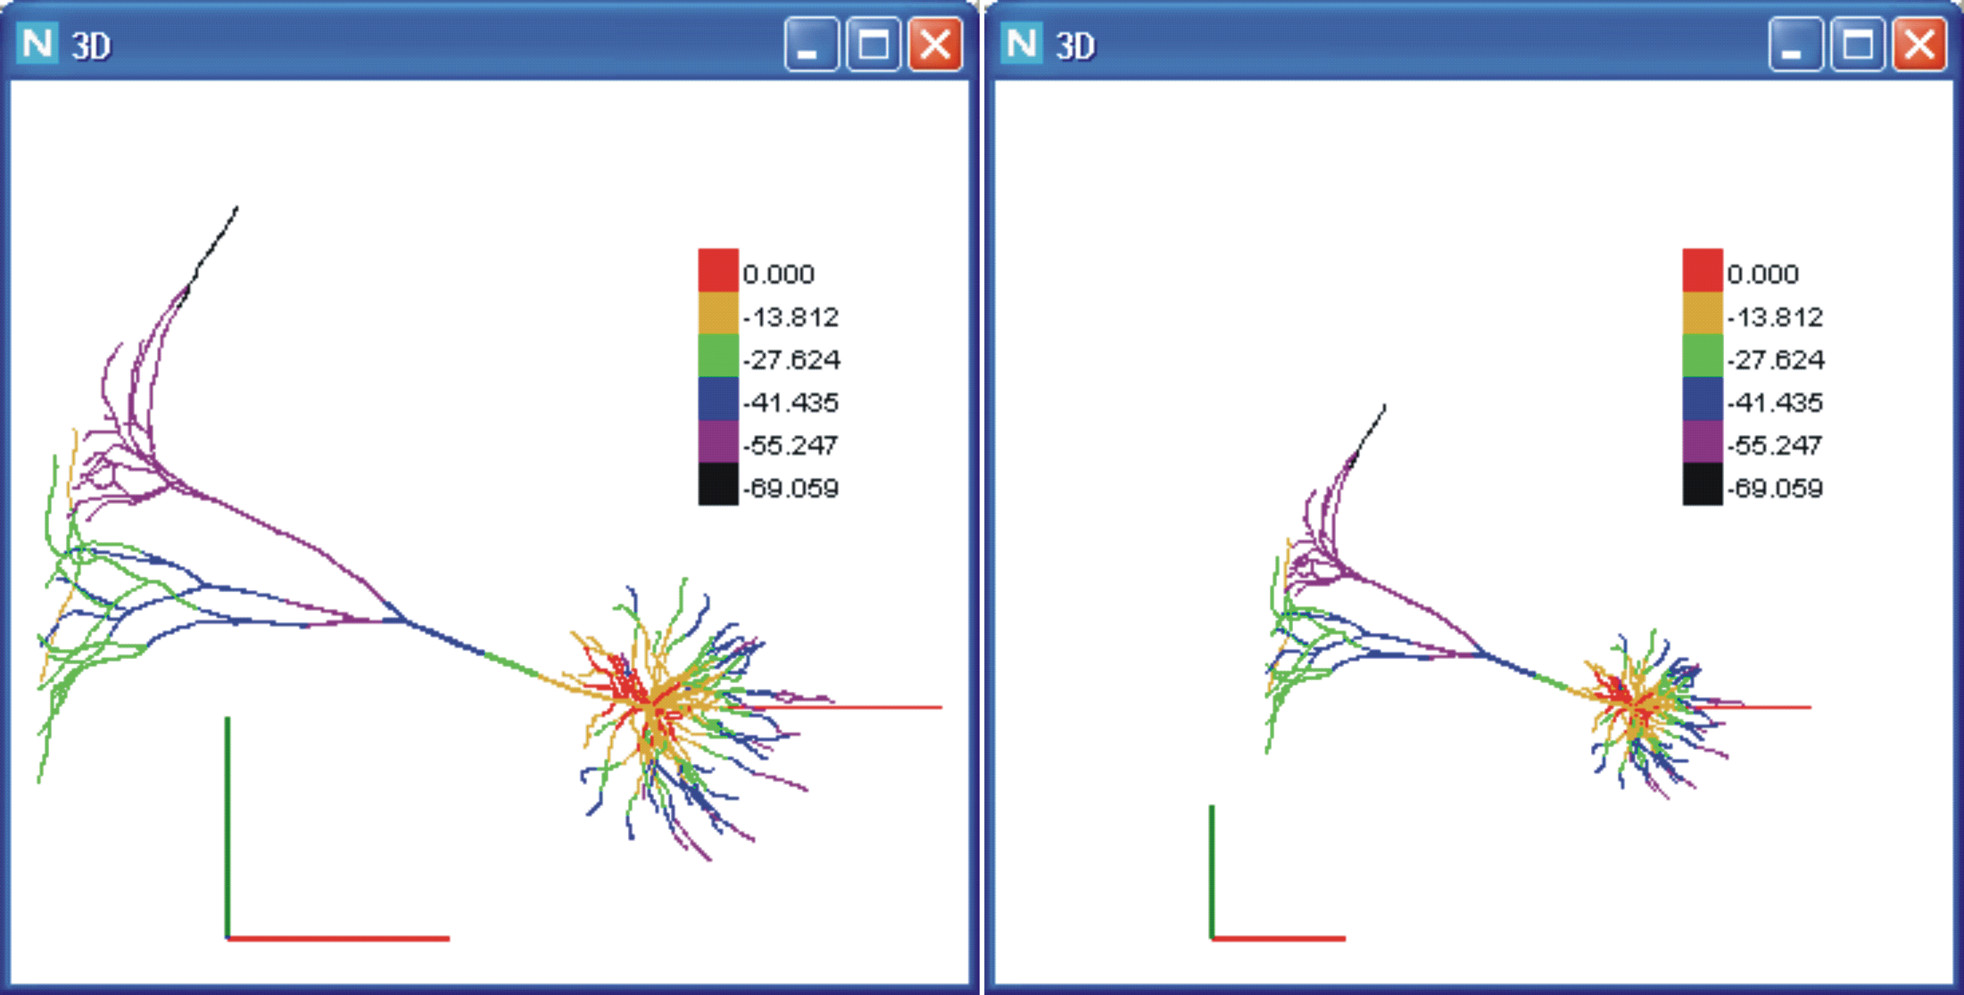
Fig. 8. Original (left) and reduced (right) images illustrating zoom operation by pressing “-” key on the numeric keypad (four times, 10% zoom-out with each key-pressing).

- F(t) display window
This window displays the voltage vs. time plots at the recording sites selected in the simulated neuron. For the abscissa (time in milliseconds) and ordinate (membrane potential in millivolts) the scales are shown but the units are not. For displaying in this window, the recording sites are selected in the 2D display window with the use of the dendrogram representation as described above (see p. 3 and Fig. 3).
This window is controlled externally from the “Data Control” and “2D” windows and internally from its own three-level context menu.
The external control consists in:
- setting the limits of the abscissa (time interval) and ordinate (voltage range);
- forming the list of the recording sites to be viewed in the window.

The limits of the time interval and voltage range are taken from the corresponding left and right boxes in the “Time scale” and “Variable scale” lines of the “Data Control” window. The list of recording sites is formed by selection on the dendrogram displayed in the 2D window as described above (see Fig. 3).

The internal control consists in a set of operations driven from the three-level context menu, which is called by right-click within the window (Fig. 9; Fig. 10, bottom left window; Fig. 11, top right window).

If the list of recording sites is empty, then the call of the context menu opens the deactivated menu box (Fig. 9) with the message:
- List of recording sites is empty.

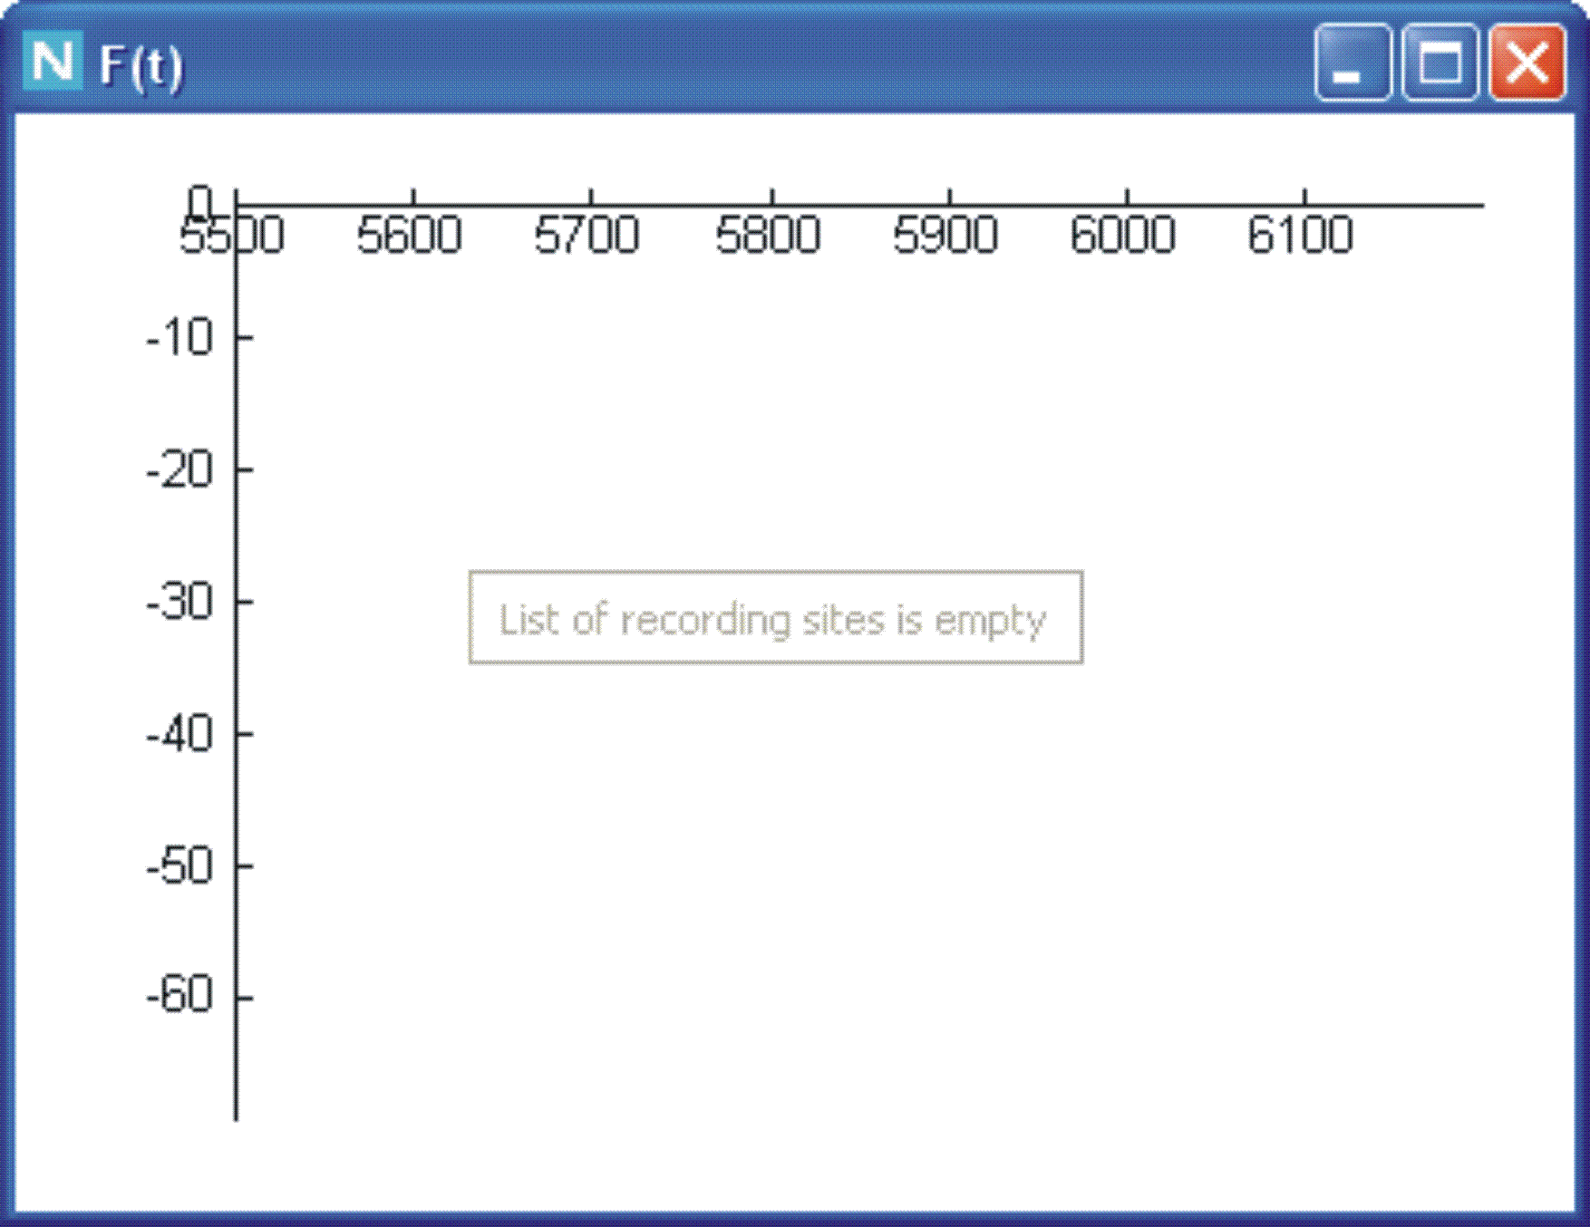
Fig. 9. Deactivated menu box appearing in response to right-click in F(t) window in the absence of sites selected for displaying their voltage-time recordings.

If the list of recording sites contains at least one entry then the activated first-level menu appears with two items (Fig. 11, top right window):
- List of recording sites;
- Delete all recording sites.

Positioning the pointer on the first item “List of sites” opens the second-level menu, of which the items are the selected recording sites (labeled as read from the data file and notified in the 2D window during the selection procedure).

Positioning the pointer on any item of the second-level menu opens the third-level menu with two items:
- Color;
- Delete.
Positioning the pointer on the “Color” item and left-clicking opens the palette window with a set of color boxes (Fig. 10). This is a standard system window (headed “Color”). Clicking in a box attributes the boxed color to the corresponding voltage-time plot displayed in the “F(t)” window and to the recording site on the dendrogram displayed in the 2D window .

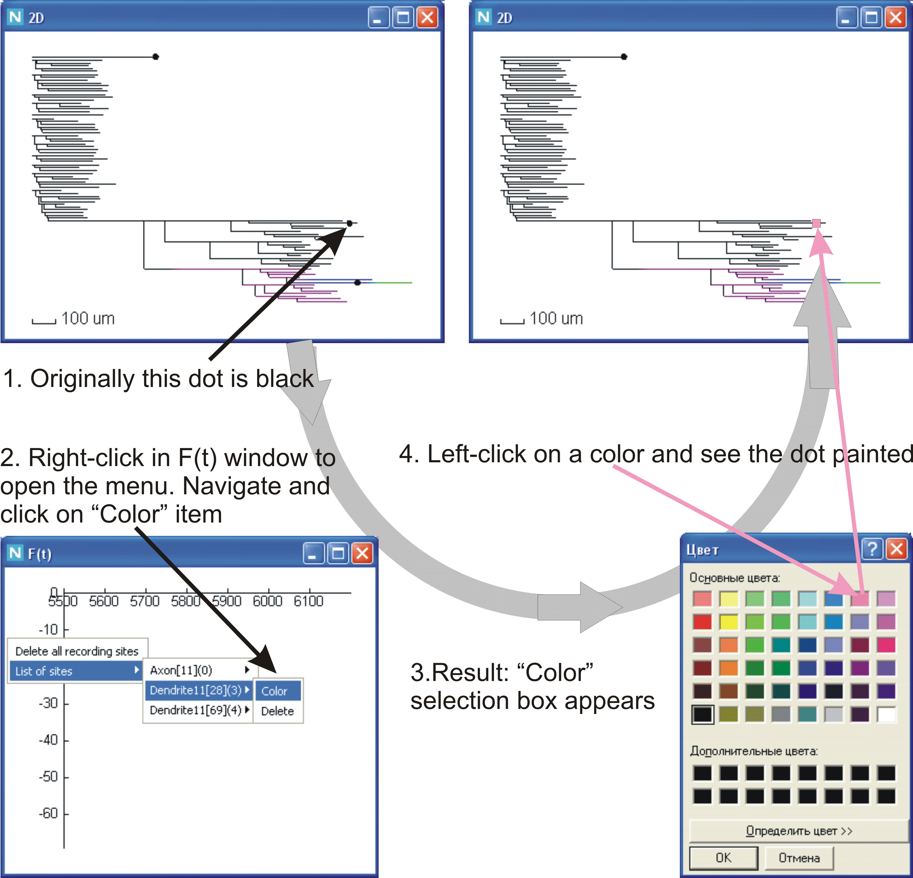
Fig. 10. Selection of color for the voltage–time plot displayed in F(t) window for the certain site indicated on the dendrogram in 2D window.

Positioning the pointer on the “Delete” item and left-clicking unselects the recording site, removes the corresponding item from the second-level menu and removes the corresponding plot from the “F(t)” window (Fig. 11).

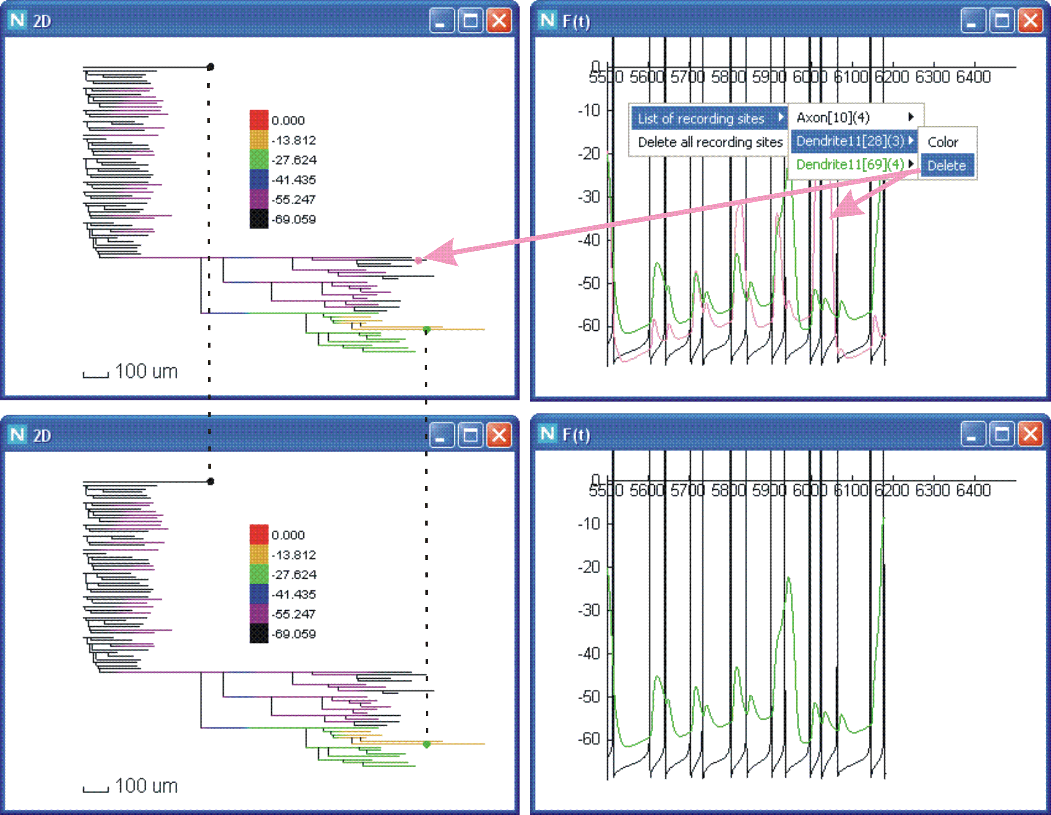
Fig. 11. Deleting the site Dendrite11[28](3) from the recording list removes the corresponding dot on the dendrogram in 2D window and the voltage-time plot in F(t) window (arrows in upper windows). The result is shown in the lower window.

Positioning the pointer and left-clicking on the second item “Delete all sites” of the first-level menu empties the whole list of selected recording sites and removes all plots from the window.

