Figure 9.1 Determination of new survey point using measurements of angle

Figure 9.2 Source location uncertainty

Figure 9.3 Four node multilateration

Figure 9.4 Symbol by symbol phase estimation

Figure 9.5 Multi-hop RBS

Figure 9.6 Three points in the plane

Figure 9.7 Communication links in multi-hop network

Figure 9.8 Relative coordinate system

Figure 9.9 Location of fourth node in plane

Figure 9.10 Euclidean distance propagation

Figure 9.11 NLOS propagation

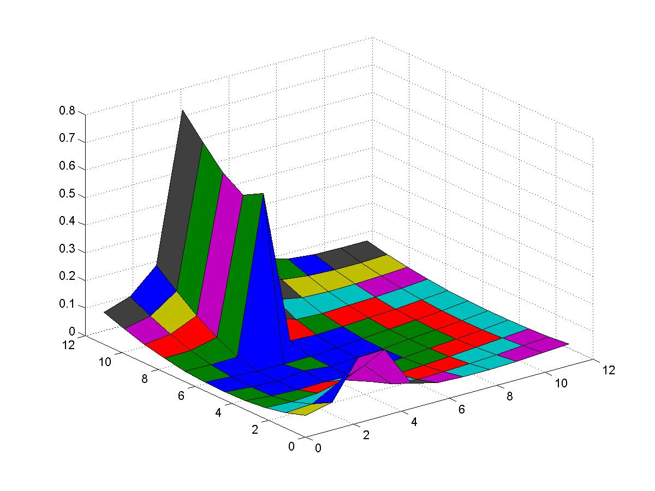

Figure 9.12 CR Bound for position uncertainty

