Figure 12.1 Detection in obstructed environment.

Figure 12.2 Node layout

Figure 12.3 Obstructed views

Figure 12.4 Shadowed regions

Figure 12.5 Transit of sun over fixed array

Figure 12.6 Mobility patterns

Figure 12.7 Heavily obstructed terrain

Figure 12.8 Shadowed region in heavy obstruction

Figure 12.9 The Dungeon

Figure 12.10 Owl and Orbs

Figure 12.11 Layout of service point G and sensor nodes A, B and C.

Figure 12.12 Communications mule tracks

(a)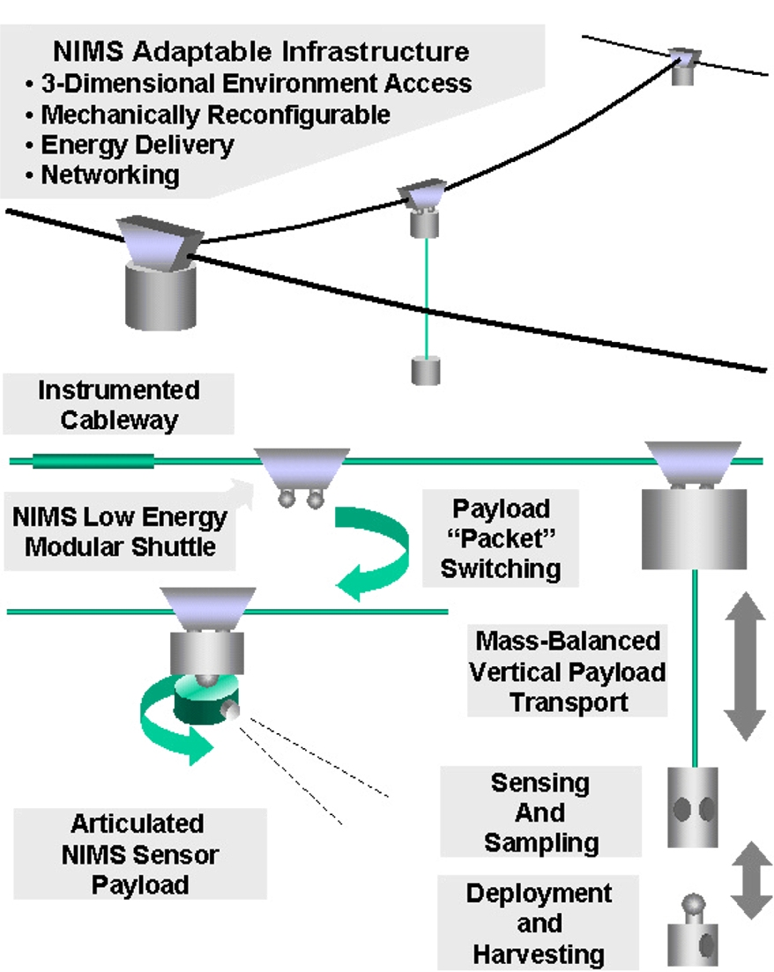 (b)

Figure 12.13 NIMS network components and stream monitoring application

Figure 12.14 Discovery of obstructions

Figure 12.15 Single camera path through obstructed environment

Figure 12.16: Obstructed region with single transect

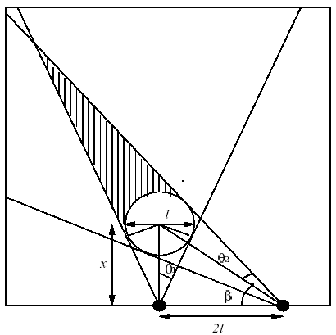

Figure 12.17 Occlusion geometry

Figure 12.18 Obstacles and cameras

Figure 12.19 Camera path and obstacles

Figure 12.20 Information source/sink layout

