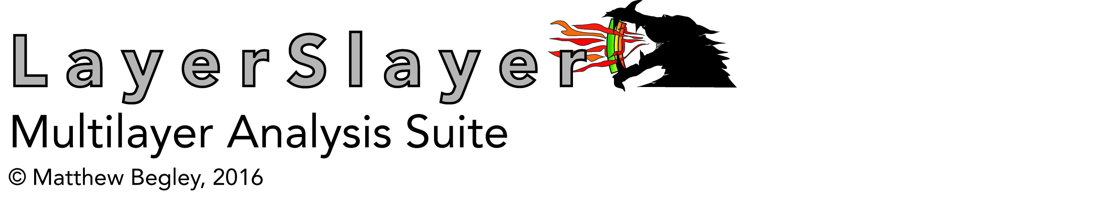

**Chapter 7 Crack Kinking from an Interface**

Files

GK kinking interpolation code with examples ☑

He & Hutchinson data file ☑

**Chapter 14 Software for Semi-infinite Multilayers: Steady-State Delamination**

Files

LSB CH 14 EXAMPLES INPUT

LSBencrypt

Subroutines

BiaxialDeformation

PlaneDeformation

GetStress

ClassicERR

BiaxialERR

PlaneStrainERR

TempSol

TempSolQ

GSensitivity (example file)

DivideMultilayer (example file)

Three-layer Example

Figure 14.2 Temperature profiles in a three layer stack  ☑

Figure 14.3a ERR at two interfaces with three different constraints  ☑

Figure 14.3b ERR at each point throughout the stack ☑

EBC/5-layer Example

Figure 14.4 Temperature profile in 5-layer EBC stack ☑

Figure 14.5a Stress in 5-layer EBC stack ☑

Figure 14.5b ERR in 5-layer EBC stack ☑

Figure 14.6 Sensitivity maps for 5-layer EBC stack ☑

**Chapter 15 Software for Semi-infinite Multilayers: Transient Delamination**

Subroutines

GetThermalSolution

GetThermalTQ

PlotTemperature

GetDeformation

GetStressDistribution

PlotStress

GetERRinterface

GetERRDistribution

PlotERR

Two-layer Step-Up Step-Down Transient Example

Figure 15.2b Temperature vs. time profiles in the example

Figure 15.3a Temperature profiles through stack for heating phase

Figure 15.3b Temperature profiles through stack for cooling phase

Figure 15.4 Surface and interface temperatures vs. time

Figure 15.5 Elongation and curvature temperatures vs. time

Figure 15.6 Stress vs. position for several times, heating and cooling

Figure 15.7 ERR vs. time for two different reference temperatures

Figure 15.8 ERR vs. position in the stack for several times and two phases

**Chapter 16 Finite Element Software for Multilayers: LayerSlayer FEA**

Subroutines

DelamFEA

PenetrateFEA

Three Layer EBC Example (Delamination)

Figure 16.4 Plane strain ERR & mode mix vs. oxide thickness

Four Layer EBC with CMAS Example (Delamination)

Figure 16.5 Plane strain ERR & mode mix vs. fraction with CMAS

Penetrating Cracks in Four Layer EBC (Channeling)

Figure 16.7 Penetrating ERR vs. depth of crack for several systems

Figure 16.8 3D Design map of critical ERR vs silicate layer thickness

**Chapter 17 Convergence and Benchmarks with LS-FEA**

Bilayer Subject to 4-Pt Bending

Figure 17.1 ERR vs. numerical parameters for two different crack lengths

Figure 17.2 SIF vs. numerical parametesr for one crack length

Thin Film on Thick Substrate Subject to Thermal Delamination

Figure 17.3 Error in ERR vs. numerical parameters for long crack

Figure 17.4 SIF vs. numerical parametesr for long crack

Penetrating Crack in Mononlithic Specimen Subjected to 3-Pt bending

Figure 17.5 Error in ERR vs. extension size for various methods/meshes

Figure 17.5 ERR in ERR vs. shifted zone size for various methods/meshes