[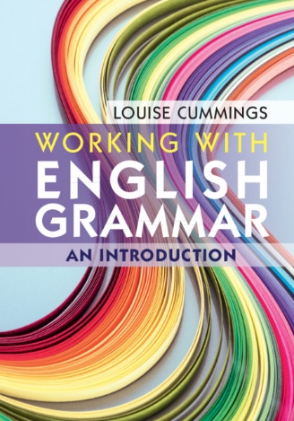](http://assets.cambridge.org/97811084/15774/large_cover/9781108415774i.jpg)

**USEFUL LINKS**

University College London – The Internet Grammar of English:

<http://www.ucl.ac.uk/internet-grammar/>

Cambridge University Press – English Grammar Today:

<http://dictionary.cambridge.org/grammar/british-grammar/>

Oxford Practice Grammar:

<https://elt.oup.com/student/practicegrammar/?cc=gb&selLanguage=en>

British Library – Grammatical Variation:

<http://www.bl.uk/learning/langlit/sounds/regional-voices/grammatical-variation/index.html>

British Library – Grammatical Variation Activities:

<http://www.bl.uk/learning/langlit/sounds/activities/grammatical-variation/>

British Library – Geordie Dialect Grammar:

<http://www.bl.uk/learning/langlit/sounds/case-studies/geordie/grammar/>

British Council – English Grammar:

<https://learnenglish.britishcouncil.org/en/english-grammar>

British Council – Quick Grammar:

<https://learnenglish.britishcouncil.org/en/quick-grammar>

University of Glasgow – English Grammar: An Introduction:

<http://www.arts.gla.ac.uk/STELLA/apps/web/grammar/>

University of Calgary – The Basic Elements of English: An Interactive Guide to Grammar:

<https://english.ucalgary.ca/grammar/menu.htm>

Universität Osnabrück, Germany – English Language and Linguistics Online:

<http://www.ello.uos.de/>