# Unsteady Combustor Physics

Errata (5/12/2016 Update)

p. 26, Eq. A2-6 should read:



Figure 2-14: Corrected errors highlighted below:



*b*

Figure 2–14. Time variation of modal amplitudes, showing nonlinear modal interactions of two oscillators described by Eqs. (2.81) and (2.82), in which solid line denotes amplitude and dashed line denotes instantaneous value (2*aa* = –0.20, 2*bb* = –0.13,  = 0.7,  and ). Calculation courtesy of Shreekrishna.

p.81 Fig. 4-7 Figure should have ff/fm on bottom axis (not fr/fm)

Figure 4-42(B), page 111. The rotating direction of the upper vortex should be counter-clock wise

Page 142, Equation (5.81) must be:

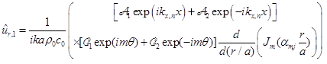

Page 142, Equation (5.82) must be:

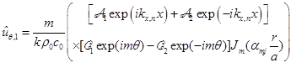

Table 6-1 - (1-M2) should be on top, not bottom

p.180 Ratio of impedances is wrong



