Network position and synchronization services

Principles of position location

- historically considered as a component of surveying or navigation.
- known reference points are used to compute the present location.
  - In surveying, allows new reference points to be constructed, enabling map-making.
  - In navigation, objective is to chart a course using the references or map.
- Both celestial and land references have been used, and more recently, electronic beacons and satellites have been constructed to aid both tasks.

Triangulation

- References are required for orientation (to set up the coordinate axes) and position.
- Traditional survey instruments establish the direction of gravity, and measure angles in azimuth (the horizontal plane), elevation or both
- distances between initial reference points may be carefully measured by means of chains or steel tape.
- Given two initial reference points, triangulation can then be successively applied to create new references and survey a larger area.
  - distance, d, between reference points 1 and 2 is measured; angle from both references to point 3 is then measured.
    - Since the pairs (x₁,y₁) and (x₂,y₂) are known, measurement of angle gives all the information required to determine the equations of the lines joining point 3 to the reference locations.
    - intersection yields (x₃,y₃). This point may then serve as a reference for later surveys.
Determination of new survey point using measurements of angle

Example: Effect of angle measurement uncertainty
- A source is located on the right bisector of the line of length d joining two survey points.
- angle is measured with an error of one degree, with nominal angles of 45 and 85 degrees.
- Compute the relative errors for the two situations and comment.

Source location uncertainty

- Solution : since tanθ=2R/d, conclude R=d/2 tanθ.
- Denote by R₁ the distance computed when measurement error causes the angle to be larger than the nominal amount by Δθ.
  - R₁=d/2 tan(θ+Δθ) so that ΔR=d/2(tan(θ+Δθ)-tanθ).
  - the relative error is given by (tan(θ+Δθ)-tanθ)/tanθ.
  - For θ=45 degrees, and Δθ=1 degree this is 0.036, while for 85 degrees it is 0.25.
- Thus, in surveying a new location using angle measurements there is greater sensitivity when the distance becomes large compared to the baseline.

Time of arrival

- Electronic beacons allow measurement of distance (range) using time of arrival (TOA) or time difference of arrival (TDOA) methods.
- TOA is the basic principle for determining distance using radar and sonar.
  - pulse train is generated by the emitter, and the time delay for the echo from the target is measured at the receiver.
  - reflected signal strength is sometimes enhanced in optical or microwave ranging systems by employing corner cube reflectors in reference markers, and by using directional emitters and receivers.
  - Since the emitter and receiver share the same clock, no elaborate synchronization is required.
  - Given the propagation velocity, v, and this measured time difference, Δt, the range of the target can be estimated as R=vΔt.
  - basic receiver is a matched filter (or equivalently, a correlation receiver), with the objective of the receiver being to estimate the position of the correlation peak.
    - Larger bandwidth allows sharper resolution in time, while noise distorts the position of the peak.
    - peak position is estimated from a sequence of pulses, and can be as good as 1% of the pulse width or even 0.1% with long integration.
- Multiple ranges are used in a number of range-finding methods, as in the Global Positioning System (GPS).
  - relies on determination of ranges from multiple satellites that have a common timing reference.
  - ranging signals from the satellites also allow the ground receiver to adjust its local timing to match those of the satellites, permitting accurate one-way path delay measurements.
  - Since time offset must be estimated along with the x, y, and z coordinates of the receiver, a minimum of four satellites must be in view to determine position.
    - this number permits position ambiguities, but if position is known to within a few hundred km a priori this is not a significant issue.

Linearization of TOA problem
- take linear approximation to the intersection of spheres problem and solve it iteratively, beginning with some initial estimate of the solution.
- E.g. two-dimensional location problem is considered, with synchronism assumed.
- Let u denote the node with unknown location, and let the position of reference node i be (x_{i},y_{i}).
- Denote by r_{i,u} the range measurement.
- Then the residual error between the range measurement and the distance to the initially estimated position is
$f_{i,u}=r_{i,u}−\sqrt{(x_{i}−{\hat{x}}_{u})^{2}+(y_{i}−{\hat{y}}_{u})^{2}}$
- objective is to select a new estimated position that minimizes
$F(x_{u},y_{u})=\text{min}\sum{f_{i,u}^{2}}$
- Taylor’s theorem produces
$r_{i,u}=r_{i}+{Dx}_{i}d_{x}+{Dy}_{i}d_{y}+O(D^{2})$
where
${Dx}_{i}=\frac{x_{i}−{\hat{x}}_{u}}{r_{i}},{Dy}_{i}=\frac{y_{i}−{\hat{y}}_{u}}{r_{i}},r_{i}=\sqrt{(x_{i}−{\hat{x}}_{u})^{2}+(y_{i}−{\hat{y}}_{u})^{2}}$,
- The least squares solution for the position correction at each iteration is given by
$d=(A^{T}A)^{−1}A^{T}z$
where
$d=\left[\begin{matrix}d_{x} \\ d_{y}\end{matrix}\right],A=\left[\begin{matrix}{Dx}_{1} & {Dy}_{1} \\ M & M \\ {Dx}_{n} & {Dy}_{n}\end{matrix}\right]\text{ and }z=\left[\begin{matrix}r_{i}−r_{1,u} \\ M \\ r_{i}−r_{n,u}\end{matrix}\right]$.
- At each iteration, the position estimate is updated according to$({\hat{x}}_{u},{\hat{y}}_{u})=({\hat{x}}_{u}+d_{x},{\hat{y}}_{u}+d_{y})$ to successively refine it.

Example: Position from ranging in two dimensions
- positions of nodes A, B, C and D are known, as indicated.
- Node U has unknown position, but there are range estimates .7, 1.5, 1.6 and 2.2 to nodes A, B, C and D respectively.
- Given an initial estimate of its position as (0,0), compute the next position estimate.
Four node multilateration

- Solution: Clearly all the r_{i} are equal to the square root of 2, and so
$$\begin{aligned}A^{T}A=\frac{1}{2}\left[\begin{matrix}1 & 1 & −1 & −1 \\ 1 & −1 & 1 & −1\end{matrix}\right]\left[\begin{matrix}1 & 1 \\ 1 & −1 \\ −1 & 1 \\ −1 & −1\end{matrix}\right]=\left[\begin{matrix}2 & 0 \\ 0 & 2\end{matrix}\right] \\ A^{T}z=\frac{1}{\sqrt{2}}\left[\begin{matrix}1 & 1 & −1 & −1 \\ 1 & −1 & 1 & −1\end{matrix}\right]\left[\begin{matrix}\sqrt{2}−\text{.}7 \\ \sqrt{2}−1\text{.}5 \\ \sqrt{2}−1\text{.}6 \\ \sqrt{2}−2\text{.}2\end{matrix}\right]=\left[\begin{matrix}1\text{.}\text{131} \\ \text{.}\text{9899}\end{matrix}\right]\end{aligned}$$
- Hence δ_{x}=0.56, δ_{y}=0.49 and the new position estimate is (0+.56, 0+.49)=(.56,.49).

- This approach can be extended to a larger number of dimensions, and to estimate an additional parameter such as velocity of propagation or relative time if there are extra reference locations.

Time difference of arrival

- two synchronized sources generate signals that are modulated so that a receiver can determine the difference in time traveled by waves originating from the two beacons.
- A given time difference corresponds to a position somewhere on one branch of a hyperbola, with the focus being the nearest beacon.
- A third beacon allows a new hyperbola to be drawn, with the position being the point of intersection.
  - basic approach taken in navigation systems such as LORAN.

Signal Strength

- Multiple beacons allow crude position determination based upon the strength of the received signal.
- If the propagation law as a function of distance is known, then the relative strengths of the signals received from different beacons may be used to roughly determine range, and thus position.
- obvious problem with this approach is signal attenuation is usually more subject to distortion than time of flight, particularly in cluttered environments.
  - can be a good first step in approximately fixing position (e.g., the first set of estimates prior to multilateration iterations) and may be all that is required in some applications.

Example : Weighted centroid computation
- For the situation depicted in prior figure, suppose nodes u and v can receive signals from each of nodes a, b, c and d.
- Simply estimating position as the centroid would place both nodes at (0,0).
- Several alternative approaches can be used to better approximate their positions, without having explicit ranging measurements available.
- Both methods assign weights to positions of beacons based on received signal strength so that the position is estimated as
$(x_{u},y_{u})=\sum{w_{i}}(x_{i},y_{i})$ where the weights satisfy $\sum{w_{i}=1\text{.}}$

Centroid of strongest signals.
- In this case, the weights are taken to be 1/k, where the k signals above some threshold are chosen.
- Suppose nodes A, B and C are the strongest for node U, and B, C and D for node V. Then one computes U=(1/3, 1/3) and V=(-1/3, -1/3).

Weighting by SNR
- If the signal propagation law is unknown, a refinement is to weight by the SNR. Assuming noise variance to be the same at each receiver, this implies weighting proportionally to the signal strength.
- Suppose that power actually declines with square of distance. Estimate the position of node U.
- Solution:The received power P_{i} from node i will be of the form c_{p}P/r² where P is the transmitted power, r is the range and c_{p} is some propagation constant.
- Assuming all nodes have the same transmitted power, the ratios of the received powers from nodes A, B, C and D are 1/.5: 1/2.25: 1/2.25: 1/2.5 and the weights are thus
$$w_{i}=\frac{P_{i}}{\sum{P_{i}}}$$

- Then U=1/3.289 [2(1,1)+1/2.25(1,-1)+1/2.25(-1,1)+1/2.5(-1,-1)]=(0.49,0.49).

Source localization

- perspective so far has been on determining the location of transceivers relative to known beacons.
- Many of the techniques can also be applied to determining the location of a source given that the receivers know their locations and are possibly synchronized.

9.2 Network synchronism

- Needed for most position location methods, and also important for communications and various coordination tasks
- Also allows sleeping for saving energy

Synchronization of two clocks

- delay difference τ between clocks is usually categorized by an initial time offset τ₀, a time-dependent frequency offset Δf (t) and jitter due to noise, as follows:
$t(t)=t_{0}+Df(t)t+D_{t}(t)$.
- frequency offset due to differences in manufacture of different clocks as well as to environmental effects such as temperature of operation.
  - A clock is stable if the frequency offset changes slowly.
  - relative phase between clocks can be obtained by differentiating with respect to delay.
- objective of synchronization algorithms is to establish a one to one correspondence between the times reported by the different clocks.
  - usually accomplished by one or more closed loops.
  - in principle one loop is sufficient to track both phase and frequency (since both are manifested in delay), in practice it is often easier to have separate lower-order loops for either phase or delay and frequency
- typical synchronization arrangement is for one oscillator to be the master and the other the slave.
  - master transmits a digital signal which is locked onto by the receiver, for example by means of delay or phase lock loops as discussed in chapters 5 and 6.
  - Until the loop filters are so narrow as to be unable to track the drift of the master oscillator, decreased loop bandwidths improve the error.
  - Local loops within the receiver will leave an offset due to propagation delay.
    - can be left alone, producing a propagation delay time drift across a network, or compensated
One shot phase estimation
- Assuming frequency lock has been achieved, the following loop may be used to perform maximum likelihood phase estimation on a symbol by symbol basis:
Symbol by symbol phase estimation

- r(t) is the received signal, and correlation is performed in both the in-phase and quadrature branches.
- optimal phase is derived from the position of the received vector in signal space.
- If a sequence of decisions on the symbols is available (or if they are known, as in a training sequence) then estimate is:

$$f={\text{tan}}^{−1}\frac{\text{Im}\left\{\sum_{n=0}^{k−1}{a_{n}^{}y_{n}}\right\}}{\text{Re}\left\{\sum_{n=0}^{k−1}{a_{n}^{}y_{n}}\right\}}$$
- a_{n} is the n^{th} received symbol, and y_{n} is the matched filter output at time n.
- the larger the number of symbols or the higher the SNR the smaller will be the error in both the numerator and denominator terms
- similar to averaging the signal space points before performing the inverse tangent operation, and assumes both frequency and symbol lock.

Network synchronism basics

- basic component in all network synchronism algorithms is propagation of some reference time measurement over one or more communication links.
- performed periodically or on demand to reduce the resource cost, at the expense of increased uncertainty on the relative time of the clocks between the synchronization epochs.
- signals might be a coherent phase reference slaved to the master clock, a specially designed pulse train (e.g., a synch sequence in a packet header), something that is derived from the message signals in a digital communication system, or round-trip times for packets.
- Could be broadcast to near neighbors, or a multicast that propagates over multiple hops.
- Errors arise in many ways.
  - variable delays in the transmitter between the reference clock and the transmitter output, involving some combination of the interface between the radio and the master clock and the propagation delay within the medium.
  - The receiver path similarly has delays.
  - jitter in synchronizing the transmitter and receiver due to noise and variable propagation time.
- Averaging over a long time period can suppress many of these errors at the price of energy and communications resources.
- Variety of algorithms, with different objectives:
  - Same level of synchronism everywhere
  - Relative synchronism
  - Variable synchronism

Error sources in network synchronization and position location

- Network synchronization and position location problems are made difficult by the likelihood of outliers:
  - measurements that contain far larger errors than most others.
- causes may be divided among
  - geometric factors: including propagation effects and positioning of nodes
  - effects of passing data through digital signal processing devices.
- desirable to be able to design systems to minimize the occurrences of such large errors, and to also be able to recognize their occurrence in order to isolate their effects within the network.

Propagation effects

- figure illustrates non line of sight (NLOS) propagation around a corner for two intersecting corridors.
- If the corridor walls are perfectly reflective, then the first arrival will come from the reflected ray and no direct path will exist.
  - Longer path implies time of arrival and the attenuation will be different from that of the direct path leading to errors in both synchronization and position location methods based upon such measurements.
  - huge error in the angle of arrival.
- if walls merely attenuate the signal so that a direct path at reduced signal strength exists.
  - Time and angle of arrival and measurements will now be accurate if the direct path is strong enough to measure
  - position location based methods that depend upon some consistent distance loss law will fail owing to the attenuation caused by the two barriers.
  - distance loss law measurements are unreliable in most realistic (cluttered) environments due to the many possibilities for deviations due to shadowing and multipath.
  - placement of a reference node at the intersection of the corridors would help in this case
    - having a high enough density to be able to establish line of sight with many neighbors is generally useful.
NLOS propagation

- Refraction can also lead to errors.
  - Gradations in the refractive index of the ionosphere can cause signals from GPS satellites to follow a curved trajectory
  - moisture gradients in the lower atmosphere can similarly refract both acoustic and radio signals.
- little to do in such conditions except wait for them to pass, or in the case of GPS reject the satellites that are close to the horizon.

Geometric factors

- relative positions of the reference and unknown nodes can have a large impact on the accuracy of position localization.
- angular measurements are problematic when the angular spread of the reference locations is small from the perspective of the node to be located.
  - location problem in this case amounts to solution of the problem of the intersection of lines, which are nearly parallel.
- when range measurements are taken the least squares position location problem is particularly ill-conditioned when the reference nodes in 2-space are nearly co-linear, or in 3-space when they are nearly co-planar.
- Since the reference nodes know their own locations, they can determine among themselves whether the resulting linear problem is ill-conditioned due to geometric factors
  - either flag the results as unreliable or if possible include extra nodes so that the errors will be reduced.

Example: Well-conditioned reference node location geometries
- All nodes are to be located within a disk of radius r, with the unknown nodes being distributed according to a uniform distribution within the disk.
- Suggest locations for reference nodes to minimize expected errors for angular or range measurements.
- Solution: With only three reference nodes, spacing them equally along the circumference of the disk is a good solution, since it provides a large angular spread and deviates maximally from being co-linear.
- With larger numbers of reference nodes not always best to equally space the reference nodes on the circumference.
  - since SNR generally declines with distance, having some nodes within the region will provide better measurements.
  - With a large number of nodes, uniformly placing them within the region will provide a large number of near neighbors at large angular spread for most of the nodes to be located.
- can rigorously answer such questions using simulations, or at less expense, using the Cramer Rao bound under the assumption of a Gaussian error process.

Example: CR bound for three beacons
- three beacons placed at coordinates (3,3), (3,4) and (3.2, 5.5)
- CR bound indicates there are positions where the uncertainty is quite high.
- plot is rms position uncertainty against location of the unknown node in the x-y plane.
- worst location set is near boresite (roughly, the line x=3) as the baseline in the x coordinate is too small for reliability.
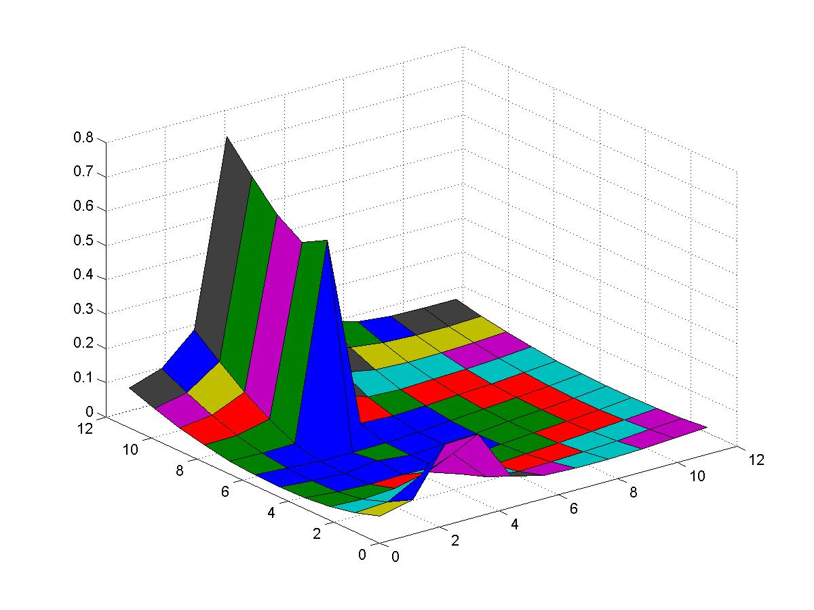
CR Bound for position uncertainty

Number of neighbors
- complexity and accuracy of position location algorithms strongly affected by the average number of neighbors with whom ranging and/or angle measurements can be shared.
  - when fewer than six to eight nodes on average can be heard for ranging, few nodes in the network will learn their positions, while with a slightly larger average number of nodes in range virtually all nodes will learn their position.
  - a small further increase in the average number of ranging neighbors will radically reduce the position error propagation since the chances of having an unfavorable geometry among all neighbors is diminished.
- consequences for average number of neighbors on algorithm design are large: near the threshold, elaborate measures may be needed to check for pathological error propagation conditions, while above the threshold much simpler procedures may be safely employed.

Software-induced delays

- Timing errors in networks due to internal processing delays (e.g., interrupts), network congestion, and medium access protocols will typically dwarf variations due to propagation time.
- due to non-linear processes, so not a Gaussian distribution.
- the earliest arrivals are the most reliable, and given enough reference sources and enough trials, there will be a large consistent set of low-delay arrivals that can be used to reject the others.
- loop can then operate on standard principles such as minimization of mean squared error.
- basic approach of identification of outliers and followed by solution of a least squares problem among the surviving data points is practical in many situations.
  - Measurements can go badly wrong for all kinds of reasons, so that it is impossible to predict the statistics of outliers with any certainty.
  - given the plethora of excellent methods for solving least squares optimizations it is usually worthwhile to use one such method if the well-known vulnerability to outliers can be dealt with.
  - easy way out is to have a surplus number of observation points beyond the minimum needed to propagate synchronization and position information.
    - e.g. likelihood of unfavorable geometries and thus the probability of ill-conditioning or lack of line of sight communication is reduced.
    - anomalous measurements can be recognized as being inconsistent with those of the rest of the group (e.g., by computing position with groups of varying membership), and rejected.
    - Repeating transmissions allows consistency checking for delay measurements, and improves SNR for angle and range measurements.
  - Estimates of the accuracy of measurements can also be incorporated into calculations to give more weight to nodes that have reliable estimates.
    - valuable if multiple iterations of distributed algorithms are performed to successively refine estimates.

