.

Figure 4.1 Ideal open loop sensing system

Figure 4.2 Ideal closed loop sensing system

Figure 4.3 Non-ideal, realistic open loop sensor system with associated noise and interference sources.

Figure 4.4 Sensitivity vs. frequency for two values of input voltage noise corner frequency.

Figure 4.5 Sensitivity vs. frequency for two values of resonance frequency

Figure 4.6 Basic MEMS pressure transducer

Figure 4.7 Capacitive detection transducer

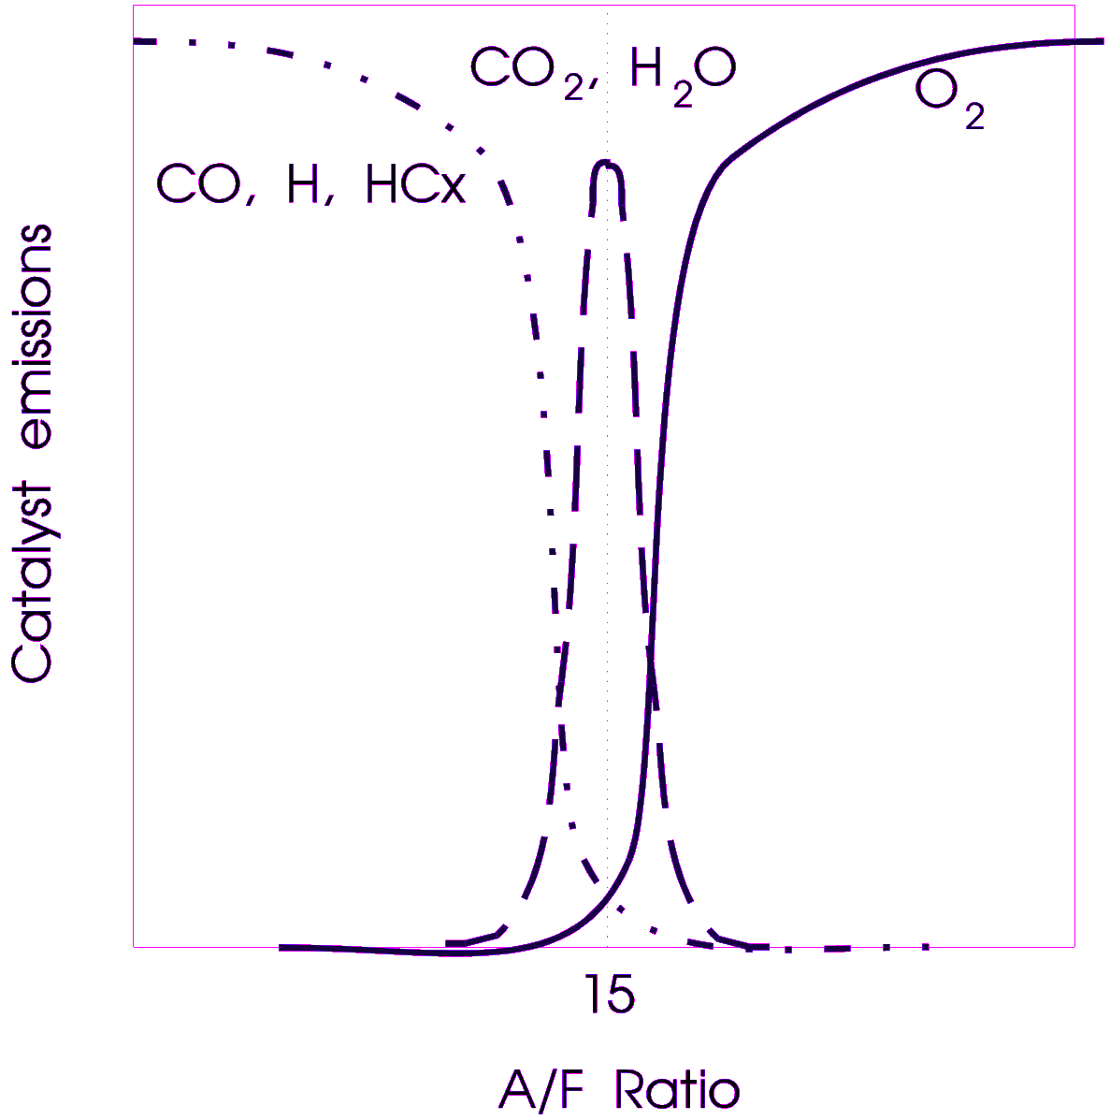

Figure 4.8 Conventional emission control with exhaust gas oxygen sensors

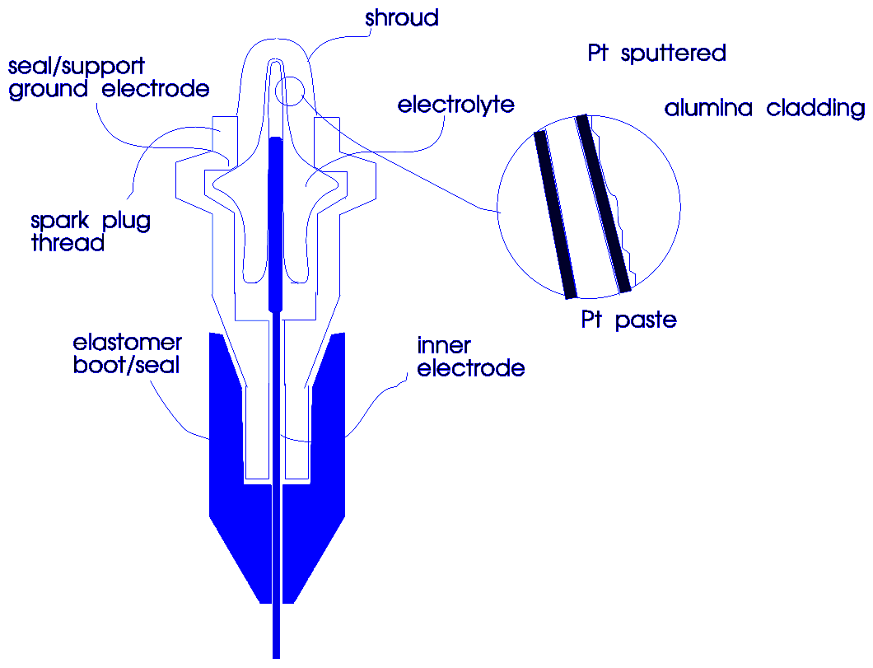

Figure 4.9 ZrO2:Y2O3 electrochemical cell

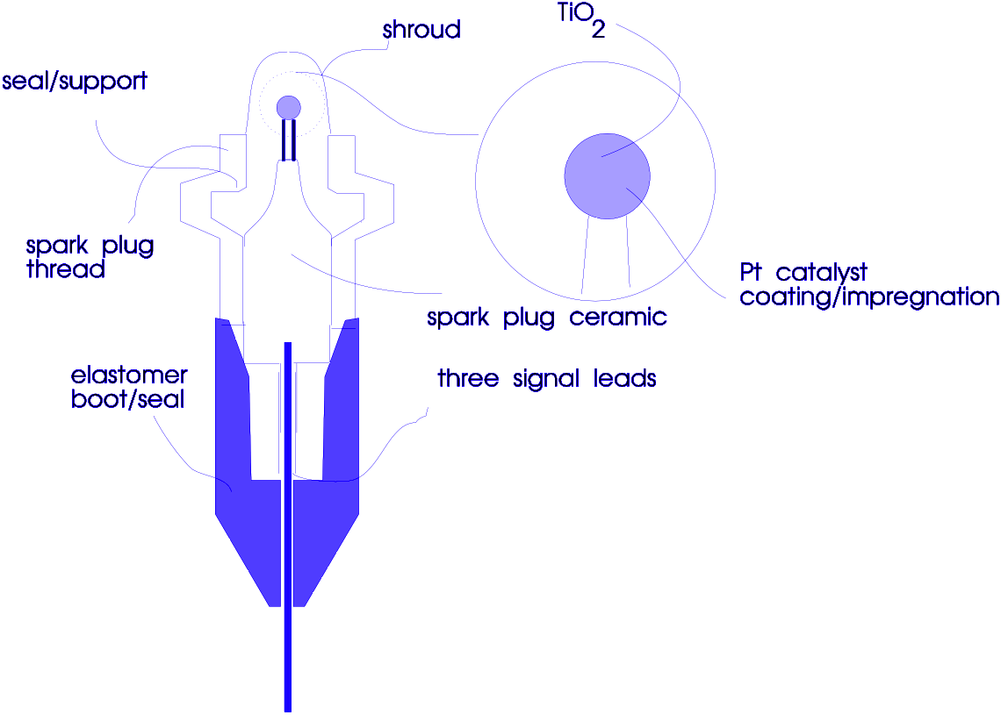

Figure 4.10 TiO₂ resistive gas sensor

Figure 4.11 Cross-sectional view of planar differential accelerometer structure schematic

Figure 4.12 Illustration of Coriolis Force effect for oscillatory rate gyroscope

Figure 4.13 Cross-sectional view of implementation of planar rate gyroscope

Figure 4.14 Errors in rate gyroscope operation

Figure 4.15 Cross-sectional view of piezoresistive strain sensor

Figure 4.16 Motorola X-ducer

Figure 4.17 Piezoelectric transducer

Figure 4.18 Vibration Accelerometer

Figure 4.19 Cross-sectional view of capacitive measurement of proof mass displacement

Figure 4.20 Blumlein capacitance bridge

Figure 4.21 Integrative capacitive bridge

Figure 4.22 Antenna sidelobes

RGRGRG
GBGBGB
RGRGRG
GBGBGB

Figure 4.23 Filter color pattern for Bayer sensor

Figure 4.24 Single-ended circuit to detect variations in C_{S}

Figure 4.25 Signal chopping

Figure 4.26 Conventional open loop pressure sensor system

Figure 4.27 Closed loop pressure sensor system

Figure 4.28 System block diagram

Figure 4.29 Planar drive actuator

