This file contains the answers, without details of the analyses, to most of the problems in ‘Atmospheric Dynamics’ by Mankin Mak

Chapter 1

1.1 (a) The trajectory of the car in the first 4 minutes is plotted below.
Locations of the car every second in the rotating coordinates from (solid dot) to (cross). The coordinates are in meters.

(b) The Coriolis force is in the coordinates system when the car is under the overpass. The centrifugal force at that instant is zero since .

(c) Kinetic energy is

(d)

1.2
Gravitational force,
Centrifugal force,
Gravity
1.3 (a)
(b)
The ring of air parcel would be approximately at and relative to its initial location.

1.4
Increase of entropy of the ice = $1\text{.}\text{23}×{\text{10}}^{3}{\text{JK}}^{−1}$

1.5 $N^{2}=\frac{g^{2}}{c_{p}T_{o}}$
For , we get .
Chapter 2
2.1
2.2
A, slower ; B, faster ; C, equal to geostrophic velocity
Sum of centrifugal force and Coriolis force balances PGF at A
Sum of centrifugal force and PGF balances Corilis force at B
PGF balances Coriolis force at C
2.3
2.4
(a)
The layer would develop an adiabatic lapse rate through mixing while remaining in hydrostatic balance.
(b)
The new pressure at would become lower.
(c) The new pressure at would become higher.
2.4 Expansion of the layer
For the data given, , , leading to
and

2.5
2.6 In one day, the surface pressure would change by (). The surface pressure 24 hours laters would be 982.7 mb.
2.7
2.8
The northerly wind over Urbana would decrease with height and the southerly wind over New York would increase with height in this layer.
2.9
(a) The wind at is in unit of 10 .
(b) This flow is non-divergent and the shearing deformation is zero everywhere
At , vorticity=, stretching deformation=
(d) The maximum stretching deformation is located at points such as .
A fluid parcel at that point would be stretched meridionally and compressed zonally.

2.10 In 24 hours, the pressure would drop by 34.7 mb.
2.11 Rate of change of wind speed
2.12
Maximum velocity of wind in the tornado is $\text{44}\text{.}7{\text{ms}}^{−1}$

2.13
(a)
(b)

2.15

With
2.16
The geostrophic equation in a height coordinate system is
Introduce notations:
Index refers to three points on the line under consideration
e.g. their locations by , and ;
pressure at by etc.;
is the pressure at on the height level of
The north-south geostrophic wind relation in finite-difference form
Assume hydrostatic balance.
Suppose that the earth’s surface slopes upward from point 0 to point 2.
;
;

Also by equation of state:

Thus, we can determine in terms of and

Chapter 3
3.1
(a) There is a flow component in the cyclockwise direction in this ring of water. This holds for other rings of water. Furthermore, the tangential velocity would be greater closer to the center of the tank (larger at smaller ).
(b)The configuration of the surface of the water in the tank as a function of radial distance is
for where
(c)
At the half radius, the depth is

3.3
3.4
(a)
(b) zero

3.5
(a) Since this is a geostrophic wind in northern hemisphere, the low pressure is on the left of the wind and the high pressure is on the right (see the sketch).
(b)
(c) average vorticity = circulation per unit area

3.6
MT stands for mountain top; UP stands for upstream

3.7
(a) Divergence equation
where
(b) The lowest order terms are , namely
(c) A more general form of the divergence equation is
It is known as the balance equation.

3.8
(a)
(b) average speed of the flow on this contour
(c)

3.9

3.10
(a)
(b)
$$h_{1}=\text{161}\text{km}$$

3.11
$$v=\text{44}\text{.}2{\text{ms}}^{−1}$$
3.12
(a) Perturbation equation
(b) Solution in the form of
(c)
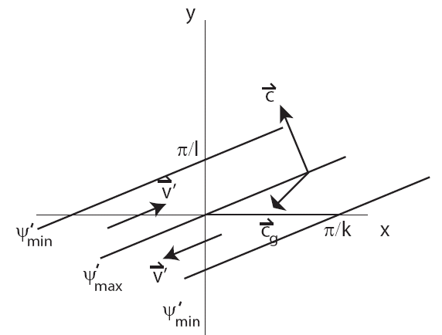
3.13
$$\bar{ζ}=1\text{.}2×{\text{10}}^{−5}s^{−1}$$

3.14
(a)
(b)
(c) $Δt=\text{200}s$

3.15
3.16
(a) $\vec{ζ}=\left(ζ_{1},ζ_{2},ζ_{3}\right)$, $\vec{F}=\left(F_{1},F_{2},F_{3}\right)$
(c)
Approximate form of the horizontal vorticity equations

Chapter 4
4.1
Region of ascent indicated by U
Region of descent indicated by D
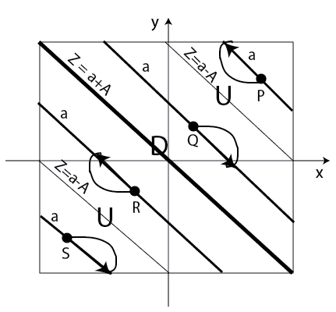

4.3
(a) When increases with height, the correlation is likely to be negative since the turbulence is expected to transport zonal momentum downward.
(b)
where
meaning that th energy of the mean flow would decrease in time when turbulence transports momentum in the down-gradient direction .
(c) , for
$$κ=λz$$

Chapter 5
5.1

5.2
The rate of decrease for the phase velocity with increasing is greater than that for the group velocity with a given $k$. The rate of decrease for the phase velocity with increasing is smaller than that for the group velocity with a given $m$.

5.3
where
Seek solution in the form of

(b) Phase velocity:
Group velocity:
(c) Structure:
where
Also, the velocity vector is not parallel to the wavefront since where ,

5.4
(a) The IGW first observed at z=H is the one that has maximum upward group velocity with a vertical wavenumber equal to .
The corresponding frequency would be $\tilde{σ}=N\sqrt{\frac{2}{3}}$
(b) $τ=\frac{H}{{\left(c_{\text{gz}}\right)}_{\text{max}}}=\frac{\text{Hk}{\left(3\right)}^{3/2}}{N2}$

5.6
(a) The governing equation is
(b)
The difference between this equation and that for the counterpart non-hydrostatic IGW is that this one does not have the term .
(c)
(d) For a hydrostatic IGW, we get
For non-hydrostatic IGW, we get

5.7
(a) , , ,
(b)
Again the phase velocity and group velocity are found to be orthogonal ,

(c)
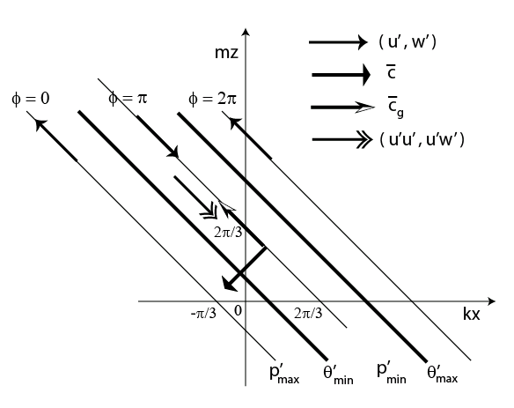
A hydrostatic IGW with , , and .
(d) Energy per unit mass
(e)
The vector on the x-z plane represents the energy flux of this IGW only varying in the vertical direction, where refers to the average over one horizontal wavelength.

5.8
(a) Governing equation
where
(b)
(c) With a westerly basic flow, a westward Doppler-shifted IGW has frequency
> 0
The phase velocity is
Thus, the basic zonal flow enhances both components of the phase velocity equally.
(d) The group velocity is
Thus the basic zonal flow only enhances the zonal component of the group velocity.
(e)
It follows that meaning that the angle between them is less than
(f)
, ,
,
(g)

(h) A uniform basic zonal flow does not change the structure of the IGW.

5.9
(a) For an orography , the governing equation of the forced response is
For ,
the response is a vertically trapped wave
$γ^{2}=k^{2}−\frac{N^{2}}{{\bar{u}}^{2}}$
(c) Most of the response is confined within a distance of from the orography.
(d) The location of maximum vertical motion is found at a quarter wavelength to the west of the topography.
(e) The vertical velocity at this location is
(f) A vertically trapped wave response has no vertical tilt.

5.10
Rossby wave stems from conservation of potential vorticity of each fluid parcel. In a prototype model of Rossby waves, the potential vorticity is simply the planetary vorticity which increases linearly with latitude. The advective influence of each PV anomaly upon its closest neighbors in conjunction with this meridional asymmetry necessarily leads to systematic westward movement of the positive and negative vorticity anomalies of a prototype Rossby wave.

5.12
Maximum value of for is found at such that
5.13
For an incident wave and . The properties of the reflected wave are indicated with a tilta. The relations between the properties of an incident wave and the reflected wave are:
Amplitude ,
Wavenumbers ,
Incident wave is indicated by subscript I.
Reflected wave is indicated by subscript R
Reflection of a Rossby wave by a north-south boundary

5.14
(a) ,
(b) , , ,
,
For constant, .
(c) For low orography, the governing equation is
where , .
, ,
(d)
(e) Solution :

(f)
(g) This is a resonant response. It arises because the forcing frequency , , matches the frequency of a corresponding intrinsic Rossby wave mode, .

5.15

5.16
(a)
(b)
normal modes
Dispersion relation
or
(c) Phase velocity vector
(d) Group velocity vector
(e)
The angle between them is
(f)
we get
For long waves
with ,
Apart from the arbitrary factor , and are large compared to .
The phase angle of and relative to approaches

For short waves
with
Apart from the arbitrary factor , and approach an asymptotic limit of . The phase angle of and relative to approaches .

5.17
The general solution is
where and is an arbitrary integration constant. For a channel in the northern hemisphere, we set and rewrite the solution as
The corresponding solution for the zonal velocity is

5.18
(a)
The linearized governing equation is

where ,

(b) Seek normal mode solution as

Dispersion relation is

So the normal mode can be rewritten as
,
(c) In the limit of short wavelength, , the attenuation approaches a constant rate .
In the limit of long wavelength, , the attenuation approaches a rate of
and is therefore vanishingly weak for waves much longer than the Rossby radius of deformation.

5.19*
(b) Basic state: ,
such that , and , , with being the scale height

The governing equations for the perturbation are
(c ) For a perturbation with
, the governing equation can be reduced to
(d) The complete solution is
for
(e) Energetics
The energetics of the wave is characterized by an exchange between its kinetic energy and its internal energy .
(f) This solution is known as Lamb wave, which is a horizontally propagating sound wave mode parallel to the earth’s surface. As such, it is a form of edge-wave from a dynamical point of view. As a sound wave, Lamb wave motion stems from the compressibility property of air compatible in the presence of the earth’s surface. The stratification plays no role in the dynamics of this edge-wave since this wave mode has no vertical motion. The analysis reveals that and of a Lamb wave decrease exponentially with height with a e-folding distance . Its increase exponentially with height so that the kinetic energy per unit mass is independent of height. Likewise, the potential energy per unit mass is also independent of height.
(g) Lamb wave is relevant to numerical atmospheric modeling when one uses a model that takes into account of the full effect of compressibility of air (i.e. without invoking Boussinesq approximation). The time step and the distance between two adjacent horizontal grid points must be chosen such that the Lamb wave modes can be adequately represented in such a model. The time step needs to be quite small since even the large scale Lamb wave modes propagate at a high speed.
5.20*
For a basic state which is isothermal in hydrostatic balance
, , with being the scale height
Define a constant
Define
Then we get
(10)
(11)
Solution
Dispersion relation
(12)
where ,
The four roots of (12) represent the frequency of two sound waves and two internal gravity waves.
Since the former is much larger than the latter, we can get good approximate roots as.
Also, in addition to having high frequency, the wavelength of sound waves are much shorter than that of internal gravity waves. We can get good approximate roots as
The complete solution
The polarization relations are

5.21*
(a) Boussinesq approximation refers to neglecting fluctuation of density unless it appears in conjunction with gravity.
With this approximation, the complete solution is
(9a,b,c,d)
So, we see that these properties are good approximations of the counterparts in the general solution. But the vertical variation of the amplitude of wave is somewhat distorted.

(b) We further approximate , a constant.
Complete solution is
(15a,b,c,d)
There is no vertical variation of the amplitude of the wave obtained with a local Boussinesq approximation.
Chapter 6
6.1
(a)
(b)

6.2
(a)
where ,
radius of deformation, stratification parameter
(b)
(c) Both wave modes propagate westward.
(d) For ,
$$ψ_{1}=ψ_{3}$$
$$ω_{2}=0$$
For
(e) The “- root” mode has no vertical motion. The streamfunction at the two levels are identical. Therefore, this mode is a barotropic Rossby wave mode independent of the stratification.
The streamfunction of the “+ root” mode at the upper level and that at the lower level is 180 degree out of phase. Its vertical velocity field leads the upper level streamfunction field by a quarter of a wavelength. The “+ root” mode is a baroclinic Rossby wave mode.

6.3
Descending motion is to be expected at A, namely descent to the west of a low-pressure center. Ascending motion is expected at B, namely ascent to the east of a low-pressure center.

6.4
(a )
(b)
Seek ,
Using the given solution of obtained from an instability analysis, we get
$$−ω^{'}=\frac{δp\left(U_{1}−U_{2}\right)λ^{3}}{f_{o}\sqrt{3}}A\text{exp}\left(i\left(k\left(x−\text{ct}\right)+ξ+η\right)\right)$$
Relative phase between $−ω^{'}$ and $ψ_{2}^{'}$ is $η=\text{60}°$

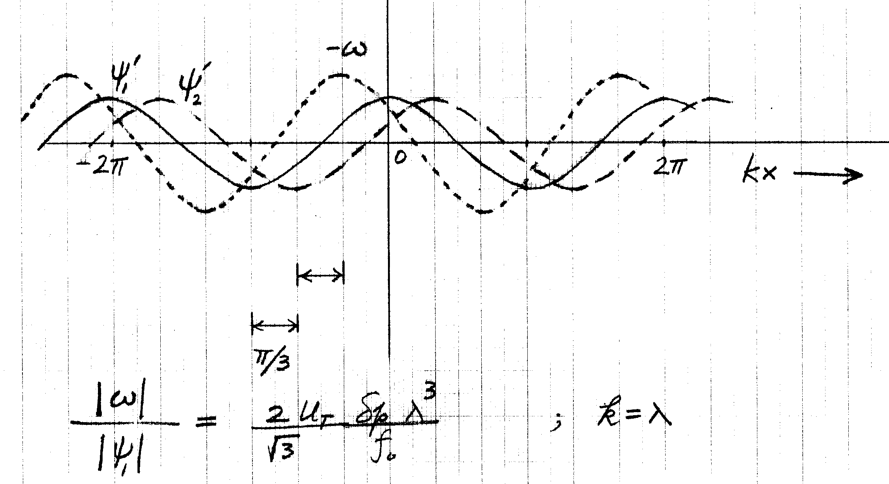

6.5
(a) The governing equations are
,
(b) PV advection

$$q_{1}\left(t=1\text{day}\right)$$

(c) These panels depict that the jet streak as an entity progressively moves eastward. The evolution of this meridionally oriented jet streak is quite different from that of the zonally meridionally oriented jet streak examined in section 6.6.2. The initial meridional symmetry in every field is broken very quickly. This is attributable to the strong beta effect associated with the orientation of the initial jet streak. The mixing of PV is strong. The initial negative PV anomaly is pushed southward by a developing trough on the east side of the jet streak. The east-west oriented distribution of local extreme values of eventually changes to a largely north-south oriented distribution by t=5.

Chapter 7

7.1
(a) The initial state is not in balance. The free surface between and would initially fall under the influence of gravity. External gravity waves would be excited. Fluid begins to move outward and hence would immediately develop nonzero value. The Coriolis force acting on would then induce nonzero value of . Gravity waves would continue to propagate outward. Adjustment in , and would go on for sometime.
At large time, the gravity waves would have propagated to far distances and a steady balanced state would emerge in the central part of the domain. By symmetry, we expect in such state.
(b) The solution is
in the region
in the region
in the region
in the region
where ( is Coriolis parameter and is gravity);
is a convergent series for small .
(c) Since the balanced state is in geostrophic balance, the velocity field is
where is the given solution for the free surface elevation and because .
(d) To make a sketch of , we need to use the analytic solution of to deduce its value at a few key locations, .
For the case $L\text{>>}λ^{−1}$
@$x=±L$, $h=H+\frac{A}{Lλ}\left(1−\frac{1}{2}\left(e^{Lλ}+e^{−Lλ}\right)\right)e^{−Lλ}≈H−\frac{A}{2Lλ}$
@ $x=0$, $h=H+A\left(\frac{1}{Lλ}+1\right)−\frac{A}{Lλ}e^{−Lλ}≈H+A$
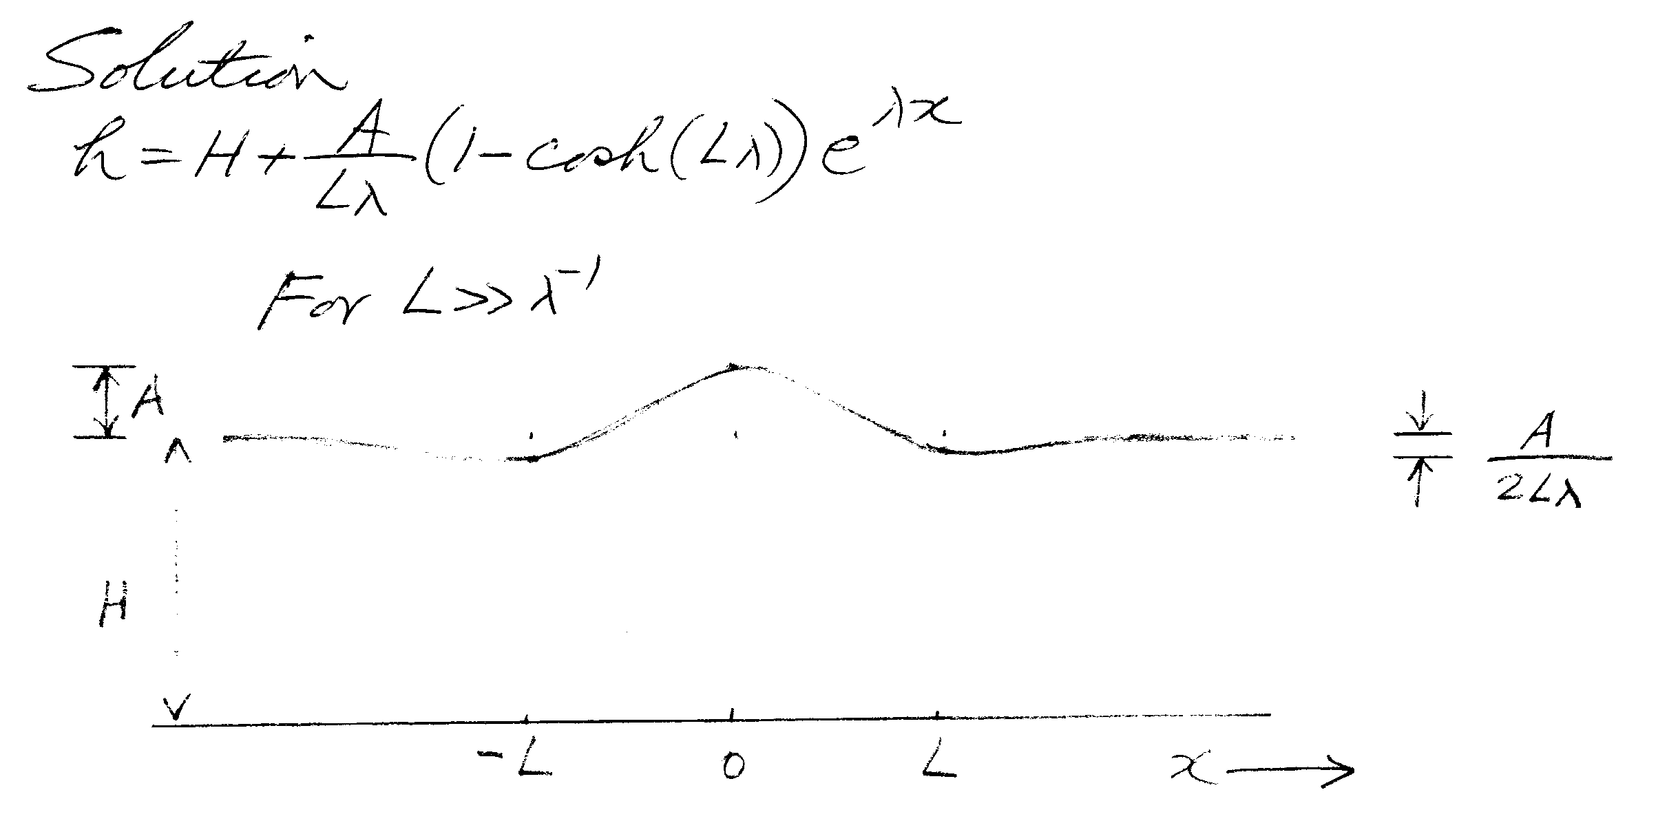

For $L\text{<<}λ^{−1}$
@ $x=−L$, $h≈H−\frac{\text{AL}λ}{2}\left(1−Lλ\right)$
@ $x=0$, $h≈H−\frac{\text{AL}λ}{2}\left(1−\frac{Lλ}{3}\right)$
@ $x=L$, $h≈H−\frac{\text{AL}λ}{2}\left(1−Lλ\right)$
$h$ is lowest at x=0. $\left(H−h\right)$ is small everywhere.
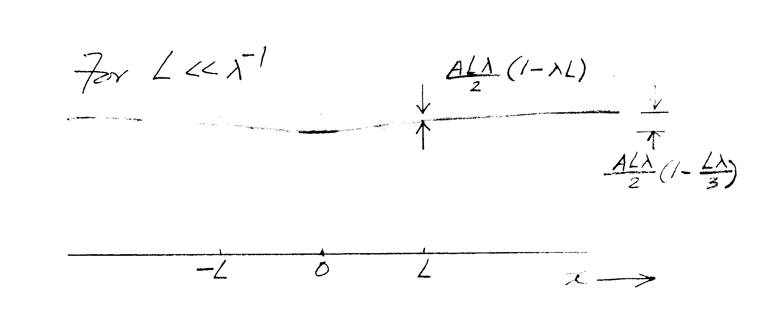

(e) Recall that the initial disturbance has no wind. The geostrophic adjustment occurs by significantly changing the velocity field, rather than the mass field, in the case of . The reason is that the longer is the length scale of the initial unbalanced disturbance, the stronger would be the influence of the Coriolis force. The pressure gradient force would be necessarily larger. There would be a larger slope in that would support a stronger wind .

Chapter 8A

8A.1
(a)
Thus the oscillation frequency is the Brunt-Vaisala frequency, .
(b)
The frequency of the oscillation is equal to .
(c)
The dispersion relation of IGW is therefore

8A.3
(a)
(b)
,
square of velocity of sound
Hence the vertical distribution of potential density determines whether or not the atmosphere is statically stable.

Chapter 8B

8B.1
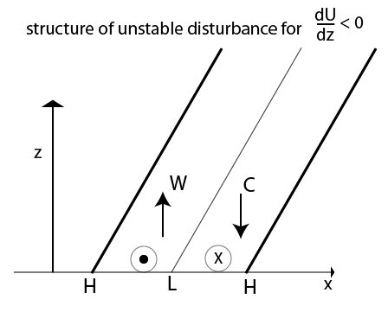

8B.3
(a) Define $\tilde{σ}=σ/γ$, $\tilde{k}=\text{ky}∗$
The variation of ${\tilde{σ}}_{i}$ with $\tilde{k}$ is plotted below
(b) ${\left({\tilde{σ}}_{i}\right)}_{\text{max}}=0\text{.}\text{201}$ for $\tilde{k}=0\text{.}4$
(c) Structure of the most unstable mode
(d) The plot suggests that the instability results from positive reinforcement between the PV anomalies of the unstable disturbance at $\tilde{y}=±1$ where the basic vorticity gradient is discontinuous.
(e) Structure of a stable mode

8B.4
(a) Define $\tilde{σ}=σ/γ$, $\tilde{k}=\text{ky}∗$
The variation of $\text{Im}\left\{{\tilde{σ}}_{i}\right\}$ with $\tilde{k}$ for three modes is plotted below

(b) The maximum growth rate is ${\tilde{σ}}_{i}=0\text{.}\text{247}$ at $\tilde{k}=1\text{.}2$
(c) The variation of $\text{Re}\left\{{\tilde{σ}}_{i}\right\}$ with $\tilde{k}$ for three modes is plotted below
(d) Structure of the most unstable mode
(e) Structure of a stable mode

(i) Relevant values of the basic parameters: $\bar{u}\left(y=0\right)=\text{20}{\text{ms}}^{−1}$ , $y∗5×{\text{10}}^{5}m$.
Wavenumber of the most unstable mode = $\frac{\tilde{k}}{y∗}=0\text{.}\text{24}×{\text{10}}^{−5}m$
Wavelength of the most unstable mode = $2\frac{πy∗}{\tilde{k}}=2\text{.}6×{\text{10}}^{6}m$
Growth rate of the most unstable mode= $1×{\text{10}}^{−5}s^{−1}$
Phase velocity of the most unstable mode= $\frac{\tilde{σ}}{\tilde{k}}u∗6\text{.}2{\text{ms}}^{−1}$

8B.5
(a) ,
(b) , there is no real value of
(c) , there is no real value of
(d) ,

8B.6
(e) The mode with $γ=1$ is an unstable mode since it intensifies in time.
The unstable wave titles westward with height. The ridge (trough) of upper level (streamfunction) wave is one quarter wavelength west of the low level ridge
(trough). Heat flux is northward, down-gradient of background temperature gradient.
$$ψ_{1}^{'}$$
$$ψ_{2}^{'}$$

(f) The one with γ = -1 is a stable mode since it will decay in time. The stable wave titles eastward with height. The ridge (trough) of upper level (streamfunction) wave is one quarter wavelength east of the low level ridge
(trough). Heat flux is southward, along the background temperature gradient.

$$ψ_{1}^{'}$$
$$ψ_{2}^{'}$$

8B.7
(a) ${\left(L\right)}_{\text{longest}}=7\text{.}9×{\text{10}}^{3}\text{km}$
(b) ${\left(L\right)}_{\text{shortest}}=3\text{.}1×{\text{10}}^{3}\text{km}$
(c) ${\left(L\right)}_{\text{max}\text{Growth}}=4\text{.}5×{\text{10}}^{3}\text{km}$
(d) ${\left(σ_{i}\right)}_{\text{max}}=1\text{.}×{\text{10}}^{−5}s^{−1}$ e-folding time $\frac{1}{σ_{i}}=1\text{.}×{\text{10}}^{5}s=\text{27}\text{.}8\text{hrs}$
(e) phase speed=
(f) is located at
Since ${\tilde{ψ}}_{2}=\frac{{\tilde{ψ}}_{1}+{\tilde{ψ}}_{3}}{2}$, we find that is located at
Therefore, is located at 1.75 to the east of , amounting to a phase angle of to the east of the trough at level-2.
(g) The result in (f) means that warm air goes north and cold air goes south at level-2 implying that basic available potential energy is being converted to wave available potential energy. The latter in turn means that part of the wave available energy is converted to wave kinetic energy.

8B.8
By considering the buoyance force acting on a displaced parcel, we deduce that the inequality for an unstable trajectory of a parcel A is
${\left(\frac{\text{dz}}{\text{dy}}\right)}_{θ}>{\left(\frac{δz}{δy}\right)}_{A}=\text{tan}φ$.

(a) parcel (A): $δz>0,δy>0$ & $0<\frac{δz}{δy}<\frac{\text{dz}}{\text{dy}}$ $⇒$ unstable
Parcel (B): $δz>0,δy>0$ & $0<\frac{\text{dz}}{\text{dy}}<\frac{δz}{δy}$ $⇒$ stable
Parcel (C): $δz<0,δy<0$ & $0<\frac{\text{dz}}{\text{dy}}<\frac{δz}{δy}$ $⇒$ stable
Parcel (D): $δz<0,δy<0$ & $0<\frac{δz}{δy}<\frac{\text{dz}}{\text{dy}}$ $⇒$ unstable
(c) Rewrite the expression for the buoyancy force as
$$\begin{aligned}F\text{sin}φ=\left({\left(\frac{\text{dz}}{\text{dy}}\right)}_{θ}−{\left(\frac{δz}{δy}\right)}_{A}\right)δy\left(\frac{∂θ}{∂z}\right)\frac{g}{θ_{A}}\text{sin}φ \\ \left(\frac{−∂θ/∂y}{∂θ/∂z}−\frac{w}{v}\right)δy\left(\frac{∂θ}{∂z}\right)\frac{g}{θ_{A}}\text{sin}φ \\ \left(−v\frac{∂θ}{∂y}−w\frac{∂θ}{∂z}\right)\frac{δy}{v}\frac{g}{θ_{A}}\text{sin}φ\end{aligned}$$
(d) A parcel going upward and northward in a trajectory that has a smaller slope than the background isentropic surface would have a positive PT anomaly. It is equivalent to a negative density anomaly. That would give rise to an upward buoyancy force that further enhances the displacement of the air parcel.
(e) If an air parcel has a horizontal trajectory, the buoyancy force is perpendicular to the trajectory. Therefore, it would have no effect on the horizontal displacement. If an air parcel has a trajectory parallel to the background isentropic surface, there would be no PT anomaly. Therefore, there would be no buoyancy force and the displacement would not be affected at all. In both cases, we have what is called marginal stability.
The trajectory of air parcels in the most unstable disturbance would have a slope half-way between the two limiting values, namely ${\left(\frac{δz}{δy}\right)}_{\text{mostUnstable}}=\frac{1}{2}{\left(\frac{\text{dz}}{\text{dy}}\right)}_{θ}$.
In the presence of beta-effect, the threshold value for instability is
${\left(\frac{\text{dz}}{\text{dy}}\right)}_{θ}>γ=\frac{βR{\bar{T}}_{2}}{{\text{gf}}_{o}}$. The trajectory of air parcels in such mode would be expected to be equal to ${\left(\frac{δz}{δy}\right)}_{\text{mostUnstable}}=γ+\frac{1}{2}\left({\left(\frac{\text{dz}}{\text{dy}}\right)}_{θ}−γ\right)=\frac{1}{2}\left({\left(\frac{\text{dz}}{\text{dy}}\right)}_{θ}+γ\right)$ .

Chapter 8C
8C.1
(a)
(b) The wavenumber is
(c) The e-folding time is
(d) The phase speed is
(f) From the horizontal tilt of noted in the answer for question (8C.2), we deduce that and are positively correlated to the south of the jet axis and negatively correlated to the north of the jet axis. Thus, and have the same signs at all values of . It follows that < 0 . Some wave kinetic energy is then converted to basic kinetic energy.

From the vertical tilt of noted in the answer for question (8C.2), we deduce that >0 . In light of the gradient of the basic temperature at level-2 as represented by , heat is transported from the south to the north ( i.e. in the down-gradient direction) . This means that some basic potential energy is converted to wave potential energy.

From the relative phase of and , we deduce that>0 . This means warm air rising and cold air sinking, thereby converting some wave potential energy to kinetic energy.

Furthermore, the structure of an unstable normal mode must be such that,
+ >0

- >0

where = wave kinetic energy, = wave available potential energy
(g)
ZP
P
K
ZK

Chapter 9
9C.1
(a) For a stationary Rossby wave
,
Thus, the group velocity is parallel to the wavenumber vector.
(b) For the case of a wave that initially has , the wavepacket would initially propagate in the northeast direction in light of the result in part (a). It would bend more and more toward the east as it propagates.

9.2
(a)
Surface pressure on the topography,
Height of the topography,
A zonal strip of atmosphere with a meridional width,
Distance of an air parcel at latitude to the axis of the earth =
Torque acting on the atmospheric strip at latitude
=
For , , , ,,
Moutain Torque =

Conclusion: the solid earth exerts a negative torque on this zonal strip of the atmosphere.

Chapter 11
11.1
(a) By (11.24a,b), we get , .
would imply . If we also have , would also mean . For waves of such wavelengths, we would then have and , meaning that those waves would intensify at the expense of the zonal baroclini c flow.
(b) According to the linear baroclinic instability, the shortwave cutoff is dependent on the basic shear. Thus, the result in (a) is compatible with the result of linear instability theory in the same setting.

11.2
(a)
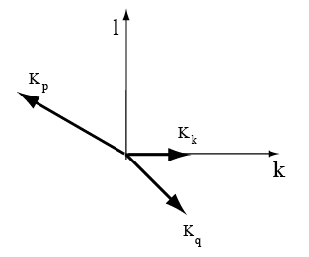
(b) Energy transfers: , . This means that 75% of energy loss from wave goes to the longer wave and 25% of it goes to the shorter wave .
Enstrophy transfers: , , . This means that 37.5% of the enstrophy loss goes to the longer wave and 62.5% of it goes to the shorter wave .

Chapter 12
12.2 A two-layer primitive-equation zonally symmetrical model with Boussinesq approximation for the Hadley circulation is formulated as follows:
(a) The zonal momemtum equation in spherical coordinates
Rewrite it in flux form
Similarly we get
The remaining governing equations are
Now apply these equations to the model levels
No net mass flux across any latitude
Since we do not allow the stratification to change in this model,
we mus treat it as a given parameter. We use the notation where is Brunt-Vaisala frequency
,
We use up-stream difference scheme for representing the vertical advective process:
If w>0, set
If w<0, set
Hence ,
with if w>0, if w<0
At level 2, ,
At level 1, ,
Governing equations for this model are then written as
(1)
(2)
(3)
(4)

(5)
Reduce this system of 7 equations to a system for 6 unknowns.
Only need to determine as a single unknown

3rd and 4th equations above
(6)

(b) Cast the equations above with a center-dfference scheme for the latitudinal dependence.
Grid points are indicated by j=1,2,3,…J ; j=1 for 90S and j=J for 90N

New notations:
, , , ,
(1)
(2)

(3)
(4)
(5)
(6)
Boundary conditions
,
,

(c) We may use a predictor-corrector scheme to integrate this set of equations. The initial state is at rest.

The following diagram shows the structure of the annual mean Hadley circulation obtained with this model for
, , , ,
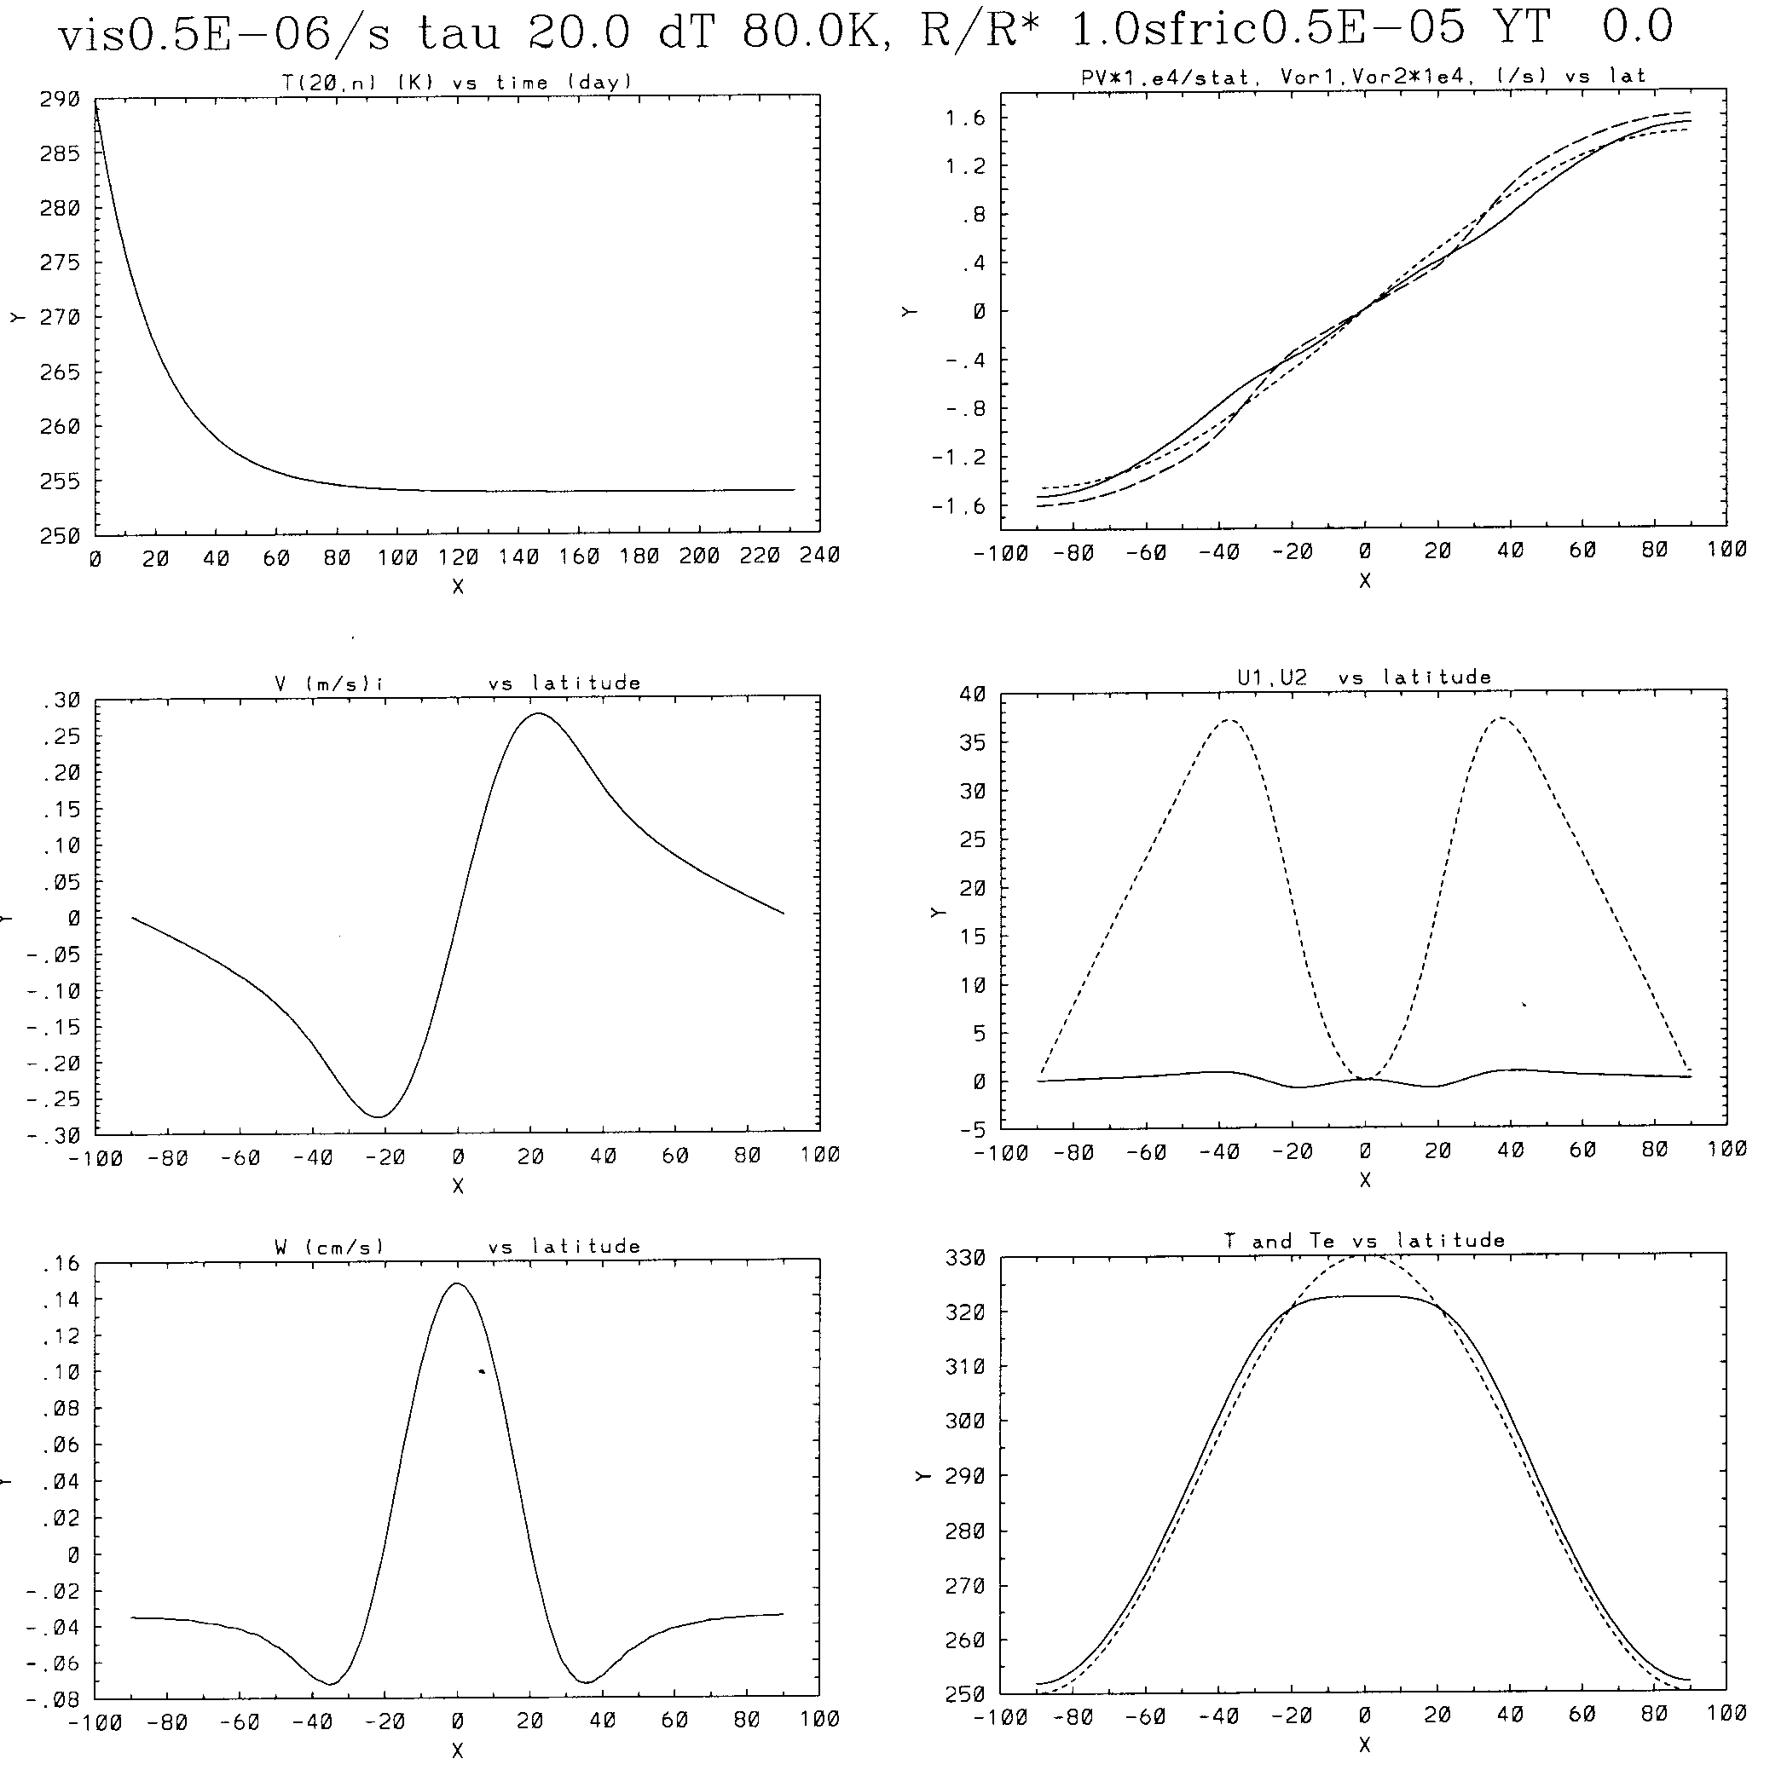
- Upper left panel: Variation of in K at the grid point j=20 with time showing that the flow essentially reaches a steady state after 80 days.
- Left middle panel: Distribution of in of the steady state
- Left bottom panel: Distrution of in of the steady state
- Upper right panel: Distribution of potential vorticity at mid level, and vorticity at each level
- Right middle panel: Distribution of and in of the steady state
- Right bottom panel: Distribution of and in K of the steady state

